Supplement 1.
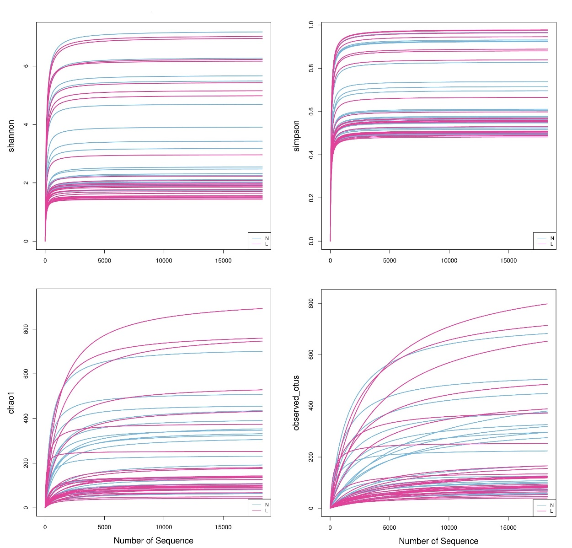
The rarefaction curve of each sample tended to be flat, indicating that most of the bacteria were detected.

Supplement 2.
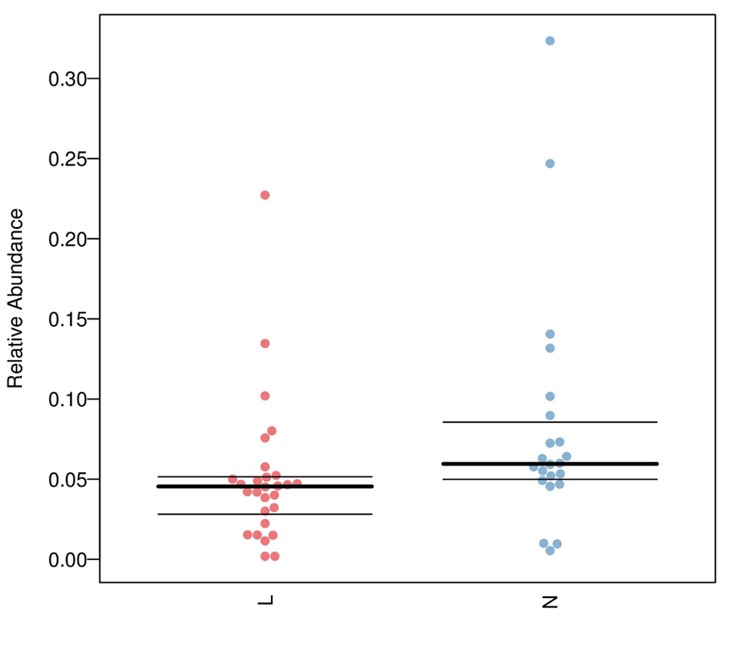 In terms of bacterial phenotypes, the abundance of facultative anaerobe decreased significantly in the OK lens group (5.07% vs. 8.23%, P = 0.009).

