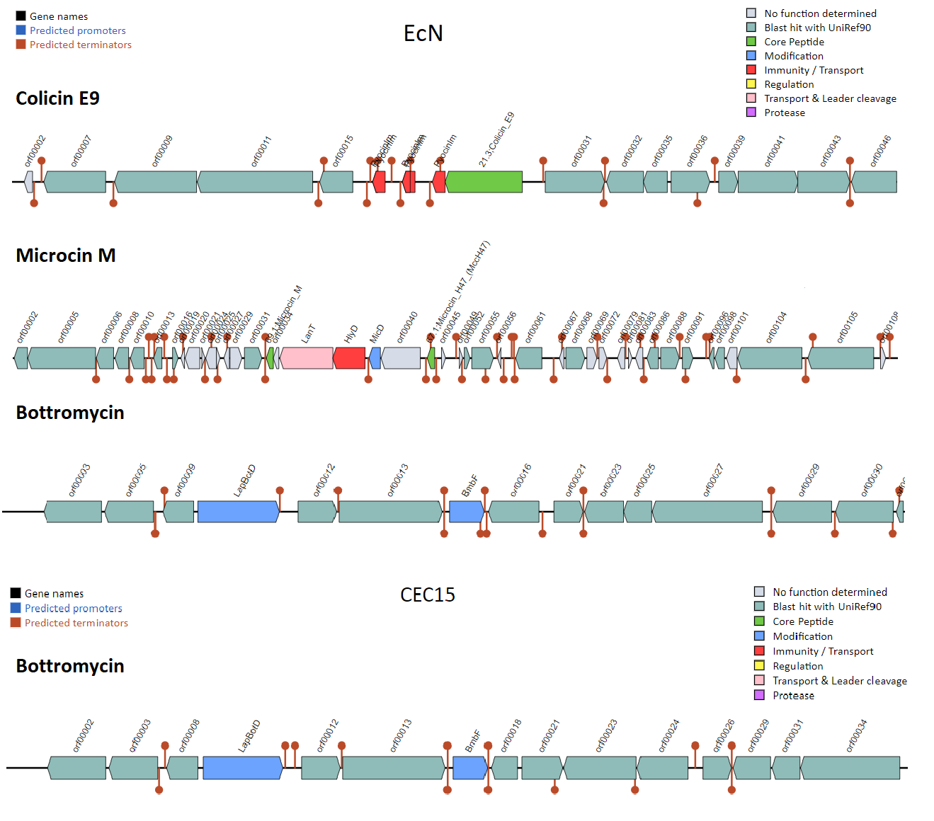
Supplementary figure S4. Bacteriocins-encoding genes present in the genome of CEC15 and EcN strains. The identification of bacteriocins-encoding genes were performed by matching the genome fasta files with the BAGEL4 database (http://bagel4.molgenrug.nl/). The image shows the cluster of genes related to each bacteriocin in each strain with the core sequence being highlighted in green. Tree bacteriocin-encoding genes were found on EcN strain (Colicin E9, Microcin M, and Bottromycin) while only one (Bottromycin) was found on CEC15.

