Diadenosine tetraphosphate modulated quorum sensing in bacteria treated with kanamycin
Xia Ji^{1#*}, Ruojing Yu^{1#}, Meilian Zhu¹, Cuilin Zhang¹, Libin Zhou^{l}, Tianshu Cai², Weiwei Li²
¹School of Life Science, Huizhou University, Huizhou, 516007, China
²Huizhou Health Sciences Polytechnic, Huizhou, 516025, China
# These authors contributed equally to this work
* Correspondence:
Xia Ji: xiaji@hzu.edu.cn

Keywords: kanamycin, diadenosine tetraphosphate, biofilm, apaH, quorum sensing
Running Title: Ap4A Regulated Bacterial Quorum Sensing
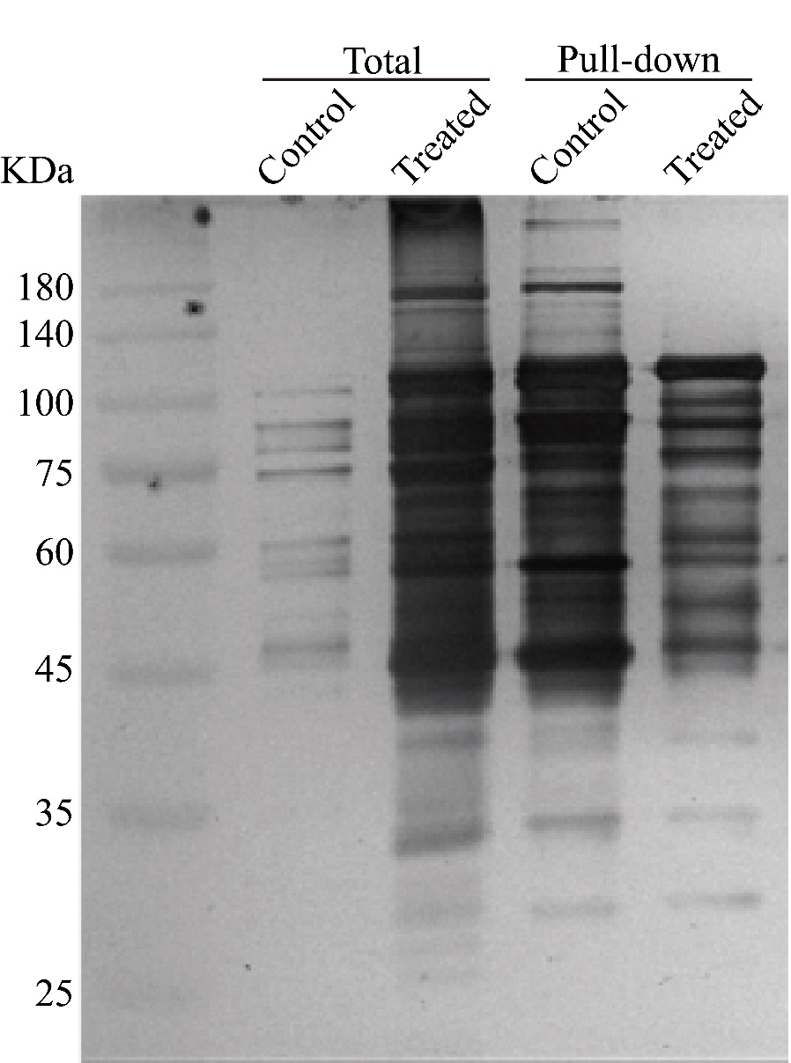
Supplementary Figure 1. Screening Ap4A binding candidate proteins. Silver stain of the Ap4A binding candidate proteins after Ap4A-biotin immunoprecipitation (IP) with the protein lysate of 100 μg/ml kanamycin treatment or not treatment with E. coli K12-MG1655.
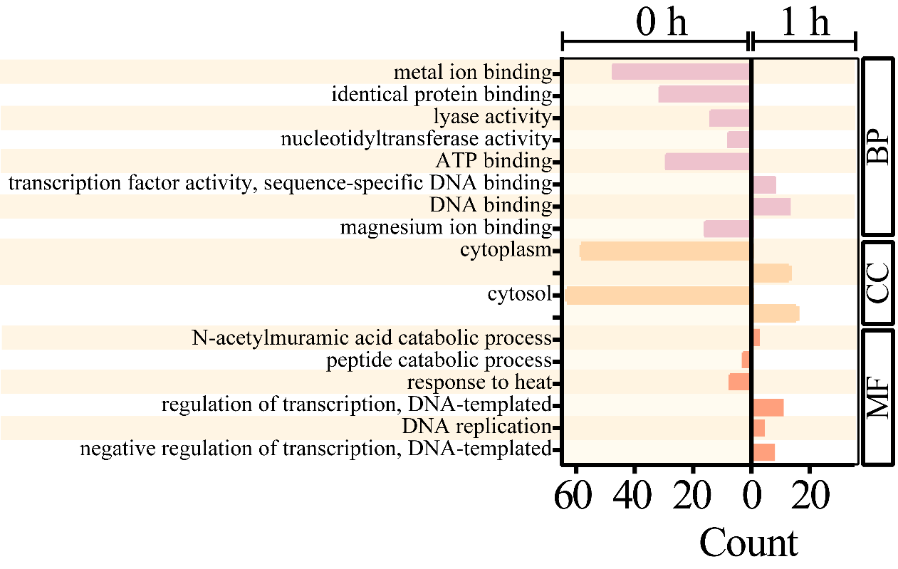
Supplementary Figure 2.Gene ontology (GO) analysis of proteome data from Ap4A binding proteins under kanamycin treatment E. coli K12-MG1655.
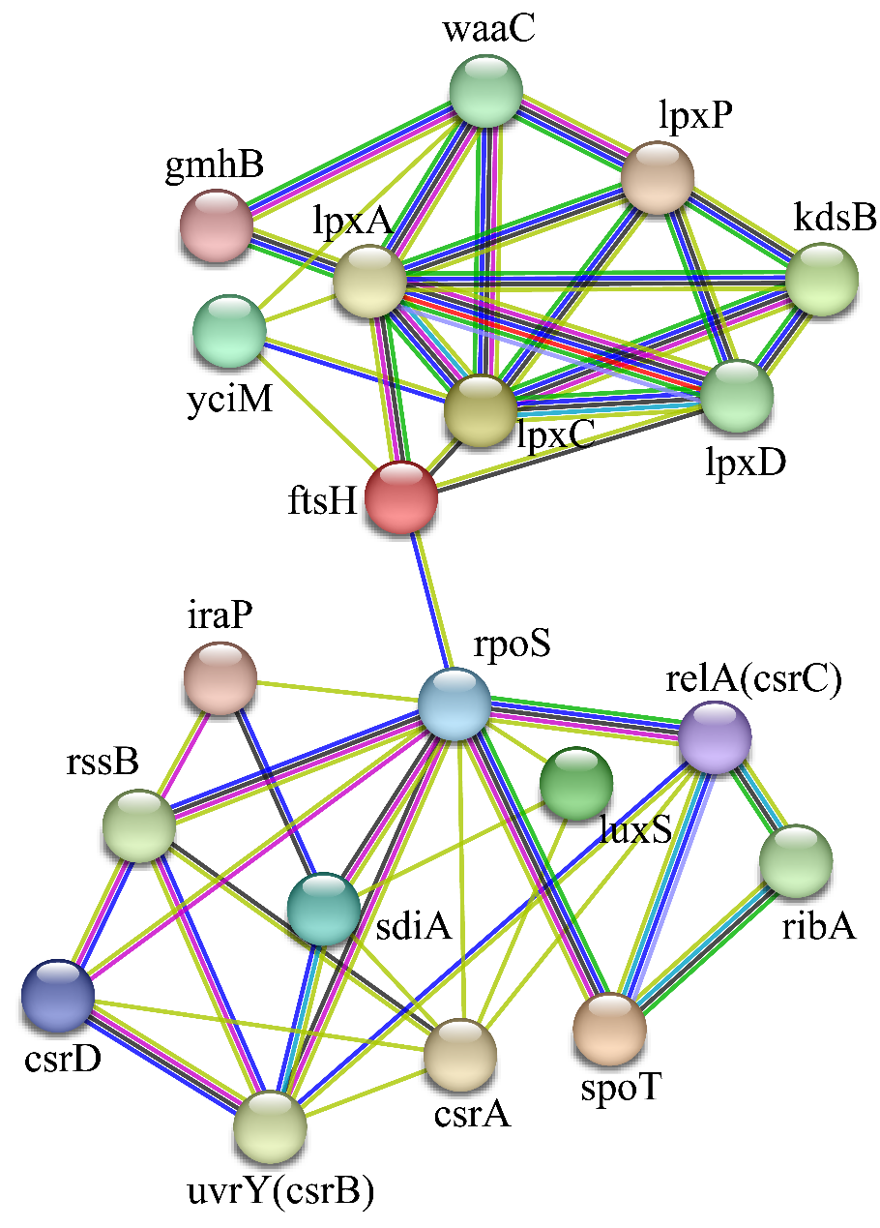
Supplementary Figure 3.The protein-protein interaction (PPI) network analyses of Ap4A binding proteins in E. coli K12 MG1655.
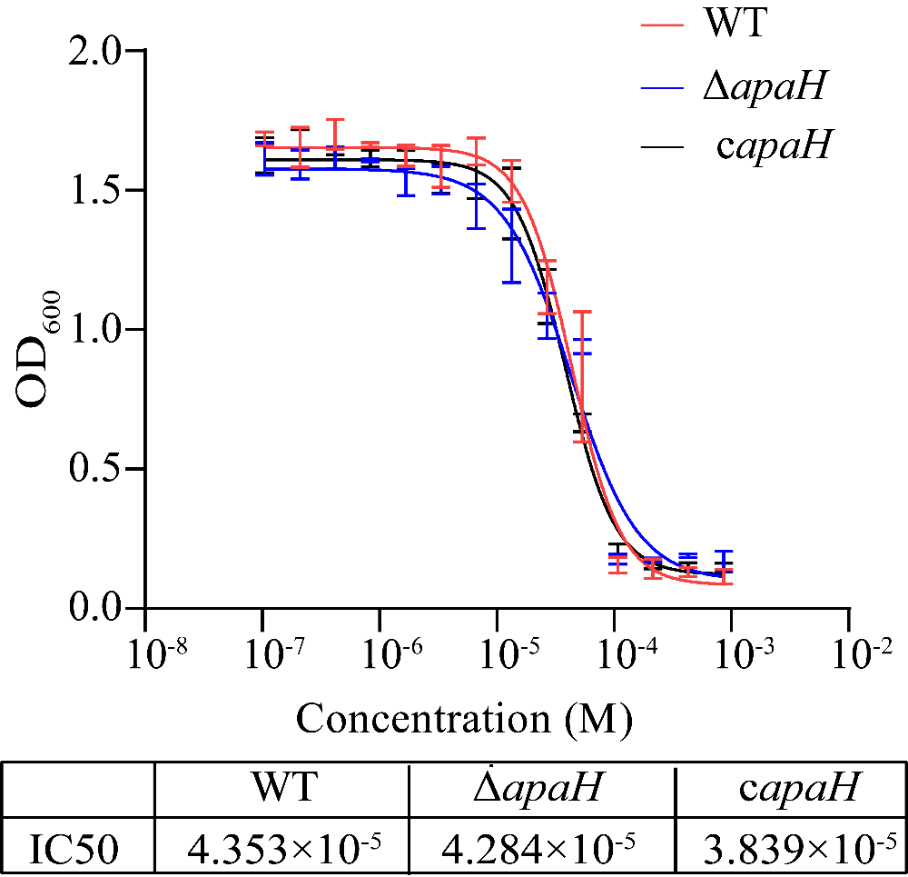
Supplementary Figure 4. The kanamycin MIC of the wild-type, mutant strain ΔapaH, and complemented strain were tested on Luria-Bertani (LB) medium.
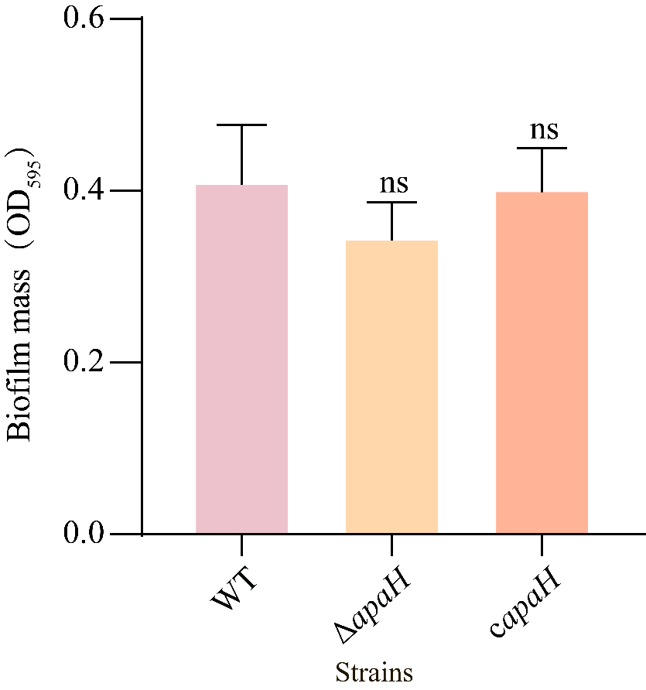
Supplementary Figure 5. The biofilm formation of the wild-type, apaH mutant, and complemented strains without kanamycin treatment.

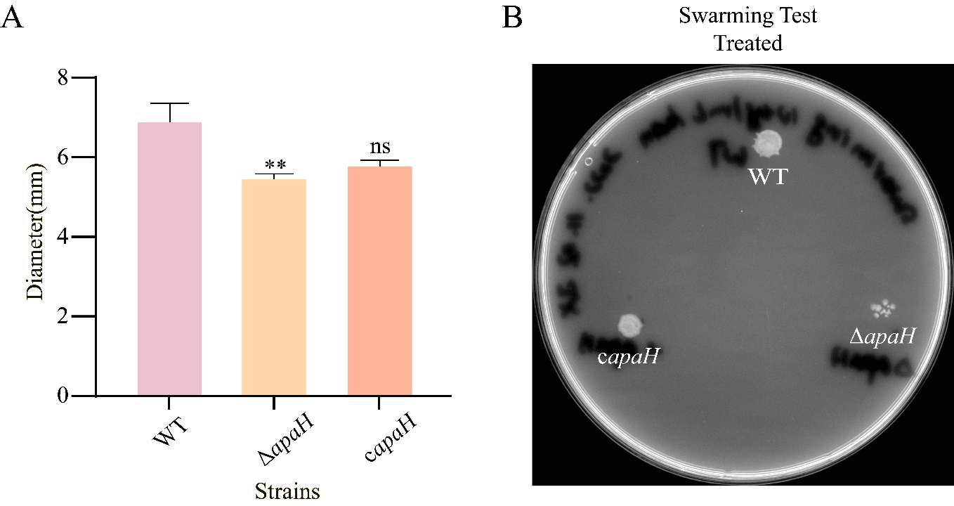
Supplementary Figure 6. The swarming motility of wild-type, apaH mutant and complemented strains with kanamycin treatment. (A)The swarming motility diameter of wild-type, apaH mutant, and complemented strains. (B)The swarming motility of wild-type, apaH mutant, and complemented strains were tested on Luria-Bertani (LB) plates containing 10 μg/ml kanamycin, 0.5% agar.

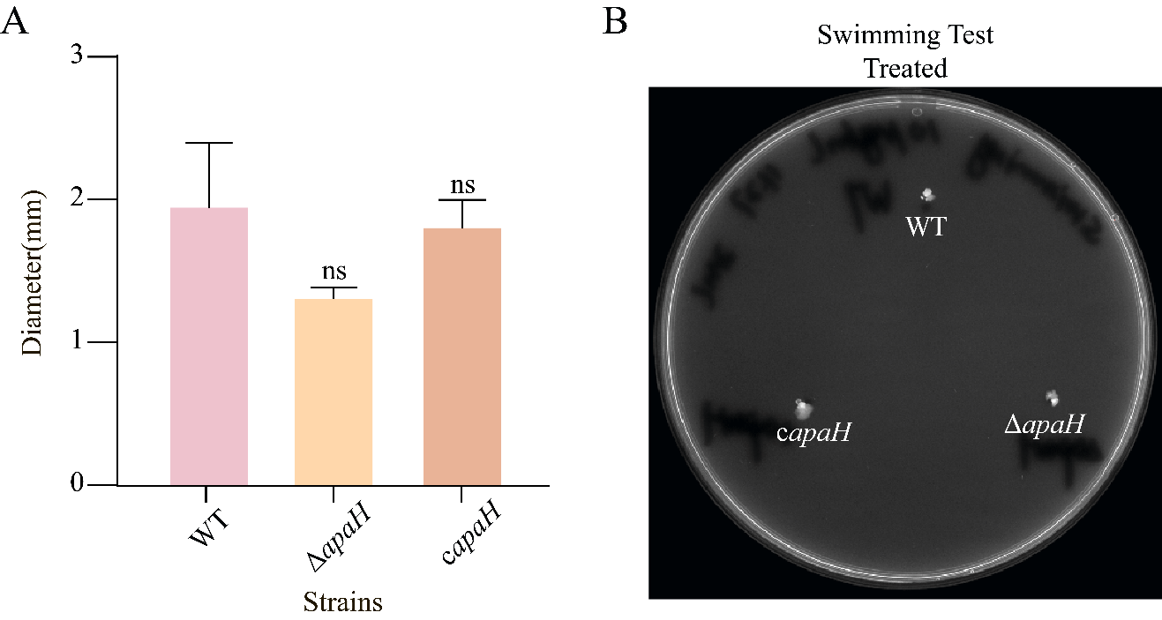
Supplementary Figure 7. The swimming motility of wild-type, apaH mutant, and complemented strains with kanamycin treatment. (A)The swimming motility diameter of wild-type, apaH mutant, and complemented strains. (B) The swimming motility of wild-type, apaH mutant, and complemented strains were tested on Luria-Bertani (LB) plates containing 10 μg/ml kanamycin, 0.3% agar.

