a
Figure1a. Original gel electrophoresis image of Pho A genes

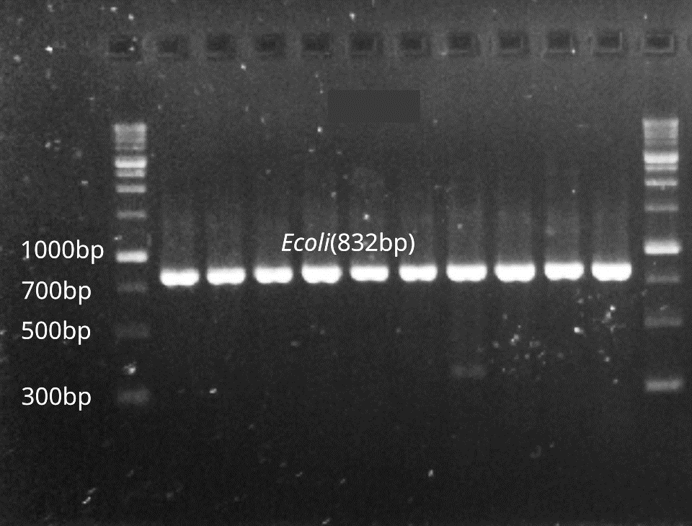
b
Figure 1b. Original gel electrophoresis image of Ecoli genes
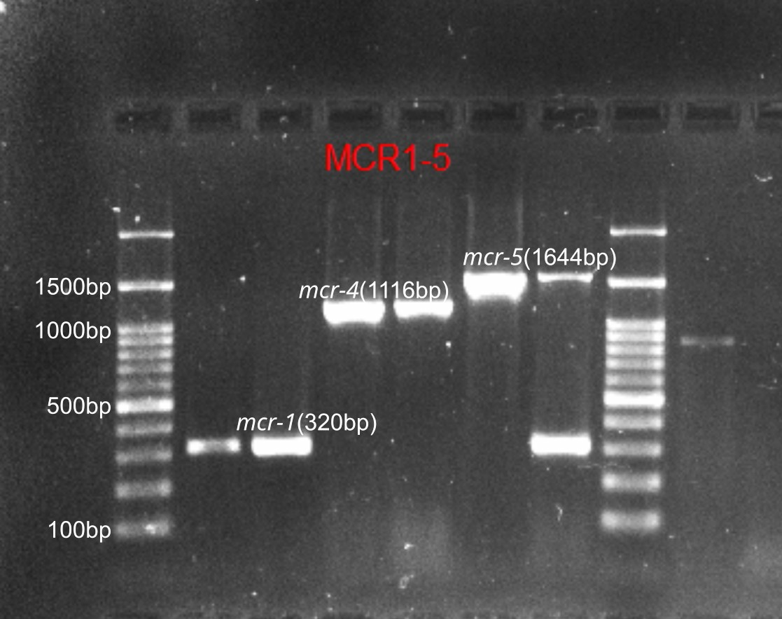
Figure 4. Original gel electrophoresis image of amplified PCR product with mcr-1, mcr-4, and mcr-5 genes

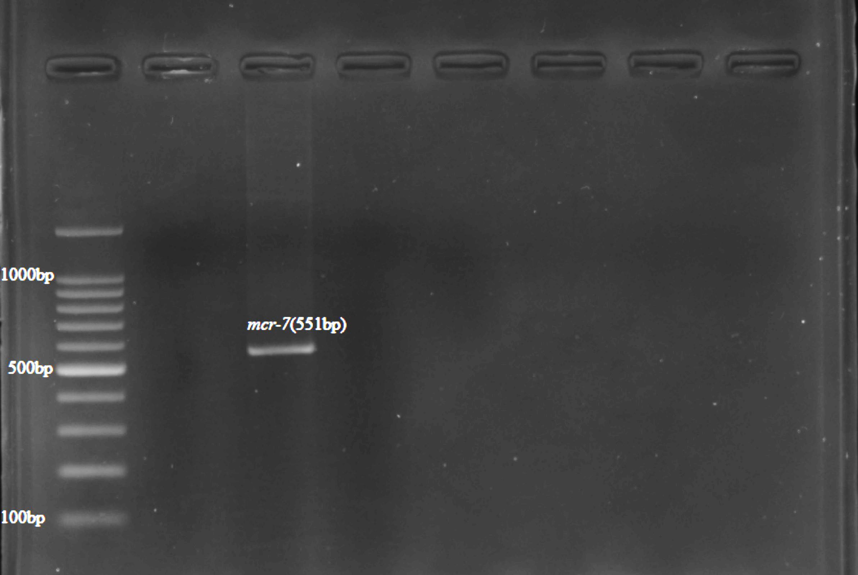
Figure 5. Original gel electrophoresis image of amplified PCR product mcr-7 gene
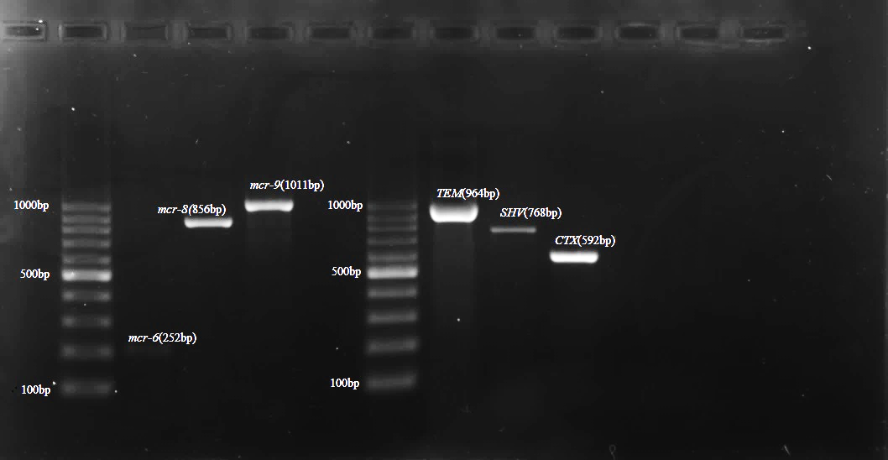
Figure 6. Original multiplex PCR6-9, gel image of mcr-6,mcr-8, mcr-9 and ESBL genes
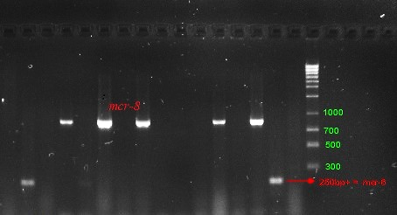
Figure 7. Original gel electrophoresis image of amplified PCR product with mcr-6 and mcr-8 genes
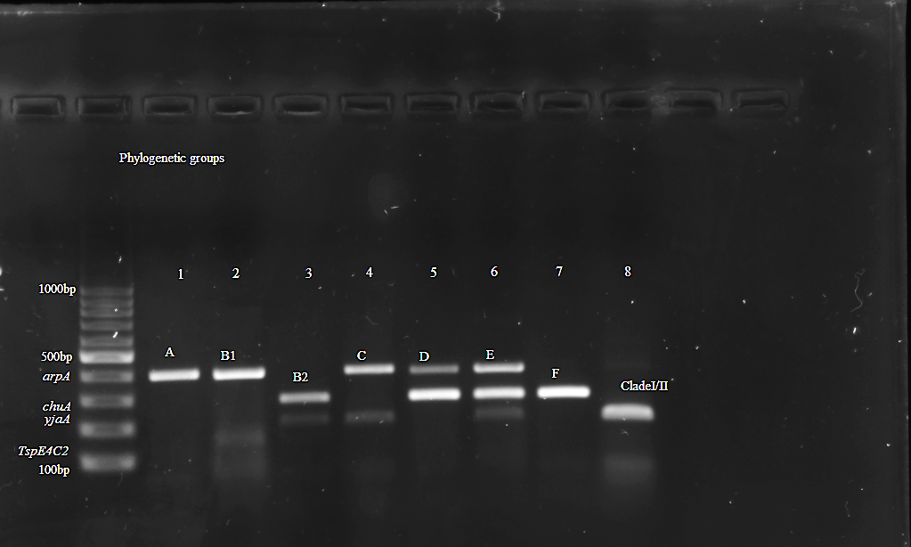
Figure 8. Agarose gel electrophoresis image of mcr positive E. coli phylogenetic typing. Amplified PCR products with E. coli phylogrouping genes; arpA (400bp), chuA (288bp), yjaA (211bp) and TspE4C2 (152bp); lane 1,+ - - -, belonging to phylogroup A; lane 2,+ - - +, belonging to group B1; lane 3,- + + -, group B2; lane 4,+ - + -, group C; lane 5,+ + - -, group D; lane 6,+ + + -, group E; lane 7,- + - - ,group F; lane 8,- - + -, clade I/II.

