Fig. S1. Dots plots of CCDM 368 and CCDM 219 viability.
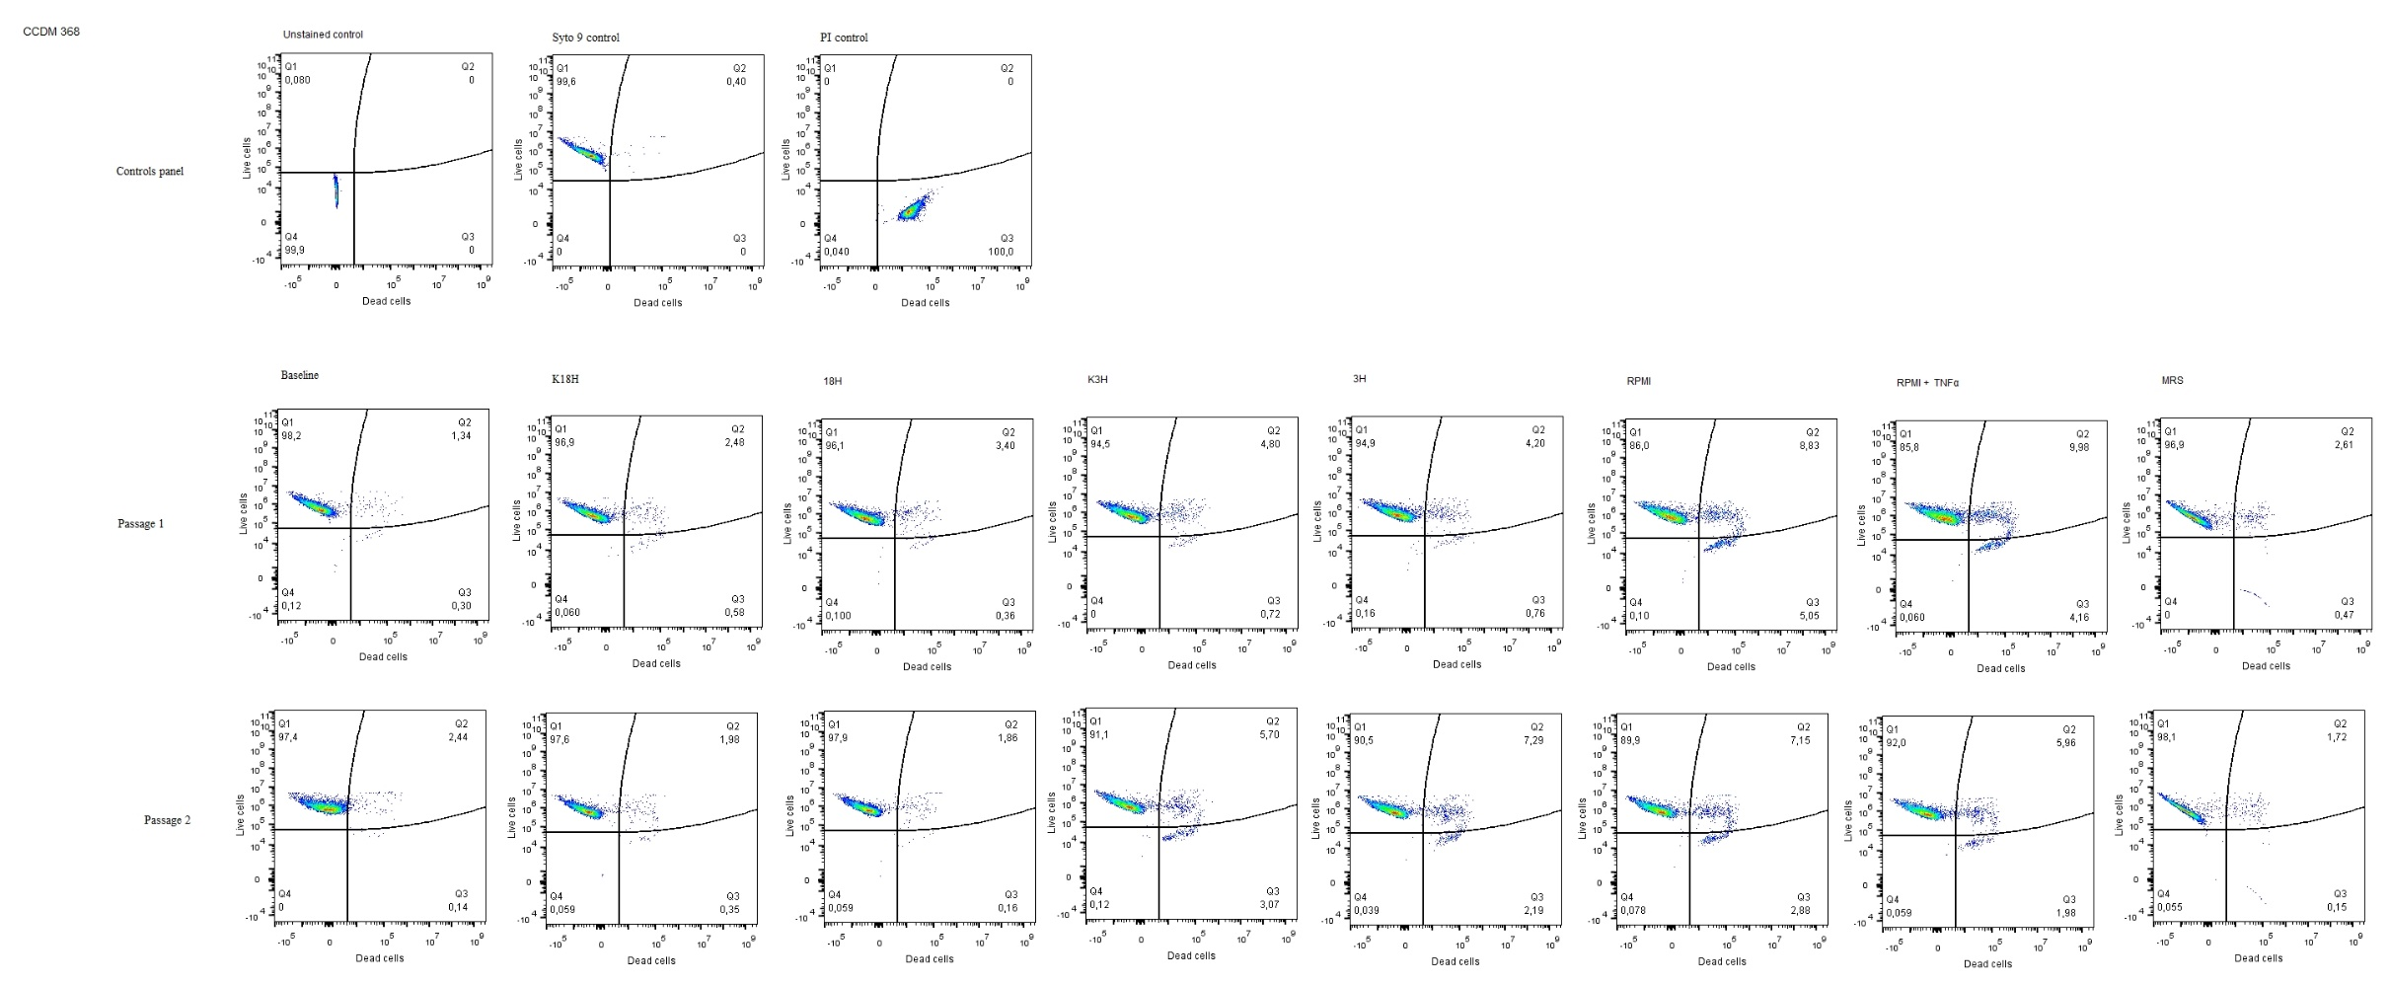
a) Examples of dot-plots for strain CCDM 368. Two different bacterial passages.

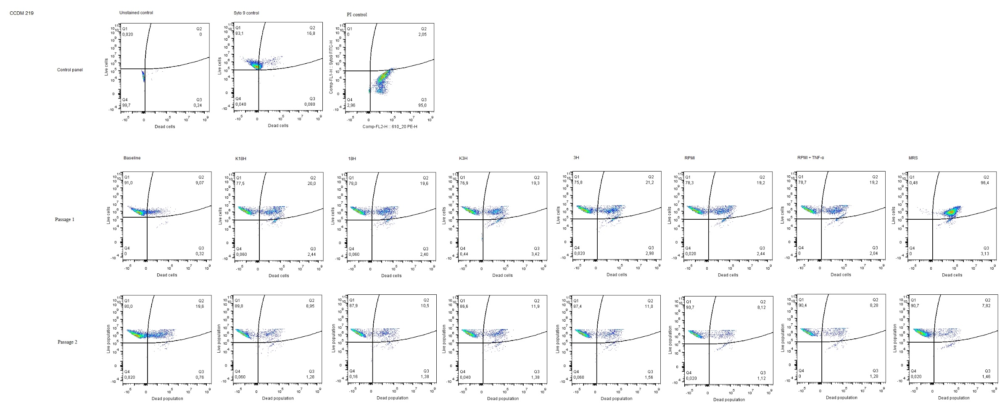
b) Examples of dot-plots for strain CCDM 219. Two different bacterial passages.

