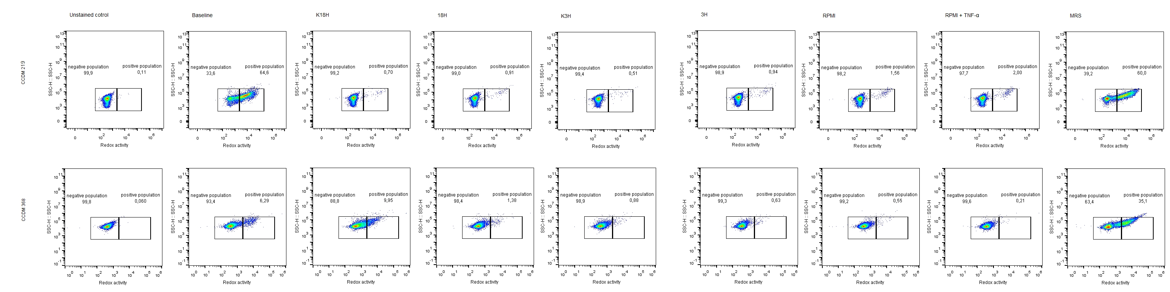
Fig. S2. The redox activity of CCDM 219 and CCDM 368 dot plots.

