Table S1: Primers used in this study.
Gene name | Sequence (5’-3’) |  | Specificity | Size base pair (bp) | Reference
bla_{OXA-51-like} | F | TAATGCTTTGAT CGGCCTTG | A, baumannii detection gene | 353 | [22]
bla_{OXA-51-like} | R | TGGATTGCACTTCATCTTGG | A, baumannii detection gene | 353 | [22]
rpoB | F | ATGCCGCCTGAAAAAGTAAC | Housekeeping gene/Rt-qPCR | 154 | [23]
rpoB | R | TCCGCACGTAAAGTAGGAAC | Housekeeping gene/Rt-qPCR | 154 | [23]
adeB | F | CTTGCATTTACGTGTGGTGT | Efflux pump genes/RT-qPCR | 168 | [23]
adeB | R | GCTTTTCTACTGCACCCAAA | Efflux pump genes/RT-qPCR | 168 | [23]
adeC | F | TACACATGCGCATATTGGTG | Efflux pump genes/RT-qPCR | 117 | [23]
adeC | R | CGTAAAATAACTATCCACTCC | Efflux pump genes/RT-qPCR | 117 | [23]
adeJ | F | GGTCATTAATATCTTTGGC | Efflux pump genes/RT-qPCR | 221 | [23]
adeJ | R | GGTACGAATACCGCTGTCA | Efflux pump genes/RT-qPCR | 221 | [23]
adeK | F | TTGATAGTTACTTGACTGTTC | Efflux pump genes/RT-qPCR | 162 | [23]
adeK | R | GGTTGGTGAACCACTGTATC | Efflux pump genes/RT-qPCR | 162 | [23]

Table S2: Minimum Inhibitory Concentrations (MICs) values of imipenem and efflux pump inhibitors against 37 CRAb strains.
A.baumannii strains | Antibiotics and Efflux Pump Inhibitors
A.baumannii strains | Imipenem |  | TMP |  | OMP |  | Pantoprazole /esmoprazole |  | CCCP |  | Cinnamon oil |  | Thyme oil |  | Clove, carraway oils
A.baumannii strains | aMICs (mg/L) | bMBC | MIC | MBC | MIC | MBC | MIC | MBC | MIC | MBC | MIC (%v/v) | MBC | MIC | MBC | MIC | MBC
91 | 32 | 32 | 25 | 25 | 25 | 25 | >50 | >50 | >1024 | >1024 | 0.5 | 0.5 | >4 | >4 | >4 | >4
92 | 16 | 32 | 25 | 25 | 25 | 25 |  |  |  |  | 0.5 | 0.5 | >4 | >4 | >4 | >4
93 | 8 | 8 | 15 | 15 | 25 | 25 |  |  |  |  | 0.25 | 0.25 | >4 | >4 | >4 | >4
94 | 16 | 16 | 15 | 15 | 25 | 25 |  |  |  |  | 0.5 | 0.5 | >4 | >4 | >4 | >4
95 | 16 | 16 | 15 | 15 | 25 | 25 |  |  |  |  | 0.5 | 0.5 | >4 | >4 | >4 | >4
9 | 16 | 16 | 15 | 15 | 25 | 25 |  |  |  |  | 0.5 | 0.5 | >4 | >4 | >4 | >4
97 | 128 | 128 | 15 | 15 | 25 | 25 |  |  |  |  | 2 | 2 | >4 | >4 | >4 | >4
98 | 64 | 64 | 25 | 25 | 20 | 25 |  |  |  |  | 0.5 | 0.5 | >4 | >4 | >4 | >4
99 | 256 | 256 | 25 | 25 | 25 | 25 |  |  |  |  | 0.5 | 0.5 | >4 | >4 | >4 | >4
100 | 1024 | 1024 | 25 | 25 | 25 | 25 |  |  |  |  | 0.5 | 0.5 | >4 | >4 | >4 | >4
70 | 64 | 64 | 15 | 25 | 25 | 25 |  |  |  |  | 0.5 | 0.5 | >4 | >4 | >4 | >4
71 | 64 | 64 | 5 | 5 | 25 | 25 |  |  |  |  | 0.5 | 0.5 | >4 | >4 | >4 | >4
72 | 64 | 64 | 5 | 5 | 25 | 25 |  |  |  |  | 0.5 | 0.5 | 1 | >4 | >4 | >4
73 | 64 | 64 | 15 | 15 | 25 | 25 |  |  |  |  | 1 | 1 | 1 | 1 | >4 | >4
74 | 32 | 32 | 15 | 15 | 25 | 25 |  |  |  |  | 0.5 | 0.5 | 1 | 1 | >4 | >4
75 | 32 | 32 | 25 | 25 | 25 | 25 |  |  |  |  | 0.5 | 0.5 | >4 | >4 | >4 | >4
76 | 32 | 32 | 25 | 25 | 25 | 25 |  |  |  |  | 0.5 | 0.5 | >4 | >4 | >4 | >4
77 | 32 | 32 | 25 | 25 | 25 | 25 |  |  |  |  | 0.5 | 0.5 | >4 | >4 | >4 | >4
78 | 64 | 64 | 25 | 25 | 20 | 20 |  |  |  |  | 0.5 | 0.5 | >4 | >4 | >4 | >4
79 | 64 | 64 | 25 | 25 | 25 | 25 |  |  |  |  | 2 | 2 | >4 | >4 | >4 | >4
80 | 64 | 64 | 25 | 25 | 25 | 25 |  |  |  |  | 0.5 | 0.5 | >4 | >4 | >4 | >4
81 | 32 | 32 | 25 | 25 | 25 | 25 |  |  |  |  | 0.5 | 0.5 | >4 | >4 | >4 | >4
82 | 128 | 128 | 25 | 25 | 25 | 25 |  |  |  |  | 0.5 | 0.5 | >4 | >4 | >4 | >4
83 | 64 | 64 | 25 | 25 | 25 | 25 |  |  |  |  | 0.5 | 0.5 | >4 | >4 | >4 | >4
84 | 128 | 128 | 25 | 25 | 25 | 25 |  |  |  |  | 0.125 | 0.125 | >4 | >4 | >4 | >4
23 | 256 | 256 | 15 | 15 | 25 | 25 |  |  |  |  | 0.5 | 0.5 | >4 | >4 | >4 | >4
16 | 128 | 128 | 15 | 15 | 25 | 25 |  |  |  |  | 0.5 | 0.5 | >4 | >4 | >4 | >4
47 | 64 | 64 | 15 | 15 | 25 | 25 |  |  |  |  | 0.5 | 0.5 | >4 | >4 | >4 | >4
65 | 32 | 32 | 25 | 25 | 25 | 25 |  |  |  |  | 0.5 | 0.5 | >4 | >4 | >4 | >4
54 | 512 | 512 | 5 | 5 | 25 | 25 |  |  |  |  | 0.25 | 0.25 | >4 | >4 | >4 | >4
13 | 512 | 512 | 15 | 15 | 25 | 25 |  |  |  |  | 0.5 | 0.5 | >4 | >4 | >4 | >4
43 | 16 | 32 | 25 | 25 | 25 | 25 |  |  |  |  | 0.25 | 0.25 | >4 | >4 | >4 | >4
17 | 256 | 256 | 15 | 15 | 25 | 25 |  |  |  |  | 0.5 | 0.5 | >4 | >4 | >4 | >4
14 | 128 | 128 | 25 | 25 | 25 | 25 |  |  |  |  | 0.25 | 0.25 | >4 | >4 | >4 | >4
59 | 128 | 128 | 15 | 15 | 25 | 25 |  |  |  |  | 0.5 | 0.5 | >4 | >4 | >4 | >4
1 | 256 | 256 | 15 | 15 | 25 | 25 |  |  |  |  | 0.5 | 0.5 | >4 | >4 | >4 | >4
15 | 16 | 16 | 25 | 25 | 25 | 50 |  |  |  |  | 0.5 | 0.5 | >4 | >4 | >4 | >4
ªMICs: Minimum Inhibitory Concertations.

Table S3: Chemical composition of cinnamon and thyme essential oils using GC/MS/MS analysis.
No. | Cinnamon oil |  | Area  (%) | Thyme oil |  | Area  (%)
No. | RT | Compound | Area  (%) | RT | Compound | Area  (%)
1 | 4.752 | 4-Terpinenyl acetate. | 1.35 | 9.24 | α-Pinene. | 0.08
2 | 4.887 | ϒ-Terpinene. | 1.51 | 9.69 | Trans-p-Menthane. | 0.04
3 | 5.347 | β-Myrcene. | 1.17 | 9.74 | β-Pinene. | 1.28
4 | 5.502 | α-Thujene. | 2.09 | 9.87 | Myrcene. | 0.55
5 | 5.695 | p-cymene. | 2.84 | 10.04 | Pseudolimonene. | 0.02
6 | 5.785 | α-Terpinene. | 6.38 | 10.21 | m-cymene. | 0.15
7 | 5.962 | α-Pinene. | 12.0 | 10.24 | p-cymene. | 29.05
8 | 6.409 | 2’-Hydroxy-3,4,5-trimethoxychalcone. | 1.32 | 10.28 | Limonene. | 3.68
9 | 6.536 | Linalool. | 18.54 | 10.31 | Eucalytol. | 0.13
10 | 7.389 | Terpinen-4-ol. | 3.98 | 10.59 | ᵞ- Terpiene. | 5.03
11 | 8.852 | Cinnamaldehyde. | 6.69 | 10.73 | Cis-Linalool oxide. | 0.05
12 | 8.725 | Coumarin. | 33.90 | 10.88 | Trans-linalool oxide (furanoid) | 0.05
13 | 9.127 | 6-methyl-phenol. | 100 | 11.00 | Linalool. | 5.24
14 | 9.476 | 2-(1,1-dimethylethyl)-5-methyl-Eugenol. | 5.23 | 11.34 | Cis-p-mentha-1(7),8-dien-2-ol. | 0.06
15 | 9.738 | Longifolene. | 45.08 | 11.68 | Trans-Verbenol. | 0.17
16 | 9.853 | Caryophyllene. | 6.23 | 11.78 | Trans- Sabienenehydrate. | 0.91
17 | 9.103 | Isoeugenol. | 15.29 | 12.60 | Trans-p-Mentha-2,8-dien-1-ol. | 0.11
18 | 10.025 | Cinnamyl alcohol. | 10.84 | 13.02 | Thymol. | 51.80
19 | 10.091 | α-Guaiene. | 7.11 | 13.07 | Carvacol. | 1.58
20 | 10.214 | Dimethylfraxetin. | 1.86
21 | 10.407 | α-Selinene. | 1.66
22 | 10.517 | 5,7-Dihydroxy-4-methylcoumarin. | 6.60
23 | 10.71 | Myricetin-3’,5’-dimethy ether. | 2.90
24 | 10.891 | 3,4,5-Trimethoxycinamic acid. | 2.45
25 | 11.108 | Cis-Sesquisabinene hydrate. | 3.99
26 | 11.21 | Ledol. | 1.65
27 | 11.538 | Nerolidol. | 1.30
28 | 11.666 | Thunbergol. | 1.22
29 | 12.309 | Nopol(terpene). | 6.78
30 | 12.887 | Gardenin. | 1.77
31 | 13.704 | 3,7,8,2’-Tetramethoxyflavone. | 1.54
32 | 13.884 | Dihydroquercitrin. | 1.59
33 | 14.429 | Diethylstilbestrol. | 1.08
34 | 14.597 | o-Cresol. | 1.76
35 | 15.75 | Α-phenyl-3,5-di-tert-butyl-4-hydroxyacetophenone. | 3.90
36 | 16.701 | (-)-Spathulenol. | 1.63
37 | 17.427 | 3’-Benzyloxy-4,5,6,7-tetramethoxyflavone. | 1.53
38 | 20.302 | Retinal. | 1.01
39 | 23.127 | 3-(3,4-Dimethoxyphenyl)-4,7-dimethylcoumarin. | 1.21

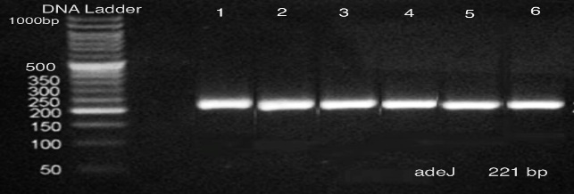  a | 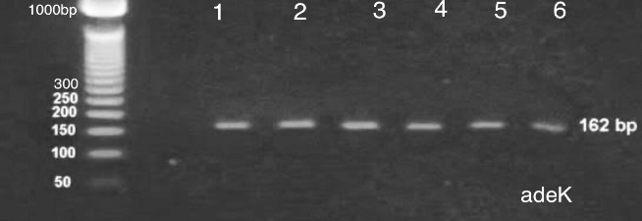  b
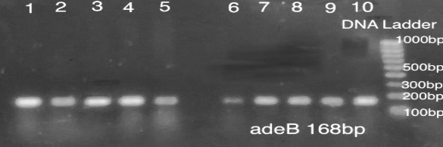  c | 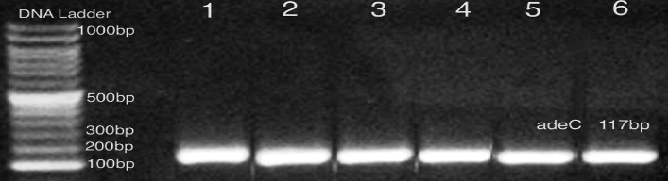  d

Figure S1: Electrophoretogram of the PCR amplification of the efflux pump genes in CRAb strains, where a. adeJ gene amplified at 221bp; b. adeK gene amplified at 162bp; c. adeB amplified at 168bp; and d. adeC gene amplified at 117bp; DNA ladder; 100-1000bp.

