Phenotypic, molecular, and in silico characterization of coumarin as carbapenemase inhibitor to fight carbapenem-resistant Klebsiella pneumoniae

Mahmoud Saad Abdel-Halim ^{1, *}, Amira M. El-Ganiny ¹ , Basem Mansour ², Galal Yahya ¹, Hemat K. Abd El Latif ¹, Momen Askoura ¹

¹ Microbiology and Immunology Department, Faculty of Pharmacy, Zagazig University, 44519, Zagazig, Egypt.
² Pharmaceutical Chemistry Department, Faculty of Pharmacy, Delta University for Science and Technology, Gamasa 11152, Egypt

* Corresponding author e-mail: mahmoudsaad@zu.edu.eg
mahmoudsaadelmasry11@gmail.com
Institutional Phone number: 002-055-2303266.
Mobile: 00201023653456.
ORCID ID: https://orcid.org/0000-0002-3944-8465

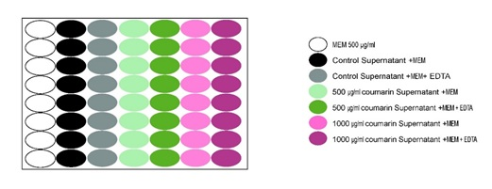

Supplementary Fig. 1: Coumarin enzyme inhibition activity: schematic diagram of the reaction plate.

Supplementary Table 1. Antimicrobial susceptibility profile of K. pneumoniae isolates.
Isolate’s  Code | Anti-microbial agents
Isolate’s  Code | MEM | CFP | CRO | TZP | FEP | ATM | OFX | LEV | AK | CN | TGC | TE | SXT | AZM | C
1K | R | R | R | R | R | R | R | R | R | R | R | R | R | R | S
2K | R | R | R | R | R | R | R | R | S | S | R | R | I | R | I
3K | R | R | R | R | R | S | R | R | R | S | I | R | R | R | I
4K | R | R | R | R | R | R | R | R | R | R | R | R | R | R | S
5K | R | R | R | R | R | R | R | R | R | R | I | I | R | R | R
6K | R | R | R | R | R | R | R | R | R | R | S | I | R | R | S

R= Resistant S= Sensitive I= Intermediate
meropenem (MEM, 10 μg), ceftriaxone (CRO, 30 μg), piperacillin-tazobactam (TZP, 100/10 μg), cefepime (FEP, 30 μg), cefoperazone (CFP, 75 μg), aztreonam (ATM, 30 μg), gentamicin (GN, 10 μg), amikacin (AK, 30 μg), trimethoprim-sulfamethoxazole (SXT, 1.25/ 23.75 μg), tetracycline (TE, 30 μg), tigecycline (TGC, 15 μg), levofloxacin (LEV, 5 μg), ofloxacin (OFX, 5 μg), and chloramphenicol (C, 30 μg), azithromycin (AZM, 15 μg).

