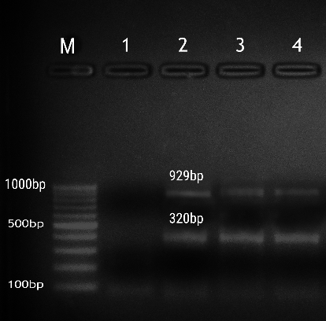

Figure S1: Agarose gel electrophoresis of multiplex PCR showing amplification of mcr-1(320bp) and mcr-3(929bp).
M: DNA marker GeneRuler 100 bp (Thermofisher), lane 1: negative control.

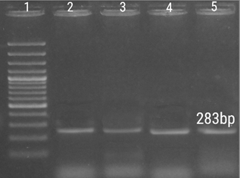

Figure S2: Agarose gel electrophoresis of uniplex PCR showing amplification of bla_{OXA48}(283bp), 1: DNA marker GeneRuler 100 bp plus (Thermofisher).

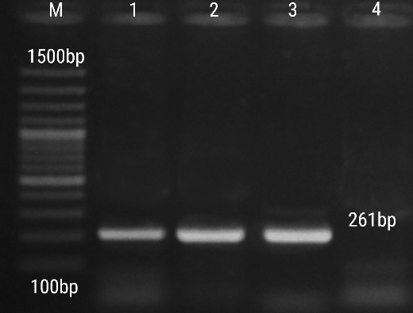

Figure S3: Agarose gel electrophoresis of uniplex PCR showing amplification of bla_{VIM} (261 bp), M: DNA marker GeneRuler 100 bp plus (Thermofisher).

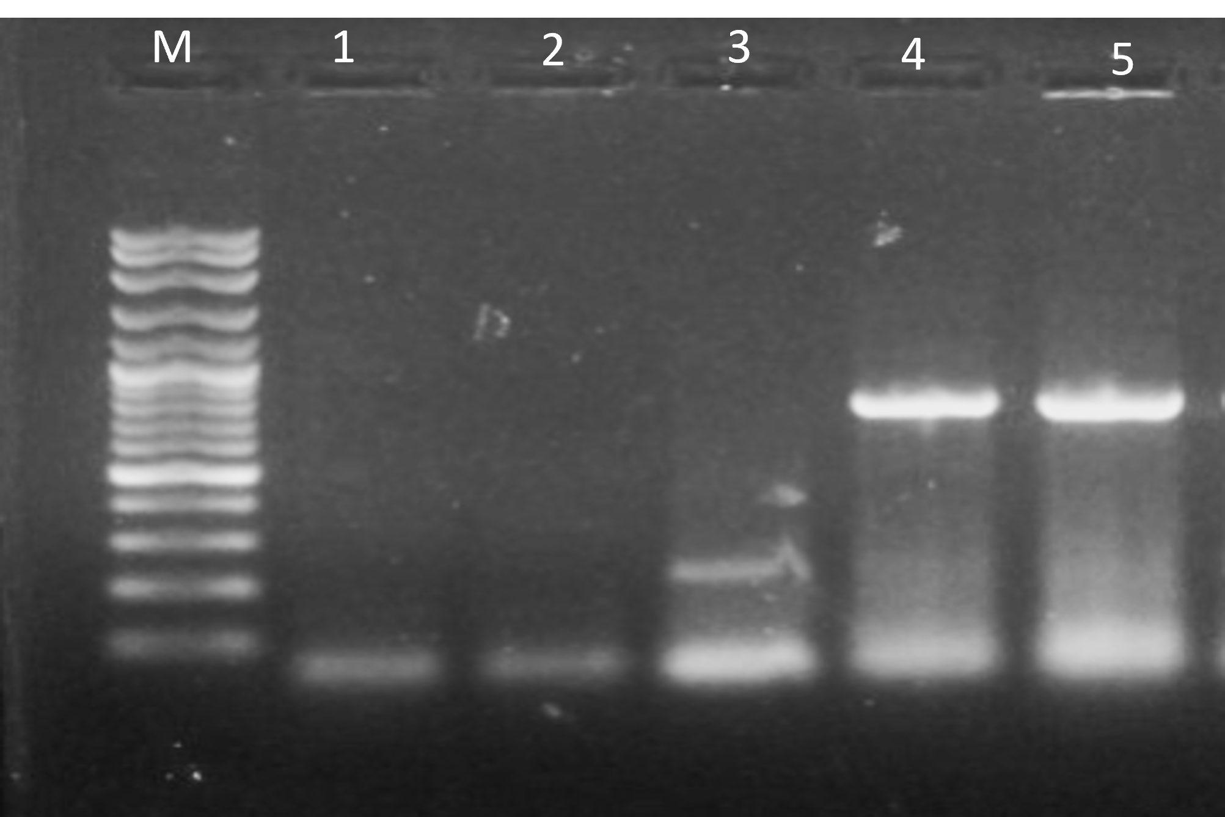

Figure S4: Agarose gel electrophoresis of multiplex PCR showing amplification of Stx1(244bp) and Stx2 (779), M: DNA marker GeneRuler 100 bp plus (Thermofisher).

Figures:
Figure S1: Agarose gel electrophoresis of multiplex PCR showing amplification of mcr-1(320bp) and mcr-3(929bp).
M: DNA marker GeneRuler 100 bp (Thermofisher), lane 1: negative control.

Figure S2: Agarose gel electrophoresis of uniplex PCR showing amplification of bla_{OXA48}(283bp), 1: DNA marker GeneRuler 100 bp plus (Thermofisher).

Figure S3: Agarose gel electrophoresis of uniplex PCR showing amplification of bla_{VIM} (261 bp), M: DNA marker GeneRuler 100 bp plus (Thermofisher).

Figure S4: Agarose gel electrophoresis of multiplex PCR showing amplification of Stx1(244bp) and Stx2 (779), M: DNA marker GeneRuler 100 bp plus (Thermofisher).

