Supplementary file

Structure predictions and functional insights into Amidase_3 domain containing N-acetylmuramyl-L-alanine amidases from Deinococcus indicus DR1

Malvika Modi¹, Menaka Thambiraja², Archana Cherukat^{1¶}, Ragothaman M Yennamalli² and Richa Priyadarshini^{1*}

¹ Department of Life Sciences, School of Natural Sciences, Shiv Nadar Institution of Eminence, Gautam Buddha Nagar, Uttar Pradesh, 201314, India
² Department of Bioinformatics, School of Chemical and Biotechnology, SASTRA Deemed to be University, Thanjavur, Tamil Nadu, 613401, India

* Corresponding author

Correspondence and reprints:
Dr. Richa Priyadarshini
Department of Life Sciences, School of Natural Sciences,
Shiv Nadar Institution of Eminence
Gautam Buddha Nagar, Uttar Pradesh, India.
Ph no: +91-120-3819100 Ext. 220
Email: richa.priyadarshini@snu.edu.in (RP)

¶ Present Address:
Department of Biology, Graduate School of Arts and Sciences
Wake Forest University
1834 Wake Forest Rd, Winston-Salem, USA

Supplementary file

Supplementary Figure 1: (a) pLDDT score for each residue in the Ami1_{Di} structure predicted by AlphaFold2 (b) PAE plots for the five models predicted by AlphaFold2.

Supplementary Figure 2: (a) pLDDT score for each residue in the Ami2_{Di} structure predicted by AlphaFold2 (b) PAE plots for the five models predicted by AlphaFold2.
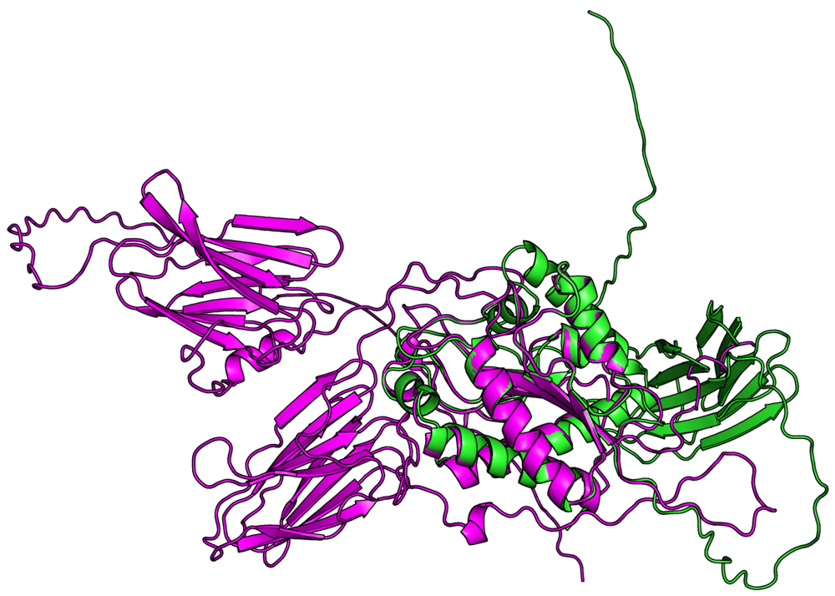
Supplementary Figure 3 : Superposed structures of Ami1_{Di} (colored green) and Ami2_{Di} (colored magenta) showing the alpha/beta domain showing high structural similarity.

Supplementary Figure 4 – (A) Western Blot of induced fraction and purified protein elutes of Ami1_{Di} (̴ 42.5kDa) and (B) Ami2_{Di} (̴ 65.6kDa). RP105 and RP106 were grown till OD₆₀₀ ̴ 0.6 and induced with 0.5 mM IPTG for 4 h at 25 °C. Supernatant and pellet fractions were separated after sonication. uninduced (UI), induced (I), supernatant (S) and pellet (P) fraction (E) elutes were loaded on SDS-PAGE gel and Western blot was performed with anti-His tag monoclonal antibody.

Supplementary figure 5
Similarity between NlpC/P60 (WP_088249103) and EnvC (WP_229843994) of D. indicus and NlpD and EnvC of E. coli
(A) Multiple Sequence Alignment of D. indicus NlpC/P60 (WP_088249103) sequence and E. coli NlpD in MULTALIN. (B) Multiple Sequence Alignment of D. indicus EnvC (WP_229843994) sequence and E. coli EnvC in MULTALIN. Highly conserved residues are represented by red color, weakly conserved residues by blue whereas a dot in the consensus line represents no conserved residue. The conserved active site residues is boxed in black.

Supplementary Table 1: Structural homologs of Ami1_{Di} and Ami2_{Di} from DALI server with hits having a Z-score of 10 and above.
 | Ami1_{Di} structural homologs |  | Ami2_{Di} structural homologs
- No | PDB Id | Z-score | PDB Id | Z-score
1. | 1JWQ | 28.9 | 4RN7 | 28.3
2. | 5EMI | 28.8 | 5EMI | 27.8
3. | 4RN7 | 28.3 | 1JWQ | 27.5
4. | 5J72 | 27.6 | 5J72 | 25.9
5. | 4LQ6 | 25.8 | 4LQ6 | 24.4
6. | 4BIN | 25.5 | 4M6G | 24.0
7. | 4M6G | 25.3 | 4BIN | 22.9
8. | 3NE8 | 24.8 | 3NE8 | 22.7
9. | 3CZX | 22.3 | 3QAY | 20.7
10. | 3QAY | 22.1 | 1XOV | 19.7
11. | 1XOV | 20.4 | 4OKO | 12.5
12. | 3A9L | 12.2 | 2GFQ | 11.3
13. | 4OKO | 12.1
14. | 2GFQ | 11.1

Supplementary table 2 – Primers used in this study
Primers used in this study
 | Primer name | Primer Sequence | Remarks
1 | pBADami1_{Di} FP | CCCCCGCTAGCGAGGAGGAAGTCATCGTGAAGCTGCCATCTCTCCTG | Amplification of full-length ami1_{Di} for cloning in pBAD18 vector
2 | pBADami1_{Di} RP | CCCCCGGTACCTCACTTGGTGTGCAGGAAGTC
3 | pBADami2_{Di} FP | CCCCCGCTAGCGAGGAGGAAGTCATCATGAAGCTGCCTGTCA | Amplification of full-length ami2_{Di} for cloning in pBAD18 vector
4 | pBADami2_{Di} RP | CCCCCGGTACCTCAGCGGGAGGTGCCG
5 | pBADami1_{Di}Tn (1-155aa) FP | CCCCCGCTAGCGAGGAGGAAGTCATCGTGAAGCTGCCATCTCTCCTG | Amplification of truncated (1-155aa) ami1_{Di} for cloning in pBAD18 vector
6 | pBADami1_{Di}Tn (1-155aa) RP | CCCCCGGTACCTCACACGCGCGGCCGGGTGGG
7 | pBADami1_{Di}SDM (H161A) FP | CTCGATCCCGGTGCCGGCGGCACC | Amplification of active site mutant (H161A) ami1_{Di} for cloning in pBAD18 vector
8 | pBADami1_{Di}SDM (H161A) FP | GTCGGTGCCGCCGGCACCGGGATC
9 | pET28bami1_{Di} FP | CCCCCGAATTCGTGAAGCTGCCATCTCTCCT | Amplification of full-length ami1_{Di} – 6X His-Tag for cloning in pET28b vector
10 | pET28bami1_{Di} RP | CCCCCAAGCTTTCAATGATGATGATGATGATGTCACTTGGTGTGCAGGAAG
11 | pET28bami2_{Di} FP | CCCCCGAATTCATGAAGCTGCCTGTCATC | Amplification of full-length ami2_{Di} – 6X His-Tag for cloning in pET28b vector
12 | pET28bami2_{Di} RP | CCCCCAAGCTTTCAATGATGATGATGATGATGGCGGGAGGTGCCGGC

