Supplementary Material

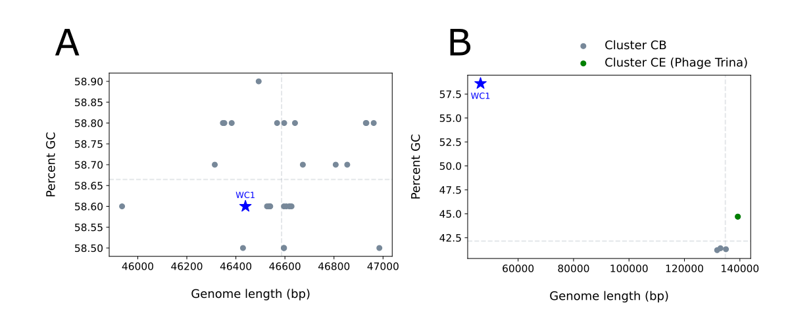
Figure S1: Genome lengths and GC content for previously identified R. erythropolis RIA-643 phage versus WC1. (A) shows data for phage in cluster CA, while (B) shows for comparison phage from clusters CB and CE.

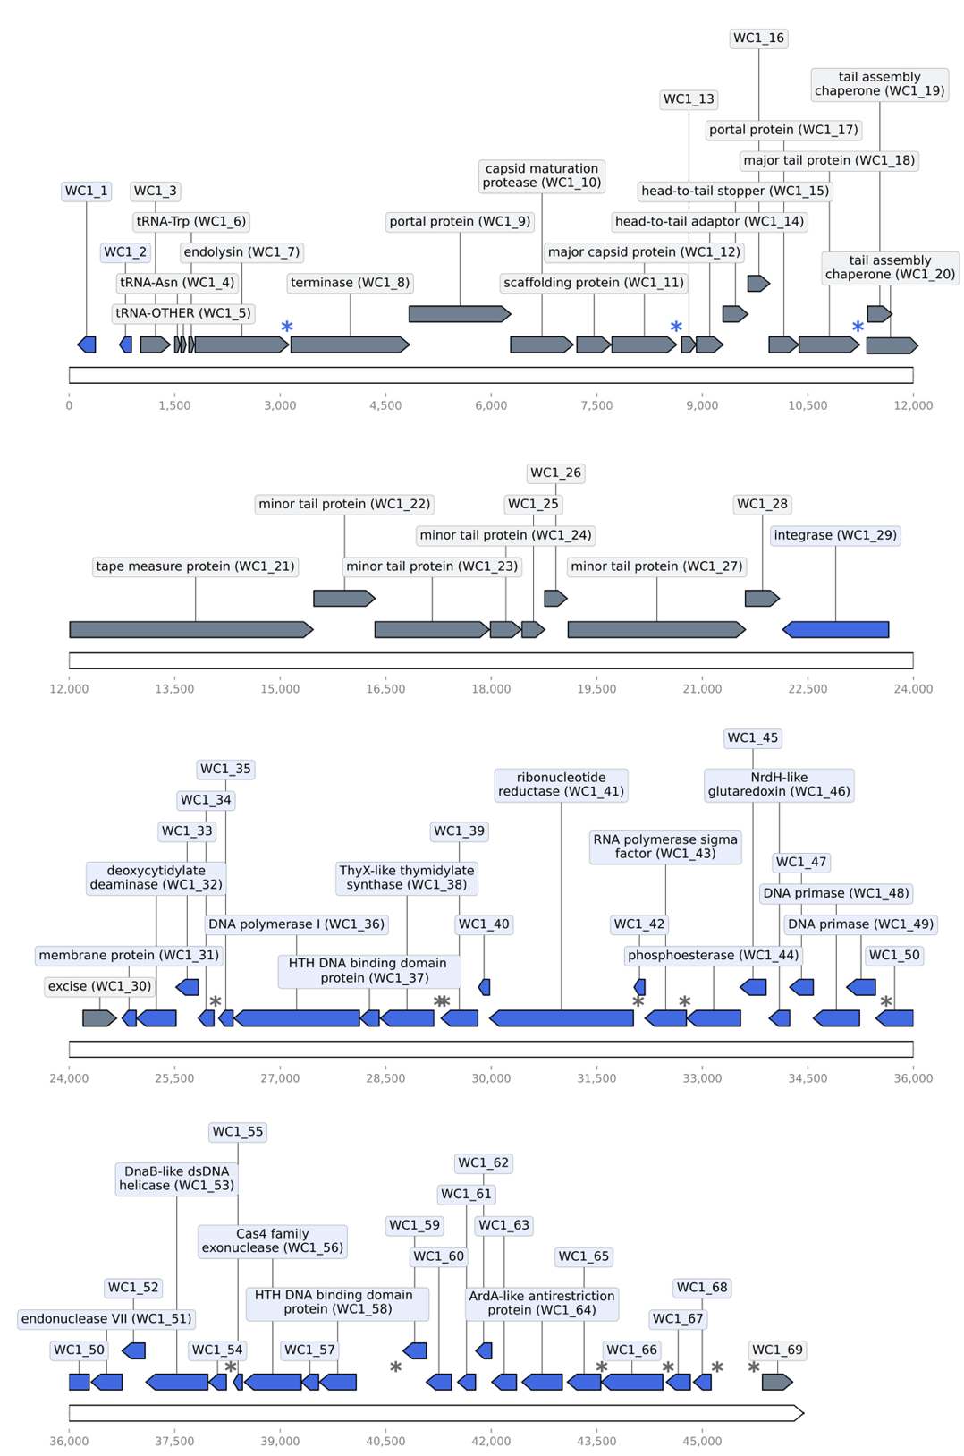

Figure S2: Genome structure of WC1. Protein-coding genes in forward orientation are shown in grey, and those in reverse are shown in blue. Stars indicate 13mer regulatory sequences: blue stars are reverse complemented sequences. Functional annotations where available and gene numbers are included in labels.
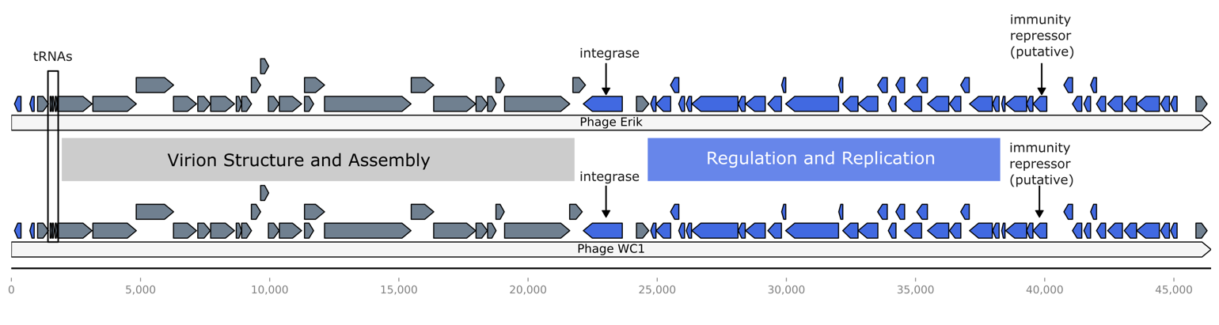
Figure S3. Genomic arrangement of Phage WC1 and Phage Erik. Erik was chosen as a representative phage for cluster CA phage of R. erythropolis RIA-643. The terms “Virion Structure and Assembly” and “Regulation and Replication” are the descriptors used in (20)to characterize regions of CA phage genomes.

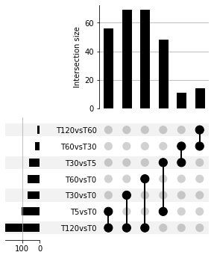
Figure S4: DE set composition and intersection between selected comparisons for phage genes. DE genes were identified as those having |FC| > 1.5 and p<0.05 in pairwise Wald tests. The height of each vertical bar shows the size of the intersection between the two comparisons indicated by dots. The length of each horizontal bar shows how many DE genes were in each individual comparison.
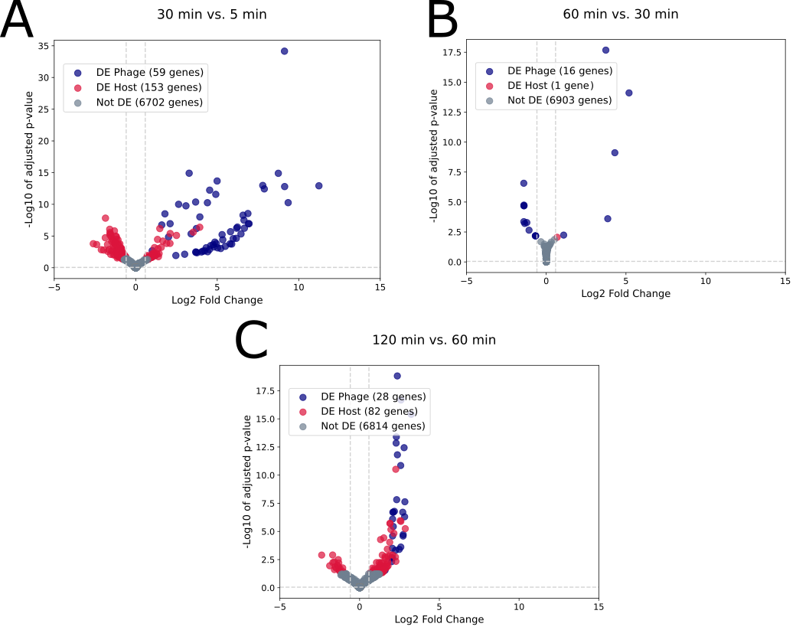

Figure S5. Differentially expressed (DE) genes over the time course of infection. Each point on the volcano plot is based on 2 replicates. Vertical lines indicate Log₂ Fold Change of 0.58 and -0.58, which corresponds to a fold change of 1.5. The horizontal line indicates p of 0.05.

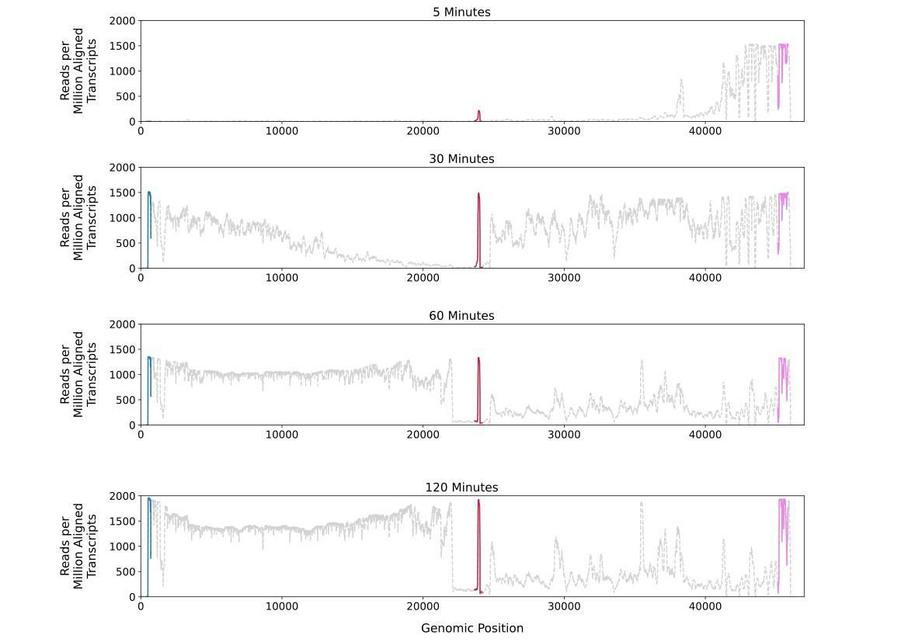

Figure S6: Overall genome coverage for reads mapped at each time point. Non-coding regions are indicated in color. Values on the y-axis represent the average of two normalized values for two replicates.

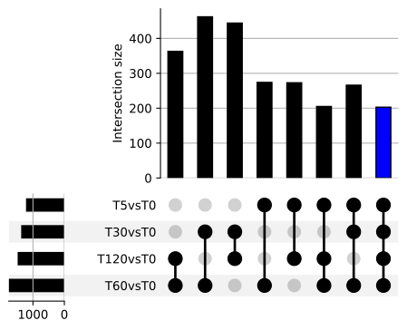
Figure S7. DE set composition and intersection between selected comparisons for host genes with baseline, with the blue bar showing the complete overlap of 203 genes between all sets. DE genes were identified as those having |FC| > 1.5 and p<0.05 in pairwise Wald tests. The height of each vertical bar shows the size of the intersection between the two comparisons indicated by dots. The length of each horizontal bar shows how many DE genes were in each individual comparison.

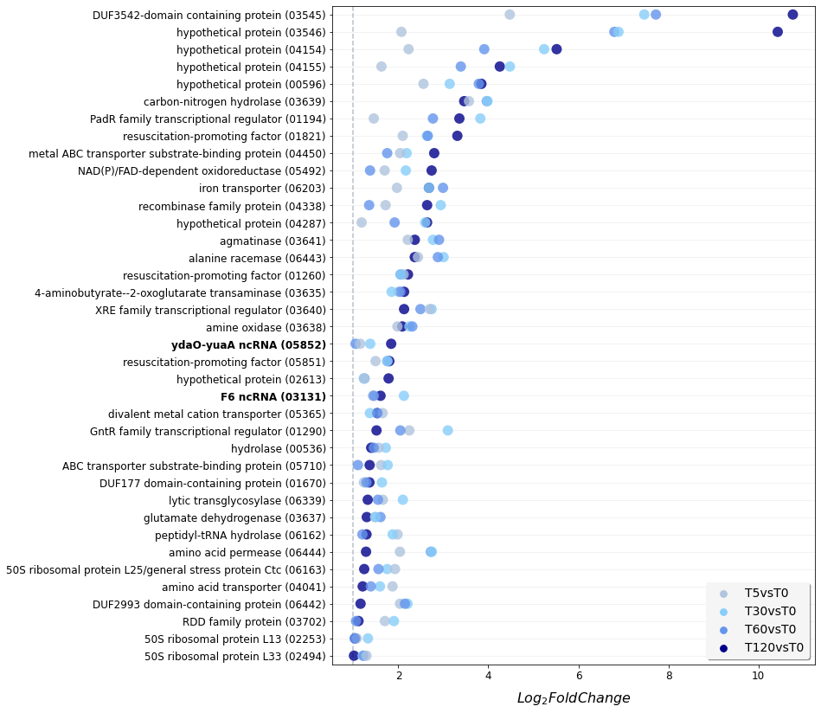

Figure S8. Core subset of 38 universally up-regulated DE genes and ncRNAs (in bold) with FC > 2 at all infection time points versus baseline (time 0). The feature identifier in RIA-643 is provided in parentheses after the description. The full list of up-regulated DE genes in the core set with |FC| > 1.5 is provided in Table S4.

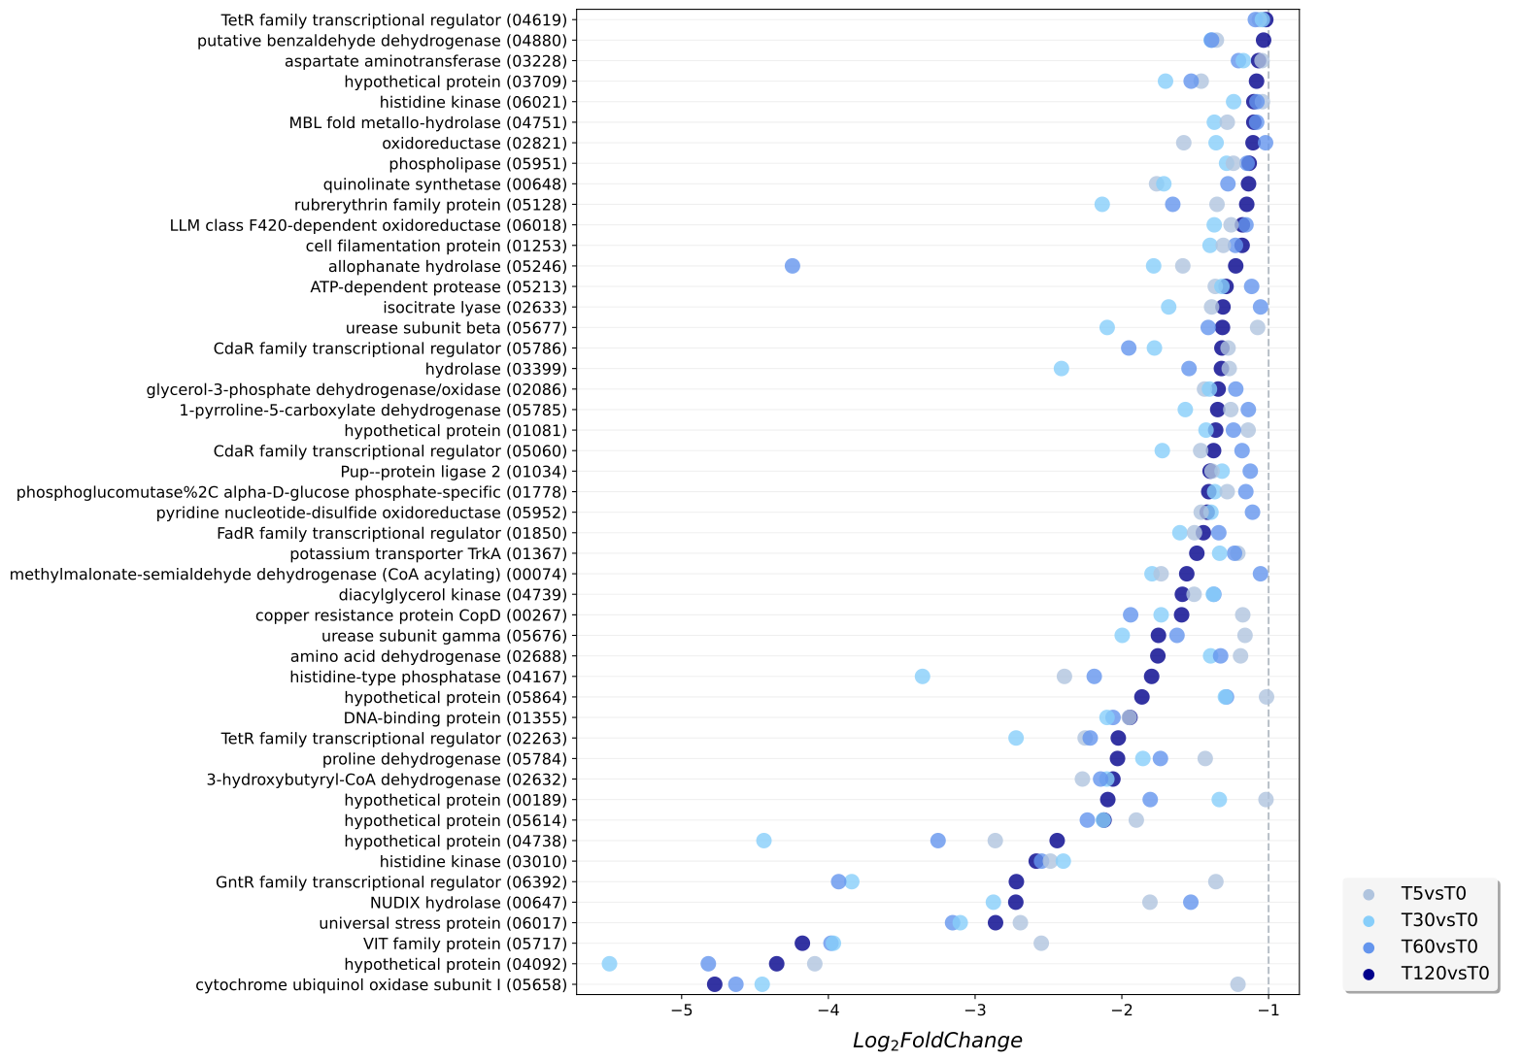
Figure S9. Core subset of 48 universally down-regulated DE genes with FC > 2 at all infection time points versus baseline (time 0). The feature identifier in RIA-643 is provided in parentheses after the description. The full list of up-regulated DE genes in the core set with |FC |> 1.5 is provided in Table S4.
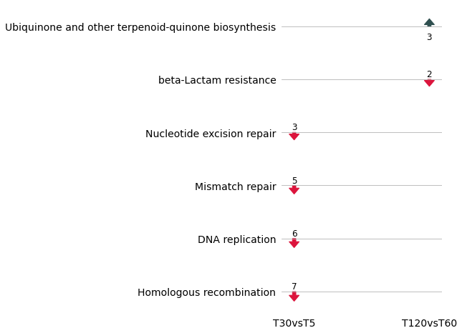

Figure S10. Enriched KEGG pathways during time course of infection for time points compared sequentially. The direction of the arrows indicate if the DE genes were up-regulated or down-regulated, and the numeric values indicate the number of genes. Only DE genes with absolute log₂ fold change greater than or less than -0.58 were included in the analysis to reflect a fold-change of 1.5. T60vsT30 is not included because there were no significant pathways.

Table S1. Phage used for comparative analysis of WC-1 genome. Accession numbers and cluster memberships were obtained from phagedb at (https://phagesdb.org/clusters/).

Phage name | Accession number | Cluster
Alatin | MF324905 | CA
Alpacados | MH271291 | CA
AngryOrchard | KY549153 | CA
AppleCloud | MF324903 | CA
Belenaria | MK524495 | CA
BobbyDazzler | KY549154 | CA
Bonanza | MF537628 | CA
Bradshaw | MH271293 | CA
Bryce | MH271294 | CA
CosmicSans | KT372002 | CA
Dinger | MN945902 | CA
Erik | MH271297 | CA
Espica | MK524487 | CA
Gollum | MH271299 | CA
Harlequin | KX611788 | CA
Hiro | MF324898 | CA
Jester | MF373842 | CA
Krishelle | MF324902 | CA
Lillie | KT990218 | CA
Naiad | MF324901 | CA
Nancinator | MH271306 | CA
Natosaleda | KX550082 | CA
Partridge | KX712237 | CA
Phrankenstein | MH271309 | CA
Rasputin | MH271311 | CA
RexFury | MF324904 | CA
Rhodalysa | KT375356 | CA
StCroix | MF324900 | CA
Swann | MH271314 | CA
Takoda | MH271315 | CA
TWAMP | KT959213 | CA
UhSalsa | MH271319 | CA
Yogi | KX712236 | CA
Yoncess | MF189179 | CA
Grayson | MH153812 | CB
Peregrin | MH153807 | CB
Weasels2 | KX774321 | CB
Trina | MF668286 | CE

Table S2. Read counts for RNA-seq libraries. Number and percentages of unmapped reads determined based on alignment with HISAT2 to the combined phage and host genomes.

Sample | Total reads | Unmapped Reads | Percent mapped
T0-1 | 6360952 | 156538 | 97.54%
T0-2 | 3862912 | 186933 | 95.16%
T5-1 | 7552000 | 156930 | 97.92%
T5-2 | 3914540 | 125504 | 96.79%
T30-1 | 5144798 | 132338 | 97.43%
T30-2 | 5436524 | 163131 | 97.00%
T60-1 | 5020254 | 255234 | 94.92%
T60-2 | 7153734 | 152833 | 97.86%
T120-1 | 3051712 | 161191 | 94.72%
T120-2 | 6151346 | 146705 | 97.62%

Table S3. Reads mapping to phage WC1 genome at time 0 (T0).

Replicate | Count Phage Reads Assigned | Total Reads Assigned | Percentage phage reads of total
T0-1 | 654 | 5805222 | 0.011%
T0-2 | 512 | 3428880 | 0.015%

Table S4. Core subset of universally DE genes with |FC |> 1.5 at all infection time points versus baseline (time 0). P-values were adjusted using the Benjamini-Hochberg method.

Gene | Description | 5 minutes |  | 30 minutes |  | 60 minutes |  | 120 minutes
 |  | log₂FC | p-value (BH) | log₂FC | p-value (BH) | log₂FC | p-value (BH) | log₂FC | p-value (BH)
DVG80_03545 | hypothetical protein | 4.48 | 4.65E-08 | 7.47 | 2.72E-21 | 7.72 | 9.26E-23 | 10.77 | 1.87E-44
DVG80_03546 | hypothetical protein | 2.07 | 5.14E-04 | 6.89 | 3.02E-18 | 6.80 | 1.13E-17 | 10.43 | 6.99E-42
DVG80_04154 | hypothetical protein | 2.23 | 1.33E-05 | 5.24 | 1.37E-18 | 3.91 | 4.45E-11 | 5.52 | 5.71E-20
DVG80_04155 | hypothetical protein | 1.62 | 1.82E-04 | 4.48 | 6.86E-21 | 3.39 | 3.97E-13 | 4.25 | 6.55E-20
DVG80_00596 | hypothetical protein | 2.56 | 8.58E-06 | 3.14 | 7.47E-07 | 3.79 | 1.41E-08 | 3.85 | 1.42E-09
DVG80_01195 | hypothetical protein | 0.96 | 3.12E-02 | 4.19 | 4.59E-12 | 2.06 | 7.84E-05 | 3.62 | 7.36E-10
DVG80_03639 | carbon-nitrogen hydrolase | 3.57 | 3.04E-24 | 3.98 | 1.97E-29 | 3.97 | 1.22E-29 | 3.46 | 2.94E-23
DVG80_01194 | PadR family transcriptional regulator | 1.45 | 1.03E-03 | 3.82 | 1.06E-14 | 2.77 | 5.26E-09 | 3.36 | 7.81E-12
DVG80_01821 | resuscitation-promoting factor | 2.10 | 9.09E-12 | 2.64 | 1.07E-17 | 2.65 | 1.38E-17 | 3.31 | 4.90E-26
DVG80_04450 | metal ABC transporter substrate-binding protein | 2.04 | 3.08E-04 | 2.18 | 1.59E-04 | 1.75 | 1.19E-03 | 2.80 | 1.92E-05
DVG80_05492 | NAD(P)/FAD-dependent oxidoreductase | 1.70 | 9.67E-06 | 2.17 | 7.80E-09 | 1.37 | 1.87E-04 | 2.74 | 8.10E-11
DVG80_06203 | iron transporter | 1.97 | 1.66E-06 | 2.68 | 1.64E-10 | 2.99 | 4.04E-12 | 2.68 | 5.47E-08
DVG80_04338 | recombinase family protein | 1.72 | 2.47E-05 | 2.94 | 1.70E-12 | 1.35 | 4.56E-04 | 2.64 | 4.94E-09
DVG80_04287 | hypothetical protein | 1.18 | 1.69E-02 | 2.60 | 5.91E-05 | 1.92 | 9.26E-04 | 2.64 | 1.80E-04
DVG80_06010 | hypothetical protein | 1.28 | 8.21E-03 | 0.95 | 3.18E-02 | 0.86 | 4.39E-02 | 2.63 | 1.36E-05
DVG80_02595 | aromatic compound degradation protein PaaI | 0.95 | 9.42E-03 | 1.13 | 1.67E-03 | 0.79 | 2.95E-02 | 2.38 | 2.54E-09
DVG80_03641 | agmatinase | 2.21 | 8.55E-08 | 2.77 | 8.24E-11 | 2.90 | 2.41E-11 | 2.36 | 5.62E-08
DVG80_06443 | alanine racemase | 2.44 | 1.05E-14 | 3.01 | 1.15E-20 | 2.88 | 4.76E-19 | 2.36 | 1.07E-12
DVG80_01260 | resuscitation-promoting factor | 2.12 | 1.14E-08 | 2.05 | 2.46E-08 | 2.05 | 4.98E-08 | 2.21 | 6.63E-07
DVG80_03635 | 4-aminobutyrate--2-oxoglutarate transaminase | 2.00 | 1.65E-07 | 1.85 | 8.18E-07 | 2.05 | 9.38E-08 | 2.13 | 1.05E-07
DVG80_03640 | XRE family transcriptional regulator | 2.70 | 1.05E-14 | 2.74 | 8.11E-15 | 2.49 | 2.22E-12 | 2.13 | 4.02E-08
DVG80_03638 | amine oxidase | 1.98 | 2.02E-12 | 2.25 | 5.84E-16 | 2.31 | 1.76E-16 | 2.09 | 4.29E-13
DVG80_05852 | ydaO-yuaA | 1.15 | 1.06E-04 | 1.37 | 1.45E-06 | 1.05 | 2.43E-04 | 1.84 | 4.26E-10
DVG80_05851 | resuscitation-promoting factor | 1.49 | 9.84E-07 | 1.76 | 1.79E-09 | 1.75 | 1.91E-09 | 1.80 | 3.95E-09
Gene | Description | 5 minutes |  | 30 minutes |  | 60 minutes |  | 120 minutes
 |  | log₂FC | p-value (BH) | log₂FC | p-value (BH) | log₂FC | p-value (BH) | log₂FC | p-value (BH)
DVG80_02613 | hypothetical protein | 1.24 | 2.39E-04 | 1.23 | 1.55E-04 | 1.25 | 9.85E-05 | 1.78 | 1.21E-06
DVG80_04723 | hypothetical protein | 1.12 | 1.86E-02 | 0.97 | 3.04E-02 | 1.47 | 2.40E-03 | 1.72 | 5.97E-03
DVG80_03542 | DsbA family oxidoreductase | 1.53 | 1.36E-06 | 1.22 | 8.74E-05 | 0.94 | 2.60E-03 | 1.65 | 7.51E-06
DVG80_03131 | F6 ncRNA | 1.43 | 2.33E-03 | 2.12 | 1.36E-05 | 1.46 | 1.28E-03 | 1.60 | 3.54E-03
DVG80_05365 | divalent metal cation transporter | 1.65 | 1.45E-03 | 1.37 | 4.44E-03 | 1.53 | 1.93E-03 | 1.53 | 8.89E-03
DVG80_01290 | GntR family transcriptional regulator | 2.24 | 3.30E-08 | 3.10 | 3.77E-13 | 2.04 | 7.35E-07 | 1.51 | 2.22E-03
DVG80_03824 | ABC transporter substrate-binding protein | 0.80 | 3.99E-02 | 1.37 | 6.89E-04 | 1.14 | 3.67E-03 | 1.46 | 1.39E-03
DVG80_00536 | hydrolase | 1.57 | 2.28E-06 | 1.72 | 5.81E-08 | 1.45 | 3.81E-06 | 1.40 | 3.09E-05
DVG80_05839 | LLM class flavin-dependent oxidoreductase | 0.78 | 4.12E-02 | 1.49 | 1.71E-04 | 0.87 | 2.25E-02 | 1.39 | 2.82E-03
DVG80_04554 | inositol-3-phosphate synthase | 0.93 | 8.69E-05 | 1.47 | 6.34E-11 | 1.46 | 6.77E-11 | 1.39 | 8.09E-09
DVG80_05710 | ABC transporter substrate-binding protein | 1.62 | 8.43E-04 | 1.76 | 1.96E-04 | 1.10 | 9.97E-03 | 1.36 | 1.02E-02
DVG80_01012 | hypothetical protein | 0.73 | 4.54E-02 | 0.87 | 2.20E-02 | 1.61 | 2.40E-05 | 1.36 | 3.24E-03
DVG80_01670 | hypothetical protein | 1.23 | 4.24E-04 | 1.63 | 1.06E-06 | 1.29 | 9.17E-05 | 1.36 | 1.18E-04
DVG80_02724 | ABC transporter ATP-binding protein | 1.12 | 5.55E-03 | 1.55 | 9.09E-05 | 0.81 | 3.31E-02 | 1.34 | 2.13E-03
DVG80_06339 | lytic transglycosylase | 1.65 | 1.87E-08 | 2.10 | 1.53E-13 | 1.55 | 4.61E-08 | 1.32 | 1.62E-05
DVG80_03637 | glutamate dehydrogenase | 1.48 | 9.53E-10 | 1.49 | 1.64E-10 | 1.60 | 4.98E-12 | 1.30 | 1.16E-07
DVG80_06162 | peptidyl-tRNA hydrolase | 1.98 | 4.67E-06 | 1.87 | 1.03E-05 | 1.20 | 2.51E-03 | 1.29 | 5.29E-03
DVG80_06444 | amino acid permease | 2.03 | 8.77E-06 | 2.74 | 1.26E-08 | 2.72 | 2.81E-08 | 1.28 | 6.90E-03
DVG80_00882 | translation initiation factor IF-3 | 1.15 | 2.97E-04 | 1.36 | 8.61E-06 | 0.96 | 1.75E-03 | 1.24 | 9.46E-05
DVG80_06163 | 50S ribosomal protein L25/general stress protein Ctc | 1.93 | 3.46E-06 | 1.75 | 1.40E-05 | 1.56 | 9.02E-05 | 1.24 | 3.44E-03
DVG80_00217 | amidase | 0.99 | 8.16E-04 | 1.21 | 2.75E-05 | 0.83 | 4.99E-03 | 1.21 | 2.20E-04
DVG80_04452 | metal ABC transporter permease | 0.88 | 4.46E-02 | 1.08 | 1.59E-02 | 0.89 | 3.48E-02 | 1.21 | 2.17E-02
DVG80_01138 | ABC transporter ATP-binding protein | 0.88 | 5.99E-03 | 1.23 | 9.34E-05 | 1.15 | 2.31E-04 | 1.21 | 3.18E-04
DVG80_04041 | amino acid transporter | 1.87 | 7.28E-05 | 1.59 | 3.74E-04 | 1.39 | 1.41E-03 | 1.21 | 1.18E-02
DVG80_06075 | gamma-aminobutyraldehyde dehydrogenase | 0.77 | 1.65E-02 | 1.79 | 1.80E-08 | 1.96 | 1.03E-09 | 1.19 | 6.34E-04
Gene | Description | 5 minutes |  | 30 minutes |  | 60 minutes |  | 120 minutes
 |  | log₂FC | p-value (BH) | log₂FC | p-value (BH) | log₂FC | p-value (BH) | log₂FC | p-value (BH)
DVG80_06442 | hypothetical protein | 2.04 | 1.17E-11 | 2.20 | 1.10E-13 | 2.15 | 9.01E-13 | 1.16 | 7.92E-04
DVG80_01389 | peroxiredoxin | 0.59 | 3.75E-02 | 1.04 | 2.47E-04 | 1.47 | 7.01E-08 | 1.14 | 1.12E-04
DVG80_04495 | hypothetical protein | 2.62 | 1.23E-24 | 1.54 | 2.22E-09 | 0.85 | 1.71E-03 | 1.13 | 1.52E-04
DVG80_03702 | RDD family protein | 1.70 | 2.17E-06 | 1.90 | 4.29E-08 | 1.06 | 1.84E-03 | 1.11 | 3.83E-03
DVG80_00909 | hypothetical protein | 1.17 | 9.60E-04 | 1.51 | 1.03E-05 | 0.90 | 8.07E-03 | 1.09 | 3.27E-03
DVG80_03957 | AraC family transcriptional regulator | 1.25 | 6.07E-03 | 1.72 | 1.71E-04 | 0.95 | 2.05E-02 | 1.09 | 2.34E-02
DVG80_03634 | NAD-dependent succinate-semialdehyde dehydrogenase | 1.46 | 1.01E-04 | 1.01 | 4.73E-03 | 0.88 | 1.22E-02 | 1.08 | 4.38E-03
DVG80_02253 | 50S ribosomal protein L13 | 1.07 | 1.10E-03 | 1.32 | 3.35E-05 | 1.03 | 1.20E-03 | 1.04 | 2.13E-03
DVG80_04087 | membrane protein | 1.13 | 5.21E-03 | 0.97 | 1.29E-02 | 0.84 | 2.71E-02 | 1.03 | 2.61E-02
DVG80_04555 | PadR family transcriptional regulator | 0.89 | 8.10E-04 | 1.32 | 2.55E-07 | 1.24 | 1.04E-06 | 1.01 | 3.10E-04
DVG80_02494 | 50S ribosomal protein L33 | 1.29 | 4.95E-04 | 1.20 | 6.65E-04 | 1.23 | 4.07E-04 | 1.01 | 7.30E-03
DVG80_00587 | hypothetical protein | 0.61 | 3.17E-02 | 0.94 | 1.09E-03 | 0.93 | 1.04E-03 | 0.95 | 2.00E-03
DVG80_04376 | hypothetical protein | 1.12 | 6.05E-03 | 1.62 | 6.33E-05 | 1.03 | 7.00E-03 | 0.94 | 2.73E-02
DVG80_00535 | ydaO-yuaA | 1.20 | 7.86E-04 | 1.15 | 8.78E-04 | 0.95 | 5.13E-03 | 0.92 | 1.30E-02
DVG80_06055 | metallopeptidase | 0.79 | 1.60E-02 | 1.17 | 3.26E-04 | 1.30 | 5.39E-05 | 0.91 | 1.03E-02
DVG80_00883 | 50S ribosomal protein L35 | 0.95 | 1.65E-03 | 1.03 | 5.83E-04 | 0.82 | 6.32E-03 | 0.90 | 5.42E-03
DVG80_01975 | ATP-dependent helicase | 1.02 | 1.01E-03 | 0.74 | 1.95E-02 | 0.85 | 5.27E-03 | 0.90 | 6.61E-03
DVG80_02444 | 30S ribosomal protein S12 | 0.70 | 2.89E-02 | 1.05 | 1.31E-03 | 0.79 | 1.67E-02 | 0.89 | 1.14E-02
DVG80_02284 | 50S ribosomal protein L24 | 0.83 | 8.15E-03 | 1.12 | 3.36E-04 | 0.87 | 5.79E-03 | 0.88 | 8.67E-03
DVG80_01668 | ribonuclease III | 0.83 | 5.32E-03 | 1.03 | 6.12E-04 | 0.70 | 2.40E-02 | 0.88 | 5.88E-03
DVG80_06126 | resuscitation-promoting factor | 0.70 | 1.84E-02 | 1.14 | 1.21E-04 | 0.86 | 4.32E-03 | 0.85 | 9.11E-03
DVG80_00114 | peptide chain release factor 1 | 1.03 | 6.34E-04 | 1.26 | 1.83E-05 | 0.99 | 7.66E-04 | 0.84 | 1.17E-02
DVG80_01525 | polyribonucleotide nucleotidyltransferase | 0.83 | 4.73E-03 | 1.00 | 7.02E-04 | 0.88 | 2.73E-03 | 0.84 | 8.04E-03
DVG80_02492 | 3-hydroxyacyl-ACP dehydratase | 1.26 | 5.70E-04 | 1.27 | 2.88E-04 | 0.88 | 1.10E-02 | 0.83 | 2.75E-02
Gene | Description | 5 minutes |  | 30 minutes |  | 60 minutes |  | 120 minutes
 |  | log₂FC | p-value (BH) | log₂FC | p-value (BH) | log₂FC | p-value (BH) | log₂FC | p-value (BH)
DVG80_00885 | RNA methyltransferase | 1.18 | 1.35E-04 | 1.28 | 1.97E-05 | 0.89 | 3.50E-03 | 0.83 | 1.30E-02
DVG80_02285 | 50S ribosomal protein L14 | 0.68 | 3.70E-02 | 1.16 | 4.62E-04 | 0.78 | 2.00E-02 | 0.82 | 2.26E-02
DVG80_02252 | 30S ribosomal protein S9 | 0.75 | 1.99E-02 | 1.07 | 1.11E-03 | 0.79 | 1.71E-02 | 0.81 | 2.31E-02
DVG80_02272 | translation initiation factor IF-1 | 0.70 | 2.17E-02 | 1.02 | 1.09E-03 | 0.90 | 3.67E-03 | 0.80 | 1.61E-02
DVG80_02493 | acyl dehydratase | 1.14 | 1.02E-03 | 1.38 | 3.98E-05 | 0.97 | 3.63E-03 | 0.80 | 2.78E-02
DVG80_01667 | formamidopyrimidine-DNA glycosylase | 1.14 | 6.67E-04 | 1.07 | 1.04E-03 | 0.83 | 1.05E-02 | 0.78 | 2.91E-02
DVG80_01655 | KH domain-containing protein | 0.67 | 3.41E-02 | 1.32 | 3.32E-05 | 0.76 | 2.07E-02 | 0.78 | 2.90E-02
DVG80_00884 | 50S ribosomal protein L20 | 0.75 | 1.72E-02 | 1.09 | 6.72E-04 | 0.77 | 1.81E-02 | 0.77 | 2.59E-02
DVG80_01656 | 30S ribosomal protein S16 | 0.70 | 2.22E-02 | 0.94 | 2.63E-03 | 0.75 | 1.74E-02 | 0.72 | 3.17E-02
DVG80_01625 | 30S ribosomal protein S2 | 0.82 | 1.07E-03 | 1.07 | 1.59E-05 | 0.81 | 1.48E-03 | 0.71 | 1.02E-02
DVG80_03773 | ABC transporter substrate-binding protein | 0.92 | 3.72E-04 | 1.12 | 1.05E-05 | 1.31 | 1.10E-07 | 0.68 | 1.89E-02
DVG80_01199 | DNA-directed RNA polymerase subunit omega | 0.66 | 2.26E-02 | 0.69 | 2.45E-02 | 0.67 | 2.88E-02 | 0.66 | 4.46E-02
DVG80_00329 | 50S ribosomal protein L27 | 0.83 | 3.19E-03 | 0.93 | 1.10E-03 | 0.73 | 1.18E-02 | 0.66 | 3.65E-02
DVG80_02488 | 50S ribosomal protein L11 | 0.65 | 1.54E-02 | 0.74 | 7.74E-03 | 0.66 | 1.85E-02 | 0.60 | 4.63E-02
DVG80_03122 | acyl-CoA dehydrogenase | -1.47 | 5.27E-06 | -1.15 | 2.17E-04 | -1.03 | 8.58E-04 | -0.73 | 4.00E-02
DVG80_02617 | hypothetical protein | -0.60 | 4.72E-02 | -0.77 | 1.60E-02 | -0.70 | 2.94E-02 | -0.74 | 4.75E-02
DVG80_01379 | UDP-glucose 4-epimerase GalE | -0.89 | 9.69E-04 | -0.84 | 2.46E-03 | -0.61 | 3.47E-02 | -0.75 | 1.69E-02
DVG80_02219 | GMP synthase (glutamine-hydrolyzing) | -0.73 | 1.03E-03 | -0.73 | 1.68E-03 | -0.80 | 4.23E-04 | -0.76 | 2.13E-03
DVG80_00206 | hypothetical protein | -0.61 | 3.22E-02 | -0.88 | 2.86E-03 | -1.17 | 3.88E-05 | -0.77 | 2.88E-02
DVG80_00984 | malate synthase G | -1.33 | 2.70E-05 | -0.84 | 7.69E-03 | -0.75 | 1.73E-02 | -0.79 | 2.05E-02
DVG80_05339 | LysR family transcriptional regulator | -0.92 | 3.50E-03 | -0.78 | 1.61E-02 | -0.83 | 8.81E-03 | -0.82 | 4.71E-02
DVG80_02590 | histidine kinase | -0.78 | 1.31E-02 | -1.00 | 1.90E-03 | -1.07 | 7.66E-04 | -0.82 | 4.28E-02
DVG80_01252 | CBS domain-containing protein | -0.95 | 6.52E-03 | -0.81 | 2.12E-02 | -0.85 | 1.47E-02 | -0.84 | 4.75E-02
DVG80_04084 | peptide-methionine (S)-S-oxide reductase | -0.63 | 4.29E-02 | -0.74 | 2.51E-02 | -0.81 | 1.18E-02 | -0.85 | 1.89E-02
DVG80_03745 | non-ribosomal peptide synthetase | -0.81 | 2.04E-02 | -0.97 | 6.62E-03 | -0.97 | 5.05E-03 | -0.86 | 2.73E-02
Gene | Description | 5 minutes |  | 30 minutes |  | 60 minutes |  | 120 minutes
 |  | log₂FC | p-value (BH) | log₂FC | p-value (BH) | log₂FC | p-value (BH) | log₂FC | p-value (BH)
DVG80_04385 | DNA replication and repair protein RecF | -0.65 | 2.28E-02 | -0.75 | 1.17E-02 | -0.65 | 3.34E-02 | -0.86 | 1.57E-02
DVG80_05858 | MFS transporter | -0.73 | 2.05E-02 | -0.81 | 1.30E-02 | -0.68 | 3.92E-02 | -0.87 | 1.63E-02
DVG80_03805 | anion transporter | -0.62 | 3.79E-02 | -0.70 | 2.63E-02 | -0.63 | 4.82E-02 | -0.89 | 1.72E-02
DVG80_01492 | lipoate--protein ligase | -0.81 | 9.42E-03 | -0.96 | 2.56E-03 | -1.00 | 1.41E-03 | -0.91 | 1.70E-02
DVG80_05167 | alpha/beta hydrolase | -1.15 | 6.66E-04 | -1.09 | 9.79E-04 | -1.03 | 1.64E-03 | -0.91 | 4.21E-02
DVG80_01764 | GTP 3'%2C8-cyclase MoaA | -0.68 | 1.08E-02 | -1.04 | 1.17E-04 | -0.84 | 1.95E-03 | -0.92 | 3.99E-03
DVG80_06279 | fumarate hydratase | -0.80 | 4.10E-03 | -0.79 | 6.69E-03 | -0.78 | 6.44E-03 | -0.92 | 3.30E-03
DVG80_00786 | GNAT family N-acetyltransferase | -1.27 | 6.34E-04 | -1.51 | 3.04E-05 | -0.97 | 5.90E-03 | -0.94 | 3.08E-02
DVG80_05863 | iron-siderophore ABC transporter substrate-binding protein | -0.64 | 4.90E-02 | -0.74 | 3.18E-02 | -0.85 | 1.27E-02 | -0.96 | 3.31E-02
DVG80_02096 | N-acyl-L-amino acid amidohydrolase | -0.75 | 3.23E-03 | -1.04 | 5.81E-05 | -1.00 | 8.38E-05 | -0.96 | 1.59E-03
DVG80_05577 | acyl-CoA dehydrogenase | -1.59 | 3.53E-05 | -1.18 | 1.20E-03 | -2.03 | 4.21E-07 | -0.97 | 4.37E-02
DVG80_03104 | threonylcarbamoyl-AMP synthase | -0.90 | 5.75E-03 | -1.07 | 1.07E-03 | -0.74 | 2.66E-02 | -0.97 | 1.84E-02
DVG80_05061 | ubiquinone biosynthesis protein | -0.95 | 6.41E-03 | -1.43 | 5.24E-05 | -1.08 | 1.75E-03 | -0.99 | 3.00E-02
DVG80_05728 | MerR family DNA-binding transcriptional regulator | -0.74 | 1.42E-02 | -1.05 | 6.19E-04 | -0.82 | 8.07E-03 | -1.00 | 8.30E-03
DVG80_04915 | TetR family transcriptional regulator | -0.86 | 1.74E-02 | -0.86 | 1.88E-02 | -0.72 | 4.85E-02 | -1.01 | 2.71E-02
DVG80_05939 | transcriptional regulator | -0.98 | 1.63E-02 | -1.36 | 8.67E-04 | -1.13 | 4.09E-03 | -1.02 | 2.37E-02
DVG80_04619 | TetR family transcriptional regulator | -1.06 | 6.33E-03 | -1.04 | 6.56E-03 | -1.09 | 3.99E-03 | -1.02 | 4.82E-02
DVG80_02165 | LysR family transcriptional regulator | -0.67 | 3.18E-02 | -0.78 | 1.85E-02 | -0.92 | 4.59E-03 | -1.02 | 2.84E-02
DVG80_00304 | hypothetical protein | -1.01 | 8.68E-04 | -0.90 | 3.31E-03 | -0.94 | 1.74E-03 | -1.03 | 3.30E-03
DVG80_04880 | putative benzaldehyde dehydrogenase | -1.36 | 1.10E-03 | -1.39 | 5.51E-04 | -1.39 | 5.58E-04 | -1.03 | 4.18E-02
DVG80_04735 | hypothetical protein | -0.72 | 3.17E-02 | -0.82 | 2.07E-02 | -0.70 | 4.82E-02 | -1.04 | 2.49E-02
DVG80_03374 | M56 family peptidase | -0.80 | 1.89E-02 | -0.74 | 3.63E-02 | -1.16 | 8.74E-04 | -1.06 | 2.54E-02
DVG80_04422 | hypothetical protein | -1.16 | 1.37E-04 | -1.02 | 6.78E-04 | -0.92 | 1.91E-03 | -1.06 | 2.41E-03
DVG80_03863 | glutamine amidotransferase | -0.66 | 2.56E-02 | -1.05 | 6.16E-04 | -0.94 | 1.95E-03 | -1.06 | 7.30E-03
Gene | Description | 5 minutes |  | 30 minutes |  | 60 minutes |  | 120 minutes
 |  | log₂FC | p-value (BH) | log₂FC | p-value (BH) | log₂FC | p-value (BH) | log₂FC | p-value (BH)
DVG80_01334 | hypothetical protein | -0.93 | 3.03E-03 | -0.90 | 4.69E-03 | -1.29 | 3.23E-05 | -1.06 | 7.65E-03
DVG80_03228 | aspartate aminotransferase | -1.04 | 6.34E-04 | -1.17 | 8.96E-05 | -1.21 | 4.42E-05 | -1.07 | 2.55E-03
DVG80_01565 | malate:quinone oxidoreductase | -1.18 | 9.04E-05 | -1.18 | 5.06E-05 | -0.85 | 4.00E-03 | -1.07 | 6.87E-04
DVG80_03709 | hypothetical protein | -1.46 | 1.51E-08 | -1.70 | 7.95E-12 | -1.53 | 7.70E-10 | -1.08 | 2.22E-04
DVG80_04417 | hypothetical protein | -1.08 | 5.72E-04 | -0.96 | 1.90E-03 | -0.88 | 4.32E-03 | -1.10 | 3.10E-03
DVG80_06021 | histidine kinase | -1.04 | 3.52E-03 | -1.24 | 4.19E-04 | -1.08 | 1.72E-03 | -1.10 | 8.53E-03
DVG80_04751 | MBL fold metallo-hydrolase | -1.28 | 4.23E-04 | -1.37 | 7.94E-05 | -1.08 | 1.51E-03 | -1.10 | 3.17E-03
DVG80_02763 | O-succinylhomoserine sulfhydrylase | -0.69 | 1.62E-03 | -0.96 | 1.61E-05 | -0.96 | 9.98E-06 | -1.10 | 6.71E-06
DVG80_02821 | oxidoreductase | -1.58 | 3.32E-05 | -1.36 | 1.82E-04 | -1.02 | 3.99E-03 | -1.11 | 9.04E-03
DVG80_04178 | RNA-binding protein | -1.09 | 6.22E-03 | -0.93 | 1.72E-02 | -0.81 | 3.26E-02 | -1.13 | 3.60E-02
DVG80_05951 | phospholipase | -1.24 | 1.03E-03 | -1.29 | 4.42E-04 | -1.15 | 1.42E-03 | -1.13 | 1.53E-02
DVG80_00648 | quinolinate synthetase | -1.76 | 3.76E-05 | -1.71 | 3.35E-05 | -1.28 | 1.27E-03 | -1.14 | 9.63E-03
DVG80_06234 | membrane protein | -0.77 | 4.92E-02 | -1.45 | 5.83E-04 | -1.21 | 2.90E-03 | -1.14 | 3.29E-02
DVG80_05245 | allophanate hydrolase | -1.49 | 2.73E-03 | -1.39 | 3.22E-03 | -0.98 | 2.28E-02 | -1.14 | 4.63E-02
DVG80_05128 | rubrerythrin family protein | -1.35 | 2.92E-03 | -2.13 | 1.83E-05 | -1.65 | 4.32E-04 | -1.15 | 4.65E-02
DVG80_02264 | acyl-CoA dehydrogenase | -2.03 | 3.38E-05 | -2.42 | 2.27E-06 | -0.80 | 4.91E-02 | -1.16 | 2.13E-02
DVG80_05905 | aldo/keto reductase | -1.07 | 1.63E-02 | -0.94 | 2.77E-02 | -0.85 | 3.91E-02 | -1.16 | 2.36E-02
DVG80_04936 | succinate dehydrogenase flavoprotein subunit | -0.90 | 4.54E-02 | -1.13 | 1.48E-02 | -0.84 | 4.74E-02 | -1.18 | 4.40E-02
DVG80_06018 | LLM class F420-dependent oxidoreductase | -1.26 | 1.48E-04 | -1.37 | 1.81E-05 | -1.15 | 2.59E-04 | -1.18 | 1.98E-03
DVG80_01253 | cell filamentation protein | -1.31 | 7.23E-04 | -1.40 | 2.15E-04 | -1.23 | 9.91E-04 | -1.18 | 2.43E-02
DVG80_06752 | molybdopterin biosynthesis protein MoeY | -0.73 | 4.13E-02 | -0.94 | 1.19E-02 | -1.12 | 2.49E-03 | -1.18 | 1.86E-02
DVG80_02064 | hypothetical protein | -0.95 | 1.47E-02 | -1.60 | 5.91E-05 | -1.07 | 4.59E-03 | -1.20 | 1.29E-02
DVG80_05246 | allophanate hydrolase | -1.58 | 2.30E-03 | -1.78 | 7.90E-04 | -4.24 | 3.05E-06 | -1.22 | 4.21E-02
DVG80_01417 | membrane protein | -0.70 | 8.69E-03 | -0.97 | 2.91E-04 | -1.29 | 6.34E-07 | -1.23 | 1.08E-04
DVG80_00411 | glycine--tRNA ligase | -0.91 | 1.48E-04 | -0.91 | 1.71E-04 | -0.94 | 8.20E-05 | -1.24 | 1.65E-06
Gene | Description | 5 minutes |  | 30 minutes |  | 60 minutes |  | 120 minutes
 |  | log₂FC | p-value (BH) | log₂FC | p-value (BH) | log₂FC | p-value (BH) | log₂FC | p-value (BH)
DVG80_06612 | hypothetical protein | -0.73 | 1.63E-02 | -0.88 | 4.94E-03 | -0.85 | 5.49E-03 | -1.24 | 7.28E-04
DVG80_05647 | amidophosphoribosyltransferase | -0.97 | 1.46E-05 | -1.04 | 2.55E-06 | -1.13 | 1.76E-07 | -1.25 | 7.61E-08
DVG80_05213 | ATP-dependent protease | -1.36 | 8.72E-05 | -1.32 | 9.09E-05 | -1.12 | 8.36E-04 | -1.29 | 7.65E-03
DVG80_02633 | isocitrate lyase | -1.39 | 6.30E-06 | -1.68 | 1.03E-08 | -1.05 | 3.54E-04 | -1.31 | 3.21E-05
DVG80_05677 | urease subunit beta | -1.07 | 1.01E-02 | -2.10 | 2.09E-06 | -1.41 | 6.58E-04 | -1.31 | 7.88E-03
DVG80_05786 | CdaR family transcriptional regulator | -1.28 | 7.61E-04 | -1.78 | 2.30E-06 | -1.95 | 5.10E-07 | -1.32 | 6.40E-03
DVG80_03399 | hydrolase | -1.27 | 1.62E-03 | -2.41 | 8.00E-09 | -1.54 | 9.02E-05 | -1.32 | 4.68E-03
DVG80_04747 | SARP family transcriptional regulator | -1.44 | 3.08E-04 | -1.30 | 7.13E-04 | -0.83 | 2.49E-02 | -1.34 | 1.69E-02
DVG80_02086 | glycerol-3-phosphate dehydrogenase/oxidase | -1.44 | 7.69E-06 | -1.40 | 6.37E-06 | -1.22 | 6.96E-05 | -1.34 | 5.48E-04
DVG80_05785 | 1-pyrroline-5-carboxylate dehydrogenase | -1.26 | 1.27E-02 | -1.57 | 2.85E-03 | -1.14 | 1.48E-02 | -1.35 | 2.48E-02
DVG80_01081 | hypothetical protein | -1.14 | 2.17E-03 | -1.43 | 8.36E-05 | -1.24 | 5.05E-04 | -1.36 | 1.71E-03
DVG80_01366 | cation:proton antiporter | -0.90 | 3.52E-03 | -1.11 | 3.47E-04 | -1.26 | 3.89E-05 | -1.37 | 9.87E-04
DVG80_05060 | CdaR family transcriptional regulator | -1.46 | 2.43E-03 | -1.72 | 4.19E-04 | -1.18 | 7.26E-03 | -1.37 | 2.78E-02
DVG80_01034 | Pup--protein ligase 2 | -1.39 | 4.04E-06 | -1.32 | 5.86E-06 | -1.12 | 9.38E-05 | -1.40 | 2.73E-05
DVG80_01778 | phosphoglucomutase%2C alpha-D-glucose phosphate-specific | -1.28 | 5.07E-03 | -1.37 | 1.90E-03 | -1.15 | 6.15E-03 | -1.41 | 6.12E-03
DVG80_00140 | hypothetical protein | -1.47 | 3.94E-04 | -1.28 | 1.09E-03 | -0.98 | 9.41E-03 | -1.42 | 4.38E-03
DVG80_05952 | pyridine nucleotide-disulfide oxidoreductase | -1.46 | 2.22E-05 | -1.39 | 2.87E-05 | -1.11 | 7.46E-04 | -1.42 | 2.04E-03
DVG80_05247 | MarR family transcriptional regulator | -0.87 | 4.24E-02 | -2.18 | 2.18E-05 | -1.30 | 3.58E-03 | -1.43 | 1.53E-02
DVG80_01850 | FadR family transcriptional regulator | -1.51 | 2.24E-04 | -1.60 | 5.01E-05 | -1.34 | 5.21E-04 | -1.44 | 5.71E-03
DVG80_01367 | potassium transporter TrkA | -1.21 | 3.94E-05 | -1.33 | 2.98E-06 | -1.23 | 1.30E-05 | -1.49 | 3.34E-05
DVG80_05714 | cell division protein FtsW | -0.91 | 1.10E-03 | -1.12 | 5.66E-05 | -1.01 | 2.60E-04 | -1.49 | 6.41E-06
DVG80_02809 | hypothetical protein | -0.93 | 1.63E-02 | -0.96 | 1.30E-02 | -0.85 | 2.43E-02 | -1.50 | 3.13E-03
DVG80_06758 | transcriptional regulator | -0.70 | 4.72E-02 | -1.30 | 5.27E-04 | -0.86 | 1.80E-02 | -1.55 | 4.14E-03
DVG80_00074 | methylmalonate-semialdehyde dehydrogenase (CoA acylating) | -1.73 | 2.38E-07 | -1.79 | 3.26E-08 | -1.06 | 1.04E-03 | -1.56 | 7.78E-06
Gene | Description | 5 minutes |  | 30 minutes |  | 60 minutes |  | 120 minutes
 |  | log₂FC | p-value (BH) | log₂FC | p-value (BH) | log₂FC | p-value (BH) | log₂FC | p-value (BH)
DVG80_00141 | ParA family protein | -1.20 | 1.45E-03 | -1.21 | 8.87E-04 | -0.76 | 3.44E-02 | -1.58 | 3.41E-04
DVG80_04739 | diacylglycerol kinase | -1.51 | 4.90E-04 | -1.38 | 8.01E-04 | -1.37 | 8.43E-04 | -1.59 | 7.76E-03
DVG80_00267 | copper resistance protein CopD | -1.18 | 1.37E-04 | -1.73 | 4.66E-09 | -1.94 | 9.27E-11 | -1.59 | 2.00E-06
DVG80_04459 | haloacid dehalogenase%2C type II | -1.33 | 2.30E-03 | -1.12 | 6.69E-03 | -0.85 | 3.31E-02 | -1.63 | 1.02E-02
DVG80_00205 | hypothetical protein | -0.97 | 1.38E-03 | -1.51 | 3.44E-07 | -1.52 | 2.60E-07 | -1.67 | 6.52E-06
DVG80_03678 | flotillin | -0.93 | 2.89E-02 | -1.88 | 6.72E-05 | -1.22 | 4.45E-03 | -1.69 | 3.33E-03
DVG80_05676 | urease subunit gamma | -1.16 | 2.40E-03 | -2.00 | 1.98E-07 | -1.62 | 1.77E-05 | -1.75 | 1.95E-04
DVG80_02688 | amino acid dehydrogenase | -1.19 | 4.88E-03 | -1.40 | 6.88E-04 | -1.33 | 1.04E-03 | -1.75 | 2.41E-04
DVG80_04167 | histidine-type phosphatase | -2.39 | 3.97E-05 | -3.36 | 2.06E-06 | -2.19 | 2.22E-04 | -1.80 | 7.63E-03
DVG80_05864 | hypothetical protein | -1.01 | 4.23E-03 | -1.29 | 2.09E-04 | -1.29 | 1.96E-04 | -1.86 | 3.18E-05
DVG80_04882 | FAD-dependent oxidoreductase | -0.76 | 2.94E-02 | -2.49 | 1.14E-11 | -1.23 | 4.27E-04 | -1.90 | 8.26E-07
DVG80_01355 | DNA-binding protein | -1.95 | 5.30E-08 | -2.10 | 3.61E-09 | -2.06 | 1.27E-08 | -1.94 | 1.14E-05
DVG80_05737 | LuxR family transcriptional regulator | -0.92 | 5.63E-03 | -1.24 | 1.85E-04 | -1.60 | 1.84E-06 | -1.97 | 6.74E-05
DVG80_02263 | TetR family transcriptional regulator | -2.25 | 6.96E-08 | -2.72 | 4.36E-10 | -2.22 | 2.38E-07 | -2.02 | 4.43E-05
DVG80_05784 | proline dehydrogenase | -1.43 | 9.75E-04 | -1.86 | 2.41E-05 | -1.74 | 8.66E-05 | -2.03 | 8.51E-03
DVG80_02632 | 3-hydroxybutyryl-CoA dehydrogenase | -2.27 | 3.40E-09 | -2.10 | 3.94E-08 | -2.14 | 4.98E-08 | -2.06 | 4.81E-05
DVG80_00189 | hypothetical protein | -1.02 | 4.39E-04 | -1.34 | 1.91E-06 | -1.81 | 1.04E-10 | -2.10 | 6.11E-11
DVG80_05614 | hypothetical protein | -1.90 | 2.97E-08 | -2.13 | 4.39E-10 | -2.23 | 1.72E-10 | -2.12 | 1.66E-06
DVG80_01099 | transcriptional regulator | -0.78 | 1.27E-02 | -1.07 | 6.76E-04 | -1.38 | 7.04E-06 | -2.14 | 7.18E-09
DVG80_06751 | molybdopterin biosynthesis protein MoeY | -0.91 | 6.36E-03 | -1.20 | 3.12E-04 | -1.32 | 6.14E-05 | -2.18 | 1.81E-06
DVG80_01963 | molybdopterin biosynthesis protein MoeY | -0.74 | 3.85E-02 | -1.40 | 1.43E-04 | -1.22 | 7.71E-04 | -2.22 | 3.11E-06
DVG80_03007 | hypothetical protein | -0.95 | 3.34E-02 | -1.86 | 2.56E-04 | -2.58 | 1.30E-05 | -2.27 | 9.87E-04
DVG80_04738 | hypothetical protein | -2.86 | 3.64E-10 | -4.44 | 9.41E-14 | -3.25 | 3.38E-10 | -2.44 | 2.03E-03
DVG80_03010 | histidine kinase | -2.49 | 3.27E-14 | -2.40 | 4.34E-13 | -2.55 | 9.86E-14 | -2.58 | 5.47E-08
Gene | Description | 5 minutes |  | 30 minutes |  | 60 minutes |  | 120 minutes
 |  | log₂FC | p-value (BH) | log₂FC | p-value (BH) | log₂FC | p-value (BH) | log₂FC | p-value (BH)
DVG80_04442 | pyruvate dehydrogenase (acetyl-transferring) E1 component subunit alpha | -0.80 | 2.39E-02 | -2.15 | 5.30E-09 | -1.88 | 3.45E-07 | -2.71 | 8.86E-09
DVG80_06392 | GntR family transcriptional regulator | -1.36 | 8.85E-03 | -3.84 | 2.82E-06 | -3.93 | 2.10E-06 | -2.72 | 2.93E-04
DVG80_00647 | NUDIX hydrolase | -1.81 | 3.09E-05 | -2.88 | 5.51E-10 | -1.53 | 2.23E-04 | -2.72 | 1.63E-06
DVG80_06017 | universal stress protein | -2.69 | 7.05E-09 | -3.10 | 2.32E-10 | -3.15 | 1.88E-10 | -2.86 | 6.01E-08
DVG80_04076 | bacterioferritin | -0.88 | 2.86E-02 | -3.34 | 2.54E-12 | -4.00 | 1.84E-16 | -3.01 | 9.40E-11
DVG80_05717 | VIT family protein | -2.55 | 1.42E-11 | -3.97 | 1.40E-21 | -3.98 | 8.90E-22 | -4.18 | 1.81E-13
DVG80_04092 | hypothetical protein | -4.09 | 1.25E-13 | -5.49 | 5.98E-22 | -4.82 | 1.13E-17 | -4.35 | 3.57E-11
DVG80_05658 | cytochrome ubiquinol oxidase subunit I | -1.21 | 1.21E-02 | -4.45 | 2.78E-11 | -4.63 | 3.99E-12 | -4.77 | 9.10E-12

Table S5. Selected host genes involved in the TCA and glycoxylate cycles. Log2FC and p-values are shown for all time points as compared to baseline (0 minutes). Entries indicated in bold are those that are involved in both pathways. Malate synthase has been italicized to indicate that it is unique to the glycoxylate cycle. Shaded cells indicate DE.

Gene | Description | T5  Log₂FC p-value |  | T30  Log₂FC p-value |  | T60  Log₂FC p-value |  | T120  Log₂FC p-value
DVG80_00049 | pyruvate dehydrogenase (acetyl-transferring) E1 component subunit alpha | -0.19 | 0.6269 | -0.90 | 0.0457 | -0.11 | 0.8243 | -0.24 | 0.6623
DVG80_01565 | malate:quinone oxidoreductase | -1.18 | 9.04E-05 | -1.18 | 5.06E-05 | -0.85 | 0.0040 | -1.07 | 6.87E-04
DVG80_03165 | phosphoenolpyruvate carboxykinase | -0.43 | 0.1162 | -0.88 | 0.0012 | -0.59 | 0.0416 | -0.88 | 0.0024
DVG80_04442 | pyruvate dehydrogenase (acetyl-transferring) E1 component subunit alpha | -0.80 | 0.0239 | -2.15 | 5.30E-09 | -1.88 | 3.45E-07 | -2.71 | 8.86E-09
DVG80_04936 | succinate dehydrogenase flavoprotein subunit | -0.90 | 0.0454 | -1.13 | 0.0148 | -0.84 | 0.0474 | -1.18 | 0.0440
DVG80_02110 | succinate dehydrogenase%2C cytochrome b556 subunit | -0.13 | 0.7187 | -0.56 | 0.0747 | -0.31 | 0.3483 | -0.71 | 0.0290
DVG80_02111 | succinate dehydrogenase | -0.10 | 0.8059 | -0.49 | 0.1605 | -0.15 | 0.6994 | -0.42 | 0.3104
DVG80_02112 | succinate dehydrogenase flavoprotein subunit | -0.01 | 0.9863 | -0.42 | 0.1814 | -0.13 | 0.7157 | -0.42 | 0.2255
DVG80_02113 | succinate dehydrogenase iron-sulfur subunit | -0.03 | 0.9470 | -0.50 | 0.1200 | -0.31 | 0.3490 | -0.39 | 0.2891
DVG80_06254 | alpha-ketoglutarate decarboxylase | 0.36 | 0.3174 | -0.11 | 0.8088 | -0.19 | 0.6496 | -0.27 | 0.5975
DVG80_06057 | succinyl-CoA ligase subunit beta | -0.13 | 0.6679 | -0.19 | 0.4709 | -0.01 | 0.9591 | -0.24 | 0.4127
DVG80_06058 | succinate--CoA ligase subunit alpha | -0.06 | 0.8604 | -0.16 | 0.5551 | -0.06 | 0.8347 | -0.29 | 0.3207
DVG80_06279 | fumarate hydratase | -0.80 | 0.0041 | -0.79 | 0.0067 | -0.78 | 0.0064 | -0.92 | 0.0033
DVG80_01274 | malate dehydrogenase | -0.48 | 0.1530 | -0.86 | 0.0174 | -0.86 | 0.0147 | -0.64 | 0.1137
DVG80_02633 | isocitrate lyase | -1.39 | 6.30E-06 | -1.68 | 1.03E-08 | -1.05 | 3.54E-04 | -1.31 | 3.21E-05
DVG80_01136 | aconitate hydratase | 0.01 | 0.9822 | 0.06 | 0.8687 | 0.18 | 0.5831 | 0.04 | 0.9354
DVG80_05876 | citrate synthase | -0.25 | 0.4625 | -0.30 | 0.3994 | -0.29 | 0.4130 | -0.53 | 0.1618
DVG80_00984 | malate synthase | -1.33 | 2.70E-05 | -0.84 | 0.0077 | -0.75 | 0.0173 | -0.79 | 0.0205

Table S6. Selected host genes related to metal homeostasis. All time points are with respect to the baseline. Blue highlights indicated significantly up-regulated DE genes, while grey highlights indicate those that were significantly down-regulated.

Gene | Annotations | T5vsT0 | T30vsT0 | T60vsT0 | T120vsT0
DVG80_04450 | metal ABC transporter substrate-binding protein; mntC | 2.04 (0.00031) | 2.18 (0.00016) | 1.75 (0.00119) | 2.8 (1.92e-05)
DVG80_06203 | iron transporter | 1.97 (1.66e-06) | 2.68 (1.64e-10) | 2.99 (4.04e-12) | 2.68 (5.47e-08)
DVG80_05365 | divalent metal cation transporter; mntH | 1.65 (0.009) | 1.37 (0.004) | 1.53 (0.00193) | 1.53 (0.01)
DVG80_03824 | ABC transporter substrate-binding protein | 0.8 (0.04) | 1.37 (0.0007) | 1.14 (0.00367) | 1.46 (0.00139)
DVG80_04452 | metal ABC transporter permease; mntB | 0.88 (0.04) | 1.08 (0.02) | 0.89 (0.03) | 1.21 (0.02)
DVG80_04451 | ABC transporter; mntA | 0.87 (0.05) | 1.12 (0.02) | 0.86 (0.05) | 1.17 (0.03)
DVG80_01342 | iron-siderophore ABC transporter substrate-binding protein | 0.54 (0.14) | 1.7 (3.53e-05) | 2.28 (1.56e-07) | 2.06 (3.03e-05)
DVG80_01095 | iron-siderophore ABC transporter permease protein | 0.34 (0.29) | 1.62 (9.1e-08) | 1.8 (3.4e-09) | 1.6 (2.33e-05)
DVG80_00319 | iron-siderophore ABC transporter substrate-binding protein | -0.03 (0.96) | 0.95 (0.0038) | 1.16 (0.00026) | 1.43 (0.00027)
DVG80_03209 | iron ABC transporter substrate-binding protein | 0.28 (0.47) | 0.93 (0.03) | 1.24 (0.0041) | 0.44 (0.41)
DVG80_00998 | iron ABC transporter permease | -0.01 (0.99) | 0.57 (0.1) | 0.61 (0.07) | 0.84 (0.04)
DVG80_01747 | iron siderophore-binding protein | 0.31 (0.42) | 0.43 (0.33) | 0.96 (0.03) | 0.05 (0.93)
DVG80_04674 | iron ABC transporter substrate-binding protein | -0.2 (0.62) | -0.97 (0.03) | -0.15 (0.74) | -0.63 (0.21)
DVG80_05863 | iron-siderophore ABC transporter substrate-binding protein | -0.64 (0.05) | -0.74 (0.03) | -0.85 (0.01) | -0.96 (0.03)
DVG80_05659 | cytochrome d ubiquinol oxidase subunit II | -0.15 (0.72) | -2.72 (4.5e-06) | -2.98 (1.74e-06) | -2.11 (0.00049)
DVG80_05658 | cytochrome ubiquinol oxidase subunit I | -1.21 (0.01) | -4.45 (2.78e-11) | -4.63 (3.99e-12) | -4.77 (9.1e-12)
DVG80_04076 | bacterioferritin | -0.88 (0.03) | -3.34 (2.54e-12) | -4.0 (1.84e-16) | -3.01 (9.4e-11)
DVG80_04068 | bacterioferritin | -0.20 (0.55) | -0.10 (0.81) | -0.10 (0.79) | -0.33 (0.45)
DVG80_05717 | VIT family protein | -2.55 (1.42e-11) | -3.97 (1.40e-21) | -3.98 (8.9e-22) | -4.18 (1.81e-13)
DVG80_04092 | UPF0016 domain-containing protein | -4.09 (1.25e-13) | -5.49 (5.98e-22) | -4.82 (1.13e-17) | -4.35 (3.57e-11)
DVG80_03017 | transcriptional repressor; furA | -0.44 (NA) | -0.46 (0.3) | -0.07 (0.89) | 0.05 (0.94)
DVG80_00409 | transcriptional repressor; furB | -0.29 (0.39) | -0.23 (0.54) | -0.12 (0.77) | -0.63 (0.17)
DVG80_01378 | dihydrofolate reductase (Genbank); ideR (eggNOG; InterProScan) | -0.31 (0.30) | -0.34 (0.30) | -0.39 (0.23) | -0.30 (0.43)

Table S7. Enriched GO terms from the Biological Process ontology for each time point as compared to the baseline. All enriched terms were up-regulated as compared to baseline. P-values were adjusted using the Benjamini-Hochberg method. The Summary Term is the grouping used in Figure 6.

GO ID | Description | Adjusted p-value | Gene  Count | Time | Ontology | Summary Term
GO:0000018 | regulation of DNA recombination | 3.44E-02 | 2 | T5_T0 | BP | negative regulation of strand invasion
GO:0006139 | nucleobase-containing compound metabolic process | 1.72E-02 | 38 | T5_T0 | BP | nucleic acid phosphodiester bond hydrolysis
GO:0006259 | DNA metabolic process | 4.41E-08 | 22 | T5_T0 | BP | DNA repair
GO:0006260 | DNA replication | 5.08E-06 | 13 | T5_T0 | BP | DNA replication
GO:0006261 | DNA-templated DNA replication | 1.82E-04 | 7 | T5_T0 | BP | DNA replication
GO:0006281 | DNA repair | 3.90E-08 | 19 | T5_T0 | BP | DNA repair
GO:0006302 | double-strand break repair | 2.37E-02 | 4 | T5_T0 | BP | DNA repair
GO:0006310 | DNA recombination | 3.24E-03 | 9 | T5_T0 | BP | DNA repair
GO:0006396 | RNA processing | 3.40E-02 | 9 | T5_T0 | BP | RNA processing
GO:0006401 | RNA catabolic process | 3.35E-02 | 4 | T5_T0 | BP | histidine catabolic process
GO:0006412 | translation | 3.18E-06 | 22 | T5_T0 | BP | translation
GO:0006518 | peptide metabolic process | 1.25E-06 | 23 | T5_T0 | BP | translation
GO:0006548 | histidine catabolic process | 2.34E-02 | 3 | T5_T0 | BP | histidine catabolic process
GO:0006950 | response to stress | 9.59E-03 | 18 | T5_T0 | BP | cellular response to stress
GO:0006974 | cellular response to DNA damage stimulus | 1.13E-05 | 15 | T5_T0 | BP | DNA repair
GO:0006996 | organelle organization | 1.53E-02 | 7 | T5_T0 | BP | ribosome biogenesis
GO:0009059 | macromolecule biosynthetic process | 6.03E-06 | 39 | T5_T0 | BP | translation
GO:0009307 | DNA restriction-modification system | 2.94E-03 | 5 | T5_T0 | BP | DNA restriction-modification system
GO:0009314 | response to radiation | 3.44E-02 | 2 | T5_T0 | BP | UV protection
GO:0009411 | response to UV | 3.44E-02 | 2 | T5_T0 | BP | UV protection
GO:0009416 | response to light stimulus | 3.44E-02 | 2 | T5_T0 | BP | UV protection
GO:0009432 | SOS response | 7.22E-03 | 5 | T5_T0 | BP | SOS response
GO:0009650 | UV protection | 3.44E-02 | 2 | T5_T0 | BP | UV protection
GO:0009892 | negative regulation of metabolic process | 4.64E-02 | 7 | T5_T0 | BP | negative regulation of metabolic process
GO:0010467 | gene expression | 6.66E-06 | 36 | T5_T0 | BP | gene expression
GO:0015942 | formate metabolic process | 3.83E-03 | 3 | T5_T0 | BP | formate metabolic process
GO:0019538 | protein metabolic process | 9.83E-05 | 30 | T5_T0 | BP | translation
GO:0019556 | histidine catabolic process to glutamate and formamide | 1.17E-02 | 3 | T5_T0 | BP | formamide metabolic process
GO:0019557 | histidine catabolic process to glutamate and formate | 1.17E-02 | 3 | T5_T0 | BP | formate metabolic process
GO:0022613 | ribonucleoprotein complex biogenesis | 4.67E-03 | 9 | T5_T0 | BP | ribosome biogenesis
GO:0033554 | cellular response to stress | 6.55E-04 | 16 | T5_T0 | BP | cellular response to stress
GO:0040007 | growth | 6.34E-03 | 41 | T5_T0 | BP | growth
GO:0042254 | ribosome biogenesis | 4.67E-03 | 9 | T5_T0 | BP | ribosome biogenesis
GO:0043043 | peptide biosynthetic process | 3.65E-06 | 22 | T5_T0 | BP | translation
GO:0043170 | macromolecule metabolic process | 3.90E-08 | 122 | T5_T0 | BP | macromolecule metabolic process
GO:0043603 | cellular amide metabolic process | 3.80E-06 | 27 | T5_T0 | BP | amide biosynthetic process
GO:0043604 | amide biosynthetic process | 1.04E-04 | 22 | T5_T0 | BP | amide biosynthetic process
GO:0043606 | formamide metabolic process | 3.83E-03 | 3 | T5_T0 | BP | formamide metabolic process
GO:0044271 | cellular nitrogen compound biosynthetic process | 2.62E-02 | 36 | T5_T0 | BP | amide biosynthetic process
GO:0045910 | negative regulation of DNA recombination | 3.44E-02 | 2 | T5_T0 | BP | negative regulation of strand invasion
GO:0051103 | DNA ligation involved in DNA repair | 3.44E-02 | 2 | T5_T0 | BP | DNA ligation involved in DNA repair
GO:0051716 | cellular response to stimulus | 1.10E-02 | 17 | T5_T0 | BP | cellular response to stress
GO:0052805 | imidazole-containing compound catabolic process | 2.34E-02 | 3 | T5_T0 | BP | imidazole-containing compound catabolism
GO:0060542 | regulation of strand invasion | 3.44E-02 | 2 | T5_T0 | BP | negative regulation of strand invasion
GO:0060543 | negative regulation of strand invasion | 3.44E-02 | 2 | T5_T0 | BP | negative regulation of strand invasion
GO:0071826 | ribonucleoprotein complex subunit organization | 2.37E-02 | 4 | T5_T0 | BP | ribosome biogenesis
GO:0071897 | DNA biosynthetic process | 2.07E-04 | 6 | T5_T0 | BP | DNA repair
GO:0090304 | nucleic acid metabolic process | 4.33E-05 | 35 | T5_T0 | BP | macromolecule metabolic process
GO:0090305 | nucleic acid phosphodiester bond hydrolysis | 1.96E-04 | 12 | T5_T0 | BP | nucleic acid phosphodiester bond hydrolysis
GO:0000027 | ribosomal large subunit assembly | 1.39E-02 | 4 | T30_T0 | BP | ribosome biogenesis
GO:0006364 | rRNA processing | 1.33E-02 | 8 | T30_T0 | BP | rRNA processing
GO:0006396 | RNA processing | 1.71E-03 | 14 | T30_T0 | BP | RNA processing
GO:0006412 | translation | 2.45E-28 | 52 | T30_T0 | BP | translation
GO:0006413 | translational initiation | 4.17E-02 | 3 | T30_T0 | BP | translational initiation
GO:0006414 | translational elongation | 1.36E-03 | 4 | T30_T0 | BP | translation
GO:0006518 | peptide metabolic process | 1.55E-28 | 53 | T30_T0 | BP | translation
GO:0006996 | organelle organization | 3.45E-02 | 8 | T30_T0 | BP | ribosome biogenesis
GO:0009059 | macromolecule biosynthetic process | 1.37E-17 | 71 | T30_T0 | BP | translation
GO:0010467 | gene expression | 4.46E-25 | 77 | T30_T0 | BP | gene expression
GO:0016070 | RNA metabolic process | 1.38E-02 | 28 | T30_T0 | BP | RNA processing
GO:0016072 | rRNA metabolic process | 2.10E-02 | 8 | T30_T0 | BP | rRNA processing
GO:0019538 | protein metabolic process | 6.37E-18 | 61 | T30_T0 | BP | translation
GO:0022613 | ribonucleoprotein complex biogenesis | 4.78E-06 | 15 | T30_T0 | BP | ribosome biogenesis
GO:0022618 | ribonucleoprotein complex assembly | 7.38E-04 | 6 | T30_T0 | BP | ribosome biogenesis
GO:0034470 | ncRNA processing | 1.39E-02 | 12 | T30_T0 | BP | RNA processing
GO:0040007 | growth | 8.76E-05 | 61 | T30_T0 | BP | growth
GO:0042254 | ribosome biogenesis | 4.78E-06 | 15 | T30_T0 | BP | ribosome biogenesis
GO:0042255 | ribosome assembly | 7.38E-04 | 6 | T30_T0 | BP | ribosome assembly
GO:0042273 | ribosomal large subunit biogenesis | 7.38E-04 | 5 | T30_T0 | BP | ribosome biogenesis
GO:0043043 | peptide biosynthetic process | 4.24E-28 | 52 | T30_T0 | BP | translation
GO:0043170 | macromolecule metabolic process | 6.90E-14 | 174 | T30_T0 | BP | macromolecule metabolic process
GO:0043603 | cellular amide metabolic process | 3.79E-24 | 58 | T30_T0 | BP | amide biosynthetic process
GO:0043604 | amide biosynthetic process | 2.31E-24 | 54 | T30_T0 | BP | amide biosynthetic process
GO:0044085 | cellular component biogenesis | 8.35E-03 | 20 | T30_T0 | BP | ribosome biogenesis
GO:0044271 | cellular nitrogen compound biosynthetic process | 1.41E-09 | 70 | T30_T0 | BP | amide biosynthetic process
GO:0070925 | organelle assembly | 2.99E-03 | 6 | T30_T0 | BP | ribosome assembly
GO:0071826 | ribonucleoprotein complex subunit organization | 9.72E-05 | 7 | T30_T0 | BP | ribosome biogenesis
GO:0071840 | cellular component organization or biogenesis | 3.09E-02 | 23 | T30_T0 | BP | ribosome assembly
GO:0090304 | nucleic acid metabolic process | 1.85E-02 | 36 | T30_T0 | BP | macromolecule metabolic process
GO:1901566 | organonitrogen compound biosynthetic process | 1.08E-05 | 61 | T30_T0 | BP | translation
GO:0043043 | peptide biosynthetic process | 2.31E-13 | 33 | T60_T0 | BP | translation
GO:0006518 | peptide metabolic process | 3.96E-13 | 33 | T60_T0 | BP | translation
GO:0006412 | translation | 9.42E-13 | 32 | T60_T0 | BP | translation
GO:0043604 | amide biosynthetic process | 2.03E-11 | 34 | T60_T0 | BP | amide biosynthetic process
GO:0043603 | cellular amide metabolic process | 3.86E-10 | 35 | T60_T0 | BP | amide biosynthetic process
GO:0010467 | gene expression | 3.36E-09 | 45 | T60_T0 | BP | gene expression
GO:0019538 | protein metabolic process | 4.67E-06 | 35 | T60_T0 | BP | translation
GO:0009059 | macromolecule biosynthetic process | 7.85E-05 | 39 | T60_T0 | BP | translation
GO:0000027 | ribosomal large subunit assembly | 6.68E-03 | 4 | T60_T0 | BP | ribosome biogenesis
GO:0006996 | organelle organization | 4.23E-02 | 7 | T60_T0 | BP | ribosome biogenesis
GO:0022613 | ribonucleoprotein complex biogenesis | 6.15E-04 | 11 | T60_T0 | BP | ribosome biogenesis
GO:0022618 | ribonucleoprotein complex assembly | 3.85E-03 | 5 | T60_T0 | BP | ribosome biogenesis
GO:0040007 | growth | 3.53E-02 | 42 | T60_T0 | BP | growth
GO:0042254 | ribosome biogenesis | 6.15E-04 | 11 | T60_T0 | BP | ribosome biogenesis
GO:0042255 | ribosome assembly | 3.85E-03 | 5 | T60_T0 | BP | ribosome assembly
GO:0042273 | ribosomal large subunit biogenesis | 6.68E-03 | 4 | T60_T0 | BP | ribosome biogenesis
GO:0043170 | macromolecule metabolic process | 6.52E-03 | 95 | T60_T0 | BP | macromolecule metabolic process
GO:0043933 | protein-containing complex organization | 1.44E-02 | 8 | T60_T0 | BP | ribosome biogenesis
GO:0044271 | cellular nitrogen compound biosynthetic process | 1.49E-02 | 41 | T60_T0 | BP | amide biosynthetic process
GO:0065003 | protein-containing complex assembly | 3.53E-02 | 7 | T60_T0 | BP | ribosome biogenesis
GO:0070925 | organelle assembly | 1.06E-02 | 5 | T60_T0 | BP | ribosome assembly
GO:0071826 | ribonucleoprotein complex subunit organization | 5.05E-04 | 6 | T60_T0 | BP | ribosome biogenesis
GO:0006281 | DNA repair | 3.46E-02 | 16 | T120_T0 | BP | DNA repair
GO:0006412 | translation | 4.46E-12 | 42 | T120_T0 | BP | translation
GO:0006518 | peptide metabolic process | 3.20E-12 | 43 | T120_T0 | BP | translation
GO:0009059 | macromolecule biosynthetic process | 4.79E-04 | 58 | T120_T0 | BP | translation
GO:0010467 | gene expression | 9.32E-08 | 63 | T120_T0 | BP | gene expression
GO:0019538 | protein metabolic process | 6.88E-06 | 52 | T120_T0 | BP | translation
GO:0043043 | peptide biosynthetic process | 6.32E-12 | 42 | T120_T0 | BP | translation
GO:0043170 | macromolecule metabolic process | 3.26E-02 | 153 | T120_T0 | BP | macromolecule metabolic process
GO:0043603 | cellular amide metabolic process | 9.32E-08 | 45 | T120_T0 | BP | amide biosynthetic process
GO:0043604 | amide biosynthetic process | 1.40E-09 | 44 | T120_T0 | BP | amide biosynthetic process
GO:0071826 | ribonucleoprotein complex subunit organization | 1.83E-02 | 6 | T120_T0 | BP | ribosome biogenesis

Table S8. Enriched GO terms from the Molecular Function ontology for each time point as compared to the baseline. All enriched terms were up-regulated as compared to baseline. P-values were adjusted using the Benjamini-Hochberg method. The Summary Term is the grouping used in Figure 6.

GO ID | Description | Adjusted p-value | Gene  Count | Time | Ontology | Summary Term
GO:0003676 | nucleic acid binding | 6.69E-18 | 67 | T5_T0 | MF | RNA binding
GO:0003678 | DNA helicase activity | 2.97E-02 | 5 | T5_T0 | MF | DNA-directed DNA polymerase activity
GO:0003684 | damaged DNA binding | 1.72E-02 | 4 | T5_T0 | MF | damaged DNA binding
GO:0003723 | RNA binding | 1.25E-06 | 25 | T5_T0 | MF | RNA binding
GO:0003724 | RNA helicase activity | 1.17E-02 | 4 | T5_T0 | MF | DNA-directed 5'-3' RNA polymerase activity
GO:0003735 | structural constituent of ribosome | 4.33E-08 | 19 | T5_T0 | MF | structural constituent of ribosome
GO:0003743 | translation initiation factor activity | 1.17E-02 | 3 | T5_T0 | MF | translation initiation factor activity
GO:0003887 | DNA-directed DNA polymerase activity | 4.04E-07 | 9 | T5_T0 | MF | DNA-directed DNA polymerase activity
GO:0004386 | helicase activity | 2.74E-04 | 10 | T5_T0 | MF | DNA-directed DNA polymerase activity
GO:0004518 | nuclease activity | 2.34E-04 | 12 | T5_T0 | MF | endonuclease activity
GO:0004519 | endonuclease activity | 7.91E-09 | 22 | T5_T0 | MF | endonuclease activity
GO:0004521 | endoribonuclease activity | 4.02E-02 | 4 | T5_T0 | MF | endonuclease activity
GO:0004527 | exonuclease activity | 1.62E-04 | 9 | T5_T0 | MF | endonuclease activity
GO:0005198 | structural molecule activity | 4.41E-08 | 19 | T5_T0 | MF | structural constituent of ribosome
GO:0005524 | ATP binding | 1.83E-02 | 44 | T5_T0 | MF | ATP binding
GO:0008094 | ATP-dependent activity, acting on DNA | 2.94E-03 | 5 | T5_T0 | MF | DNA-directed DNA polymerase activity
GO:0008311 | double-stranded DNA 3'-5' exodeoxyribonuclease activity | 3.44E-02 | 2 | T5_T0 | MF | endonuclease activity
GO:0008408 | 3'-5' exonuclease activity | 3.35E-02 | 4 | T5_T0 | MF | endonuclease activity
GO:0016772 | transferase activity, transferring phosphorus-containing groups | 3.44E-02 | 14 | T5_T0 | MF | DNA-directed DNA polymerase activity
GO:0016779 | nucleotidyltransferase activity | 2.94E-03 | 10 | T5_T0 | MF | DNA-directed DNA polymerase activity
GO:0016787 | hydrolase activity | 6.13E-04 | 51 | T5_T0 | MF | endonuclease activity
GO:0016788 | hydrolase activity, acting on ester bonds | 2.31E-03 | 15 | T5_T0 | MF | endonuclease activity
GO:0016813 | hydrolase activity, acting on carbon-nitrogen (but not peptide) bonds, in linear amidines | 2.34E-02 | 3 | T5_T0 | MF | hydrolase activity, acting on carbon-nitrogen (but not peptide)
GO:0016818 | hydrolase activity, acting on acid anhydrides, in phosphorus-containing anhydrides | 3.70E-02 | 12 | T5_T0 | MF | ATP hydrolysis activity
GO:0016887 | ATP hydrolysis activity | 3.61E-03 | 23 | T5_T0 | MF | ATP hydrolysis activity
GO:0016891 | endoribonuclease activity, producing 5'-phosphomonoesters | 3.53E-02 | 3 | T5_T0 | MF | endonuclease activity
GO:0017111 | ribonucleoside triphosphate phosphatase activity | 2.66E-02 | 11 | T5_T0 | MF | ATP hydrolysis activity
GO:0019843 | rRNA binding | 1.62E-04 | 12 | T5_T0 | MF | RNA binding
GO:0034061 | DNA polymerase activity | 1.04E-04 | 6 | T5_T0 | MF | DNA-directed DNA polymerase activity
GO:0043021 | ribonucleoprotein complex binding | 2.34E-02 | 3 | T5_T0 | MF | ribosome binding
GO:0043022 | ribosome binding | 2.34E-02 | 3 | T5_T0 | MF | ribosome binding
GO:0140097 | catalytic activity, acting on DNA | 3.80E-06 | 14 | T5_T0 | MF | DNA-directed DNA polymerase activity
GO:0140658 | ATP-dependent chromatin remodeler activity | 3.53E-02 | 3 | T5_T0 | MF | DNA-directed DNA polymerase activity
GO:0003676 | nucleic acid binding | 5.39E-20 | 83 | T30_T0 | MF | RNA binding
GO:0003723 | RNA binding | 1.15E-24 | 53 | T30_T0 | MF | RNA binding
GO:0003724 | RNA helicase activity | 4.91E-02 | 4 | T30_T0 | MF | DNA-directed 5'-3' RNA polymerase activity
GO:0003735 | structural constituent of ribosome | 2.73E-32 | 43 | T30_T0 | MF | structural constituent of ribosome
GO:0003743 | translation initiation factor activity | 1.36E-03 | 4 | T30_T0 | MF | translation initiation factor activity
GO:0003746 | translation elongation factor activity | 1.36E-03 | 4 | T30_T0 | MF | translation initiation factor activity
GO:0003899 | DNA-directed 5'-3' RNA polymerase activity | 1.39E-02 | 4 | T30_T0 | MF | DNA-directed 5'-3' RNA polymerase activity
GO:0003924 | GTPase activity | 1.03E-02 | 7 | T30_T0 | MF | GTPase activity
GO:0004519 | endonuclease activity | 9.77E-04 | 17 | T30_T0 | MF | endonuclease activity
GO:0005198 | structural molecule activity | 7.32E-32 | 43 | T30_T0 | MF | structural constituent of ribosome
GO:0008135 | translation factor activity, RNA binding | 4.02E-06 | 8 | T30_T0 | MF | translation initiation factor activity
GO:0016779 | nucleotidyltransferase activity | 4.30E-02 | 10 | T30_T0 | MF | DNA-directed 5'-3' RNA polymerase activity
GO:0019843 | rRNA binding | 4.39E-21 | 30 | T30_T0 | MF | RNA binding
GO:0034062 | 5'-3' RNA polymerase activity | 1.39E-02 | 4 | T30_T0 | MF | DNA-directed 5'-3' RNA polymerase activity
GO:0097747 | RNA polymerase activity | 1.39E-02 | 4 | T30_T0 | MF | DNA-directed 5'-3' RNA polymerase activity
GO:0003676 | nucleic acid binding | 8.95E-07 | 49 | T60_T0 | MF | RNA binding
GO:0003723 | RNA binding | 9.42E-13 | 35 | T60_T0 | MF | RNA binding
GO:0003735 | structural constituent of ribosome | 6.11E-15 | 27 | T60_T0 | MF | structural constituent of ribosome
GO:0005198 | structural molecule activity | 8.06E-15 | 27 | T60_T0 | MF | structural constituent of ribosome
GO:0008135 | translation factor activity, RNA binding | 6.66E-03 | 5 | T60_T0 | MF | translation initiation factor activity
GO:0019843 | rRNA binding | 2.72E-12 | 21 | T60_T0 | MF | RNA binding
GO:0003676 | nucleic acid binding | 2.93E-12 | 89 | T120_T0 | MF | RNA binding
GO:0003723 | RNA binding | 2.19E-10 | 44 | T120_T0 | MF | RNA binding
GO:0003735 | structural constituent of ribosome | 1.05E-16 | 36 | T120_T0 | MF | structural constituent of ribosome
GO:0003743 | translation initiation factor activity | 9.29E-03 | 4 | T120_T0 | MF | translation initiation factor activity
GO:0004519 | endonuclease activity | 3.68E-05 | 24 | T120_T0 | MF | endonuclease activity
GO:0005198 | structural molecule activity | 1.83E-16 | 36 | T120_T0 | MF | structural constituent of ribosome
GO:0008135 | translation factor activity, RNA binding | 1.83E-02 | 6 | T120_T0 | MF | translation initiation factor activity
GO:0019843 | rRNA binding | 1.29E-13 | 28 | T120_T0 | MF | RNA binding

Table S9. Enriched GO terms from the Molecular Function ontology for each time point as compared to the baseline. All enriched terms were up-regulated as compared to baseline. P-values were adjusted using the Benjamini-Hochberg method. The Summary Term is the grouping used in Figure 6.

GO ID | Description | Adjusted p-value | Gene  Count | Time | Ontology | Summary term
GO:0005829 | cytosol | 2.23E-03 | 34 | T5_T0 | CC | cytosol
GO:0005840 | ribosome | 7.91E-09 | 21 | T5_T0 | CC | ribosome
GO:0009360 | DNA polymerase III complex | 2.34E-02 | 3 | T5_T0 | CC | excinuclease repair complex
GO:0009380 | excinuclease repair complex | 1.17E-02 | 3 | T5_T0 | CC | excinuclease repair complex
GO:0015934 | large ribosomal subunit | 4.11E-04 | 9 | T5_T0 | CC | ribonucleoprotein complex
GO:0015935 | small ribosomal subunit | 1.61E-02 | 6 | T5_T0 | CC | ribonucleoprotein complex
GO:0022625 | cytosolic large ribosomal subunit | 2.15E-04 | 9 | T5_T0 | CC | ribonucleoprotein complex
GO:0022626 | cytosolic ribosome | 7.99E-05 | 12 | T5_T0 | CC | cytosolic ribosome
GO:0032991 | protein-containing complex | 1.24E-07 | 31 | T5_T0 | CC | ribonucleoprotein complex
GO:0043226 | organelle | 1.56E-05 | 21 | T5_T0 | CC | ribosome
GO:0043228 | non-membrane-bounded organelle | 4.41E-08 | 21 | T5_T0 | CC | ribosome
GO:0043229 | intracellular organelle | 1.13E-05 | 21 | T5_T0 | CC | ribosome
GO:0043232 | intracellular non-membrane-bounded organelle | 4.41E-08 | 21 | T5_T0 | CC | ribosome
GO:0044391 | ribosomal subunit | 3.70E-06 | 15 | T5_T0 | CC | ribonucleoprotein complex
GO:1902494 | catalytic complex | 2.23E-02 | 10 | T5_T0 | CC | excinuclease repair complex
GO:1905347 | endodeoxyribonuclease complex | 1.17E-02 | 3 | T5_T0 | CC | excinuclease repair complex
GO:1905348 | endonuclease complex | 1.17E-02 | 3 | T5_T0 | CC | excinuclease repair complex
GO:1990391 | DNA repair complex | 1.17E-02 | 3 | T5_T0 | CC | excinuclease repair complex
GO:1990904 | ribonucleoprotein complex | 7.91E-09 | 21 | T5_T0 | CC | ribonucleoprotein complex
GO:0005618 | cell wall | 2.99E-03 | 44 | T30_T0 | CC | cell wall
GO:0005829 | cytosol | 9.92E-09 | 58 | T30_T0 | CC | cytosol
GO:0005840 | ribosome | 1.21E-33 | 46 | T30_T0 | CC | ribonucleoprotein complex
GO:0015934 | large ribosomal subunit | 2.31E-13 | 19 | T30_T0 | CC | ribonucleoprotein complex
GO:0015935 | small ribosomal subunit | 1.21E-10 | 15 | T30_T0 | CC | ribonucleoprotein complex
GO:0022625 | cytosolic large ribosomal subunit | 6.02E-13 | 18 | T30_T0 | CC | ribonucleoprotein complex
GO:0022626 | cytosolic ribosome | 9.79E-20 | 28 | T30_T0 | CC | cytosolic ribosome
GO:0022627 | cytosolic small ribosomal subunit | 1.08E-05 | 9 | T30_T0 | CC | ribonucleoprotein complex
GO:0030312 | external encapsulating structure | 3.17E-03 | 44 | T30_T0 | CC | cell wall
GO:0032991 | protein-containing complex | 6.34E-16 | 50 | T30_T0 | CC | ribonucleoprotein complex
GO:0043226 | organelle | 1.58E-23 | 48 | T30_T0 | CC | intracellular non-membrane-bounded organelle
GO:0043228 | non-membrane-bounded organelle | 3.59E-30 | 46 | T30_T0 | CC | intracellular non-membrane-bounded organelle
GO:0043229 | intracellular organelle | 5.39E-24 | 48 | T30_T0 | CC | intracellular non-membrane-bounded organelle
GO:0043232 | intracellular non-membrane-bounded organelle | 3.59E-30 | 46 | T30_T0 | CC | intracellular non-membrane-bounded organelle
GO:0044391 | ribosomal subunit | 3.01E-24 | 34 | T30_T0 | CC | ribonucleoprotein complex
GO:1990904 | ribonucleoprotein complex | 2.07E-33 | 46 | T30_T0 | CC | ribonucleoprotein complex
GO:0005829 | cytosol | 1.05E-03 | 38 | T60_T0 | CC | cytosol
GO:0005840 | ribosome | 1.52E-15 | 29 | T60_T0 | CC | ribonucleoprotein complex
GO:0015934 | large ribosomal subunit | 2.12E-06 | 12 | T60_T0 | CC | ribonucleoprotein complex
GO:0015935 | small ribosomal subunit | 1.18E-05 | 10 | T60_T0 | CC | ribonucleoprotein complex
GO:0022625 | cytosolic large ribosomal subunit | 8.31E-07 | 12 | T60_T0 | CC | ribonucleoprotein complex
GO:0022626 | cytosolic ribosome | 7.17E-11 | 19 | T60_T0 | CC | cytosolic ribosome
GO:0022627 | cytosolic small ribosomal subunit | 4.68E-03 | 6 | T60_T0 | CC | ribonucleoprotein complex
GO:0032991 | protein-containing complex | 8.95E-07 | 31 | T60_T0 | CC | ribonucleoprotein complex
GO:0043226 | organelle | 1.91E-12 | 32 | T60_T0 | CC | intracellular non-membrane-bounded organelle
GO:0043228 | non-membrane-bounded organelle | 2.77E-14 | 29 | T60_T0 | CC | intracellular non-membrane-bounded organelle
GO:0043229 | intracellular organelle | 1.10E-12 | 32 | T60_T0 | CC | intracellular non-membrane-bounded organelle
GO:0043232 | intracellular non-membrane-bounded organelle | 2.77E-14 | 29 | T60_T0 | CC | intracellular non-membrane-bounded organelle
GO:0044391 | ribosomal subunit | 3.26E-12 | 22 | T60_T0 | CC | ribonucleoprotein complex
GO:1990904 | ribonucleoprotein complex | 1.52E-15 | 29 | T60_T0 | CC | ribonucleoprotein complex
GO:0005840 | ribosome | 1.05E-16 | 38 | T120_T0 | CC | ribonucleoprotein complex
GO:0015934 | large ribosomal subunit | 6.44E-08 | 17 | T120_T0 | CC | ribonucleoprotein complex
GO:0015935 | small ribosomal subunit | 5.59E-07 | 14 | T120_T0 | CC | ribonucleoprotein complex
GO:0022625 | cytosolic large ribosomal subunit | 1.23E-07 | 16 | T120_T0 | CC | ribonucleoprotein complex
GO:0022626 | cytosolic ribosome | 1.34E-12 | 26 | T120_T0 | CC | cytosolic ribosome
GO:0022627 | cytosolic small ribosomal subunit | 3.55E-04 | 9 | T120_T0 | CC | ribonucleoprotein complex
GO:0032991 | protein-containing complex | 1.04E-06 | 45 | T120_T0 | CC | ribonucleoprotein complex
GO:0043226 | organelle | 3.02E-10 | 40 | T120_T0 | CC | intracellular non-membrane-bounded organelle
GO:0043228 | non-membrane-bounded organelle | 1.28E-14 | 38 | T120_T0 | CC | intracellular non-membrane-bounded organelle
GO:0043229 | intracellular organelle | 1.60E-10 | 40 | T120_T0 | CC | intracellular non-membrane-bounded organelle
GO:0043232 | intracellular non-membrane-bounded organelle | 1.28E-14 | 38 | T120_T0 | CC | intracellular non-membrane-bounded organelle
GO:0044391 | ribosomal subunit | 8.05E-15 | 31 | T120_T0 | CC | ribonucleoprotein complex
GO:1990904 | ribonucleoprotein complex | 1.05E-16 | 38 | T120_T0 | CC | ribonucleoprotein complex

Table S10. Enriched GO terms for sequential comparisons at 30 minutes versus 5 minutes and 120 minutes versus 60 minutes. There were no significantly enriched terms at 60 minutes versus 30 minutes. P-values were adjusted using the Benjamini-Hochberg method.

ID | Description | Adjusted p-value | Gene  Count | Comparison
Up-regulated
GO:0006633 | fatty acid biosynthetic process | 3.83E-02 | 4 | T30_T5
GO:0004519 | endonuclease activity | 2.54E-09 | 13 | T120_T60
GO:0003676 | nucleic acid binding | 9.55E-05 | 18 | T120_T60
Down-regulated
GO:0006259 | DNA metabolic process | 9.45E-08 | 13 | T30_T5
GO:0006260 | DNA replication | 1.00E-06 | 9 | T30_T5
GO:0004386 | helicase activity | 4.01E-06 | 8 | T30_T5
GO:0006974 | cellular response to DNA damage stimulus | 1.44E-05 | 9 | T30_T5
GO:0003887 | DNA-directed DNA polymerase activity | 1.02E-04 | 5 | T30_T5
GO:0004527 | exonuclease activity | 1.21E-04 | 6 | T30_T5
GO:0006281 | DNA repair | 1.68E-04 | 8 | T30_T5
GO:0140097 | catalytic activity, acting on DNA | 2.21E-04 | 7 | T30_T5
GO:0090305 | nucleic acid phosphodiester bond hydrolysis | 2.72E-04 | 7 | T30_T5
GO:0004518 | nuclease activity | 2.86E-04 | 7 | T30_T5
GO:0008094 | ATP-dependent activity, acting on DNA | 4.96E-04 | 4 | T30_T5
GO:0006950 | response to stress | 1.26E-03 | 10 | T30_T5
GO:0033554 | cellular response to stress | 1.76E-03 | 8 | T30_T5
GO:0090304 | nucleic acid metabolic process | 4.51E-03 | 13 | T30_T5
GO:0006310 | DNA recombination | 5.77E-03 | 5 | T30_T5
GO:0004748 | ribonucleoside-diphosphate reductase activity, thioredoxin disulfide as acceptor | 5.77E-03 | 2 | T30_T5
GO:0005971 | ribonucleoside-diphosphate reductase complex | 5.77E-03 | 2 | T30_T5
GO:0016728 | oxidoreductase activity, acting on CH or CH2 groups, disulfide as acceptor | 5.77E-03 | 2 | T30_T5
GO:0061731 | ribonucleoside-diphosphate reductase activity | 5.77E-03 | 2 | T30_T5
GO:0034061 | DNA polymerase activity | 6.90E-03 | 3 | T30_T5
GO:0016788 | hydrolase activity, acting on ester bonds | 7.18E-03 | 7 | T30_T5
GO:0016818 | hydrolase activity, acting on acid anhydrides, in phosphorus-containing anhydrides | 7.18E-03 | 7 | T30_T5
GO:0071897 | DNA biosynthetic process | 8.46E-03 | 3 | T30_T5
GO:0008408 | 3'-5' exonuclease activity | 1.06E-02 | 3 | T30_T5
GO:0051716 | cellular response to stimulus | 1.06E-02 | 8 | T30_T5
GO:0004519 | endonuclease activity | 1.17E-02 | 6 | T30_T5
GO:0017111 | ribonucleoside triphosphate phosphatase activity | 1.22E-02 | 6 | T30_T5
GO:0006261 | DNA-templated DNA replication | 1.84E-02 | 3 | T30_T5
GO:0050896 | response to stimulus | 1.84E-02 | 11 | T30_T5
GO:0016787 | hydrolase activity | 1.84E-02 | 17 | T30_T5
GO:0009380 | excinuclease repair complex | 1.84E-02 | 2 | T30_T5
GO:0016725 | oxidoreductase activity, acting on CH or CH2 groups | 1.84E-02 | 2 | T30_T5
GO:1905347 | endodeoxyribonuclease complex | 1.84E-02 | 2 | T30_T5
GO:1905348 | endonuclease complex | 1.84E-02 | 2 | T30_T5
GO:1990391 | DNA repair complex | 1.84E-02 | 2 | T30_T5
GO:0016462 | pyrophosphatase activity | 2.15E-02 | 6 | T30_T5
GO:1902494 | catalytic complex | 2.32E-02 | 5 | T30_T5
GO:0016817 | hydrolase activity, acting on acid anhydrides | 2.32E-02 | 6 | T30_T5
GO:0032553 | ribonucleotide binding | 3.25E-02 | 11 | T30_T5
GO:0006139 | nucleobase-containing compound metabolic process | 3.27E-02 | 14 | T30_T5
GO:0009263 | deoxyribonucleotide biosynthetic process | 3.57E-02 | 2 | T30_T5
GO:0140658 | ATP-dependent chromatin remodeler activity | 3.57E-02 | 2 | T30_T5
GO:0097367 | carbohydrate derivative binding | 3.57E-02 | 11 | T30_T5
GO:0044260 | cellular macromolecule metabolic process | 4.53E-02 | 14 | T30_T5
GO:0003676 | nucleic acid binding | 4.85E-02 | 12 | T30_T5

