Supplementary materials

Identification, gene typing and sequencing analysis of functional genes of poly-γ-glutamic acid secreting Bacillus subtilis N3378-2at and N3378-3At strains
Jiayue Zhu^{1†}, Xue Wang^{2†}, Jianan Zhao², Fang Ji², Jun Zeng², Yanwen Wei², LiLi Xu^{3*}, Chengmin Wang^{2*} ,Xingyuan Ma^{1*}
¹State Key Laboratory of Bioreactor Engineering, East China University of Science and Technology, Shanghai, China
²Guangdong key Laboratory of Wild Animal Conservation and Utilization, Institute of Zoology, Guangdong Academy of Science, Guangzhou, China.
³Union Biology (Shanghai) Co., Ltd, Shanghai, China.

Supplementary figures legends

FIGURE 1 | Phylogenetic trees of the amino acid sequences for the PgsA and PgsB of the B. subtilis, B. velezensis and B. amyloliquefaciens strains.
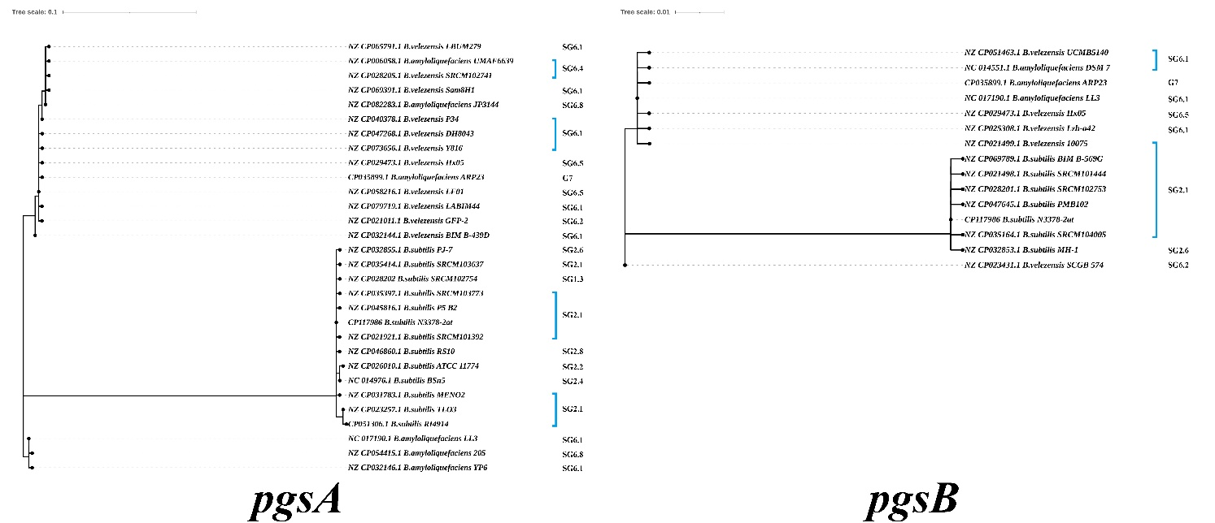

FIGURE 2 | Phylogenetic trees of the amino acid sequences for the PgdS of the B. subtilis strains and the B. velezensis and B. amyloliquefaciens strains.
.
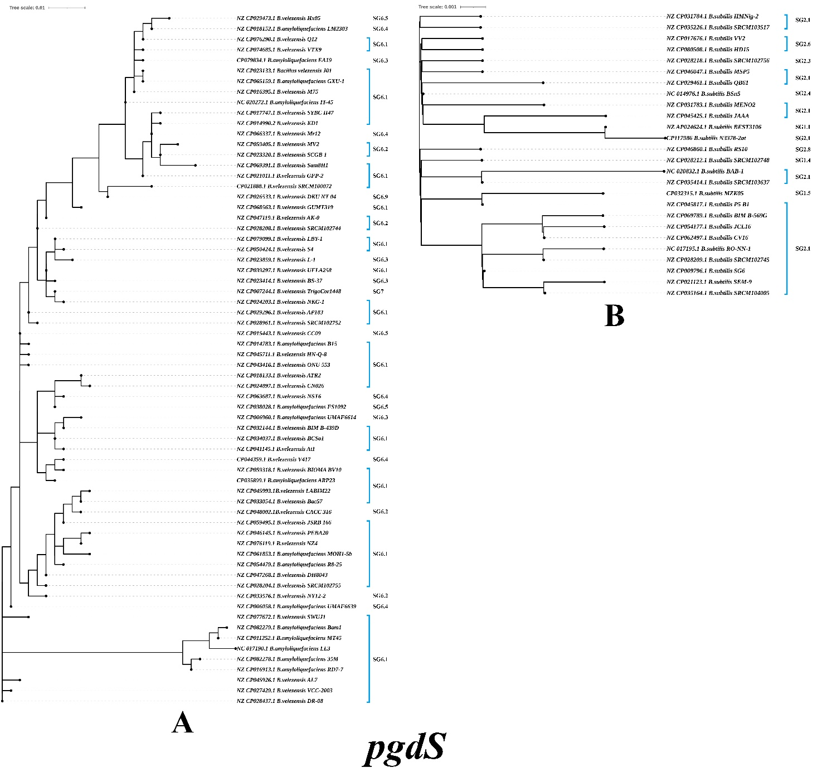

FIGURE 3 | Phylogenetic trees of the amino acid sequences for the PghB enzyme of the B. subtilis strains and the B. velezensis and B. amyloliquefaciens strains
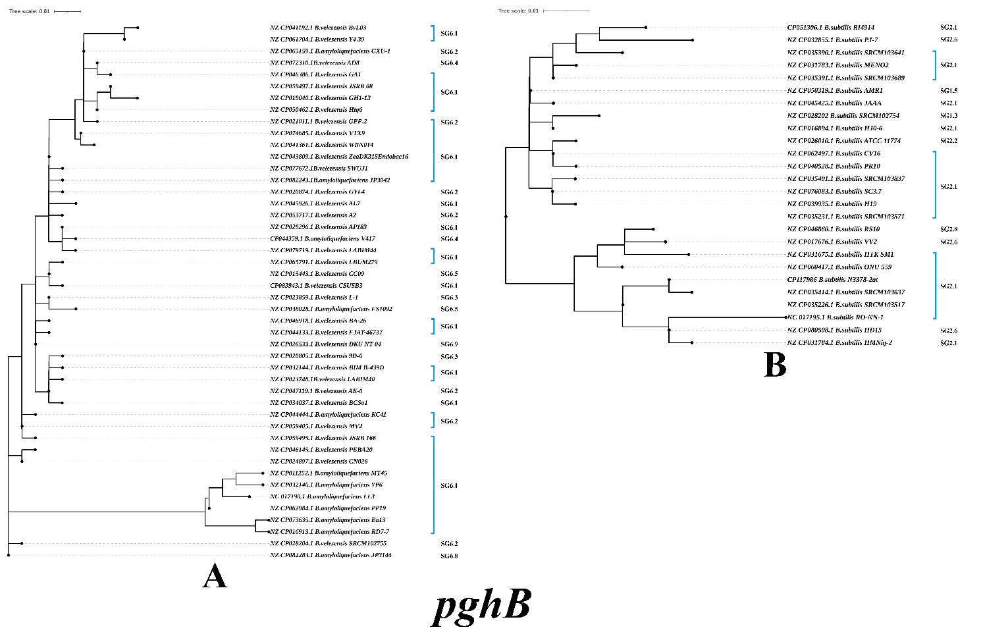
FIGURE 4 | Phylogenetic trees of the amino acid sequences for the PghC and RacE of the B. velezensis and B. amyloliquefaciens strains.

