Supplementary Materials for

Bacillus subtilis SOM8 Isolated from Sesame Oil Meal for Potential Probiotic Application in Inhibiting Human Enteropathogens
Zhongtian Zhao ¹, Wenrui Li ¹, Tran The Thien ¹, Say Chye Joachim Loo ^{1, 2, 3, #}

# Correspondence to: joachimloo@ntu.edu.sg

This PDF file includes:

Supplementary Figure S1 to S7; Table S1 to S4

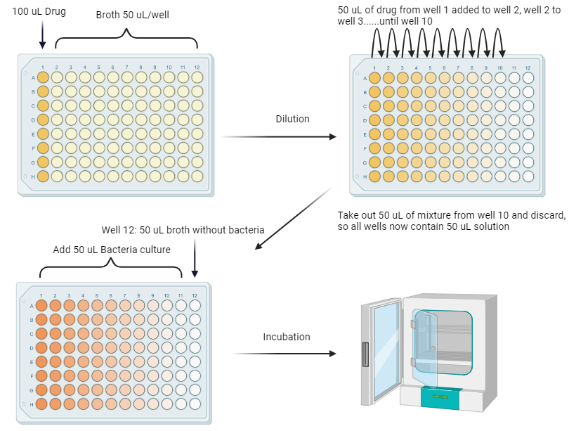
Figure S1. The protocol of CLSI M07 MIC evaluation.
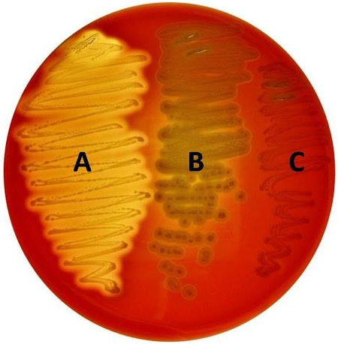
Figure S2. Three types of hemolytic activity (β, α, γ respectively from A to C).
- B. cereus ATCC11778
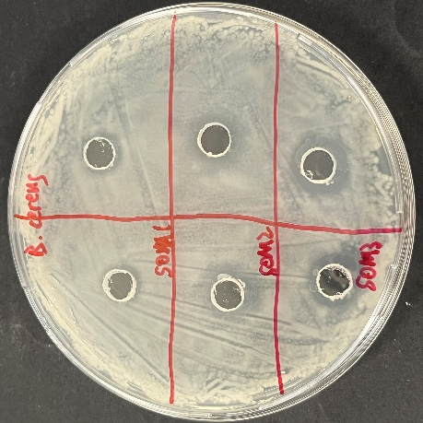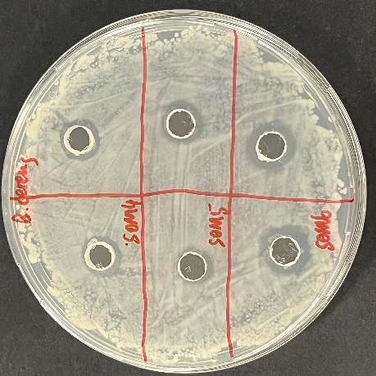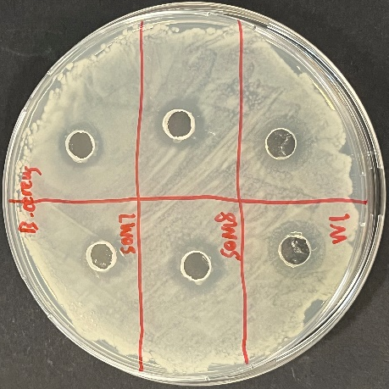
- E. Coli O157:H7 ATCC43888
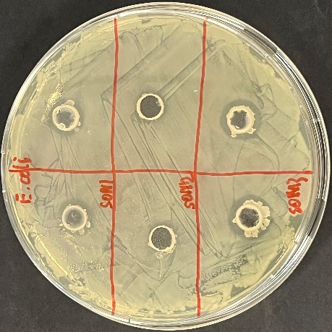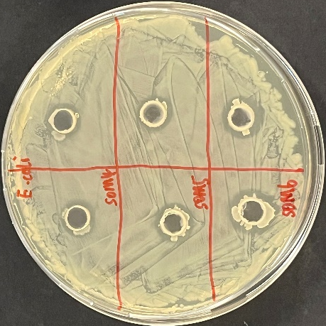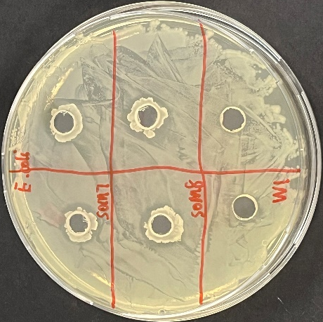
- S. aureus USA300
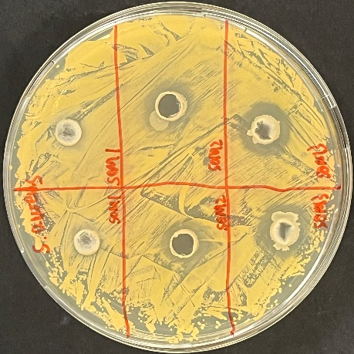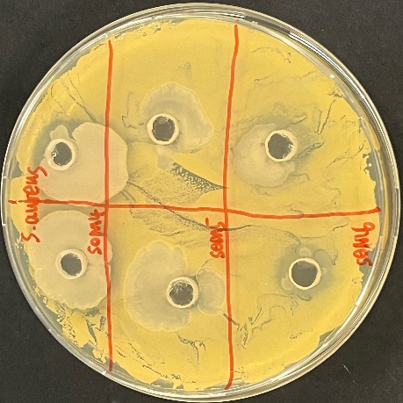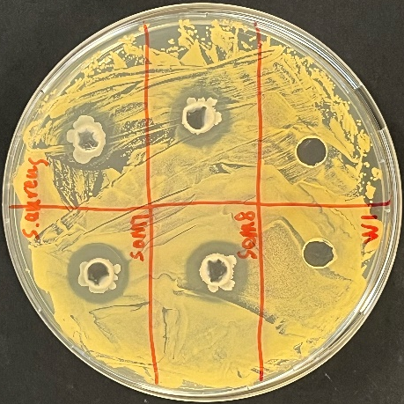
- S. enterica subsp. enterica ATCC BAA-190
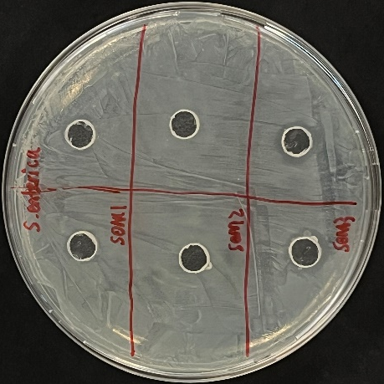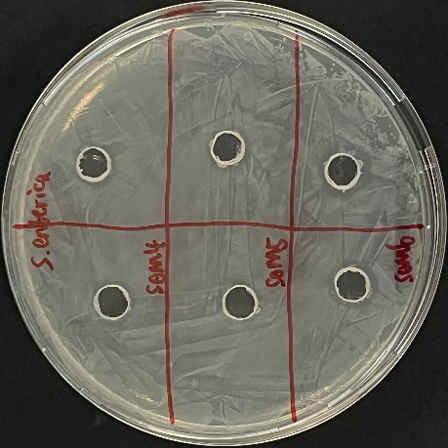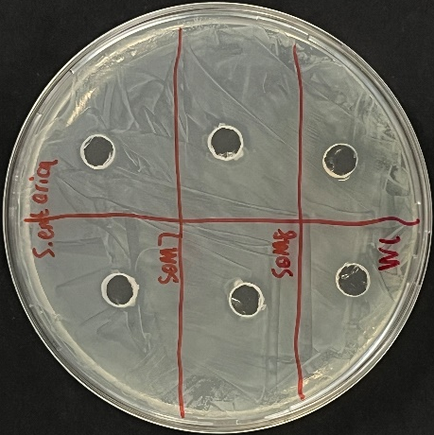

- V. parahaemolyticus ATCC 17802
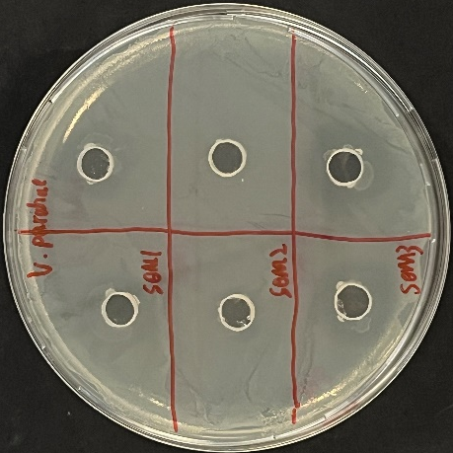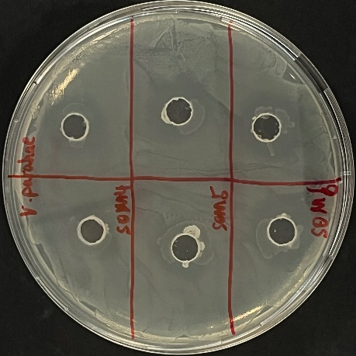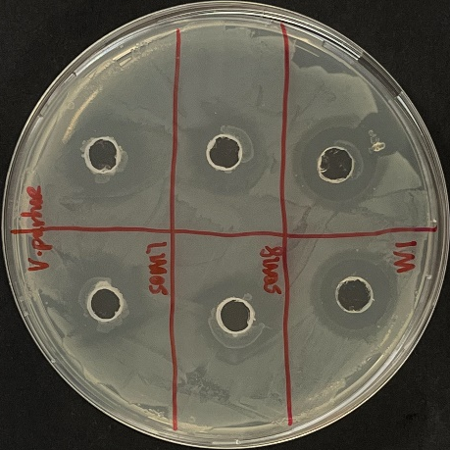
Figure S3. Antipathogenic activities of B. subtilis SOM1-8 and W. paramesenteroides (W1) to inhibit five enteropathogens through agar well diffusion assay.

Table S1. Isolated strains’ inhibition to human enteropathogens.
Species | Strain | Diameter of Inhibition Zone (mm)
Species | Strain | S. aureus | E. coli O157:H7 | B. cereus | S. enterica | V. parahaemolyticus
B. subtilis | 1 | 1.2 | 2.2 | 1.2 | 1.0 | 0.8
B. subtilis | 1 | - | 2.5 | 1.5 | 1.2 | -
B. subtilis | 2 | 3.6 | 1.5 | 3.8 | 0.5 | -
B. subtilis | 2 | 4.5 | 1.5 | 3.5 | - | 0.5
B. subtilis | 3 | 6.2 | 4.5 | 4.8 | 2.0 | 3.5
B. subtilis | 3 | 6.5 | 4.2 | 5.0 | 2.0 | 3.8
B. subtilis | 4 | 4.2 | 3.0 | 2.5 | 1.0 | 2.5
B. subtilis | 4 | 3.2 | 3.5 | 3.0 | 1.5 | 3.5
B. subtilis | 5 | 1.0 | 3.0 | 2.0 | 0.5 | 5.0
B. subtilis | 5 | 0.5 | 2.5 | 2.5 | 1.0 | 4.2
B. subtilis | 6 | 3.5 | 4.5 | 4.8 | 2.2 | 3.0
B. subtilis | 6 | 3.0 | 4.0 | 4.5 | 2.5 | 3.5
B. subtilis | 7 | 4.5 | 2.5 | 4.0 | 1.5 | 6.5
B. subtilis | 7 | 3.8 | 2.5 | 4.5 | 1.5 | 6.0
B. subtilis | 8 | 5.0 | 4.0 | 5.0 | 2.5 | 6.5
B. subtilis | 8 | 4.5 | 3.8 | 4.8 | 2.5 | 6.5
Weissella paramesenteroides | 1 | - | 1.0 | 4.8 | 1.0 | 8.0
Weissella paramesenteroides | 1 | - | 1.0 | 3.8 | 1.8 | 7.5

Table S2. Strains in TYGS dataset
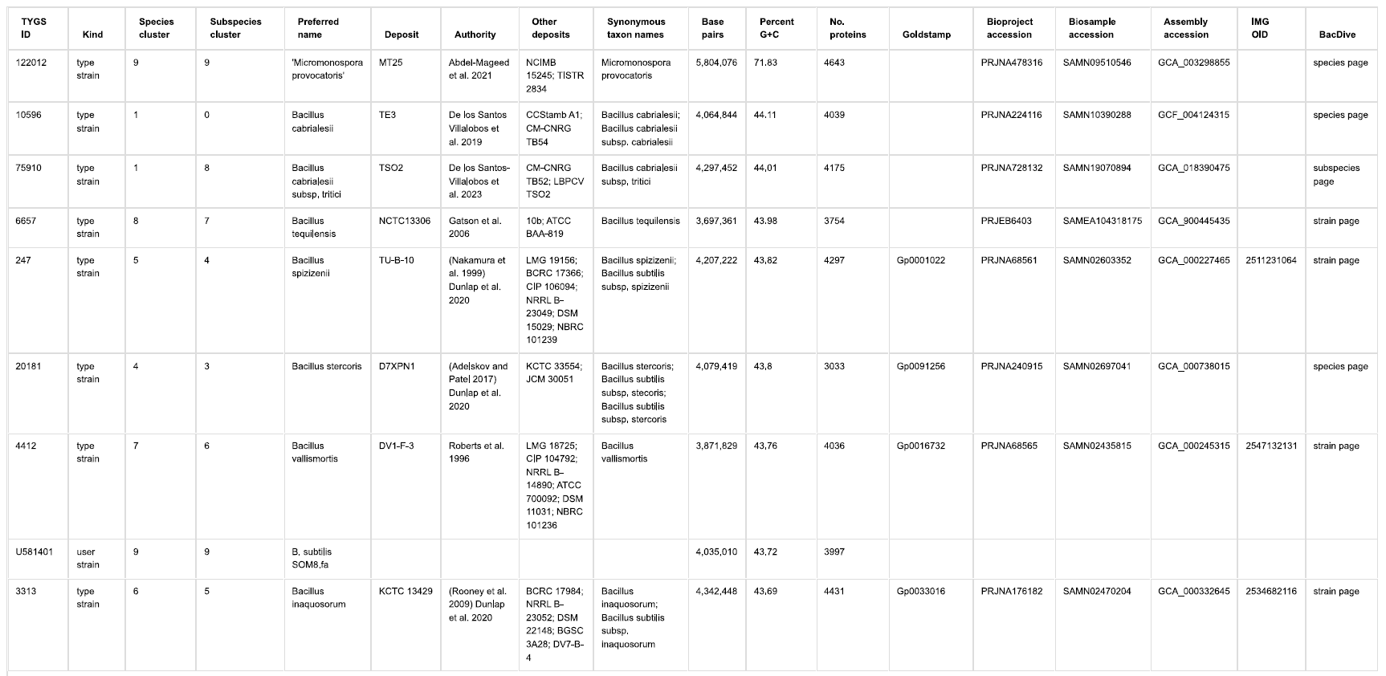
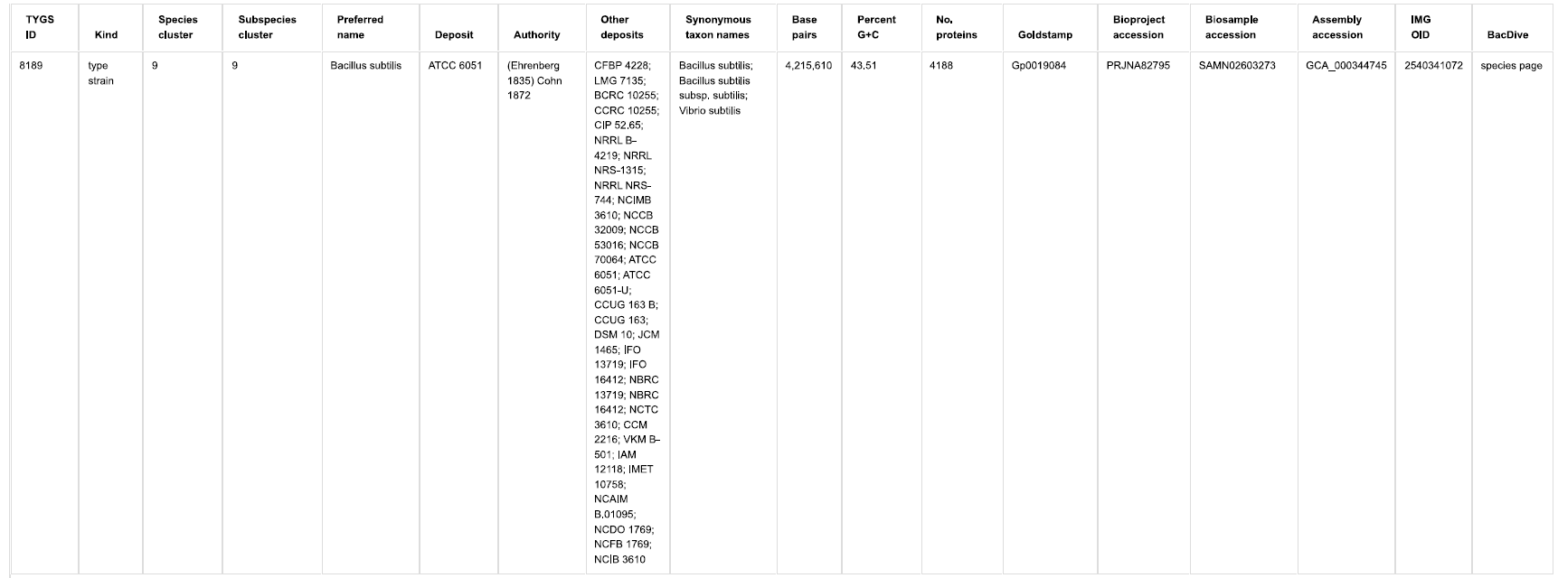

Table S3. Pairwise comparisons of user genomes B. subtilis SOM8 vs. type strain genomes
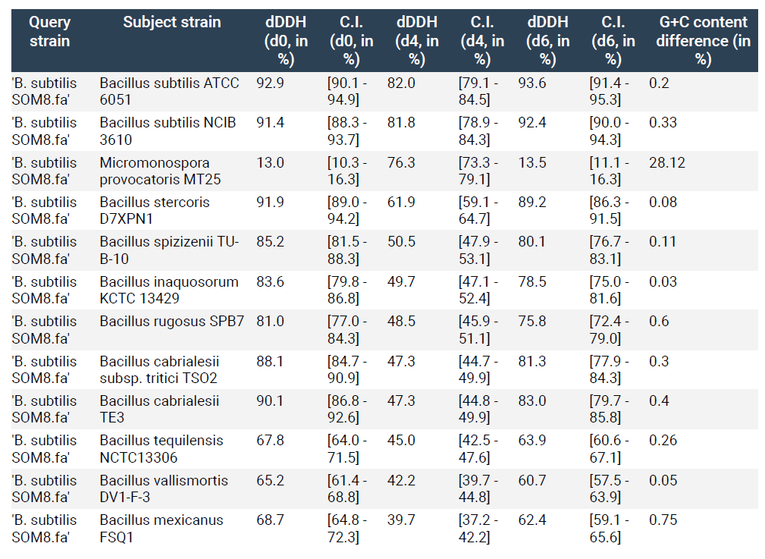

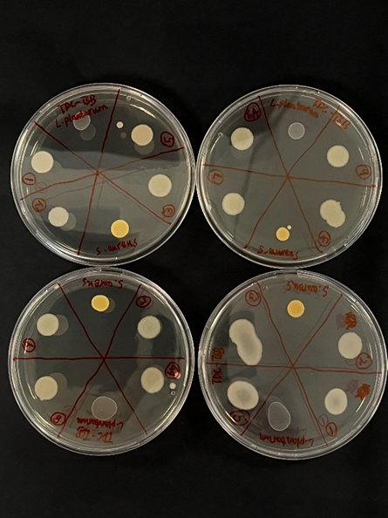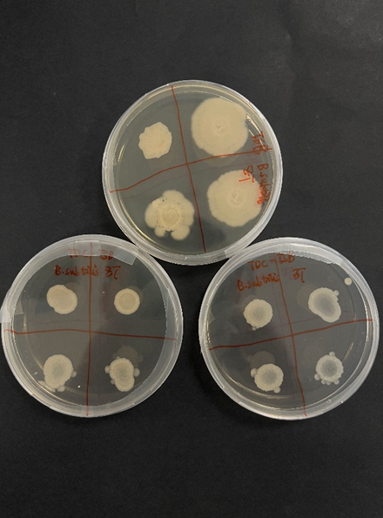
Figure S4. BSH activity of isolated B. subtilis SOM (1-8). On the left, duplicates of B. subtilis SOM8 (1-8) are presented alongside S. aureus and L. plantarum, serving as the negative and positive controls, respectively. On the right, B. subtilis SOM8 growth on TDC-TS agar plates is displayed in duplicates, compared with growth on normal TS agar plates without TDC.

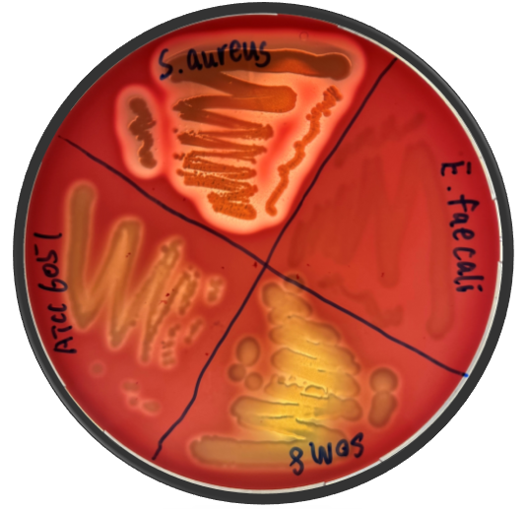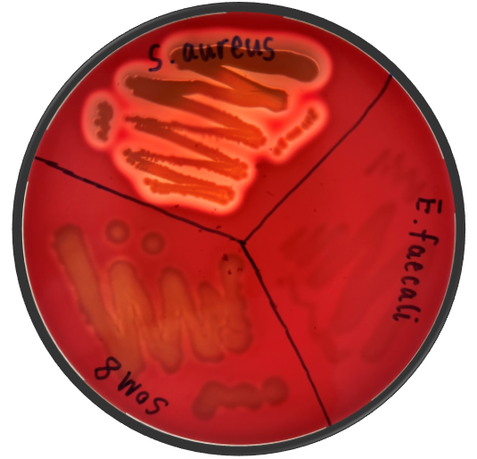
Figure S5. Hemolytic activity of B. subtilis SOM8 and B. subtilis ATCC 6051.

Table S4. Summary of B. subtilis SOM8 genome for antibiotic resistance prediction.
Gene | Gene Family | Drug Class | % Identity
B, subtilis mprF | defensin resistant mprF | peptide antibiotic | 99.88
blt | major facilitator superfamily (MFS) antibiotic efflux pump | fluoroquinolone antibiotic, disinfecting agents and antiseptics | 99.75
ykkC | small multidrug resistance (SMR) antibiotic efflux pump | aminoglycoside antibiotic, tetracycline antibiotic, phenicol antibiotic | 99.11
ykkD | small multidrug resistance (SMR) antibiotic efflux pump | aminoglycoside antibiotic, tetracycline antibiotic, phenicol antibiotic | 99.05
lmrB | ATP-binding cassette (ABC) antibiotic efflux pump | lincosamide antibiotic | 98.74
bmr | major facilitator superfamily (MFS) antibiotic efflux pump | fluoroquinolone antibiotic, nucleoside antibiotic, phenicol antibiotic, disinfecting agents and antiseptics | 98.71
aadK | ANT(6) | aminoglycoside antibiotic | 98.59
mphK | macrolide phosphotransferase (MPH) | macrolide antibiotic | 98.35
vmlR | Miscellaneous ABC-F subfamily ATP-binding cassette ribosomal protection proteins | lincosamide antibiotic, streptogramin antibiotic, streptogramin B antibiotic | 98.18
tmrB | tunicamycin resistance protein | nucleoside antibiotic | 96.95

a) 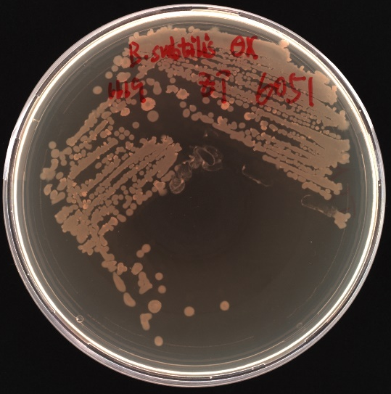 (b) 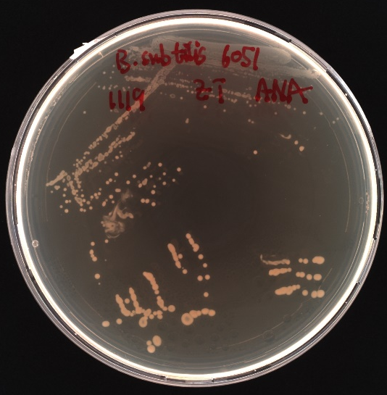
(c) 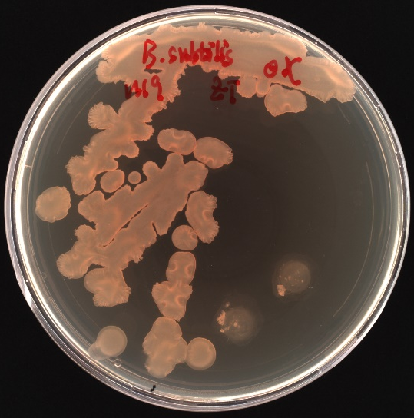 (d) 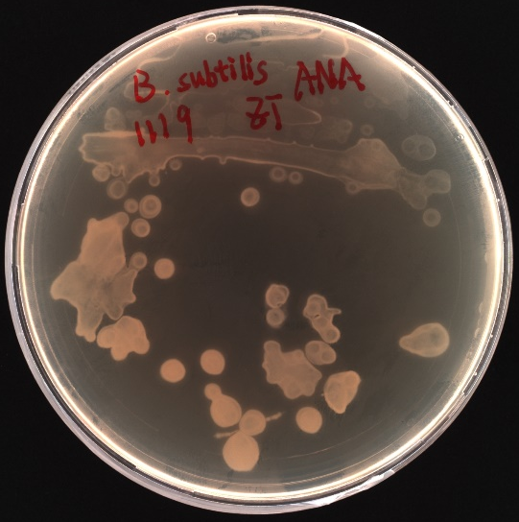
Figure S6. Growth of B. subtilis ATCC 6051 and B. subtilis SOM8 under aerobic and anaerobic conditions respectively. (a) B. subtilis ATCC 6051-OX; (b) B. subtilis ATCC 6051-ANA; (c) B. subtilis SOM8-OX; (d) B. subtilis SOM8-ANA.

(a)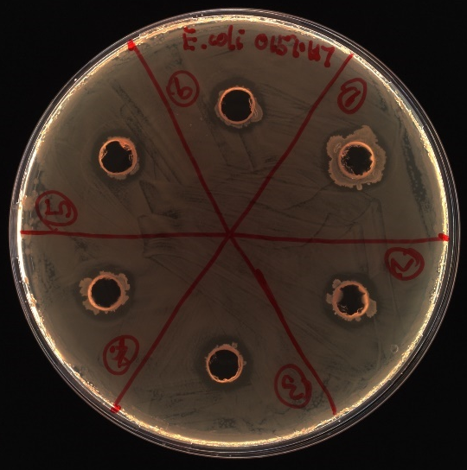 (b) 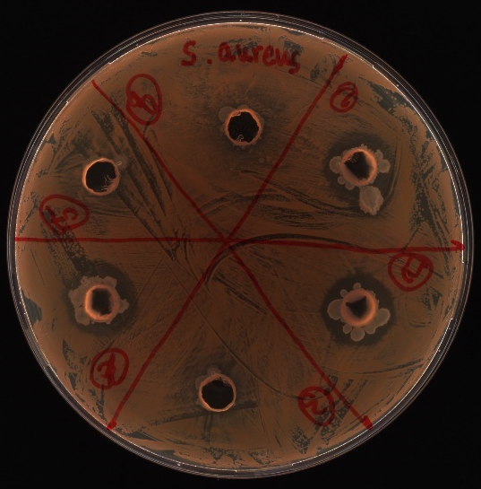
(c)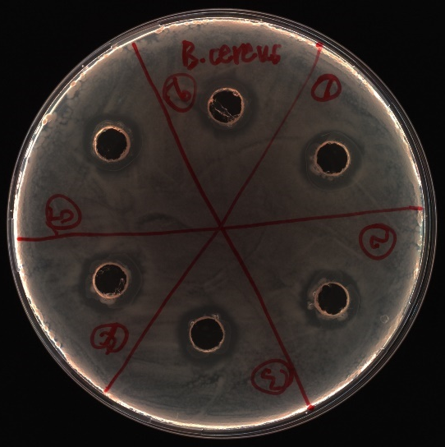(d) 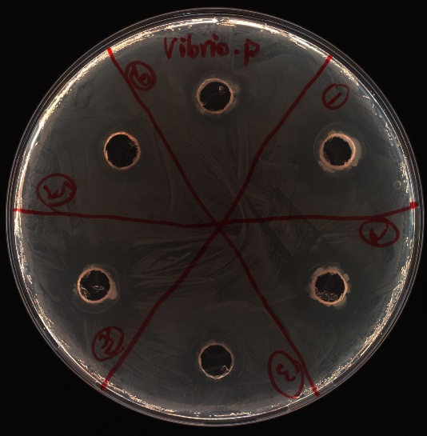
Figure S7. Examples of antimicrobial activities of B. subtilis SOM8 and B. subtilis ATCC 6051 against human enteropathogen. Number 1 to 6 are B. subtilis SOM8 (OX-OX: Firstly, grown in aerobic condition, then incubate aerobically), B. subtilis SOM8 (OX to ANA), B. subtilis SOM8 (ANA-ANA), B. subtilis ATCC 6051 (OX-OX), B. subtilis ATCC 6051 (OX to ANA), B. subtilis ATCC 6051 (ANA-ANA) respectively. (a) E. Coli O157:H7; (b) S. aureus; (c) B. cereus; (d) V. parahaemolyticus.

