Supplementary materials

Figure S1. Composition of the colonic microbiota at 72 h after cefoperazone sodium and sulbactam sodium solution gavage, as analyzed using the 16S rDNA method.

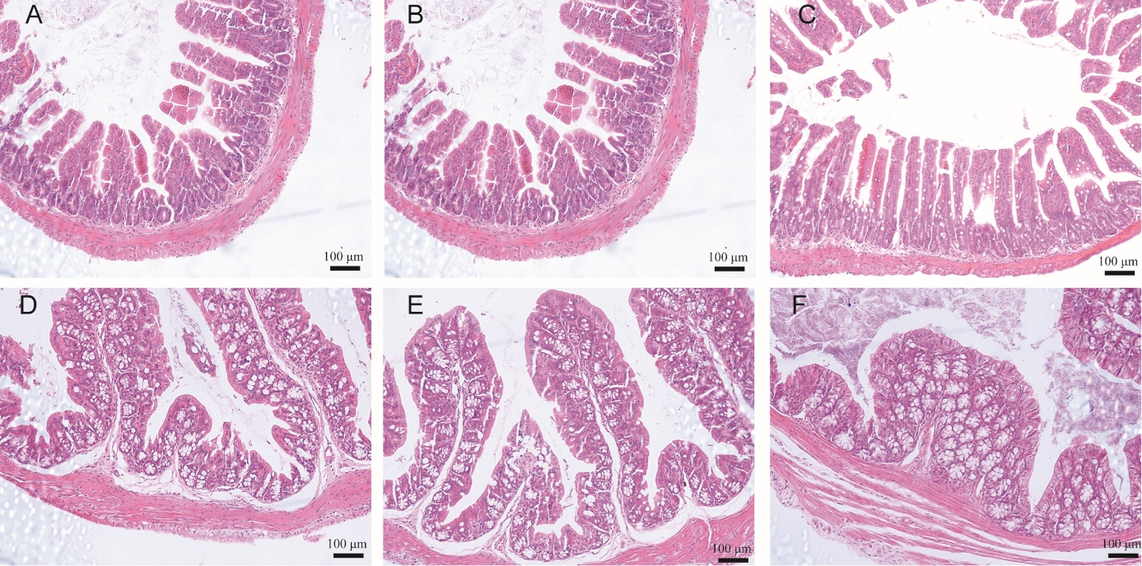
Figure S2. Hematoxylin and eosin (HE) staining of mouse intestinal tissues on day 7 after modeling completion. A. Ileum tissue in the normal group. B. Ileum tissue in the control group. C. Ileum tissue in the experimental group. D. Colon tissue in the normal group. E. Colon tissue in the control group. F. Colon tissue in the experimental group. Scale bar: 100 μm.

