Supplementary Material.

Exploring the Decolorization Efficiency and Biodegradation Mechanisms of Different Functional Textile Azo Dyes by Streptomyces albidoflavus 3MGH

Mohamed E. El Awady^{1,} Fatma N. El-Shall², Ghada E. Mohamed³, Ahmed M. Abd-Elaziz⁴, Mohamed O. Abdel-Monem^{3*} and Mervat G. Hassan³

Supplementary table 1. Chemical structure of selected azo dyes used in study.
C.I.name | Functionality | Molecular Formula, Molecular Weight, and Chemical Structure
Reactive Orange 122 | Mono | C₃₁H₂₀ClN₇Na₄O₁₆S₅ 1034.27 g·mol⁻¹
Direct Blue 15 | Di | C₃₄H₂₄N₆Na₄O₁₆S₄ 992.79 g·mol⁻¹
Direct Black 38 | Tri | C₃₄H₂₅N₉Na₂O₇S₂ 781.73 g.mol⁻¹

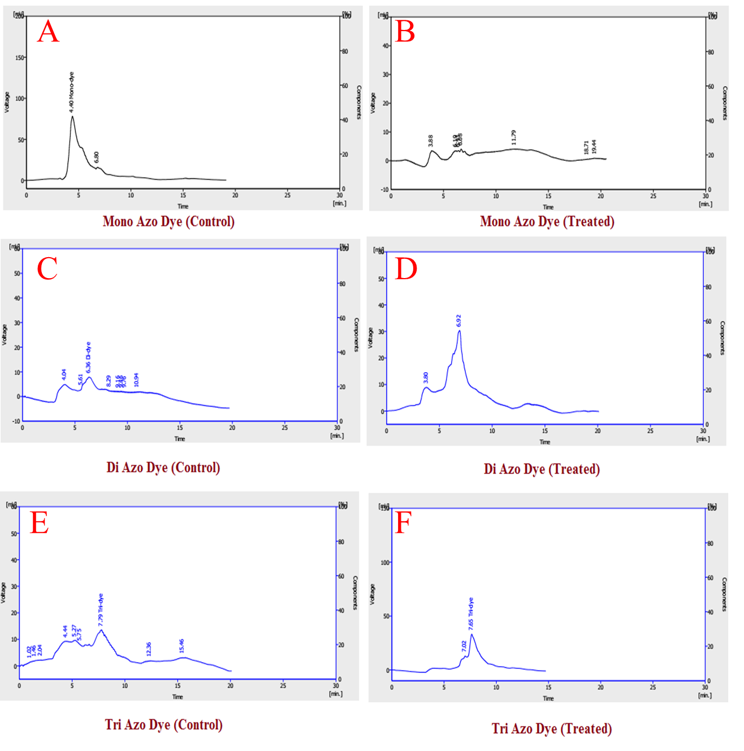
Supplementary figure 1: HPLC Chromatogram Profiles of Mono Azo Dye (RO 122) (A&B), Di Azo Dye (DB 15) (C&D), and Tri Azo Dye (DB 38) (E&F) before and after treatment with S. albidoflavus 3MGH.

