Supplementary information

Mining biosynthetic gene clusters in Paenibacillus genomes to discover novel antibiotics

Man Su Kim^{1,2†}, Da-Eun Jeong^{1†}, Jun-Pil Jang^{3†}, Jae-Hyuk Jang^{3,4*}, and Soo-Keun Choi^{1,2*}

¹Infectious Disease Research Center, Korea Research Institute of Bioscience and Biotechnology (KRIBB), Daejeon, Republic of Korea,
²Department of Biosystems and Bioengineering, KRIBB School of Biotechnology, University of Science and Technology (UST), Daejeon, Republic of Korea,
³Chemical Biology Research Center, Korea Research Institute of Bioscience and Biotechnology, Cheongju, Republic of Korea
⁴Department of Applied Biological Engineering, KRIBB School of Biotechnology, University of Science and Technology (UST), Daejeon, Republic of Korea

The following Supplementary information is available for this article:
Table S1. Bacterial strains used in this study.
Table S2. Plasmids used in this study.
Table S3. Oligonucleotides and primers used in this study.
Table S4. Paenibacillus genomes selected for biosynthetic gene cluster analysis.
Fig. S1. AntiSMASH analysis of Paenibacillus brazilensis genome to identify gene clusters for secondary metabolites.
Fig. S2. 1D NMR spectrum of the novel compound.
Fig. S3. 2D NMR spectrum of the novel compound.
References
Supplementary Table S1. Bacterial strains used in this study.
Strain | Genotype | Reference
Escherichia coli
MC1061 | araD139 △(araA-leu)7697 △(lac)X74 galK16 galE15(GalS) lambda- e14- mcrA0 relA1 rpsL150(strR) spoT1 mcrB1 hsdR2 | Laboratory stock
Bacillus subtilis
BS5918 | B. subtilis 168 △rapI-attR::hyg^{R} △alrA::Sp^{R}-P_{xylA}-rapI △oriT_{ICE} △sigK | [1]
MICEaRep | BS5918 △amyE::P_{ara}-rep | [2]
Paenibacillus
P. alvei DSM 29 |  | KCTC 3623
P. assamensis DSM 18201 |  | KCTC 13627
P. azotifigens LMG 29963 |  | KACC 18967
P. borealis DSM 13188 |  | KCTC 3805
P. brasilensis KACC 13842 |  | KACC 13842
P. cellulositrophicus KACC 16577 |  | KCTC 13135
P. curdlanolyticus YK9 |  | KCTC 3759
P. daejeonensis DSM 15491 |  | KCTC 3745
P. donghaensis KCTC 13049 |  | KCTC 13049
P. durus ATCC 35681 |  | KCTC 3740
P. ehimensis NBRC 15659 |  | KCTC 43209
P. fonticola DSM 21315 |  | KCTC 13624
P. glacialis DSM 22343 |  | KCTC 13874
P. graminis DSM 15220 |  | KCTC 13926
P. harenae DSM 16969 |  | KCTC 3951
P. jilunlii KACC 16679 |  | KACC 16679
P. kribbensis AM49 |  | KACC 17402
P. nuruki TI45-13ar |  | KACC 18728
P. pabuli NBRC 13638 |  | KCTC 3398
P. pini JCM 16418 |  | KCTC 13694
P. pinihumi DSM 23905 |  | KCTC 13695
P. polymyxa ATCC 842 |  | KCTC 3627
P. stellifer DSM 14472 |  | KCTC 3931
P. taiwanensis DSM 18679 |  | KCTC 13628
P. thiaminolyticus NRRL B-4156 |  | KCTC 3764
P. tianmuensis CGMCC 1.8946 |  | KACC 16677
RB5 | P. brasilensis △BGC1a △BGC1b △BGC3 △BGC11 | This study
RB5d5 | RB5 △BGC5::Cm | This study
Indicator for antimicrobial activity assay
Acinetobacter baumannii |  | ATCC 19606
E. coli |  | KCTC 22003
Pseudomonas aeruginosa |  | ATCC 27853
Bacillus cereus |  | ATCC 4342
Micrococcus luteus |  | KCTC 2177
Pythium ultimum |  | KACC 40705
Fusarium graminearum |  | KACC 41040
Rhizoctonia solani |  | KACC 40146

Supplementary Table S2. Plasmids used in this study.
Plasmid | Description | Reference
pMGoldi-sCBE4 | pMGold-sCBE4 derivative containing oriT_{ICE} (for MICE) instead of oriT (for EBC) | [2]
pMisCBE4-RB5 | pMGoldi-sCBE4 with sgRNA: BGC1a, BGC1b, BGC3, and BGC11 | This study
pSGC4iN | pSGC2iN derivative containing synsthtic gene circuit | [3]
pSGC4iN-RB5d | pSGC4iN derivative, inserting P_{spac}-cat at BGC5 locus of P. brasilensis | This study

Supplementary Table S3. Oligonucleotides and primers used in this study
Oligonucleotide | Sequence (5’ to 3’) | Purpose
1a-BraPK-gRF | ATTGTTCAAGCCGGAGCAGATCAG | Oligonucleotides for cloning of synthetic gRNA sequence used in this study
1a-BraPK-gRR | AAACCTGATCTGCTCCGGCTTGAA
1b-BraPK-gRF | ATTGTCAGAGTCCCCGACTTCTTA
1b-BraPK-gRR | AAACTAAGAAGTCGGGGACTCTGA
3-BraNRP-gRF | ATTGCAGCGAGCTTTTGAGATACT
3-BraNRP-gRR | AAACAGTATCTCAAAAGCTCGCTG
11-BraNRP-gRF | ATTGGCAGGCAGGAAGCGAATACG
11-BraNRP-gRR | AAACCGTATTCGCTTCCTGCCTGC
Primer | Sequence (5’ to 3’) | Purpose
BB-vec-sgF | GGAAGATCTGGTCTCCATTGAGCCAGCAAGACAGCGATAA | Primers for multiplex gRNA cloning
Bsa-sgR1 | ACGGTCTCCCCTTAAAAAAAGCACCGACTCGGTG | Primers for multiplex gRNA cloning
Bsa-sgF1 | CTGGTCTCCAAGGAGCCAGCAAGACAGCGATAA | Primers for multiplex gRNA cloning
Bsa-sgR2 | ACGGTCTCCGAGTAAAAAAAGCACCGACTCGGTG | Primers for multiplex gRNA cloning
Bsa-sgF2 | CTGGTCTCCACTCAGCCAGCAAGACAGCGATAA | Primers for multiplex gRNA cloning
Bsa-sgR3 | ACGGTCTCCTCCTAAAAAAAGCACCGACTCGGTG | Primers for multiplex gRNA cloning
Bsa-sgF3 | CTGGTCTCCAGGAAGCCAGCAAGACAGCGATAA | Primers for multiplex gRNA cloning
SCBB-vec-sgR | GGAGTCGACATCGATGGATCCGGTCTCCAAACAAAAAAAGCACCGACTCGGTG | Primers for multiplex gRNA cloning
1G-BRB5-FF | CTGGTCTCCATTGTCCTTTGCGAATATCCATGC | Primers for amplifying homologous arm fragments to delete target gene
1G-BRB5-FR | ACGGTCTCCCCTTAGTAGCCAAACCTTTGCCGA
3GX-BRB5-BF | CTGGTCTCCACTCATGCCTTAAAGCGCTCCATC
3GX-BRB5-BR | ACGGTCTCCAAACCAGATCATTGACTTCATCGC
Pspac-F | CTGGTCTCCAAGGTACACAGCCCAGTCCAGACT | Primers for amplifying P_{spac}-cat
cat-R | ACGGTCTCCGAGTGCGAATGGCGACTAACGGGG | Primers for amplifying P_{spac}-cat
1a-BraPK-F | TGCCTTGATCCAAACAGTCA
1a-BraPK-R | TCCGGAAAACACTTCATACG
1b-BraPK-F | GGCTATTCCGGTCAATTCTC
1b-BraPK-R | GCCGCACCTGTATATCTCAA
3-BraNRP-F | CTGTATAATGCCCTTCATGATC
3-BraNRP-R | GCCTATATTATCTATACCTCAGG
11-BraNRP-F | GATATCCGGACGAACATCAG
11-BraNRP-R | TCCTAGCGCTCAGACGGATC
1a-BraPK-seqF | CCGCACAAATAATCGCCTTG
1b-BraPK-seqF | ATCCTTATGTCAACACCAAC
3-BraNRP-seqF | CTCCTTCACCGCCTATATAC
11-BraNRP-seqF | AACCTAGCGAGCGGATGTAC
Underlined sequences are the restriction enzyme sites.
Bolded sequences represent the 20 bp synthetic gRNA.
Supplementary Table S4. Paenibacillus genomes selected for biosynthetic gene cluster analysis.
Organism name | Infraspecific_name | Genome assembly_level | Accession number
P. alvei |  | Chromosome | GCF_900519125.1
P. antarcticus | KACC 11469 | Complete Genome | GCF_008369725.1
P. baekrokdamisoli | KCTC 33723 | Complete Genome | GCF_003945345.1
P. beijingensis | DSM 24997 | Complete Genome | GCF_000961095.1
P. borealis | DSM 13188 | Complete Genome | GCF_000758665.1
P. bovis | BD3526 | Complete Genome | GCF_001421015.2
P. brasilensis | KACC 13842 | Complete Genome | GCF_009363115.1
P. cellulositrophicus | KACC 16577 | Complete Genome | GCF_009363095.1
P. chitinolyticus | KCCM 41400 | Complete Genome | GCF_004117095.1
P. crassostreae | LPB0068 | Complete Genome | GCF_001857945.1
P. donghaensis | KCTC 13049 | Complete Genome | GCF_002192415.1
P. durus | DSM 1735 | Complete Genome | GCF_000756615.1
P. durus | ATCC 35681 | Complete Genome | GCF_000993825.1
P. glucanolyticus | 5162 | Chromosome | GCF_001632305.1
P. glucanolyticus | W10507 | Chromosome | GCF_003033945.1
P. graminis | DSM 15220 | Complete Genome | GCF_000758705.1
P. guangzhouensis | KCTC 33171 | Complete Genome | GCF_009363075.1
P. ihbetae | IHBB 9852 | Complete Genome | GCF_002741055.1
P. kribbensis | AM49 | Complete Genome | GCF_002240415.1
P. larvae subsp. larvae | ATCC 9545 | Complete Genome | GCF_002003265.1
P. larvae subsp. larvae | ERIC_I | Complete Genome | GCF_002951875.1
P. larvae subsp. larvae | Eric_III | Complete Genome | GCF_002951915.1
P. larvae subsp. larvae | Eric_IV | Complete Genome | GCF_002951935.1
P. larvae subsp. larvae | DSM 25430 | Complete Genome | GCF_000511405.1
P. larvae subsp. larvae | DSM 25430; ERIC_II | Complete Genome | GCF_002951895.1
P. larvae subsp. pulvifaciens | ATCC 13537 | Complete Genome | GCF_002007765.1
P. larvae subsp. pulvifaciens | CCM 38 | Complete Genome | GCF_002043025.1
P. larvae subsp. pulvifaciens | SAG 10367 | Complete Genome | GCF_002082155.1
P. lautus | E7593-69 | Complete Genome | GCF_003590055.1
P. lentus | DSM 25539 | Complete Genome | GCF_003931855.1
P. mucilaginosus | 3016 | Complete Genome | GCF_000250655.1
P. mucilaginosus | K02 | Complete Genome | GCF_000258535.2
P. mucilaginosus | KNP414 | Complete Genome | GCF_000218915.1
P. naphthalenovorans | 32O-Y | Complete Genome | GCF_001465255.1
P. odorifer | DSM 15391 | Complete Genome | 1GCF_000758725.1
P. odorifer | CBA7130 | Complete Genome | GCF_003255855.1
P. odorifer |  | Complete Genome | GCF_902386945.1
P. peoriae | HS311 | Complete Genome | GCF_001272655.2
P. physcomitrellae | XB | Chromosome | GCF_002240225.1
P. polymyxa | CF05 | Chromosome | GCF_000785455.1
P. polymyxa | Sb3-1 | Complete Genome | GCF_000819665.1
P. polymyxa | J | Complete Genome | GCF_001719045.1
P. polymyxa | YC0136 | Complete Genome | GCF_001874405.2
P. polymyxa | YC0573 | Complete Genome | GCF_001874425.3
P. polymyxa | ATCC 15970 | Complete Genome | GCF_001922145.1
P. polymyxa | HY96-2 | Complete Genome | GCF_002893885.1
P. polymyxa | ZF129 | Complete Genome | GCF_006274405.1
P. polymyxa | ZF197 | Complete Genome | GCF_007858415.1
P. polymyxa | CR1 | Complete Genome | GCF_000507205.3
P. polymyxa | E681 | Complete Genome | GCF_000146875.3
P. polymyxa | M1 | Complete Genome | GCF_000237325.1
P. polymyxa | SC2 | Complete Genome | GCF_000164985.3
P. polymyxa | SQR21 | Complete Genome | GCF_000597985.1
P. psychroresistens | ML311-T8 | Complete Genome | GCF_009728935.1
P. riograndensis | SBR5 | Complete Genome | GCF_000981585.1
P. sabinae | T27 | Complete Genome | GCF_000612505.1
Paenibacillus sp. | 18JY67-1 | Complete Genome | GCF_003952225.1
Paenibacillus sp. | 32O-W | Complete Genome | GCF_001465275.1
Paenibacillus sp. | 37 | Complete Genome | GCF_008386395.1
Paenibacillus sp. | B01 | Complete Genome | GCF_009649995.1
Paenibacillus sp. | BIHB4019 | Complete Genome | GCF_002741035.1
Paenibacillus sp. | CAA11 | Complete Genome | GCF_003060825.1
Paenibacillus sp. | Cedars | Complete Genome | GCF_003184205.1
Paenibacillus sp. | DCT19 | Complete Genome | GCF_003268635.1
Paenibacillus sp. | FSL H7-0357 | Complete Genome | GCF_000758525.1
Paenibacillus sp. | FSL H7-0737 | Complete Genome | GCF_000758545.1
Paenibacillus sp. | FSL P4-0081 | Complete Genome | GCF_000758565.1
Paenibacillus sp. | FSL R5-0345 | Complete Genome | GCF_000758585.1
Paenibacillus sp. | FSL R5-0912 | Complete Genome | GCF_000758605.1
Paenibacillus sp. | FSL R7-0273 | Complete Genome | GCF_000758625.1
Paenibacillus sp. | FSL R7-0331 | Complete Genome | GCF_000758645.1
Paenibacillus sp. | FW100M-2 | Complete Genome | GCF_004135365.1
Paenibacillus sp. | HB172198 | Complete Genome | GCF_005577435.1
Paenibacillus sp. | IHB B 3084 | Complete Genome | GCF_001447315.1
Paenibacillus sp. | 10380 | Complete Genome | GCF_000949425.1
Paenibacillus sp. | JDR-2 | Complete Genome | GCF_000023585.1
Paenibacillus sp. | lzh-N1 | Complete Genome | GCF_002872435.1
Paenibacillus sp. | M-152 | Complete Genome | GCF_003856555.1
Paenibacillus sp. | MBLB1234 | Complete Genome | GCF_003991425.1
Paenibacillus sp. | RUD330 | Chromosome | GCF_002243345.1
Paenibacillus sp. | Y412MC10 | Complete Genome | GCF_000024685.1
P. stellifer | DSM 14472 | Complete Genome | GCF_000758685.1
P. swuensis | DY6 | Complete Genome | GCF_001644605.1
P. terrae | HPL-003 | Complete Genome | GCF_000235585.1
P. thiaminolyticus | NRRL B-4156 | Chromosome | GCF_007066085.1
P. thiaminolyticus | Mbale | Chromosome | GCF_007066225.1
P. xylanexedens | PAMC 22703 | Complete Genome | GCF_001908275.1
P. xylanilyticus | W4 | Complete Genome | GCF_009664365.1
P. yonginensis | DCY84 | Complete Genome | GCF_001685395.1

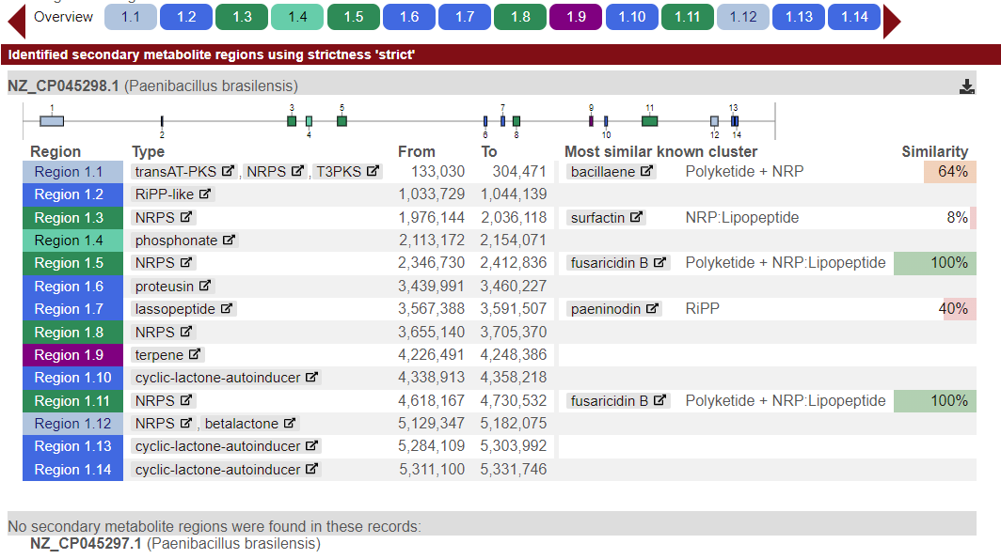

Fig. S1. AntiSMASH analysis of Paenibacillus brazilensis genome to identify gene clusters for secondary metabolites.

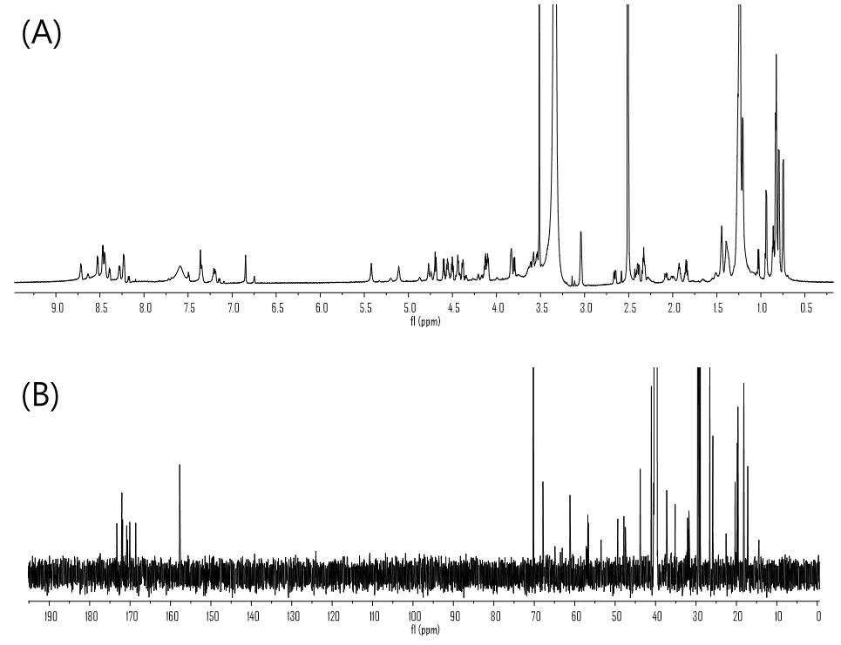

Fig. S2. 1D NMR spectrum of the novel compound (MW 926). (A) ¹H NMR spectrum (900 MHz) of the compound in DMSO-d₆. (B) ¹³C NMR spectrum (225 MHz) of the compound in DMSO-d₆.

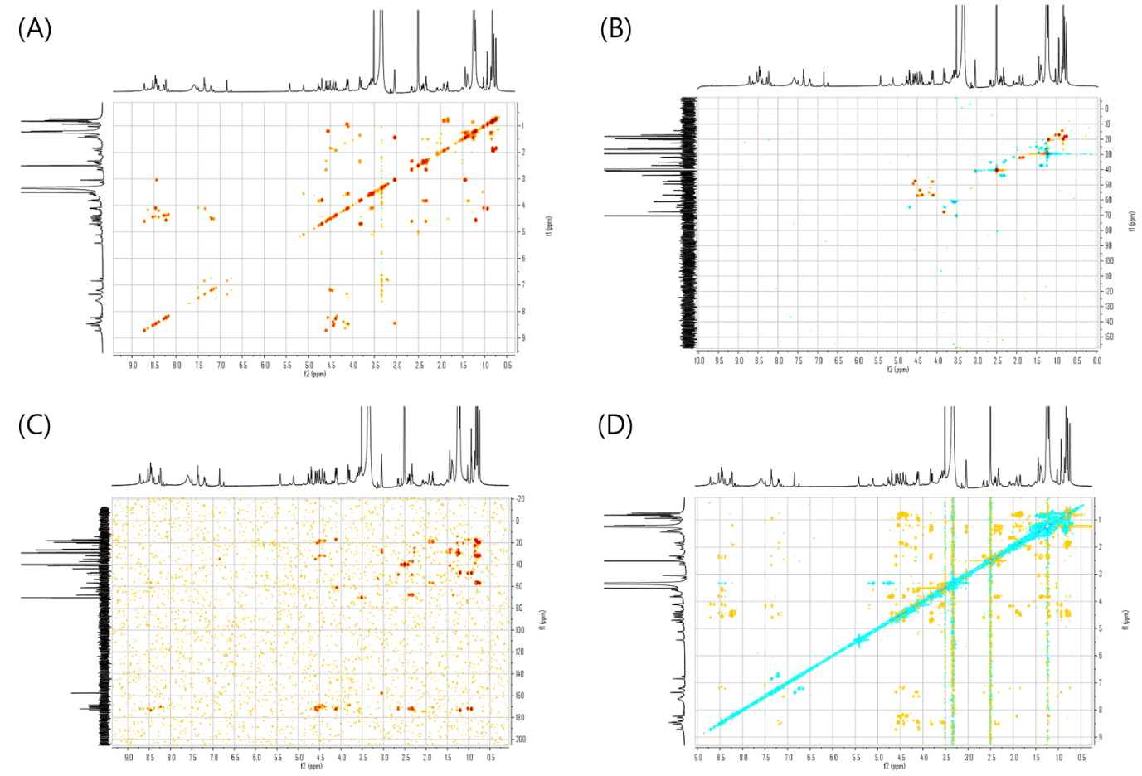

Fig. S3. 2D NMR spectrum of the novel compound. (A) COSY spectrum of the compound in DMSO-d₆. (B) HSQC-DEPT spectrum of the compound in DMSO-d₆. (C) HMBC spectrum of the compound in DMSO-d₆. (D) ROESY spectrum of the compound in DMSO-d₆.
References

1. Jeong DE, Kim MS, Kim HR, Choi SK. Cell Factory Engineering of Undomesticated Bacillus Strains Using a Modified Integrative and Conjugative Element for Efficient Plasmid Delivery. Front Microbiol. 2022;13:802040.
2. Kim MS, Kim HR, Jeong DE, Choi SK. Cytosine Base Editor-Mediated Multiplex Genome Editing to Accelerate Discovery of Novel Antibiotics in Bacillus subtilis and Paenibacillus polymyxa. Front Microbiol. 2021;12:691839.
3. Kim MS, Jeong DE, Choi SK. Bacillus integrative plasmid system combining a synthetic gene circuit for efficient genetic modifications of undomesticated Bacillus strains. Microb Cell Fact. 2022;21(1):259.

