Annex II. Explanation of equations 2, 3 and 4.

To estimate the abundance of certain pathway in DiTing [39 in the manuscript, 2 in this annex], the relative abundance of proteins for each step were added up. Several proteins may participate, either cooperatively, complementarily or isoenzymes sometimes for the same step. In this case, the values were weighted by the number of proteins involved in such step.
As an example of this calculation, the abundance of the assimilatory nitrate reduction function, which can be fractionated in three pathway steps, is given in the scheme below:
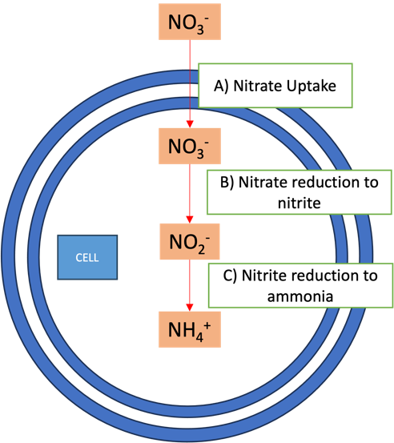

Nitrate reduction to nitrite requires uptake of nitrate itself. This step needs to be considered as one main step for nitrate assimilation. As can be seen in Table II-1, several proteins involved in the different steps have not been considered in DiTing approach [39 in the manuscript, 2 in this annex]. Therefore, we used new formulae to determine the abundances of these functions, which have been described in the body of the manuscript.

A. Uptake
Three different mechanisms can be involved in the uptake of nitrate (Moreno et al. [26 in the manuscript, 1 in this annex], Table II-1).
1) NADH-dependent in archaea, i.e. two isoenzymes, both with the KEGG id K02575,
2) NADH-dependent in bacteria, which requires three proteins:
a) NasF classified as K15576
b) NasE classified as K15577 or K26138
c) NasD classified as K155788 or K26139
As these five types encode only for three different proteins, they are divided by 3. NasE function may be classified in K15577 or in K26138. They both account for the same NasE, so they should not be averaged but added up. They do not substitute the other, but account for the same protein function. They are classified into either K15577 or K26138, so their sum represent the NasE function. The same applies for NasD.
3) Fd-dependent bacteria, which requires four proteins:
a) NrtA classified as K15576
b) NrtB classified as K15577
c) NrtC classified as K15578
d) NrtD classified as K15579

B. Nitrate reduction to nitrite
This pathway has four known steps (Table II-1).
1) NADH-dependent in archaea. This step requires Nia1 or Nar1, which has not been classified in Uniprot or KEGG databases. Because of this, they are not accounted for in the final version of the equation.
2) NADH-dependent in bacteria. This step requires two proteins:
a) NasA classified as K00372 or K02575
b) NasBC classified as K00360
As in step 2 of uptake pathway, K00372 and K02575 should be added up, as they are classified differently but belong to the same step. As they are related only to two peptides required for the step (a or b) their abundance are averaged.
3) Fd-dependent bacteria
This step is done by a complex requiring four proteins:
a) NarB classified as K00367
b) NarG classified as K00370
c) NarH classified as K00371
d) NarI classified as K00374
4) Other
There is another step that authors have coded as nitrate reductase (NR) and databases classify it as K10534. It is not repeated with another code (Perhaps is the one described in substep 1 of this step?).

C. Nitrite reduction to ammonia
There are four ways for this to occur:
1) NADH-dependent in archaea.
This step requires two different proteins Nii1 and Nar5, neither of them classified in KEGG or UniProt.
2) NADH-dependent in bacteria.
This step requires nasBDE proteins which are classified as K00360.
3) Fd-dependent bacteria.
This step is done by the NirA protein.
4) Other
Authors have described another protein that might be related to an NADH-dependent step in archaea, which is called NIT-6 and has been classified as K17877.

Table II-1. Comparison of the id's proteins related to steps of assimilatory nitrate pathways according to different sources and databases.
 |  | Class/observation by source of information
Pathway | Step/class | Moreno et al. | Uniprot | DiTing
Nitrate Uptake | NADH dependent archaea | Nrt2;2 | K02575
Nitrate Uptake |  | Nrt2;1 | K02575
Nitrate Uptake | NADH-dependent bacteria | NasF | K15576
Nitrate Uptake |  | NasE | K15577
Nitrate Uptake |  |  | K26138
Nitrate Uptake |  | NasD | K15578
Nitrate Uptake |  |  | K26139
Nitrate Uptake | Fd-Dependent Bacteria | NrtA | K15576
Nitrate Uptake |  | NrtB | K15577
Nitrate Uptake |  | NrtC | K15578
Nitrate Uptake |  | NrtD | K15579
Nitrate reduction to nitrite | NADH dependent archaea | Nia1
Nitrate reduction to nitrite |  | Nar1
Nitrate reduction to nitrite | NADH-dependent bacteria | nasA | K00372 | K00372
Nitrate reduction to nitrite |  |  | K02575
Nitrate reduction to nitrite |  | nasBC | K00360 | K00360
Nitrate reduction to nitrite | Fd-Dependent Bacteria | narB | K00367 | K00367
Nitrate reduction to nitrite |  | narG | K00370
Nitrate reduction to nitrite |  | narH | K00371
Nitrate reduction to nitrite |  | narI | K00374
Nitrate reduction to nitrite | Other | NR | K10534 | K10534
Nitrite reduction to ammonia | NADH dependent archaea | Nii1
Nitrite reduction to ammonia |  | Nar5
Nitrite reduction to ammonia | NADH-dependent bacteria | nasBDE | K00360/ K15578/ K15577 | K00360
Nitrite reduction to ammonia | Fd-Dependent Bacteria | NirA | K00366 | K00366
Nitrite reduction to ammonia | Other | NIT-6 | K17877 | K17877

References
- Moreno-Vivián C, Cabello P, Martínez-Luque M, Blasco R, Castillo F. Prokaryotic Nitrate Reduction: Molecular Properties and Functional Distinction among Bacterial Nitrate Reductases. J Bacteriol. 1999;181(21):573-84.
- Xue CX, Lin H, Zhu XY, Liu J, Zhang Y, Rowley G, Todd JD, Li M, Zhang XH. DiTing: A Pipeline to Infer and Compare Biogeochemical Pathways From Metagenomic and Metatranscriptomic Data. Front Microbiol. 2021;12:698286. doi: 10.3389/fmicb.2021.698286.

