Additional file 1. Agarose gel pictures of amplified AMR genes

Picture 1. Agarose gel showing PCR amplicons of tetM gene of Staphylococci
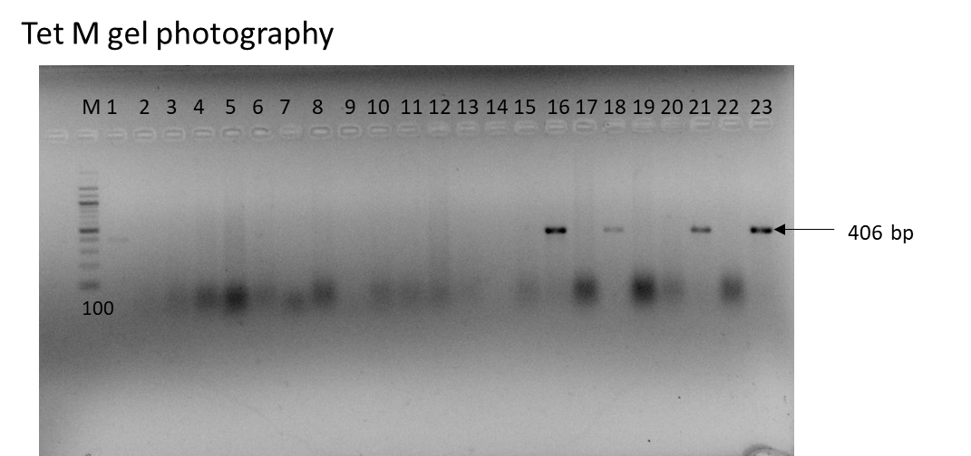
The gel shows tetM gene amplicons (406bp), depicting tetracycline resistance genes among Staphylococcus isolates. M- 1Kb DNA ladder; 2- Negative control; 23 - Positive control; Test samples: 1,16, 18,21 are positive, 3-15, 17, 19,20 and 22 are negative samples.

Picture 2. Agarose gel showing PCR amplicons of tetK gene of Staphylococci
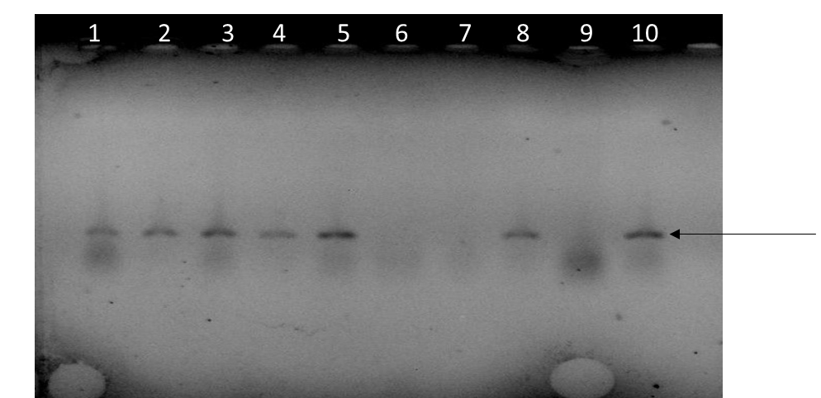
155bp
The gel shows tetK gene amplicons (155bp), depicting tetracycline resistance genes among Staphylococcus isolates. 6 - Negative control; 10 - Positive control; Test samples:1-5 are positive, 7 and 9 are negative samples.

