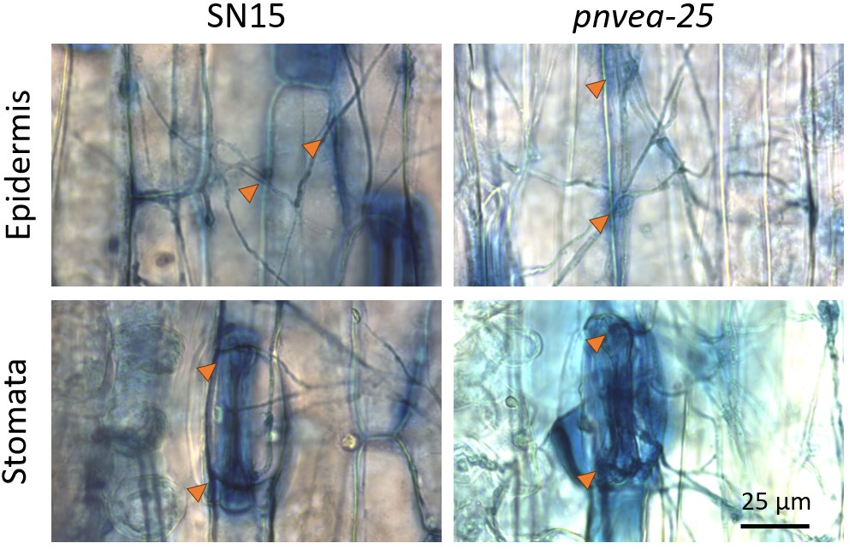
Additional file 3 Trypan blue staining of P. nodorum strains infecting wheat (cv. Axe) 10 days after inoculation shows that the wildtype (SN15) and a mutant with a deletion of PnVeA (pnvea-25) can both attempt to penetrate the wheat leaf. Orange arrows indicate the locations of attempted penetration (dark blue halos) in either the epidermis (first row) or stomata (second row) of the wheat leaves.

