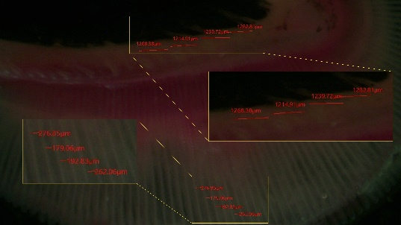  Striped catfish | 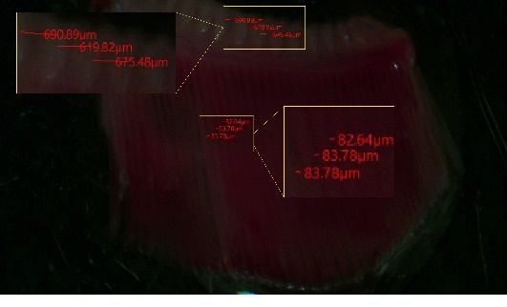  Silver barb | 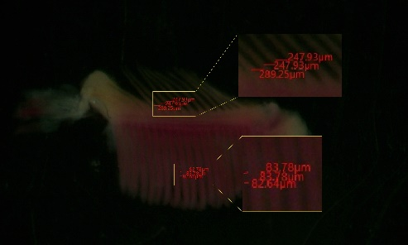  Stinging catfish
racker gap: 1245.81±19.8  filament gap:216.24 ±30.56 | racker gap: 663.06±21.91  filament gap:83.4±0.38 | racker gap: 261.70±13.77  filament gap:83.4±0.38
S1: Microscopy of gills of the three freshwater species after 90 days of rearing in different treatments (T1-only feed, T2-feed+ floc, T3-only floc) with measured inter-racker and inter-filament gaps (µm)

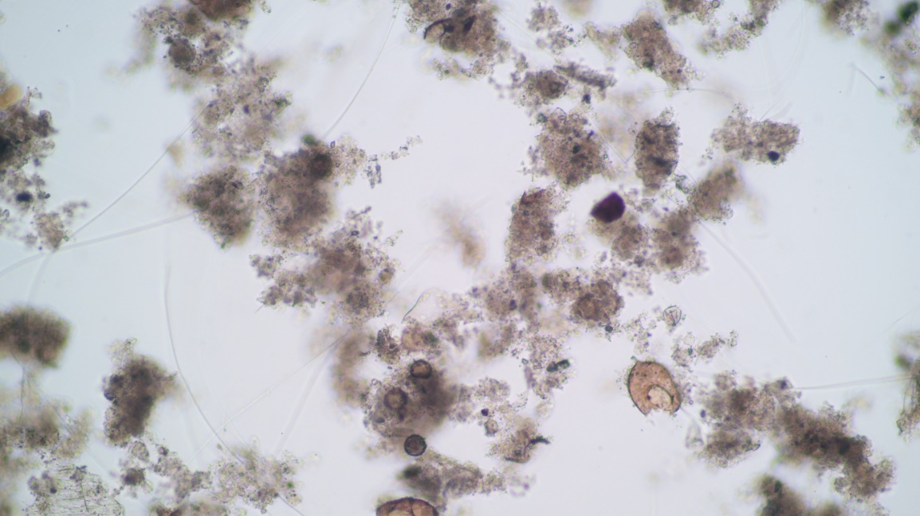
S2: Microscopic picture of biofloc

