1 Supplementary Figures
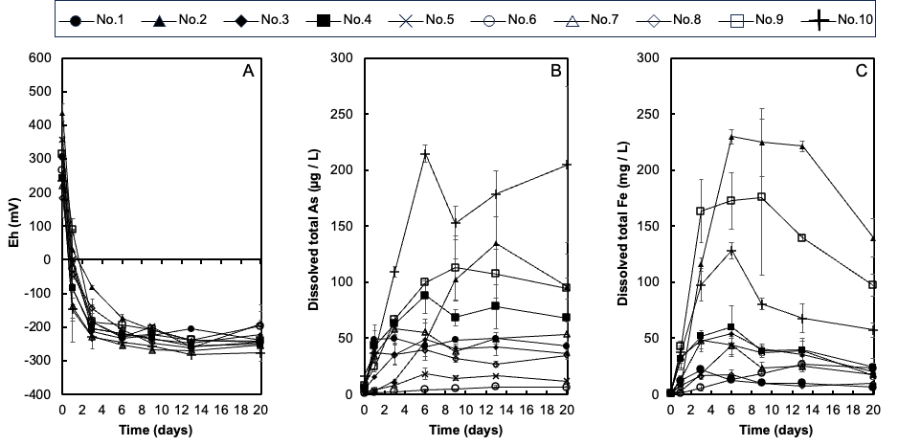
Supplementary Figure 1. Changes in redox potential (Eh) (A), dissolved As (B) and dissolved Fe (C) in the soil solutions of ten soils. Each concentration and Eh value shown is the mean (n = 3) with the standard deviation.

Supplementary Figure 2. Histogram of the frequency of ttrA length (bp) assembled by gene-targeted assembly. The white bars and the solid line denote the frequency of ttrA length (bp) and the sum of RPM, respectively.
Supplementary Figure 3. Taxonomic composition of the transcripts of the respiratory As(V) reductase gene ttrA at the phylum level. The small letters (a~c) denote the replicates of each sample.

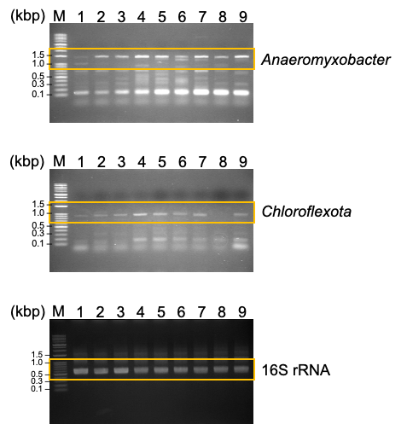
Supplementary Figure 4. Transcriptional analysis of ttrA expressed during incubation of soil no. 10. The numbers 1-3, 4-6, and 7-9 denote the triplicate samples at 3 d, 9 d and 20 d, respectively. M indicates the DNA ladder marker. The orange enclosures indicate the target amplicon sizes of each gene.

2 Supplementary Tables
Table S1. Soil physicochemical parameters
No. | Soil Type |  |  | mS/cm | g/kg |  | cmol(+)/kg | g/kg |  |  | mg/kg
No. | USDA soil taxonomy | CSCSJ | pH | EC | Total C | Total N | CEC | Al_{o} | Fe_{o} | Si_{o} | P | Mn | As
1 | Entisols, Inceptisols | Fine-textured Haplic Gray Lowland soil | 6.34 | 0.13 | 19.4 | 1.91 | 14.0 | 2.56 | 3.88 | 0.38 | 277 | 67.3 | 1.40
2 | Entisols, Inceptisols | Fine-textured Gley Lowland soil | 5.39 | 0.07 | 29.3 | 2.74 | 22.5 | 1.99 | 17.5 | 0.42 | 7.34 | 532 | 3.86
3 | Entisols, Inceptisols | Fine-textured Mottled Gley Lowland soils | 5.54 | 0.03 | 14.1 | 1.17 | 9.58 | 2.40 | 5.01 | 0.30 | 128 | 409 | 2.10
4 | Entisols, Inceptisols | Fine-textured Gray Lowland soils | 5.59 | 0.12 | 15.9 | 1.48 | 11.1 | 1.18 | 5.53 | 0.25 | 116 | 97.6 | 2.89
5 | Entisols, Ultisols, Inceptisols | Reformed soils | 6.26 | 0.06 | 12.4 | 1.15 | 17.5 | 4.07 | 9.06 | 1.17 | 115 | 60.0 | 0.59
6 | Andisols | High-humic Andosols | 6.22 | 0.09 | 77.8 | 5.85 | 36.3 | 51.1 | 21.0 | 19.6 | 46.6 | 14.6 | 0.65
7 | Entisols, Inceptisols | Medium-textured Mottled Gley Lowland soils | 6.41 | 0.04 | 16.4 | 1.33 | 9.89 | 1.05 | 7.03 | 0.18 | 125 | 83.4 | 1.63
8 | Entisols, Inceptisols | Coarse-medium-textured Gray Lowland soil | 5.38 | 0.08 | 15.2 | 1.53 | 8.14 | 1.88 | 1.74 | 0.27 | 78.3 | 49.5 | 2.60
9 | Entisols, Inceptisols | Humic Gley Lowland soil | 5.04 | 0.19 | 56.6 | 4.43 | 25.3 | 5.82 | 21.0 | 0.63 | 122 | 448 | 6.44
10 | Entisols, Inceptisols | Fine-textured Gray Lowland soil | 5.8 | 0.35 | 18.0 | 1.79 | 23.2 | 1.44 | 10.1 | 0.55 | 53.9 | 1502 | 20.0
CSCSJ: Comprehensive soil classification system of Japan (Obara et al. 2011)
Al_{o}: oxalate-extractable Al; Fe_{o}: oxalate-extractable Fe; Si_{o}: oxalate-extractable Si.
P: available P (Truog 1930), Mn: ammonium acetate-extractable Mn, As: 1 m HCl-extractable As

Table S2. Amino acid sequences used for the construction of the reference gene database of ttrA
Accession no. | Microorganisms
WP_059435911.1 | Anaeromyxobacter sp. PSR-1
WP_242394125.1 | Anaeromyxobacter sp. SG63
MBI1920608.1 | Geobacter sp.
MBI5068328.1 | Deltaproteobacteria bacterium
WP_217288014.1 | Geomonas subterranea
WP_224957755.1 | Geomonas fuzhouensis
OGU10529.1 | Geobacteraceae bacterium GWC2_58_44
WP_088534015.1 | Geobacter sp. DSM 9736
OGT97375.1 | Geobacteraceae bacterium GWB2_52_12
MCM2276937.1 | Oligoflexia bacterium
WP_011937417.1 | Geotalea uraniireducens
WP_012646441.1 | Geotalea daltonii
WP_015723985.1 | Desulfobulbus propionicus
WP_246559276.1 | Citrifermentans pelophilum
MBT0664282.1 | Citrifermentans pelophilum
WP_041969781.1 | Geobacter sp. OR-1
NVO00414.1 | Geobacteraceae bacterium
MCM2264772.1 | Desulfuromonadales bacterium
MBK8571958.1 | Holophagaceae bacterium
MBI3131795.1 | Acidobacteria bacterium
NTW84983.1 | Holophagaceae bacterium
WP_246525152.1 | Geobacter luticola
MBT0652424.1 | Geobacter luticola
KAB2888530.1 | Desulfobulbaceae bacterium

Table S3. PCR primers used in this study.
Primer | Sequence  (5’ → 3’) | Expected size (bp) | Reference
Specific primers used in RT‒PCR
Anaero_ ttrA_697F | AAGAACAACCAGTTCGTCTAC | 1479 | This study
Anaero_ ttrA_2176R | TTCACCGGCATGTTCGGGTG | 1479 | This study
Chloroflexota_ttrA_82F | CAGGGTGAGCTCTTCGTCAC | 925 | This study
Chloroflexota_ttrA_1007R | CCTGCTTCAGGTACAGGTGC | 925 | This study
27F | AGAGTTTGATCCTGGCTCAG | 527 | Lane 1991
519R | GWATTACCGCGGCKGCTG | 527 | Lane 1991
Specific primers used in RT‒qPCR
ttrA_qPCR_soil_10_F | GGGCTACCCGKCGAAGCG | 274 | This study
ttrA_qPCR_soil_10_R | CTCCCAGCGCTCGAGGTAG | 274 | This study
arrA-CVF1 | CACAGCGCCATCTGCGCCGA | 330 | Mirza et al. 2017
arrA_CVR1 | CCGACGAACTCCYTGYTCCA | 330 | Mirza et al. 2017
arsMF1 | TCYCTCGGCTGCGGCAAYCCVAC | 232 | Jia et al. 2013
arsMR1 | AGGTTGATGACRCAGTTWGAGAT | 232 | Jia et al. 2013

Table S4. Summary of the metatranscriptome.
Incubation days | Soil no. | Replicate | Clean reads | Raw data
 |  |  |  | (Gb)
3 | 4 | a | 200124032 | 30.4
3 | 4 | b | 178336630 | 27.1
3 | 4 | c | 173653920 | 26.3
3 | 6 | a | 219865876 | 34
3 | 6 | b | 214841430 | 32.7
3 | 6 | c | 185488734 | 28.3
3 | 10 | a | 187010254 | 28.4
3 | 10 | b | 170931570 | 26
3 | 10 | c | 172419584 | 26.2
9 | 4 | a | 188465488 | 28.8
9 | 4 | b | 192928058 | 29.3
9 | 4 | c | 233556060 | 35.5
9 | 6 | a | 185100228 | 28.5
9 | 6 | b | 188580804 | 28.8
9 | 6 | c | 181661696 | 27.7
9 | 10 | a | 196809272 | 30
9 | 10 | b | 182933218 | 27.8
9 | 10 | c | 203891790 | 31

3 References
- Obara H, Ohkura T, Takata Y, Kohyama K, Maejima Y, Hamazaki T. Comprehensive soil classification system of Japan first approximation. Bull. Natl. Inst. Agro-Environ. Sci., 2011;29: 1–73. (in Japanese)
- Truog E. The determination of the readily available phosphorus of soils. J. Am. Soc. Agron. 1930;22, 874-882
- Lane DJ. 16S/23S rRNA sequencing. In: Nucleic acid techniques in bacterial systematics. Stackebrandt, E., and Goodfellow, M., eds., John Wiley and Sons, New York, NY, 1991;pp. 115-175.
- Mirza BS, Sorensen DL, Dupont RR, McLean JE. New arsenate reductase gene (arrA) PCR primers for diversity assessment and quantification in environmental samples. Appl Envrion Microbiol. 2017;83(4): e02725-16; doi: 10.1128/AEM.02725-16.
- Jia Y, Huang H, Zhong M, Wang F-H, Zhang L-M, Zhu Y-G. Microbial arsenic methylation in soil and rice rhizosphere. Environ Sci Technol. 2013;47(7):3141-48; doi: 10.1021/es303649v.

