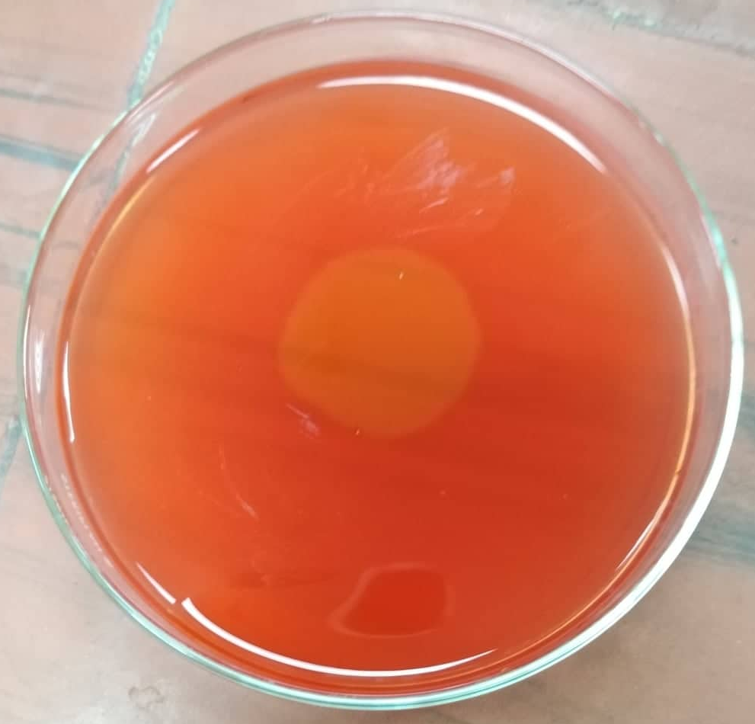

Fig. S1 Qualitative screening of the bacterial isolate MA1 showing a clear zone on CMC-agar plate

