Supplement materials
Nasal, dermal, oral and indoor dust microbe and their interrelationship in children with allergic rhinitis

Table S1 Demographic characteristics, living habits, indoor and outdoor environment in AR and healthy children (complement)
Table S2. Relative abundance of microbial taxa in nasal, dermal, oral and dust samples in the total subjects
Table S3. Statistical P-values for comparing the transfer proportions between any two types of samples (nasal, dermal, oral, and dust samples) in the total subjects and in AR and control groups, respectively.
Table S4. Comparisons of bacterial transfer proportions (%) in each sample type (sink) attributed to other sampling sites (source) between AR and control groups for those differentially abundant species (the relative abundance>0.004) by FEAST method
Table S5. Statistical P-values for comparing the mutual transfer proportions (%) in 6 pairs of sample types (nasal, dermal, oral, and dust samples) for those differentially abundant species (the relative abundance>0.004) in the total subjects
Table S6. Statistical P-values for comparing the mutual transfer proportions (%) in 6 pairs of sample types (nasal, dermal, oral, and dust samples) for those differentially abundant species (the relative abundance>0.004) in AR subjects
Table S7. Statistical P-values for comparing the mutual transfer proportions (%) in 6 pairs of sample types (nasal, dermal, oral, and dust samples) for those differentially abundant species (the relative abundance>0.004) in the control group
Figure S1 Top 10 microbial taxa in relative abundance at phylum, genus, and species levels in dust, skin, nasal, and oral, respectively
Figure S2. Differences of dust microbial VFs(A) and ARGs(B) between AR children and healthy children.
Figure S3. Proportions of all bacterial species in a certain sample site (sink) originated from other sampling sites (source) by FEAST analysis in all subjects
Figure S4. Proportions of all bacteria species in a certain sample type (sink) originated from other sampling sites (source) by FEAST analysis in AR and healthy children, respectively

Table S1. Demographic characteristics, living habits, indoor and outdoor environment in AR and healthy children
Categories | Variables, n (%) | Total (n=113) | AR (n=62) | Controls (n=51) | P | FDR adjusted P
Self-reported family income levels | Family income level-low | 12 (10.6) | 6 (9.7) | 6 (11.8) | 0.727 | 0.969
Self-reported family income levels | Family income level-median | 88 (77.9) | 50 (80.6) | 38 (74.5) | 0.727 | 0.969
Self-reported family income levels | Family income level-high | 13 (11.5) | 6 (9.7) | 7 (13.7) | 0.727 | 0.969
Housing and children’s bedroom | Multi-family apartment housing | 100 (88.5) | 58 (93.5) | 42 (82.3) | 0.140 | 0.560
Housing and children’s bedroom | Home buildings constructed before 2010 | 89 (78.8) | 53 (85.5) | 36 (70.6) | 0.097 | 0.560
Housing and children’s bedroom | Solid wood floor in children’s bedrooms | 74 (65.5) | 42 (67.7) | 32 (62.7) | 0.694 | 0.969
Housing and children’s bedroom | Carpet in bedroom | 14 (12.4) | 10 (16.1) | 4 (7.8) | 0.292 | 0.818
Housing and children’s bedroom | Wall-paper in children’s bedrooms | 94 (83.2) | 52 (83.9) | 42 (82.4) | 0.970 | 1.000
FDR adjusted: false detection rate adjusted

Table S2. Relative abundance of microbial taxa in nasal, dermal, oral and dust samples in the total subjects

Samples | Taxa | Nr. | Relative abundance of microbial taxa at phyla, genera and species levels | Sum %
Nasal | Phyla | 15 | Proteobacteria (49.2%), Firmicutes (44.4%), Actinobacteria (5.2%), Bacteroidetes (0.65%) | 94.3
Nasal | Genera | 297 | Burkholderia (29.3%), Moraxella (15.8%), Staphylococcus (11.4%), Corynebacterium (4.5%). | 61.0
Nasal | Species | 432 | Staphylococcus aureus (11.8%), Streptococcus pneumoniae (3.2%), Staphylococcus epidermidis (2.9%), Moraxella catarrhalis (1.1%) | 19.0
Skin | Phyla | 81 | Firmicutes(50.3%), Proteobacteria (34.7%), Actinobacteria (6.1%), Bacteroidetes (4.9%) | 96.0
Skin | Genera | 566 | Staphylococcus(25.4%), Mesorhizobium (14.5%), Streptococcus (12.3%), Neisseria (3.1%) | 55.3
Skin | Species | 1023 | Staphylococcus epidermidis(23.8%), Mesorhizobium sp. NBIMC_P2 (14.5%), Streptococcus sanguinis (5.7%), Neisseria mucosa (3.1%) | 47.1
Oral | Phyla | 13 | Proteobacteria(63.0%), Firmicutes (27.9%), Actinobacteria (5.2%), Bacteroidetes (2.3%) | 98.4
Oral | Genera | 227 | Burkholderia(56.5%), Streptococcus (17.6%), Rothia (3.6%), Enterococcus (2.4%) | 80.1
Oral | Species | 342 | Streptococcus thermophilus(4.1%), Streptococcus pneumoniae acnes (2.5%), Haemophilus parainfluenzae (1.5%), Abiotrophia defectiva (0.7%) | 8.8
Dust | Phyla | 30 | Actinobacteria(41.2%), Proteobacteria (29.0%), Firmicutes (24.1%), Bacteroidetes (3.3%) | 97.6
Dust | Genera | 1251 | Staphylococcus(13.3%), Corynebacterium (11.4%), Cutibacterium (5.4%), Streptococcus (4.5%) | 34.6
Dust | Species | 6247 | Staphylococcus aureus(5.2%), Cutibacterium acnes (3.8%), Micrococcus luteus (2.6%), Staphylococcus epidermidis (1.9%) | 13.5

Table S3. Statistical P-values for comparing the transfer proportions between any two types of samples (nasal, dermal, oral, and dust samples) in the total subjects, AR, and control group, respectively
Comparison pairs of transfer routes | All children | AR Children | Healthy children
From dust to skin vs. from skin to dust | 0.004 | 0.195 | 0.002
From dust to oral vs. from oral to dust | 0.001 | 0.001 | 0.009
From nasal to dust vs. from dust to nasal | 0.996 | 0.650 | 0.668
From nasal to skin vs. from skin to nasal | 0.001 | 0.001 | 0.024
From nasal to oral vs. from oral to nasal | 0.001 | 0.001 | 0.001
From oral to skin vs. from skin to oral | 0.236 | 0.105 | 0.890
P-values<0.05 reached statistical significance.
All bold texts indicate the transfer proportions between two samples sites reached statistically significant.

Table S4. Comparisons of bacterial transfer proportions (%) in each sample type (sink) attributed to other sampling sites (source) between AR and control groups for those differentially abundant species (the relative abundance>0.004) by FEAST method
Microbial species | Sink | Nasal |  |  | Skin |  |  | Oral |  |  | Dust
Microbial species | Source | Skin | Oral | Dust | Nasal | Oral | Dust | Nasal | Skin | Dust | Nasal | Skin | Oral
Staphylococcus aureus | AR | 0.0115 | 0.0011 | 5.9068 | 6.8411 | 0.0010 | 4.9552 | 6.4504 | 0.0113 | 4.9921 | 9.4259 | 0.8700 | 0.0010
 | Controls | 0.0573 | 0.0010 | 5.3951 | 1.7578 | 0.0010 | 5.1897 | 1.5970 | 0.0016 | 4.8268 | 3.0817 | 0.6148 | 0.0010
 | P | 0.081 | 0.826 | 0.677 | 0.031 | 0.815 | 0.941 | 0.012 | 0.032 | 0.622 | 0.021 | 0.039 | 0.815
Staphylococcus epidermidis | AR | 2.6457 | 0.0007 | 4.3183 | 8.8478 | 0.0010 | 2.5402 | 7.6955 | 2.3361 | 2.3734 | 10.1138 | 4.3511 | 0.0010
 | Controls | 2.5744 | 0.0005 | 3.4104 | 2.7008 | 0.0010 | 1.5905 | 2.3446 | 1.1701 | 1.4670 | 3.8613 | 3.3211 | 0.0010
 | P | 0.009 | 0.919 | 0.001 | 0.011 | 0.870 | 0.003 | 0.004 | 0.001 | 0.001 | 0.002 | 0.019 | 0.856
Micrococcus luteus | AR | 0.0011 | 0.0010 | 3.3037 | 0.0010 | 0.0010 | 3.4670 | 0.0010 | 0.0011 | 3.4634 | 0.0010 | 0.0011 | 0.0010
 | Controls | 0.0016 | 0.0010 | 2.4217 | 0.0010 | 0.0010 | 2.4964 | 0.0010 | 0.0013 | 2.3353 | 0.0010 | 0.0013 | 0.0010
 | P | 0.333 | 1 | 0.004 | 1 | 1 | 0.002 | 1 | 0.485 | 0.001 | 1 | 0.485 | 1
Moraxella osloensis | AR | 0.0106 | 0.0010 | 2.1600 | 0.0007 | 0.0010 | 2.1964 | 0.0007 | 0.0107 | 2.2034 | 0.3850 | 0.7826 | 0.0010
 | Controls | 0.0040 | 0.0010 | 1.2801 | 0.0004 | 0.0010 | 1.2853 | 0.0003 | 0.0032 | 1.2312 | 0.7410 | 0.2768 | 0.0010
 | P | 0.007 | 0.809 | 0.588 | 0.338 | 0.809 | 0.603 | 0.455 | 0.001 | 0.373 | 0.436 | 0.002 | 0.809
Streptococcus sanguinis | AR | 0.0200 | 0.0018 | 0.7220 | 0.0329 | 0.0008 | 0.7334 | 0.0255 | 0.0206 | 0.7327 | 0.5203 | 0.4885 | 0.0012
 | Controls | 0.0308 | 0.0018 | 0.2639 | 0.0161 | 0.0008 | 0.2677 | 0.0141 | 0.0310 | 0.2484 | 0.4354 | 0.2645 | 0.0054
 | P | 0.004 | 0.538 | 0.061 | 0.647 | 0.390 | 0.080 | 0.534 | 0.002 | 0.082 | 0.453 | 0.003 | 0.490
Paracoccus sphaerophysae | AR | 0.0046 | 0.0010 | 1.3840 | 0.0010 | 0.0010 | 1.4467 | 0.0010 | 0.0046 | 1.4528 | 0.0010 | 0.2146 | 0.0010
 | Controls | 0.0161 | 0.0010 | 1.5245 | 0.0010 | 0.0010 | 1.6147 | 0.0010 | 0.0158 | 1.5358 | 0.0183 | 0.0158 | 0.0010
 | P | 0.915 | 0.016 | 0.793 | 0.016 | 0.016 | 0.852 | 0.016 | 0.907 | 0.981 | 0.016 | 0.843 | 0.016
Enhydrobacter sp. H5 | AR | 0.0021 | 0.0010 | 0.9546 | 0.0010 | 0.0010 | 1.0435 | 0.0010 | 0.0022 | 1.0389 | 0.0010 | 0.0022 | 0.0010
 | Controls | 0.0011 | 0.0010 | 1.2558 | 0.0010 | 0.0010 | 1.2935 | 0.0010 | 0.0011 | 1.2472 | 0.0010 | 0.0011 | 0.0010
 | P | 0.007 | 1.000 | 0.051 | 1.000 | 1.000 | 0.255 | 1.000 | 0.004 | 0.433 | 1.000 | 0.004 | 1.000
Rothia mucilaginosa | AR | 0.0002 | 0.0025 | 0.0035 | 0.0008 | 0.0026 | 0.0035 | 0.0010 | 0.0002 | 0.0045 | 0.0018 | 0.0015 | 0.0033
 | Controls | 0.0002 | 0.0014 | 0.0049 | 0.0002 | 0.0016 | 0.0050 | 0.0006 | 0.0002 | 0.0054 | 0.0004 | 0.0002 | 0.0019
 | P | 0.432 | 0.012 | 0.840 | 0.241 | 0.017 | 0.687 | 0.395 | 0.432 | 0.830 | 0.448 | 0.412 | 0.019
Neisseria mucosa | AR | 0.3769 | 0.0010 | 0.2008 | 0.0010 | 0.0010 | 0.2130 | 0.0010 | 0.3817 | 0.2068 | 0.0010 | 0.3819 | 0.0010
 | Controls | 0.2570 | 0.0010 | 0.4350 | 0.0010 | 0.0010 | 0.5290 | 0.0010 | 0.2517 | 0.4480 | 0.0010 | 0.2470 | 0.0010
 | P | 0.090 | 0.200 | 0.461 | 1.000 | 0.200 | 0.526 | 1.000 | 0.024 | 0.663 | 1.000 | 0.045 | 0.200
Acinetobacter pittii | AR | 0.0010 | 0.0010 | 0.4411 | 0.0010 | 0.0010 | 0.4442 | 0.0010 | 0.0010 | 0.4515 | 0.0010 | 0.0010 | 0.0010
 | Controls | 0.0010 | 0.0010 | 0.5497 | 0.0010 | 0.0010 | 0.5523 | 0.0010 | 0.0010 | 0.5350 | 0.0010 | 0.0010 | 0.0010
 | P | 1 | 1 | 0.505 | 1 | 1 | 0.44 | 1 | 1 | 0.701 | 1 | 1 | 1
Solobacterium moorei | AR | 0.0044 | 0.0010 | 0.2395 | 0.0010 | 0.0010 | 0.2485 | 0.0010 | 0.0044 | 0.2493 | 0.0010 | 0.0044 | 0.0010
 | Controls | 0.0015 | 0.0010 | 0.4144 | 0.0010 | 0.0010 | 0.4170 | 0.0010 | 0.0015 | 0.3410 | 0.0010 | 0.0015 | 0.0010
 | P | 0.008 | 1.000 | 0.373 | 1.000 | 1.000 | 0.437 | 1.000 | 0.008 | 0.743 | 1.000 | 0.008 | 1.000
Staphylococcus cohnii | AR | 0.0010 | 0.0010 | 0.5049 | 0.0010 | 0.0010 | 0.5176 | 0.0010 | 0.0010 | 0.5273 | 0.0010 | 0.0010 | 0.0010
 | Controls | 0.0010 | 0.0010 | 0.5561 | 0.0010 | 0.0010 | 0.5683 | 0.0010 | 0.0010 | 0.5552 | 0.0010 | 0.0010 | 0.0010
 | P | 1.000 | 1.000 | 0.648 | 1.000 | 1.000 | 0.605 | 1.000 | 1.000 | 0.920 | 1.000 | 1.000 | 1.000
Cutibacterium acnes | AR | 0.0144 | 0.0010 | 3.5721 | 0.0010 | 0.0010 | 3.6590 | 0.0010 | 0.0153 | 3.6883 | 0.0010 | 0.0153 | 0.0010
 | Controls | 0.0109 | 0.0010 | 2.5371 | 0.0010 | 0.0010 | 2.5770 | 0.0010 | 0.0108 | 2.5249 | 0.0010 | 0.0108 | 0.0010
 | P | 0.022 | 1.000 | 0.002 | 1.000 | 1.000 | 0.002 | 1.000 | 0.057 | 0.001 | 1.000 | 0.057 | 1.000
Moraxella catarrhalis | AR | 0.0010 | 0.0001 | 0.2025 | 0.0010 | 0.0010 | 0.3880 | 1.1123 | 0.0010 | 0.4230 | 1.3180 | 0.0010 | 0.0010
 | Controls | 0.0010 | 0.0029 | 0.5029 | 1.2315 | 0.0001 | 0.2394 | 1.1978 | 0.0010 | 0.2313 | 1.4856 | 0.0010 | 0.0048
 | P | 1.000 | 0.001 | 0.001 | 0.038 | 0.001 | 0.001 | 0.073 | 1.000 | 0.002 | 0.043 | 1.000 | 0.001
Streptococcus mitis | AR | 0.0004 | 0.0010 | 0.0130 | 0.0050 | 0.0010 | 0.0988 | 0.0042 | 0.0004 | 0.0190 | 0.0075 | 0.0146 | 0.0010
 | Controls | 0.0010 | 0.0010 | 0.3763 | 0.0120 | 0.0010 | 0.3797 | 0.0114 | 0.0010 | 0.3762 | 0.0121 | 0.0010 | 0.0010
 | P | 0.054 | 1.000 | 0.096 | 0.041 | 1.000 | 0.026 | 0.036 | 0.054 | 0.263 | 0.066 | 0.054 | 1.000
Moraxella nonliquefaciens | AR | 0.0073 | 0.0009 | 0.0009 | 0.0021 | 0.0009 | 0.0056 | 0.0018 | 0.0067 | 0.0042 | 0.0954 | 0.0976 | 0.0077
 | Controls | 0.0022 | 0.0005 | 0.0008 | 0.0010 | 0.0005 | 0.0088 | 0.0006 | 0.0022 | 0.0081 | 0.0302 | 0.0243 | 0.0005
 | P | 0.536 | 0.026 | 0.759 | 0.718 | 0.032 | 0.870 | 0.474 | 0.382 | 0.861 | 0.588 | 0.099 | 0.022
Actinomyces oris | AR | 0.0010 | 0.0010 | 0.7361 | 0.0010 | 0.0010 | 0.8120 | 0.0010 | 0.0010 | 0.8124 | 0.0010 | 0.0010 | 0.0010
 | Controls | 0.0010 | 0.0010 | 0.4002 | 0.0010 | 0.0010 | 0.4090 | 0.0010 | 0.0010 | 0.4046 | 0.0010 | 0.0010 | 0.0010
 | P | 1.000 | 1.000 | 0.651 | 1.000 | 1.000 | 0.671 | 1.000 | 1.000 | 0.827 | 1.000 | 1.000 | 1.000
FEAST: Fast Expectation-Maximization Source Tracking. Microbial species with the relative abundance >0.004 in the total microbial community and identified as more abundant in either AR or control group by LEfSe were analyzed. The transfer proportions reaching statistical significance between AR and control groups were in underlined bold text and those proportions >1.0% were in red text.
Table S5. Statistical P-values for comparing the mutual transfer proportions (%) in 6 pairs of sample types (nasal, dermal, oral, and dust samples) for those differentially abundant species (the relative abundance>0.004) in the total subjects
 | Skin to Nasal | Oral to Nasal | Dust to Nasal | Oral to Skin | Dust to Skin | Dust to Oral
 | Nasal to Skin | Nasal to Oral | Nasal to Dust | Skin to Oral | Skin to Dust | Oral to Dust
Staphylococcus aureus | 0.001 | 0.001 | 0.081 | 0.001 | 0.001 | 0.001
Staphylococcus epidermidis | 0.361 | 0.001 | 0.110 | 0.001 | 0.002 | 0.001
Micrococcus luteus | 0.001 | 1.000 | 0.001 | 0.001 | 0.001 | 0.001
Moraxella osloensis | 0.001 | 0.001 | 0.001 | 0.001 | 0.001 | 0.001
Streptococcus sanguinis | 0.001 | 0.014 | 0.001 | 0.001 | 0.178 | 0.001
Paracoccus sphaerophysae | 0.001 | 0.004 | 0.001 | 0.001 | 0.001 | 0.001
Enhydrobacter sp. H5 | 0.001 | 1.000 | 0.001 | 0.001 | 0.001 | 0.001
Rothia mucilaginosa | 0.011 | 0.001 | 0.001 | 0.001 | 0.001 | 0.001
Neisseria mucosa | 0.001 | 0.156 | 0.001 | 0.001 | 0.001 | 0.001
Acinetobacter pittii | 1.000 | 1.000 | 0.001 | 1.000 | 0.001 | 0.001
Solobacterium moorei | 0.001 | 1.000 | 0.001 | 0.001 | 0.001 | 0.001
Staphylococcus cohnii | 1.000 | 1.000 | 0.001 | 1.000 | 0.001 | 0.001
Cutibacterium acnes | 0.001 | 1.000 | 0.001 | 0.001 | 0.001 | 0.001
Moraxella catarrhalis | 0.001 | 0.001 | 0.014 | 0.001 | 0.001 | 0.001
Streptococcus mitis | 0.001 | 0.001 | 0.001 | 0.004 | 0.001 | 0.001
Moraxella nonliquefaciens | 0.004 | 0.025 | 0.002 | 0.001 | 0.006 | 0.001
Actinomyces oris | 1.000 | 1.000 | 0.001 | 1.000 | 0.001 | 0.001
Microbial species with the relative abundance >0.004 in the total microbial community and identified as more abundant in either AR or control group by LEfSe were analyzed. Fast Expectation-Maximization Source Tracking was applied to calculate the transfer proportions.

Table S6. Statistical P-values for comparing the mutual transfer proportions (%) in 6 pairs of sample types (nasal, dermal, oral, and dust samples) for those differentially abundant species (the relative abundance>0.004) in AR subjects
 | Skin to Nasal | Oral to Nasal | Dust to Nasal | Oral to Skin | Dust to Skin | Dust to Oral
 | Nasal to Skin | Nasal to Oral | Nasal to Dust | Skin to Oral | Skin to Dust | Oral to Dust
Staphylococcus aureus | 0.001 | 0.001 | 0.001 | 0.001 | 0.001 | 0.001
Staphylococcus epidermidis | 0.005 | 0.001 | 0.001 | 0.001 | 0.008 | 0.001
Micrococcus luteus | 0.001 | 1.000 | 1.000 | 0.001 | 0.001 | 0.001
Moraxella osloensis | 0.001 | 0.001 | 0.001 | 0.001 | 0.001 | 0.001
Streptococcus sanguinis | 0.001 | 0.015 | 0.010 | 0.001 | 0.267 | 0.001
Paracoccus sphaerophysae | 0.001 | 0.081 | 0.081 | 0.001 | 0.001 | 0.001
Enhydrobacter sp. H5 | 0.001 | 1.000 | 1.000 | 0.001 | 0.001 | 0.001
Rothia mucilaginosa | 0.323 | 0.001 | 0.001 | 0.001 | 0.001 | 0.015
Neisseria mucosa | 0.001 | 0.156 | 0.156 | 0.001 | 0.007 | 0.001
Acinetobacter pittii | 1.000 | 1.000 | 1.000 | 1.000 | 0.001 | 0.001
Solobacterium moorei | 0.001 | 1.000 | 1.000 | 0.001 | 0.001 | 0.001
Staphylococcus cohnii | 1.000 | 1.000 | 1.000 | 1.000 | 0.001 | 0.001
Cutibacterium acnes | 0.001 | 1.000 | 1.000 | 0.001 | 0.001 | 0.001
Moraxella catarrhalis | 0.001 | 0.001 | 0.001 | 0.007 | 0.001 | 0.001
Streptococcus mitis | 0.001 | 0.001 | 0.001 | 0.007 | 0.001 | 0.001
Moraxella nonliquefaciens | 0.022 | 0.294 | 0.163 | 0.001 | 0.079 | 0.001
Actinomyces oris | 1.000 | 1.000 | 1.000 | 1.000 | 0.001 | 0.001
Microbial species with the relative abundance >0.004 in the total microbial community and identified as more abundant in either AR or control group by LEfSe were analyzed. Fast Expectation-Maximization Source Tracking was applied to calculate the transfer proportions.

Table S7. Statistical P-values for comparing the mutual transfer proportions (%) in 6 pairs of sample types (nasal, dermal, oral, and dust samples) for those differentially abundant species (the relative abundance>0.004) in the control group
 | Skin to Nasal | Oral to Nasal | Dust to Nasal | Oral to Skin | Dust to Skin | Dust to Oral
 | Nasal to Skin | Nasal to Oral | Nasal to Dust | Skin to Oral | Skin to Dust | Oral to Dust
Staphylococcus aureus | 0.001 | 0.001 | 0.016 | 0.085 | 0.001 | 0.001
Staphylococcus epidermidis | 0.721 | 0.001 | 0.015 | 0.001 | 0.003 | 0.001
Micrococcus luteus | 0.001 | 1.000 | 0.001 | 0.001 | 0.001 | 0.001
Moraxella osloensis | 0.034 | 0.001 | 0.001 | 0.001 | 0.001 | 0.001
Streptococcus sanguinis | 0.260 | 0.308 | 0.027 | 0.003 | 0.378 | 0.009
Paracoccus sphaerophysae | 0.001 | 0.017 | 0.001 | 0.078 | 0.001 | 0.001
Enhydrobacter sp. H5 | 0.001 | 1.000 | 0.001 | 0.001 | 0.001 | 0.001
Rothia mucilaginosa | 0.010 | 0.001 | 0.001 | 0.001 | 0.001 | 0.002
Neisseria mucosa | 0.001 | 1.000 | 0.001 | 0.001 | 0.001 | 0.001
Acinetobacter pittii | 1.000 | 1.000 | 0.001 | 1.000 | 0.001 | 0.001
Solobacterium moorei | 0.001 | 1.000 | 0.001 | 0.001 | 0.001 | 0.001
Staphylococcus cohnii | 1.000 | 1.000 | 0.001 | 1.000 | 0.001 | 0.001
Cutibacterium acnes | 0.001 | 1.000 | 0.001 | 0.001 | 0.001 | 0.001
Moraxella catarrhalis | 0.001 | 0.001 | 0.442 | 0.001 | 0.001 | 0.001
Streptococcus mitis | 0.001 | 0.001 | 0.001 | 0.317 | 0.001 | 0.001
Moraxella nonliquefaciens | 0.068 | 0.019 | 0.015 | 0.001 | 0.034 | 0.001
Actinomyces oris | 1.000 | 1.000 | 0.001 | 1.000 | 0.001 | 0.001
Microbial species with the relative abundance >0.004 in the total microbial community and identified as more abundant in either AR or control group by LEfSe were analyzed. Fast Expectation-Maximization Source Tracking was applied to calculate the transfer proportions.

Figure S1 Top 10 microbial taxa in relative abundance at phylum, genus, and species levels in dust, skin, nasal, and oral, respectively
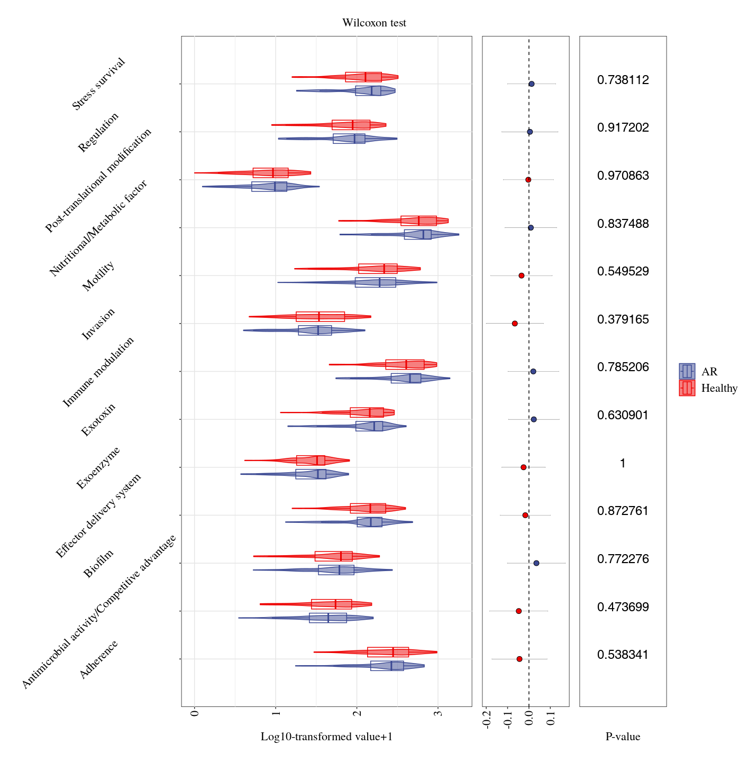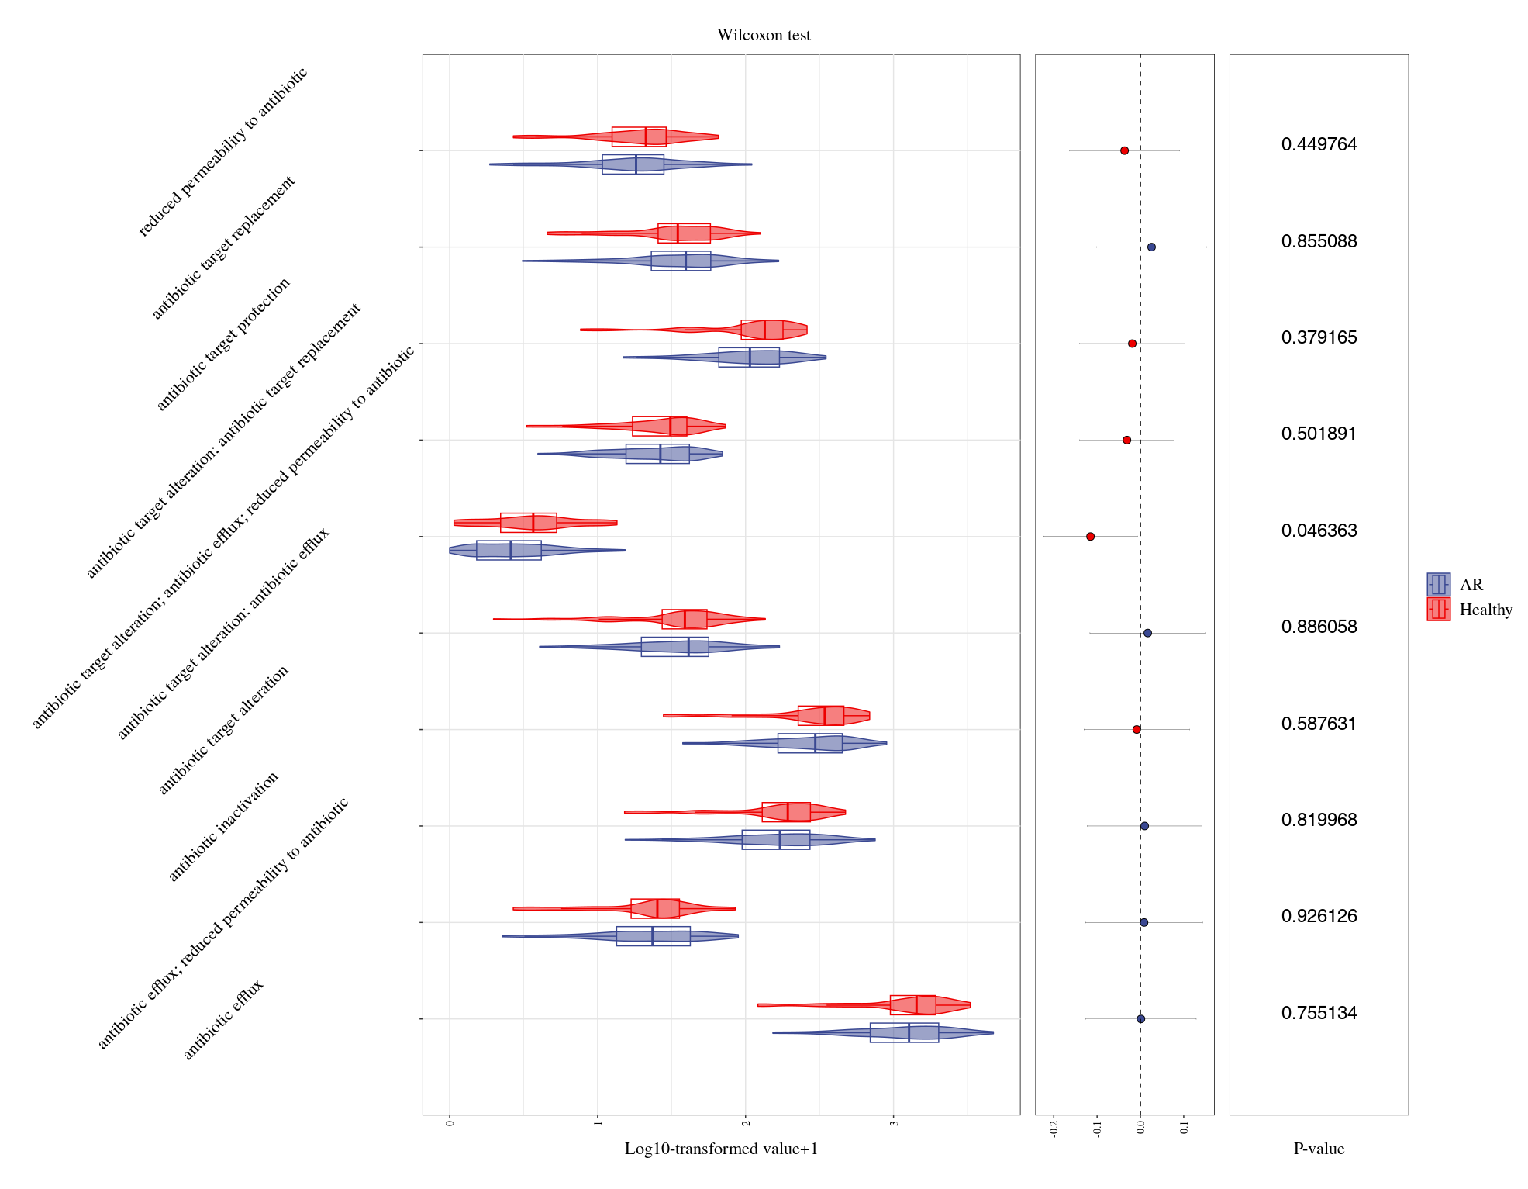
B
A
Figure S2. Differences of dust microbial VFs(A) and ARGs(B) between AR children and healthy children.

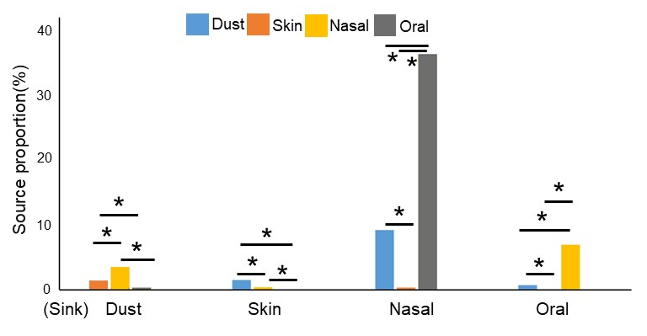
Figure S3. Proportions of all bacterial species in a certain sample site (sink) originated from other sampling sites (source) by FEAST analysis in all subjects

Blue: the dust source, orange: the skin source, yellow: the nasal source, gray: the oral source. * The transfer proportions were significantly different between pairs of sample types (P<0.05).

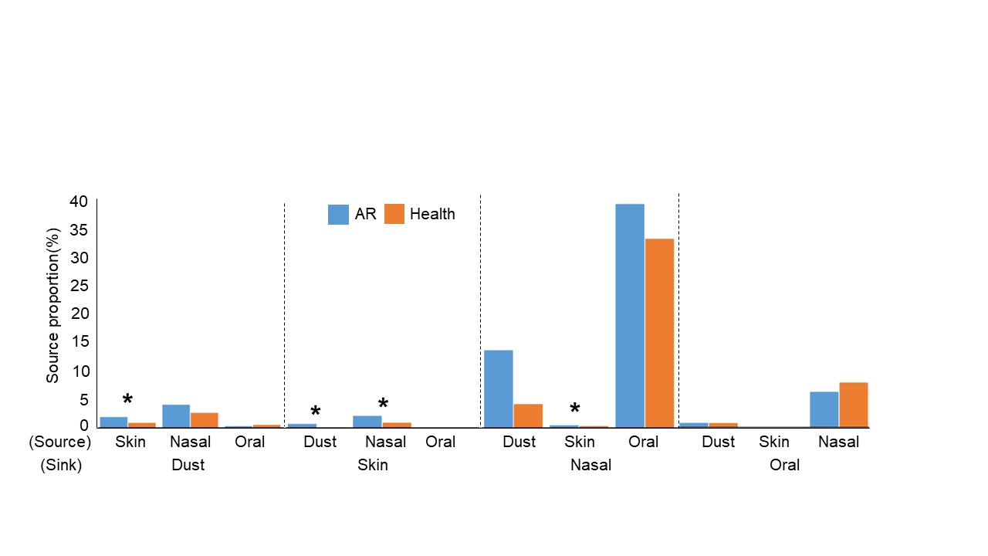
Figure S4. Proportions of all bacteria species in a certain sample type (sink) originated from other sampling sites (source) by FEAST analysis in AR and healthy children, respectively
Blue: the AR group; orange: the healthy group.
*The transfer proportions were significantly different between AR group and the healthy group (P<0.05).

