Supplementary figures and their legends
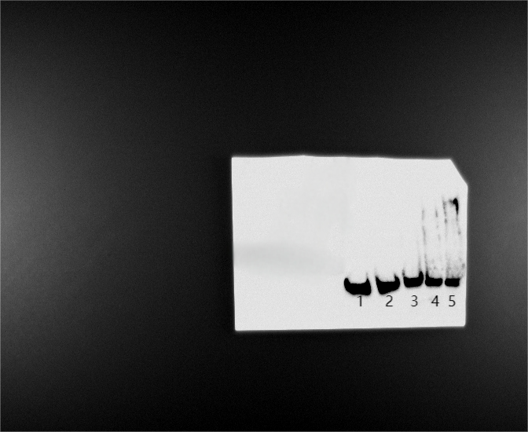
Supplementary figure S1 The original EMSA picture of YbdO binding to the kpsM promoter. From lane 1 to lane 5: the concentrations of YbdO were 8, 0, 2, 4 and 8 µM, respectively; the amount of Biotin-labeled probes in all lanes was 100 fmol. In lane 1, besides the labeled probes, 1 pmol of unlabeled probe was added as the competitive control (Ctrl).
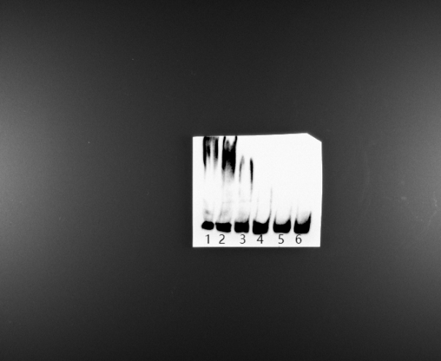
Supplementary figure S2 The original EMSA picture of YbdO binding to the fepG promoter. From lane 1 to lane 6: the concentrations of YbdO were 16, 8, 4, 2, 0 and 8 µM, respectively; the amount of Biotin-labeled probes in all lanes was 100 fmol. In lane 6, besides the labeled probes, 1 pmol of unlabeled probe was added as the competitive control (Ctrl).
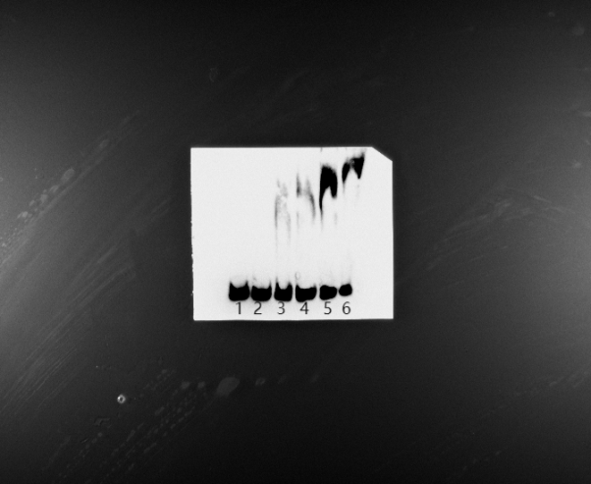
Supplementary figure S3 The original EMSA picture of YbdO binding to the ycgV promoter. From lane 1 to lane 6: the concentrations of YbdO were 8, 0, 2, 4, 8 and 16 µM, respectively; the amount of Biotin-labeled probes in all lanes was 100 fmol. In lane 1, besides the labeled probes, 1 pmol of unlabeled probe was added as the competitive control (Ctrl).
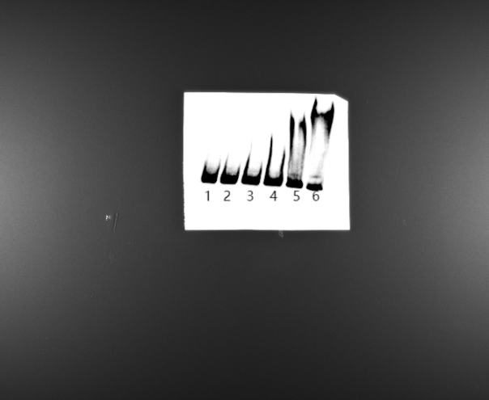
Supplementary figure S4 The original EMSA picture of YbdO binding to the sodA promoter. From lane 1 to lane 6: the concentrations of YbdO were 16, 8, 0, 2, 4 and 8 µM, respectively; the amount of Biotin-labeled probes in all lanes was 100 fmol. In lane 1 and lane 2, besides the labeled probes, 1 pmol of unlabeled probe was added as the competitive control (Ctrl).
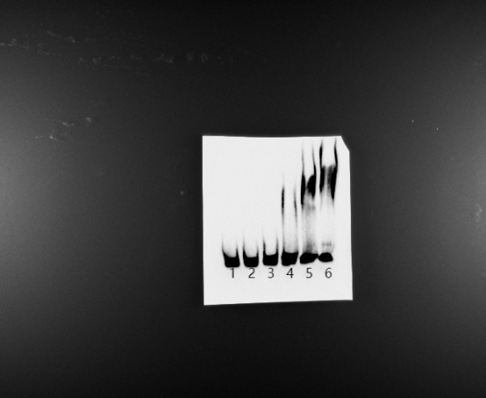
Supplementary figure S5 The original EMSA picture of YbdO binding to the soxR promoter. From lane 1 to lane 6: the concentrations of YbdO were 16, 8, 0, 2, 4 and 8 µM, respectively; the amount of Biotin-labeled probes in all lanes was 100 fmol. In lane 1 and lane 2, besides the labeled probes, 1 pmol of unlabeled probe was added as the competitive control (Ctrl).
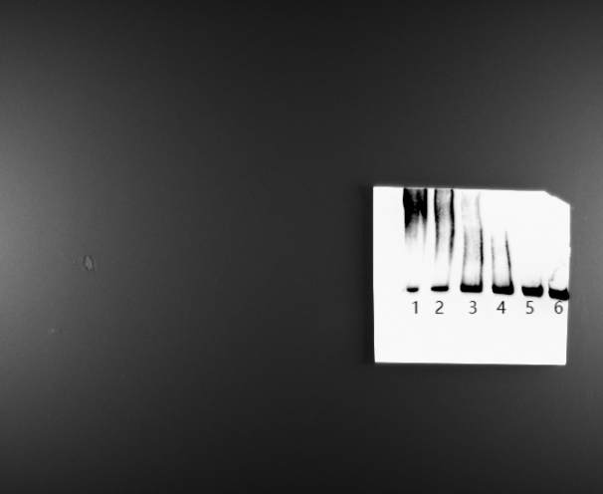
Supplementary figure S6 The original EMSA picture of YbdO binding to the ahpC promoter. From lane 1 to lane 6: the concentrations of YbdO were 16, 8, 4, 2, 0 and 8 µM, respectively; the amount of Biotin-labeled probes in all lanes was 100 fmol. In lane 6, besides the labeled probes, 1 pmol of unlabeled probe was added as the competitive control (Ctrl).
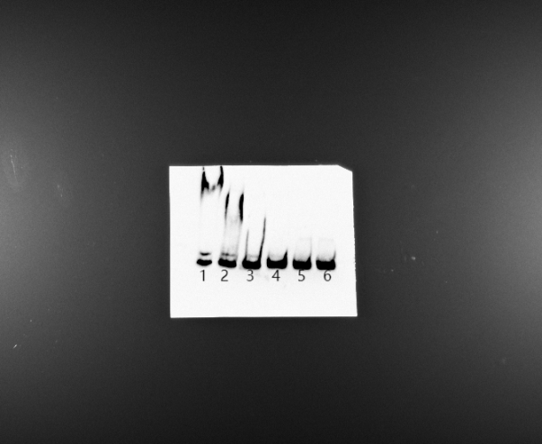
Supplementary figure S7 The original EMSA picture of YbdO binding to the katG promoter. From lane 1 to lane 6: the concentrations of YbdO were 8, 4, 2, 0, 8 and 16 µM, respectively; the amount of Biotin-labeled probes in all lanes was 100 fmol. In lane 5 and lane 6, besides the labeled probes, 1 pmol of unlabeled probe was added as the competitive control (Ctrl).
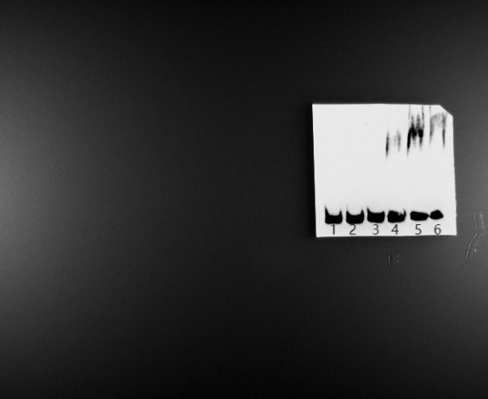
Supplementary figure S8 The original EMSA picture of YbdO binding to the oxyR promoter. From lane 1 to lane 6: the concentrations of YbdO were 16, 8, 0, 2, 4 and 8 µM, respectively; the amount of Biotin-labeled probes in all lanes was 100 fmol. In lane 1 and lane 2, besides the labeled probes, 1 pmol of unlabeled probe was added as the competitive control (Ctrl).
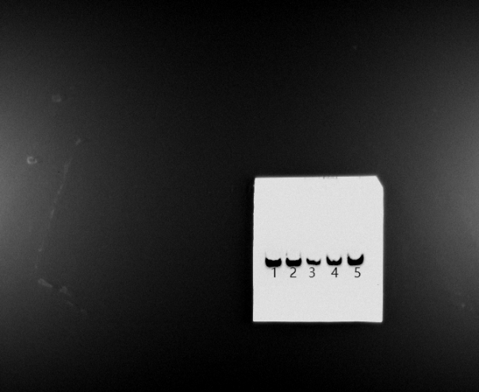
Supplementary figure S9 The original EMSA picture of YbdO binding to the lacZ encoding DNA fragment. From lane 1 to lane 5: the concentrations of YbdO were 8, 0, 2, 4 and 8 µM, respectively; the amount of Biotin-labeled probes in all lanes was 100 fmol. In lane 1, besides the labeled probes, 1 pmol of unlabeled probe was added as the competitive control (Ctrl).

