Teichmann et al., Supplementary data

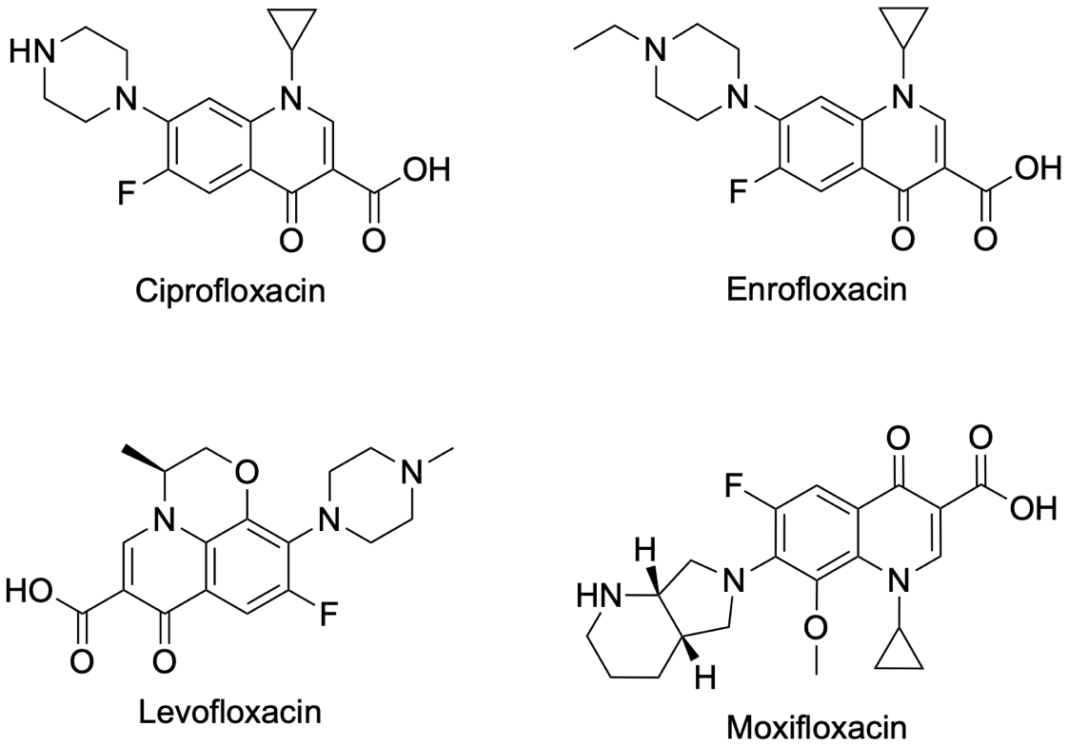
Figure S1 Chemical Structures Fluoroquinolones.
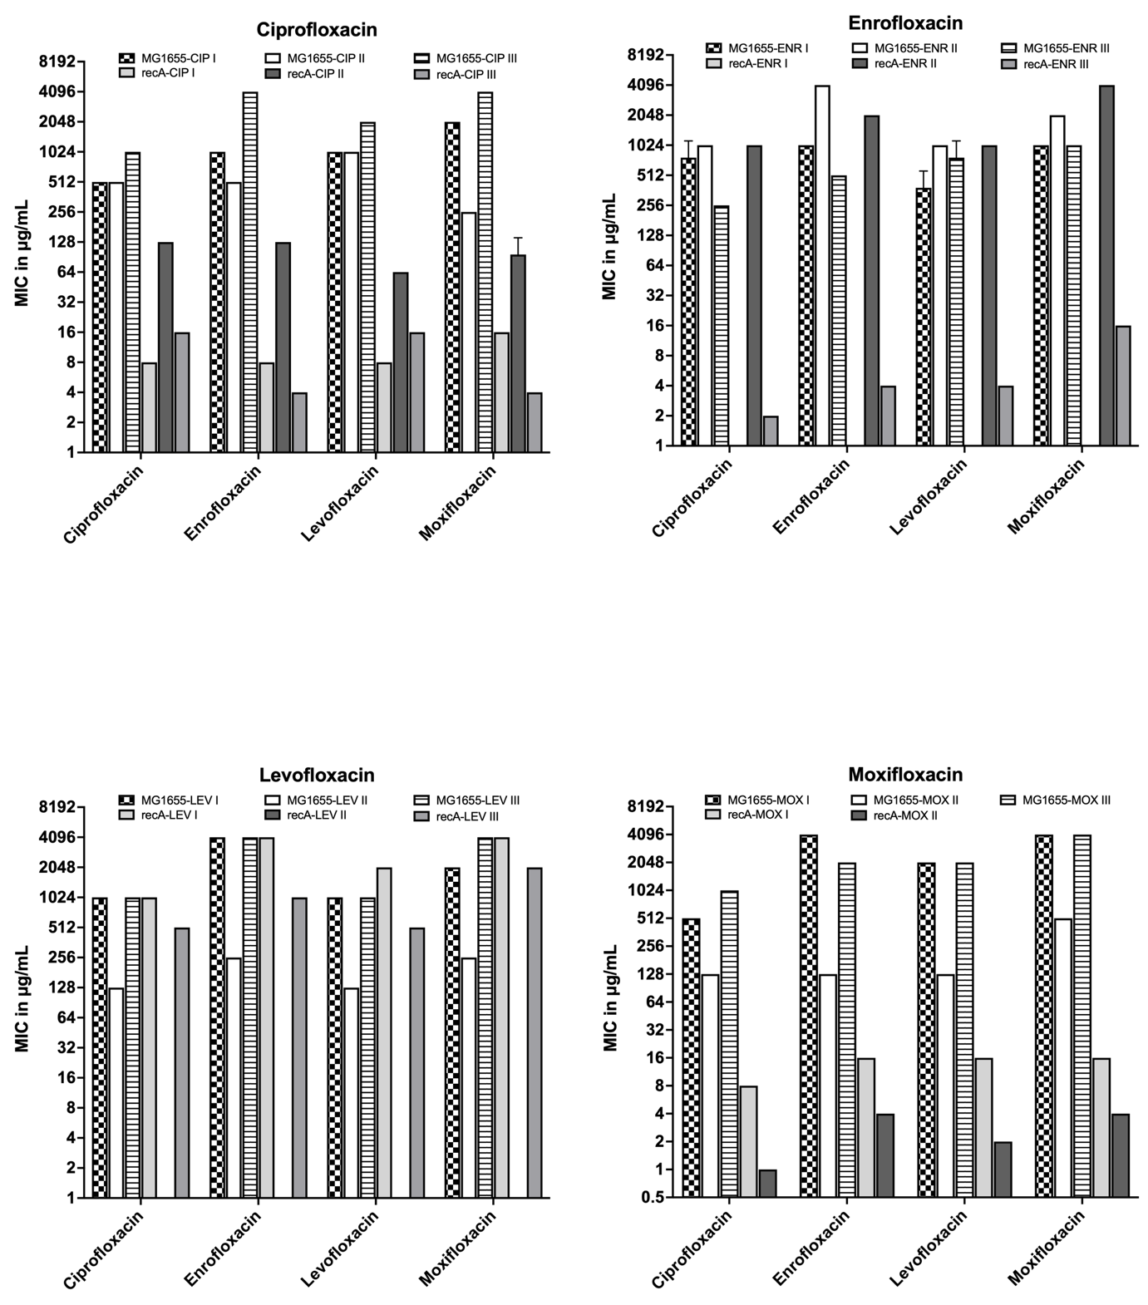
Figure S2 Cross-Resistance of Evolved Strains as indicated by the MIC. For each fluoroquinolone a strain has been made resistant to 6 bars are shown: 2 replicates each of the three other compounds.

Table S1 MIC breakpoints.
Fluoroquinolone | MIC breakpoints [μg/mL]
Fluoroquinolone | S ≤ | R≥
CIP | 0.25 | 0.5
LEV | 0.5 | 1
MOX | 0.25 | 0.25
ENR* | 0.12 | 0.5
ENR** | 0.25 | 2
The table lists the MIC breakpoints for CIP, LEV, and MOX according to the clinical

Table S2 Starting concentrations of the evolution experiments.
Antibiotic | Antibiotic concentration [μg/mL]
Antibiotic | MG1655 | ΔrecA
CIP | 0.015625 | 0.00390625
ENR | 0.03125 | 0.00390625
LEV | 0.03125 | 0.0078125
MOX | 0.0625 | 0.01562
The table compares the starting concentrations for the evolution experiment for each strain and antibiotic. Starting concentrations were ¼ of the initial MIC of the susceptible, non-exposed strain.

Table S3 Concentrations of the antibiotics during the evolution experiments on the MG1655 wildtype. Concentrations of each incubation are given in [μg/mL]
Transfer | CIP |  |  | ENR |  |  | LEV |  |  | MOX
Transfer | Replicate
Transfer | 1 | 2 | 3 | 1 | 2 | 3 | 1 | 2 | 3 | 1 | 2 | 3
1 | 0.01563 | 0.01563 | 0.01563 | 0.03125 | 0.03125 | 0.03125 | 0.03125 | 0.03125 | 0.03125 | 0.0625 | 0.0625 | 0.0625
2 | 0.03125 | 0.03125 | 0.03125 | 0.0625 | 0.0625 | 0.0625 | 0.0625 | 0.0625 | 0.0625 | 0.125 | 0.125 | 0.125
3 | 0.0625 | 0.0625 | 0.0625 | 0.125 | 0.125 | 0.125 | 0.125 | 0.125 | 0.125 | 0.25 | 0.25 | 0.125
4 | 0.125 | 0.125 | 0.125 | 0.25 | 0.25 | 0.25 | 0.25 | 0.25 | 0.25 | 0.5 | 0.5 | 0.25
5 | 0.25 | 0.25 | 0.25 | 0.5 | 0.25 | 0.5 | 0.5 | 0.25 | 0.5 | 1 | 0.5 | 0.5
6 | 0.25 | 0.25 | 0.25 | 1 | 0.5 | 1 | 1 | 0.25 | 1 | 2 | 0.5 | 1
7 | 0.25 | 0.5 | 0.25 | 1 | 1 | 1 | 1 | 0.5 | 1 | 2 | 1 | 2
8 | 0.5 | 1 | 0.5 | 1 | 1 | 2 | 2 | 1 | 1 | 2 | 1 | 4
9 | 1 | 1 | 0.5 | 2 | 1 | 2 | 4 | 1 | 1 | 2 | 2 | 4
10 | 1 | 1 | 1 | 4 | 2 | 2 | 4 | 1 | 1 | 2 | 2 | 4
11 | 1 | 1 | 2 | 4 | 2 | 4 | 8 | 2 | 2 | 4 | 4 | 4
12 | 2 | 1 | 2 | 4 | 4 | 4 | 16 | 4 | 2 | 8 | 4 | 8
13 | 4 | 1 | 2 | 4 | 8 | 4 | 16 | 8 | 4 | 8 | 8 | 16
14 | 4 | 1 | 4 | 4 | 16 | 8 | 16 | 8 | 4 | 16 | 8 | 32
15 | 8 | 1 | 4 | 8 | 16 | 8 | 32 | 8 | 4 | 16 | 4 | 32
16 | 8 | 1 | 8 | 8 | 16 | 16 | 32 | 8 | 4 | 32 | 4 | 64
17 | 4 | 1 | 4 | 8 | 16 | 16 | 32 | 4 | 4 | 32 | 2 | 64
18 | 8 | 1 | 8 | 8 | 32 | 32 | 32 | 8 | 8 | 32 | 4 | 128
19 | 4 | 1 | 8 | 8 | 32 | 64 | 32 | 8 | 16 | 64 | 4 | 128
20 | 8 | 1 | 8 | 8 | 64 | 64 | 32 | 16 | 32 | 128 | 8 | 256
21 | 16 | 2 | 16 | 16 | 64 | 64 | 32 | 16 | 64 | 256 | 8 | 512
22 | 32 | 4 | 16 | 32 | 64 | 64 | 32 | 16 | 64 | 256 | 4 | 256
23 | 32 | 4 | 32 | 32 | 128 | 128 | 64 | 32 | 128 | 256 | 8 | 256
24 | 32 | 4 | 16 | 32 | 128 | 128 | 128 | 32 | 128 | 256 | 8 | 256
25 | 64 | 8 | 32 | 32 | 256 | 128 | 128 | 32 | 128 | 256 | 8 | 128
26 | 64 | 8 | 64 | 32 | 512 | 128 | 128 | 32 | 128 | 512 | 8 | 256
27 | 128 | 16 | 64 | 32 | 512 | 128 | 256 | 32 | 256 | 512 | 8 | 512
28 | 128 | 32 | 128 | 32 | 512 | 256 | 128 | 64 | 256 | 256 | 16 | 1024
29 | 64 | 64 | 128 | 64 | 512 | 256 | 128 | 64 | 256 | 512 | 32 | 2048
30 | 128 | 128 | 256 | 32 | 512 | 256 | 128 | 64 | 256 | 512 | 32 | 1024

Table S4 Concentrations of the antibiotics during the evolution experiments on the recA knockout mutant. Concentrations of each incubation are given in [μg/mL]
Transfer | CIP |  |  |  |  |  | ENR |  |  |  |  |  | LEV |  |  |  |  |  | MOX
Transfer | Replicate
Transfer | 1 |  | 2 |  | 3 |  | 1 |  | 2 |  | 3 |  | 1 |  | 2 |  | 3 |  | 1 |  | 2 |  | 3
1 | 0.00391 | 0.00391 |  | 0.00391 |  | 0.00391 |  | 0.00391 |  | 0.00391 |  | 0.00781 |  | 0.00781 |  | 0.00781 |  | 0.01563 |  | 0.01563 |  | 0.01563
2 | 0.00781 | 0.00781 |  | 0.00391 |  | 0.00781 |  | 0.00391 |  | 0.00781 |  | 0.01563 |  | 0.01563 |  | 0.01563 |  | 0.01563 |  | 0.03125 |  | 0.01563
3 | 0.01563 | 0.01563 |  | 0.00781 |  | 0.01563 |  | 0.00391 |  | 0.01563 |  | 0.03125 |  | 0.03125 |  | 0.03125 |  | 0.03125 |  | 0.0625 |  | 0.03125
4 | 0.03125 | 0.03125 |  | 0.00781 |  | 0.03125 |  | 0.00391 |  | 0.03125 |  | 0.0625 |  | 0.03125 |  | 0.0625 |  | 0.0625 |  | 0.125 |  | 0.0625
5 | 0.0625 | 0.0625 |  | 0.01563 |  | 0.03125 |  | 0.00781 |  | 0.03125 |  | 0.125 |  | 0.0625 |  | 0.125 |  | 0.125 |  | 0.25 |  | 0.0625
6 | 0.125 | 0.125 |  | 0.03125 |  | 0.03125 |  | 0.01563 |  | 0.0625 |  | 0.25 |  | 0.125 |  | 0.25 |  | 0.125 |  | 0.5 |  | 0.0625
7 | 0.125 | 0.125 |  | 0.03125 |  | 0.0625 |  | 0.0625 |  | 0.0625 |  | 0.25 |  | 0.25 |  | 0.25 |  | 0.125 |  | 0.5 |  | 0.125
8 | 0.25 | 0.25 |  | 0.0625 |  | 0.125 |  | 0.125 |  | 0.125 |  | 0.5 |  | 0.5 |  | 0.25 |  | 0.25 |  | 1 |  | 0.125
9 | 0.25 | 0.25 |  | 0.0625 |  | 0.125 |  | 0.125 |  | 0.125 |  | 1 |  | 0.5 |  | 0.25 |  | 0.5 |  | 1 |  | 0.125
10 | 0.25 | 0.25 |  | 0.0625 |  | 0.125 |  | 0.125 |  | 0.125 |  | 2 |  | 1 |  | 0.25 |  | 0.5 |  | 1 |  | 0.25
11 | 0.25 | 0.5 |  | 0.125 |  | 0.25 |  | 0.25 |  | 0.25 |  | 4 |  | 0.5 |  | 0.25 |  | 1 |  | 1 |  | 0.25
12 | 0.25 | 0.5 |  | 0.25 |  | 0.25 |  | 0.25 |  | 0.5 |  | 4 |  | 1 |  | 0.5 |  | 0.5 |  | 1 |  | 0.5
13 | 0.25 | 0.5 |  | 0.25 |  | 0.25 |  | 0.25 |  | 0.25 |  | 8 |  | 1 |  | 0.5 |  | 1 |  | 1 |  | 0.5
14 | 0.25 | 0.5 |  | 0.25 |  | 0.5 |  | 0.25 |  | 0.5 |  | 16 |  | 1 |  | 0.5 |  | 1 |  | 1 |  | 0.5
15 | 0.25 | 0.5 |  | 0.25 |  | 0.5 |  | 0.25 |  | 0.5 |  | 8 |  | 1 |  | 1 |  | 2 |  | 1 |  | 1
16 | 0.25 | 0.5 |  | 0.25 |  | 0.5 |  | 0.25 |  | 0.5 |  | 8 |  | 2 |  | 1 |  | 1 |  | 0.5 |  | 1
17 | 0.25 | 1 |  | 0.25 |  | 0.5 |  | 0.5 |  | 0.5 |  | 8 |  | 1 |  | 1 |  | 2 |  | 0.5 |  | 2
18 | 0.25 | 1 |  | 0.25 |  | 0.5 |  | 1 |  | 0.5 |  | 8 |  | 2 |  | 2 |  | 1 |  | 1 |  | 0.5
19 | 0.25 | 1 |  | 0.5 |  | 1 |  | 1 |  | 0.5 |  | 8 |  | 1 |  | 1 |  | 1 |  | 1 |  | 1
20 | 0.25 | 1 |  | 0.5 |  | 1 |  | 1 |  | 0.5 |  | 8 |  | 1 |  | 2 |  | 1 |  | 1 |  | 1
21 | 0.5 | 1 |  | 0.5 |  | 1 |  | 1 |  | 0.5 |  | 16 |  | 1 |  | 1 |  | 2 |  | 1 |  | 1
22 | 0.25 | 1 |  | 1 |  | 1 |  | 1 |  | 0.5 |  | 16 |  | 1 |  | 1 |  | 2 |  | 1 |  | 1
23 | 0.5 | 1 |  | 0.5 |  | 1 |  | 1 |  | 0.5 |  | 16 |  | 1 |  | 2 |  | 4 |  | 1 |  | 1
24 | 0.25 | 1 |  | 0.25 |  | 2 |  | 1 |  | 1 |  | 32 |  | 2 |  | 1 |  | 4 |  | 1 |  | 1
25 | 0.5 | 1 |  | 0.25 |  | 4 |  | 1 |  | 1 |  | 32 |  | 1 |  | 2 |  | 4 |  | 1 |  | 2
26 | 0.5 | 1 |  | 0.5 |  | 8 |  | 1 |  | 1 |  | 32 |  | 2 |  | 4 |  | 2 |  | 1 |  | 1
27 | 1 | 2 |  | 1 |  | 16 |  | 1 |  | 1 |  | 32 |  | 2 |  | 2 |  | 4 |  | 2 |  | 2
28 | 0.5 | 4 |  | 0.5 |  | 16 |  | 2 |  | 1 |  | 64 |  | 2 |  | 2 |  | 4 |  | 2 |  | 1
29 | 1 | 4 |  | 1 |  | 16 |  | 4 |  | 1 |  | 64 |  | 4 |  | 2 |  | 4 |  | 2 |  | 1
30 | 1 | 4 |  | 1 |  | 32 |  | 8 |  | 1 |  | 64 |  | 2 |  | 2 |  | 4 |  | 2 |  | 1

Table S5 Results WGS

Strain | Replicate | Concentration | FQ | gyrA |  | gyrB |  | parC |  | parE
 |  |  |  | Type | Effect | Type | Effect | Type | Effect | Type | Effect
MG1655 | 1 | 128 | CIP | Complex | DS82GD | SNP | Q465P |  |  | SNP | Q459P
MG1655 | 2 | 128 | CIP | SNP, SNP | D87G, S83L | SNP | Q465P | SNP | E84G
MG1655 | 3 | 256 | CIP | SNP, SNP | D87G, G81C | SNP, SNP | E466D, I471T | SNP | S80R | SNP | E460K, T447A
MG1655 | 1 | 32 | ENR | SNP, SNP | D87G, S83L | DEL, SNP | D399_L403del, S464Y | INS, SNP | D519dup, S80R | SNP | S425P
MG1655 | 2 | 512 | ENR | SNP | D87Y | SNP | E446D | SNP | S80R
MG1655 | 3 | 256 | ENR | SNP, SNP | D87G, G81C |  |  | SNP | G78C
MG1655 | 1 | 128 | LEV | SNP, SNP | D87G, S83A | SNP | S464A | SNP | A30V
MG1655 | 2 | 64 | LEV | SNP, SNP | D87Y, S83L |  |  |  |  | INS | V461_H462insL
MG1655 | 3 | 256 | LEV | SNP, SNP | A119E, D87N | SNP | S464F | SNP | S80I | SNP | I437F
MG1655 | 1 | 512 | MOX |  |  | SNP | V453F
MG1655 | 2 | 32 | MOX | SNP, SNP, MNP | A614V, D87N, S83V | SNP | E466A | SNP | S80I | SNP | E460V
 | 3 | 1024 | MOX | SNP, Complex | D87G, SA83LP |  |  | SNP | S80R | SNP | V461G
ΔrecA | 1 | 1 | CIP | SNP | D87G | SNP | S464F | SNP | S80R | INS | H51dup
ΔrecA | 2 | 4 | CIP | SNP | D87Y | DEL | R457_K460del |  |  | SNP | K390T
ΔrecA | 3 | 1 | CIP | SNP | A119E |  |  | SNP | R614G
ΔrecA | 1 | 32 | ENR |  | A119E
ΔrecA | 2 | 8 | ENR | SNP, DEL | D87G, P618del |  |  |  |  | SNP | K610T
ΔrecA | 3 | 1 | ENR | SNP, SNP | D82N, D87G |  |  |  | G78D
ΔrecA | 1 | 64 | LEV | SNP | D87Y | SNP, SNP | D105E, D426E |  |  | SNP | I437L
ΔrecA | 2 | 2 | LEV | SNP | D87G | SNP, SNP | D426E, F458L | SNP | R96C
ΔrecA | 3 | 2 | LEV | SNP, SNP | D87G, S83L | SNP | E446D | SNP | S80R | SNP | V461G
ΔrecA | 1 | 4 | MOX | SNP | D87Y | SNP | V453L |  |  | SNP | R481C
ΔrecA | 2 | 2 | MOX | SNP | D82G |  |  |  |  | SNP | L502F
ΔrecA | 3 | 1 | MOX | SNP | D87G | SNP | T469P |  |  | SNP | E449V

