Antimicrobial peptide AP2 ameliorates Salmonella Typhimurium infection by modulating gut microbiota

Lianglan Li^{1, †}, Qiufen Mo ^{2,3,†}, Yi Wan², Yuanhao Zhou², Weiqin Li^{*1}, Weifen Li^{*2}

1 Department of Critical Care Medicine, Jinling Hospital, Affiliated Hospital of Medical School, Nanjing University, Nanjing 210008, China

2 Key Laboratory of Animal Molecular Nutrition of Education of Ministry, College of Animal Sciences, Zhejiang University, Hangzhou, China

3 College of Food and Health，Zhejiang A&F University, 311300 , Hangzhou, China.

† The two authors contributed equally to this work

*: Corresponding author:

*Weiqin Li

liweiqindr@nju.edu.cn Department of Critical Care Medicine, Jinling Hospital, Affiliated Hospital of Medical School, Nanjing University, Nanjing 210008, China

*Weifen Li

wfli@zju.edu.cn Key Laboratory of Animal Molecular Nutrition of Education of Ministry, College of Animal Sciences, Zhejiang University, Hangzhou, China

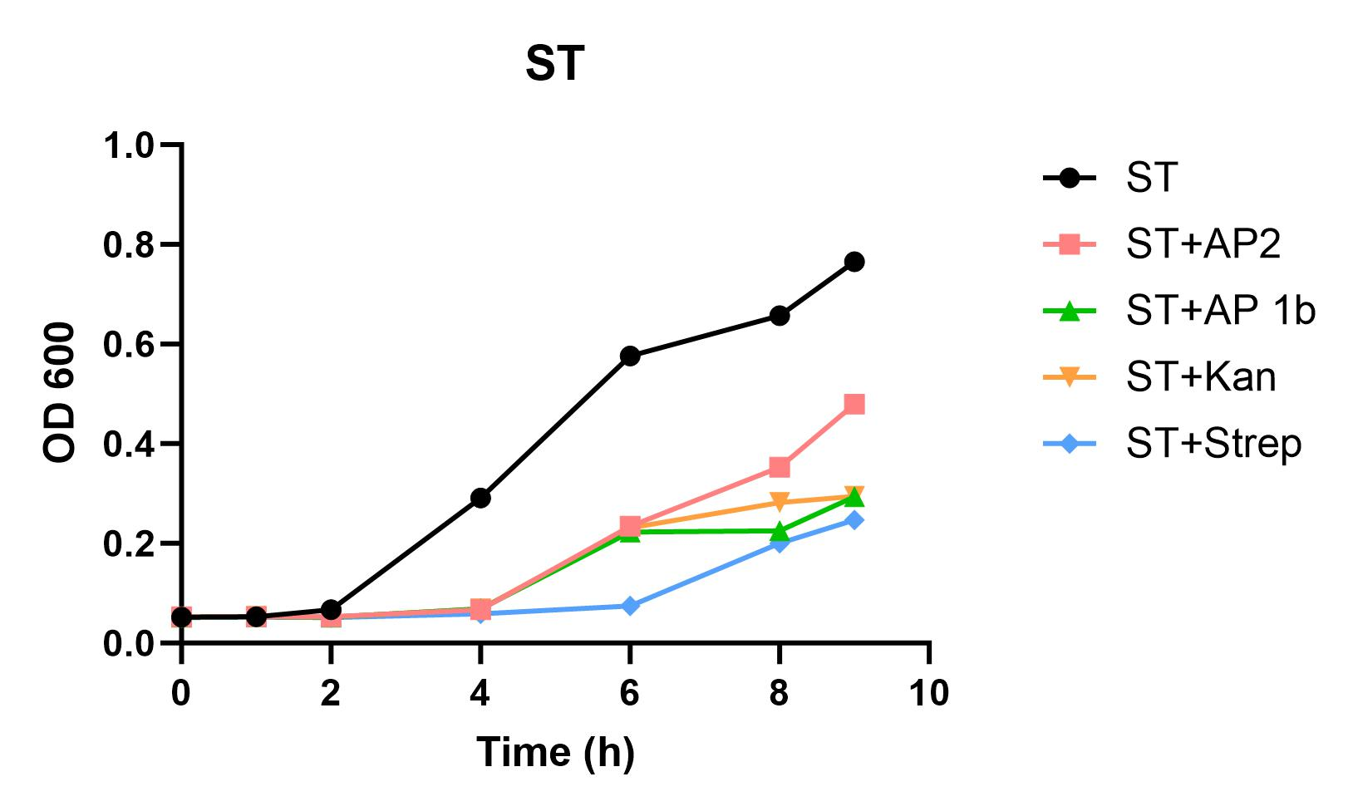
Supplementary Fig.1 Growth kinetics curves of ST incubated without or with AP2, AP 1b, Kan, Strep.
Supplementary Fig.2 The α-diversity analysis including Shannon, Chao1, Faith’s phylogenetic diversity, and observed species indexes among different groups.
Supplementary Fig.3 The different proportions of intestinal flora between control and AP2 group with or without ST inoculation.
Supplementary Fig.4 Genera of Gram-positive (G⁺) and Gram-negative (G⁻) bacteria with high relative abundance.

