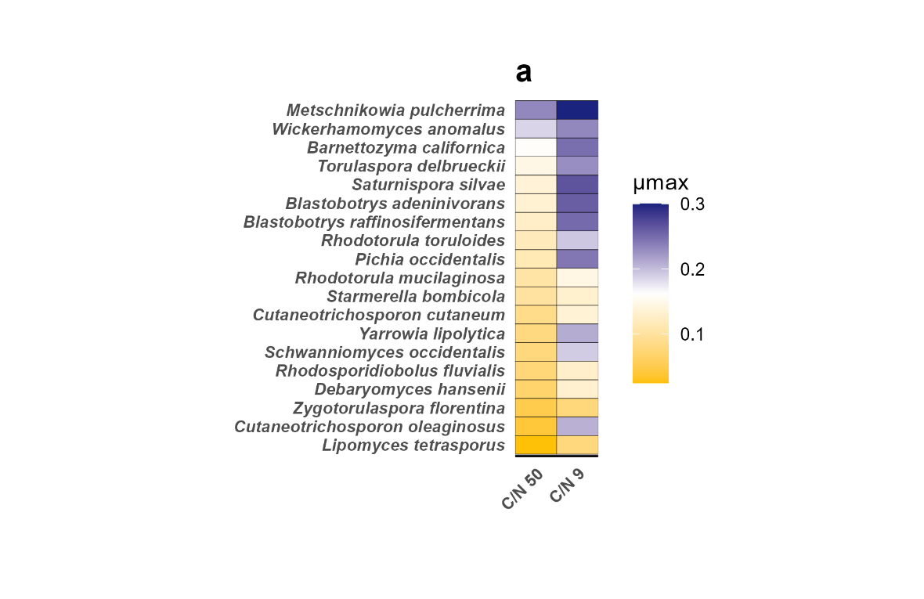
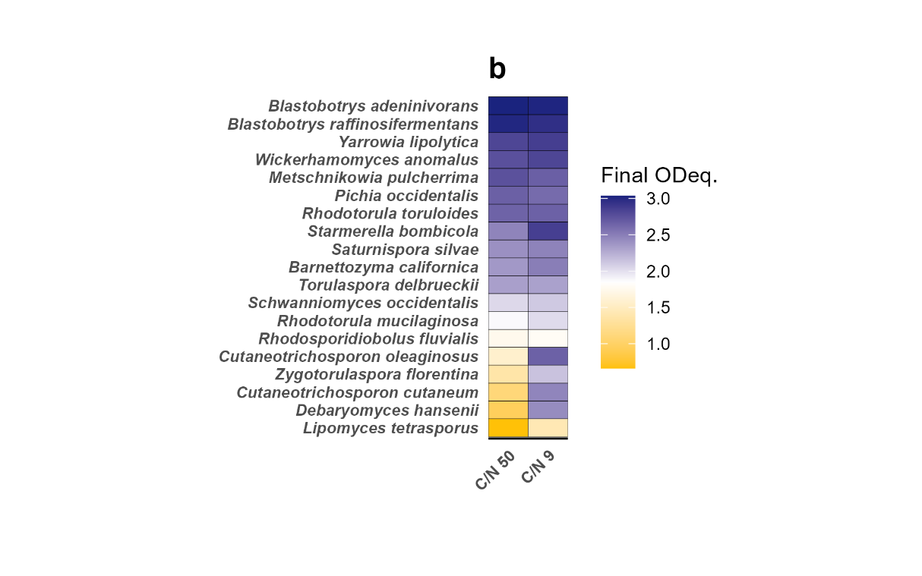
Supplementary Information
A
B

Figure S1. Heat maps of maximum specific growth rate and final ODeq. of the strains grown in 20 g/L glucose at molar C/N ratios 9 and 50. The graphs display maximum specific growth rate (A) and final ODeq reached after about 4-5 days of cultivation (B) by all strains grown in 20 g/L of glucose at low and high C/N ratio. The strains are sorted in descending order for the C/N ratio 50 condition. The maximum specific growth rate has been calculated in R using the all_spline function. This function intercepts the first inflection point of the curve using an exponential function.

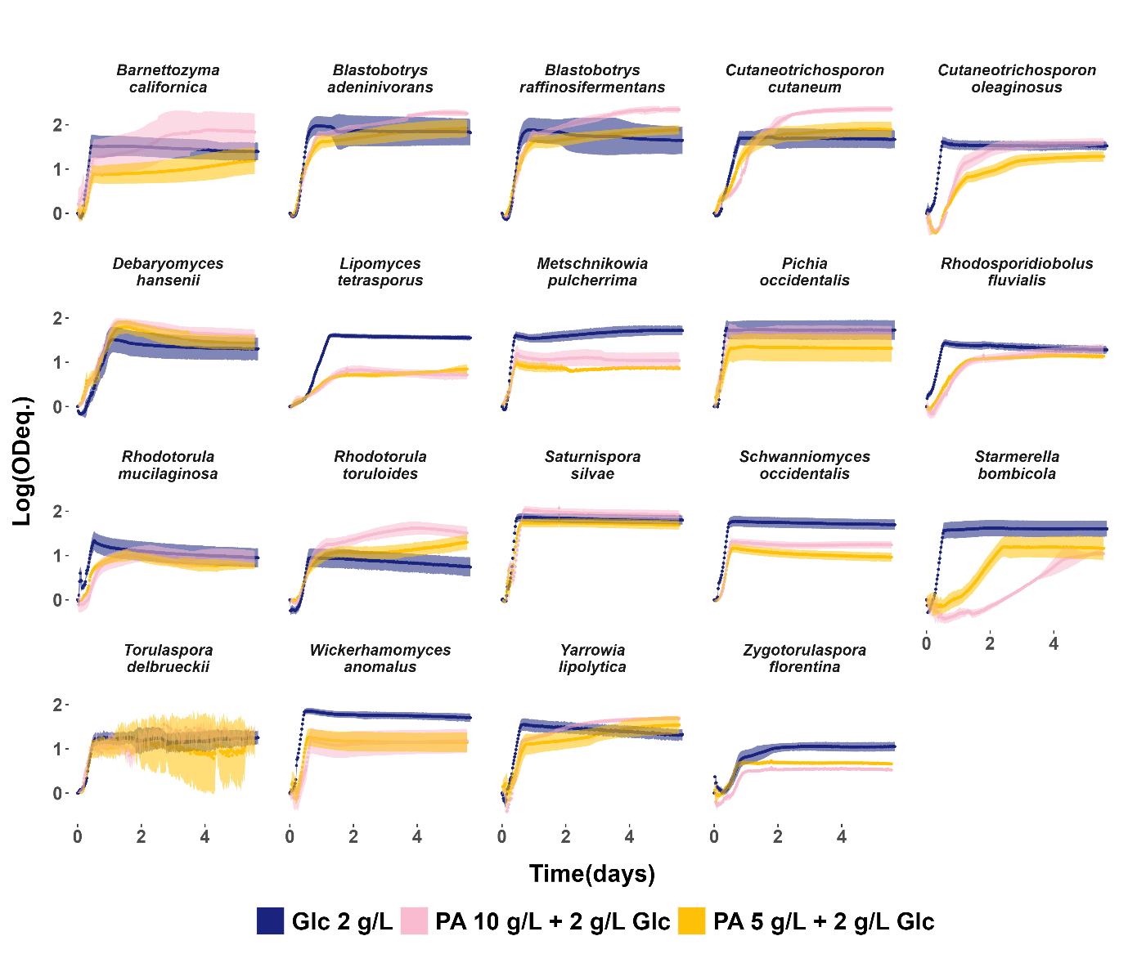
Figure S2. Comparison of growth profiles in 2 g/L glucose with or without addition of 5 and 10 g/L of PA, respectively. The graphs display data obtained from a Growth Profiler in a 96-well plate system. Data are shown as mean ± standard deviation for biological triplicates. The y-axis shows the biomass formed during cultivation on a logarithmic scale using green values, considered equivalent to OD, plotted against time (days) on the x-axis. The Growth Profiler utilizes image analysis, capturing pictures from the transparent bottom of the 96-well plate every 30 minutes to measure cell density. The green values depict yeast cell growth based on pixel counts from multiple images.

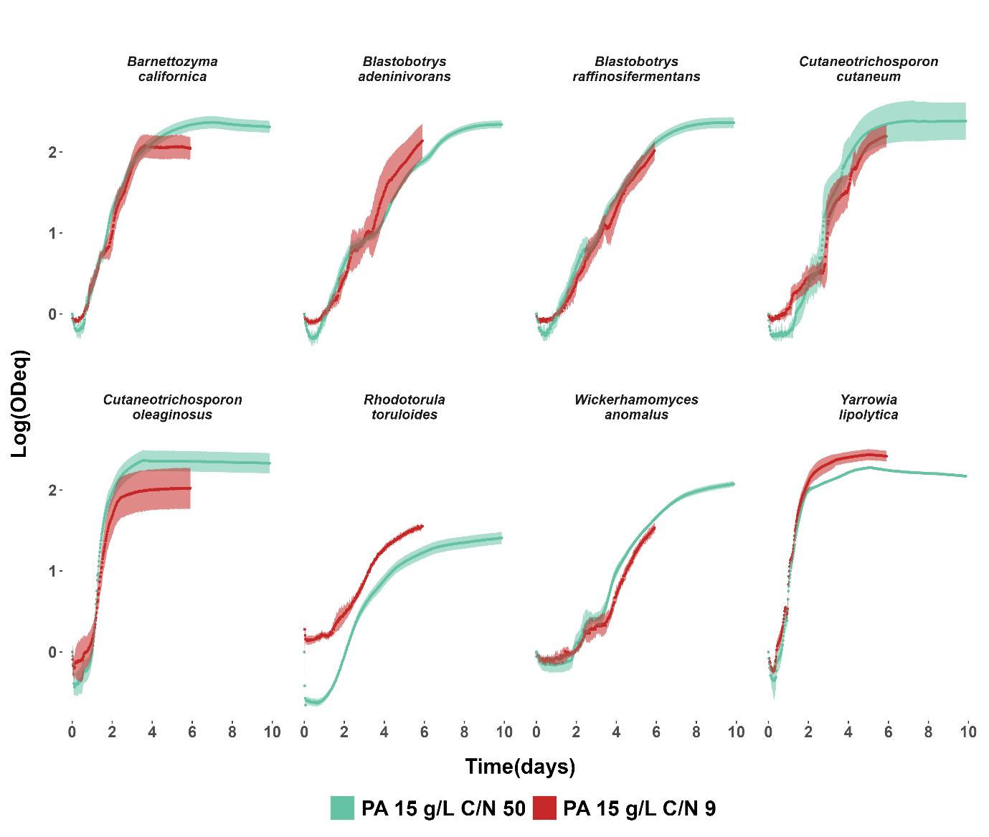

Figure S3. Comparison of growth profiles in 15 g/L PA at molar C/N ratios 9 and 50. The graphs display data obtained from a Growth Profiler in a 96-well plate system. Data are shown as mean ± standard deviation for biological triplicates. The y-axis shows the biomass formed during cultivation on a logarithmic scale using green values, considered equivalent to OD, plotted against time (days) on the x-axis. The Growth Profiler utilizes image analysis, capturing pictures from the transparent bottom of the 96-well plate every 30 minutes to measure cell density. The green values depict yeast cell growth based on pixel counts from multiple images.

