Title:
Towards unravelling antimicrobial resistance dynamics: A longitudinal exploration of rectal swab metagenomes.

Supplementary figure 1. Co-occurrence network based on Spearman correlation between the relative abundance of each species. Only correlation with an absolute Rho ≥ 0.5 and a p-value ≤ 0.01 are displayed.

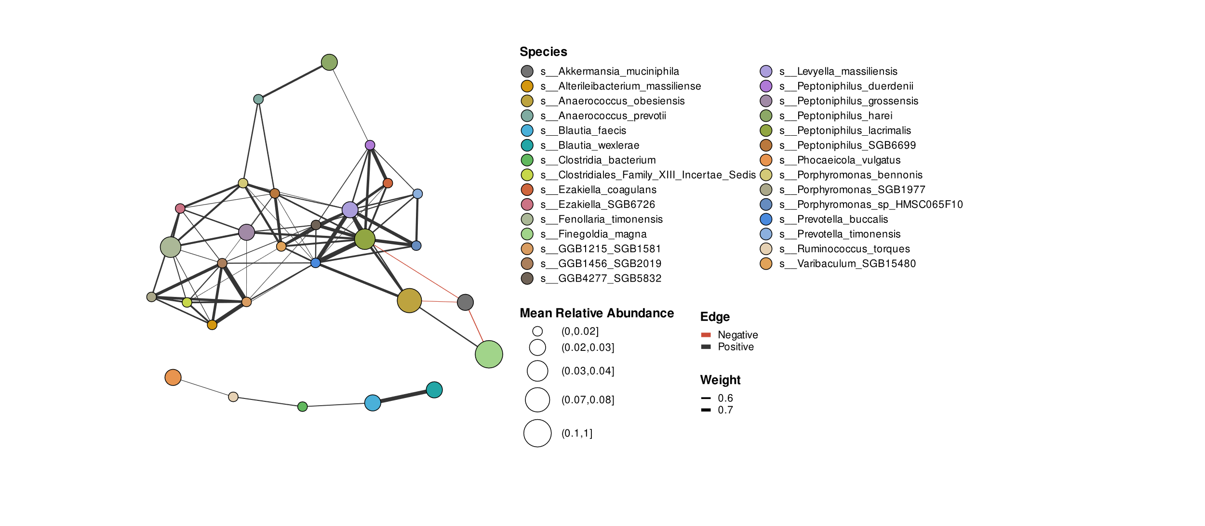
Supplementary figure 2. Impact of the timespan between the time points on the β-diversity measured by the Morisita-Horn dissimilarity index.
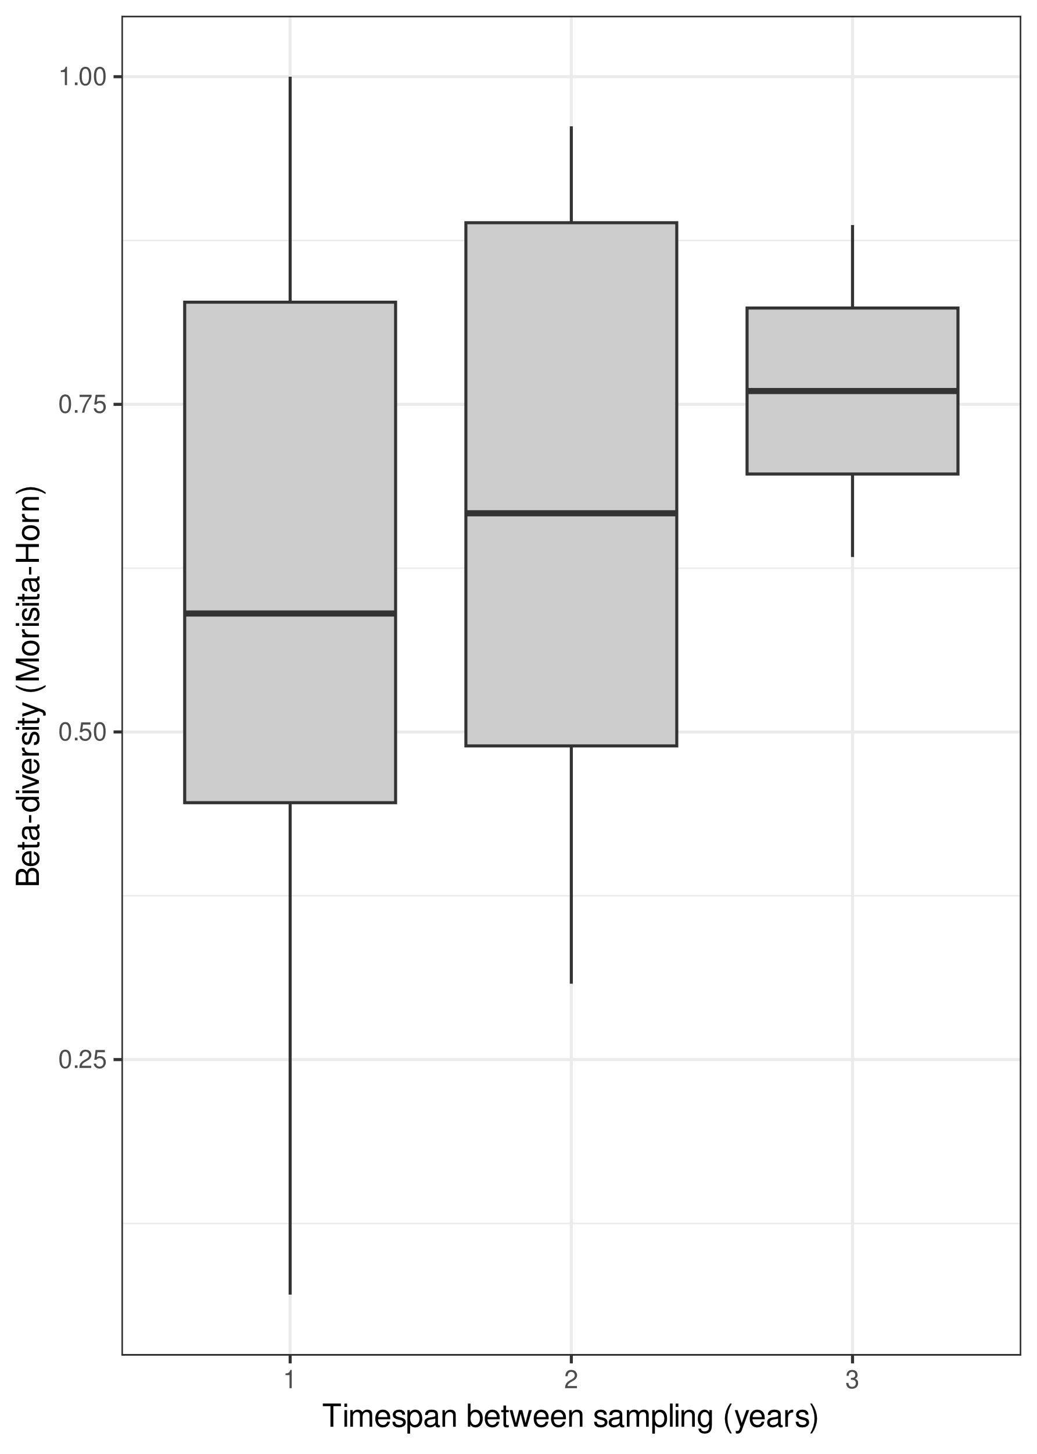

Supplementary figure 3. Heatmap represents the AMR genes detected in either the genomes from isolated K.aerogenes (A) or K. pneumoniae (B) and their corresponding metagenomes. The AMR genes displayed were selected based on their presence in at least one of the isolated strains.
