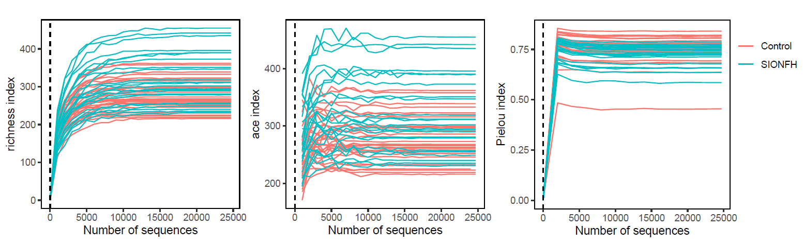
Figure S1. The rarefaction analysis of alpha-diversity between two groups (control and SIONFH). And the richness, Ace, and Pielou indexes are shown from left to right.

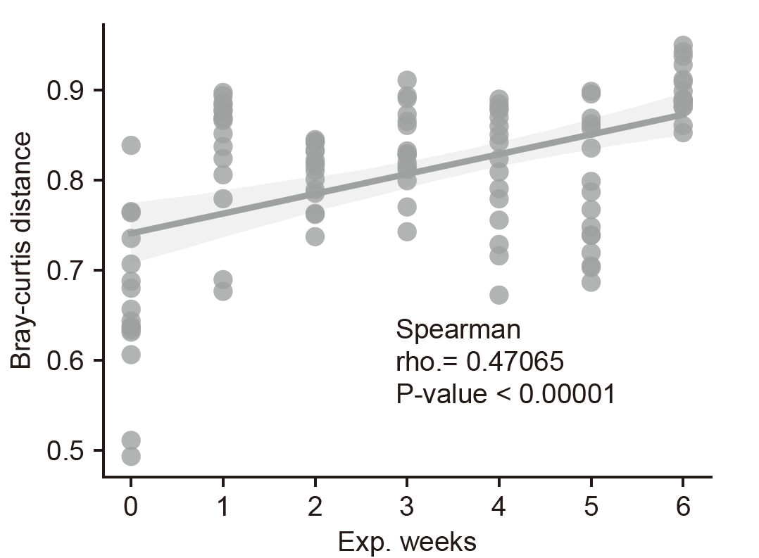
Figure S2. The Bray-Curtis distance between two groups (control and SIONFH) at the same experimental week.

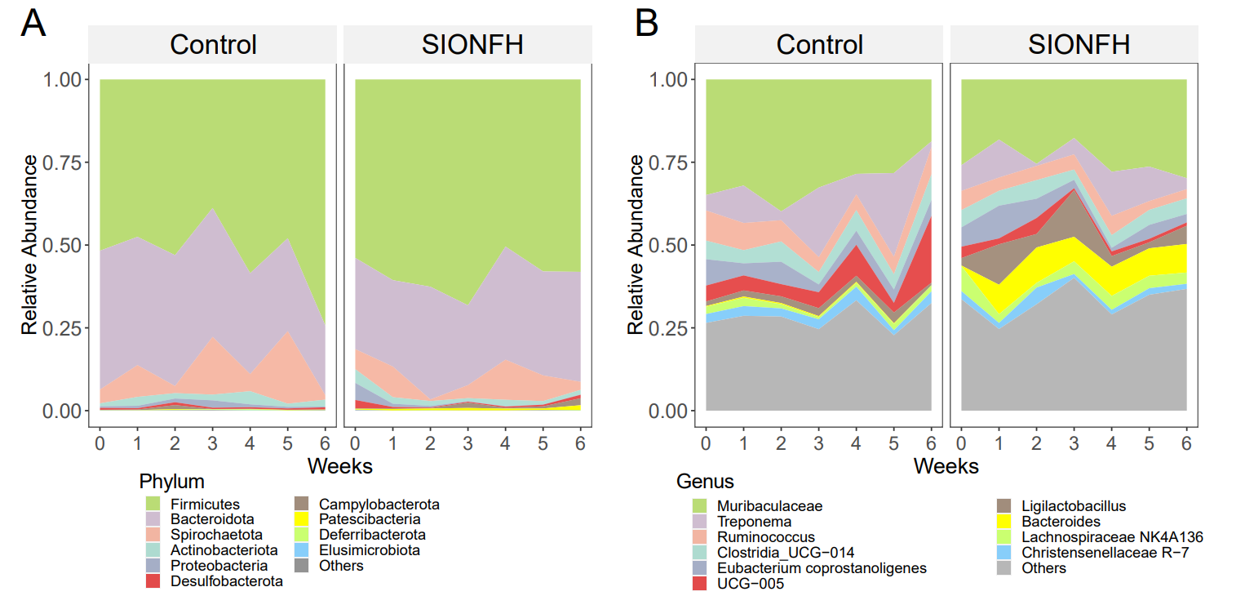
Figure S3. Microbial composition of Control and SIONFH groups at phylum level (left) and genus level (right). Only the top ten taxa were shown at each taxonomic level.

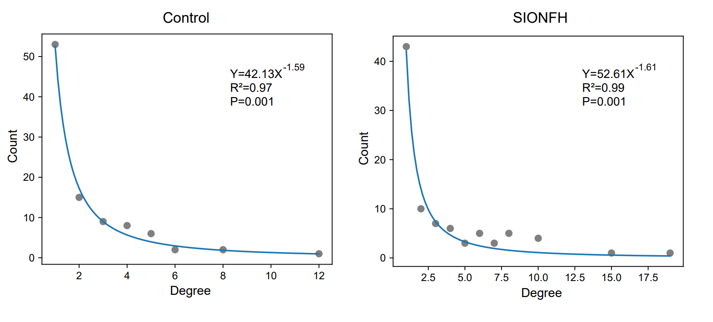
Figure S4. The degree distribution for co-occurrence networks in control and SIONFH groups. The fitting model was showed on the subplots.

