Supplementary Figures
Fig. S1. Antibiotic sensitivity test of JS01 APEC. 1.AMK；2.CTR；3.CXM；4.CZ；5.CN；6.AMP；7.MY；8.VAN；9.STR；10.MI；11.ERY；12.CIP；13.AZI；14.DO；15.LEV；16.PEN；17.GEN；18.KAN；19.FFC；20.PB；21.SXT；22.CHL；23.CC；24.IPM.
Fig. S2. Solation, culture and Gram stain of pathogenic bacteria from liver tissue of dead mice in JS01 strain challenge group (EJCG). A: colonies of the bacterial isolate on the NA plate; B: pink colonies on MAC agar; C: purple-black colonies with green metallic sheen on EMB agar; D: microscopic analysis of Gram stain of pathogenic bacteria isolated, magnification: ×1000.
Fig. S3. Statistical map of common and specific annotations in the General Database of coding genes. The left side is the general database gene annotation statistics; the right side is the common and unique statistics. For example, the first column is the common statistics of all general databases, the top is the number statistics, and the bottom is the annotation of common or unique databases.

Fig. S1

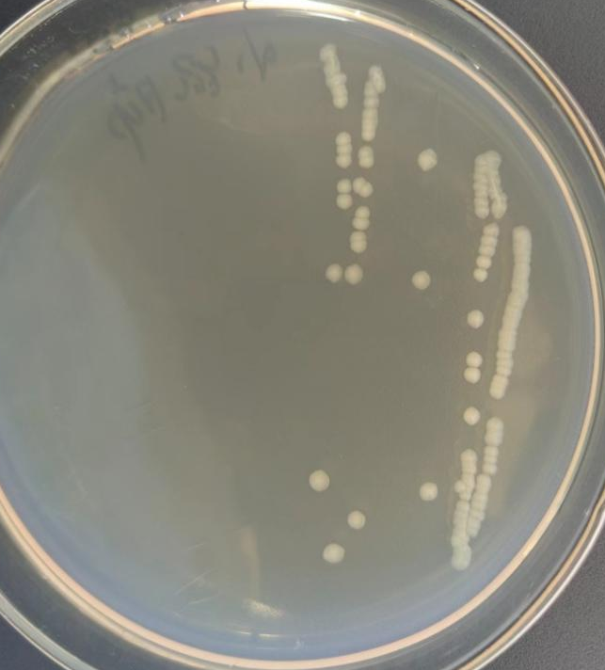 | 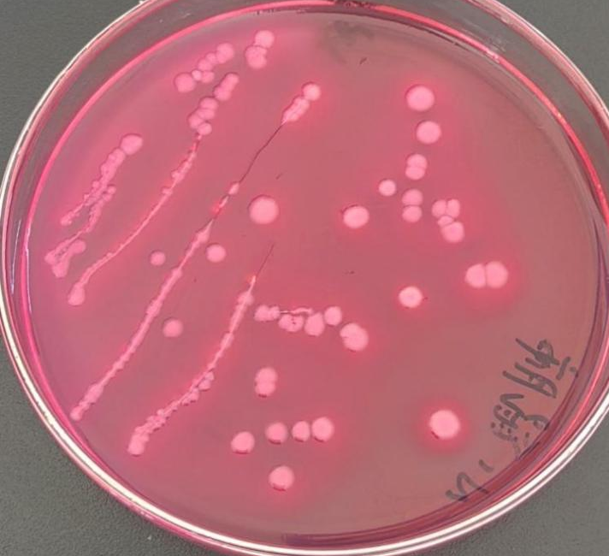
(A) | (B)
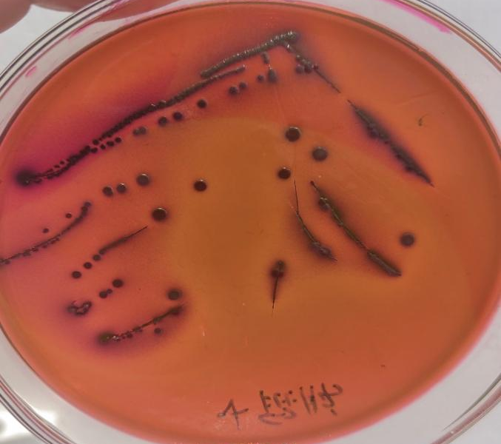 | 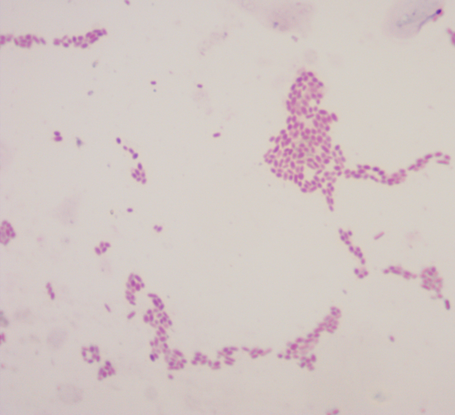
(C) | (D)

Fig. S2

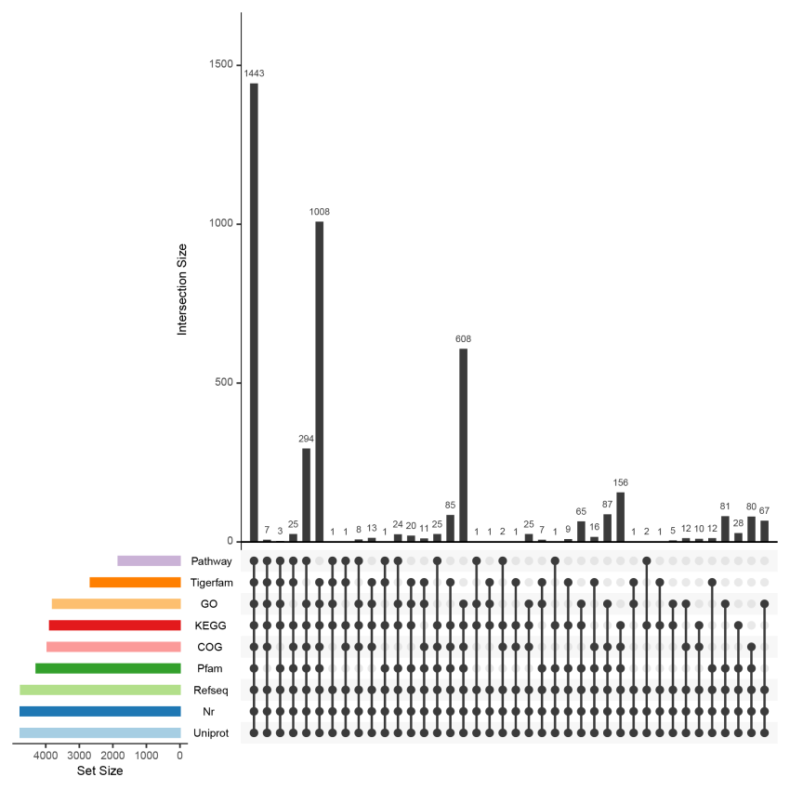

Fig. S3

