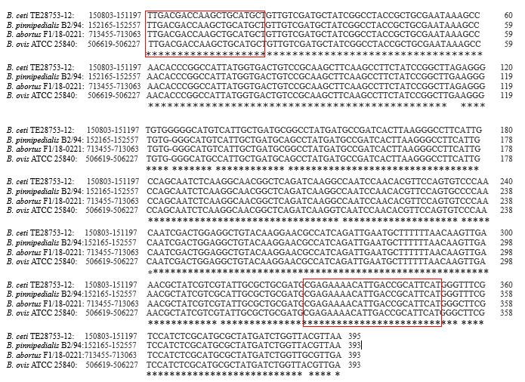
Figure S1: Alignment of IS711 gene in Brucella spp.

