Electronic Supplementary Material

Pseudomonas aeruginosa clinical isolates in Egypt: phenotypic, genotypic, and antibiofilm assessment of Pluronic F-127

Mai Hamed Salem^{1,2}*, Ahmed F. Azmy², Tarek Dishisha², Nesrein Dessouky¹

¹Department of Microbiology and Immunology, College of Pharmaceutical Sciences and Drug Manufacturing, Misr University for Sciences and Technology, P.O. Box 77, Giza, Egypt
²Department of Pharmaceutical Microbiology and Immunology, Faculty of Pharmacy, Beni-Suef University, 62511 Beni-Suef, Egypt

* Corresponding authors:
E-mail address: may.hamed@must.edu.eg
Tel: +201124776488
Table S1. Demographics of collected strains
Demographics |  | P. aeruginosa (n=118) | Percentage
Gender | Male | 69 | 58.5%
Gender | Female | 49 | 41.5%
Age Group | <1-20 | 40 | 34%
Age Group | 21-40 | 16 | 13.55%
Age Group | 41-60 | 55 | 46.6%
Age Group | 61-80 | 7 | 5.9%
Specimen | Pus | 37 | 31.36%
Specimen | Urine | 24 | 20.34%
Specimen | Wound | 15 | 12.71%
Specimen | Endotracheal tube | 14 | 11.86%
Specimen | Blood | 13 | 11.02%
Specimen | Sputum | 10 | 8.47%
Specimen | Vaginal swap | 5 | 4.24%

Figure S1
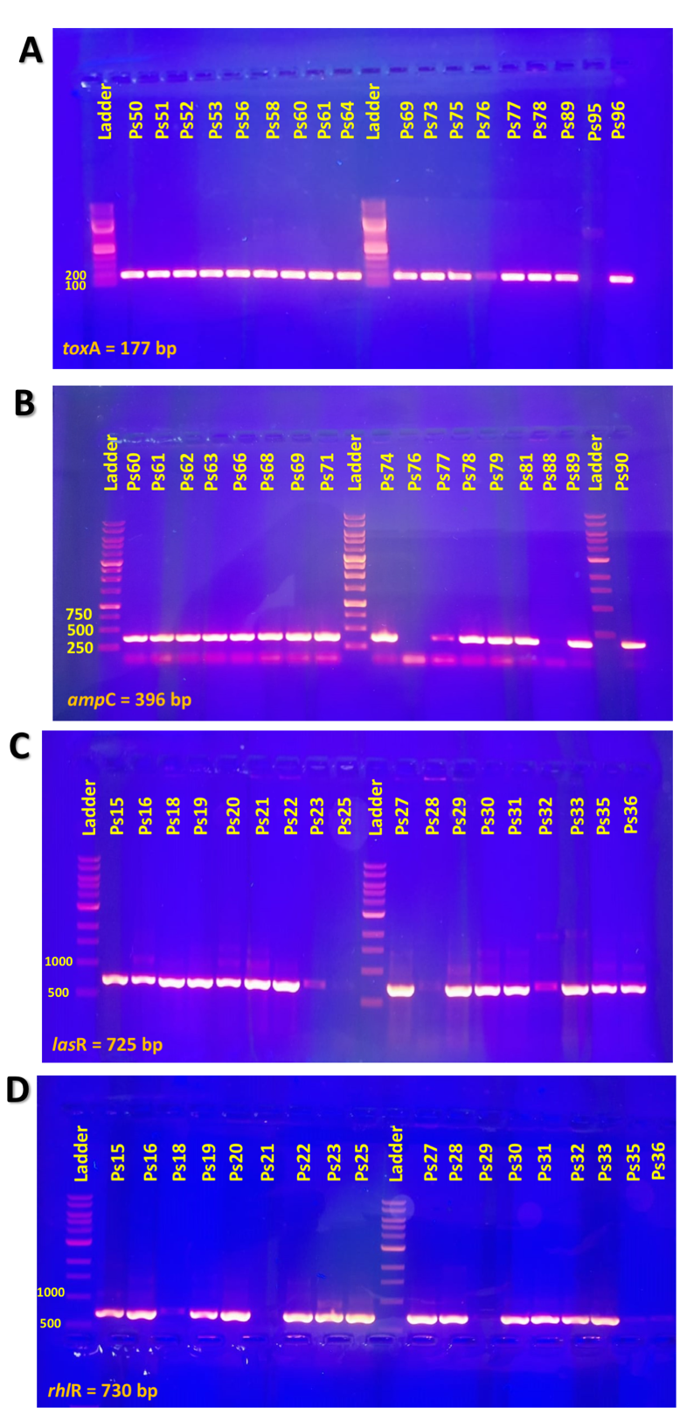
Fig. S1. A: toxA gene appeared at 177 bp using 100 bp DNA ladder all isolates were positive for toxA gene , B: ampC gene appeared in 396bp, all isolates were ampC+ except for Ps76 and Ps88 isolates, C: lasR gene appeared in 725bp using 1Kb ladder; all isolates were positive for lasR except for Ps25 isolate, D: rhlR gene appeared in 730bp whereas Ps21,Ps29,Ps35and Ps36 were negative for rhlR.
Figure S2

Figure S2. The distribution of XDR Pseudomonas aeruginosa isolates in relation to biofilm forming capacity.

