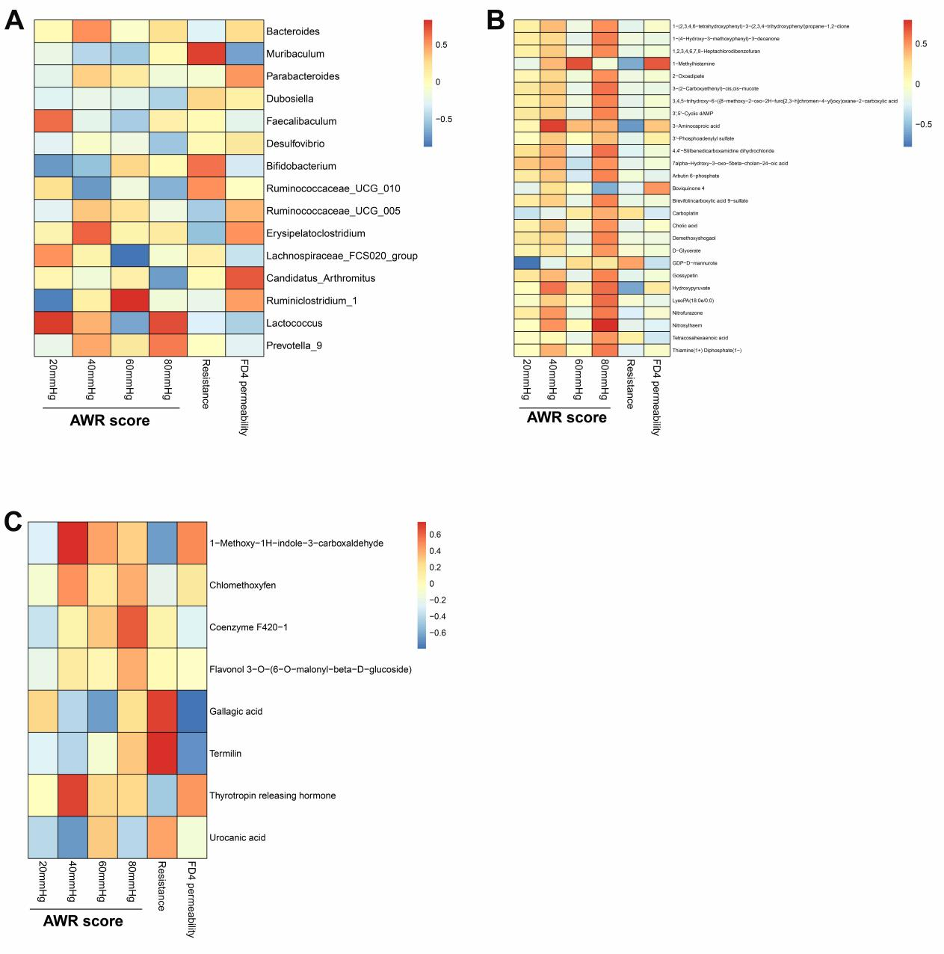
Supplementary figure 1 (A) Spearman correlations among AWR scores, transepithelial resistance, FD4 permeability of colonic samples and microbial genera in PN group. Spearman correlations among AWR scores, transepithelial resistance, FD4 permeability of colonic samples and microbial metabolites in the (B) positive and (C) negative modes of untargeted metabolomics analysis in PN group. Differential genera and metabolites between NN and PN were used in correlation analysis. No significant correlations were detected in these analysis.

