Figure S1 The flowchart of the study
Figure S2 Color parameter of tongue images in different groups of CRC. All colors were represented by the combination of L, A and B. Where L stands for Luminance, ranging from 0 (black) to 100 (white); A stands for red and green, positive numbers are red and negative numbers are green, ranging from −100 to +100; B stands for yellow and blue, positive numbers are yellow and negative numbers are blue, ranging from −100 to +100.
Figure S3 Comparative analysis of Rothia mucilaginosa_B and Rothia sp001808955 abundance across four tongue images.
Figure S4 Relative abundance of tongue coating bacteria in different groups based on disease location, gender, and disease stage.
Figure S5 Difference analysis in different groups based on disease stage, disease location, and gender.
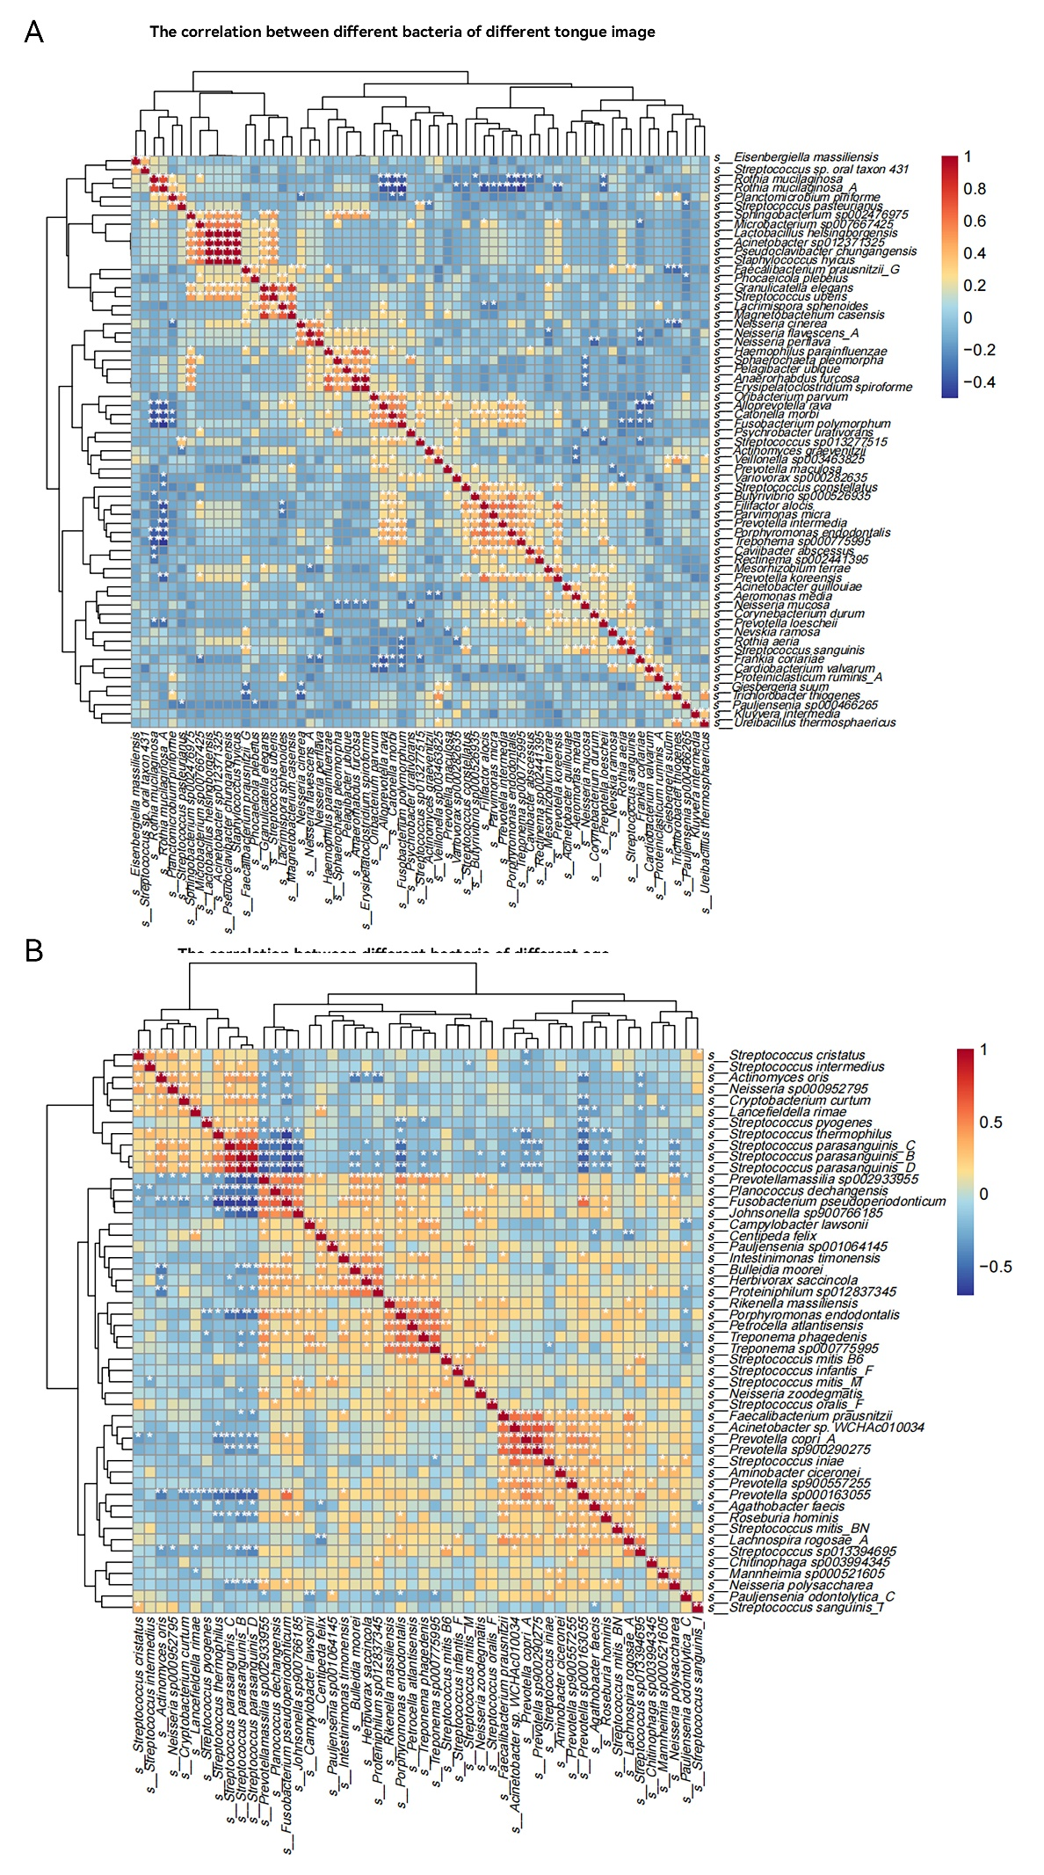
Figure S6 Correlation analysis between different bacteria. A: The correlation between different bacteria of different tongue conditions. B: The correlation between different bacteria of different age.
Figure S7 Linear correlations of Rothia mucilaginosa_A with seven selected bacteria (based on Figure S6A).

Table S1 PERMANOVA analysis to evaluate the significance of beta diversity in tongue coating microbiota among the four tongue images.
 | Df | SumOfSqs | R2 | F | Pr(>F)
Model | 1 | 0.349218 | 0.023621 | 1.378969 | 0.07
Residual | 57 | 14.435 | 0.976379 | NA | NA
Total | 58 | 14.78421 | 1 | NA | NA

Table S2 PERMANOVA analysis to evaluate the significance of beta diversity in tongue coating microbiota among the different age groups.
 | Df | SumOfSqs | R2 | F | Pr(>F)
Model | 3 | 0.796088 | 0.053847 | 1.043381 | 0.352
Residual | 55 | 13.98813 | 0.946153 | NA | NA
Total | 58 | 14.78421 | 1 | NA | NA

