Supplemental figures
A
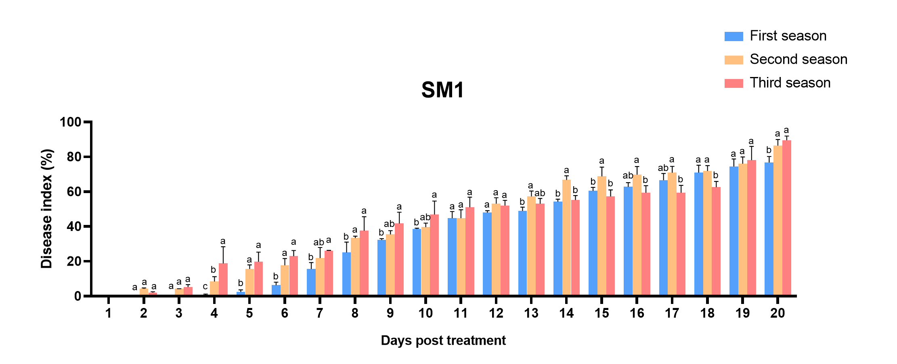

B
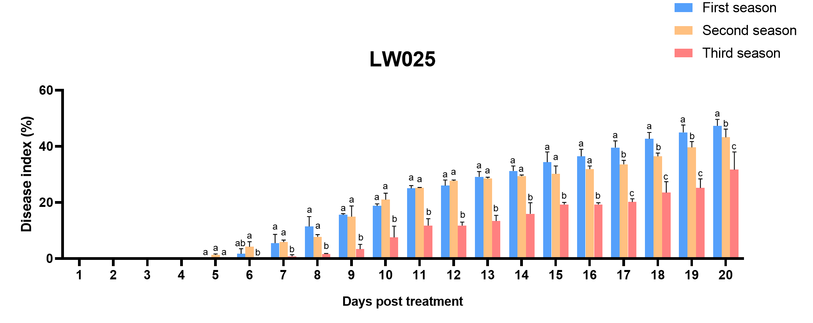

Fig. S1 The analysis of the significant differences in the disease index.
A. The difference analysis in disease index of susceptible variety SM1 between three consecutive plantings (Tuket test; P<0.05). B. The difference analysis in disease index of disease-resistant variety LW025 between three consecutive plantings (Tuket test; P<0.05).

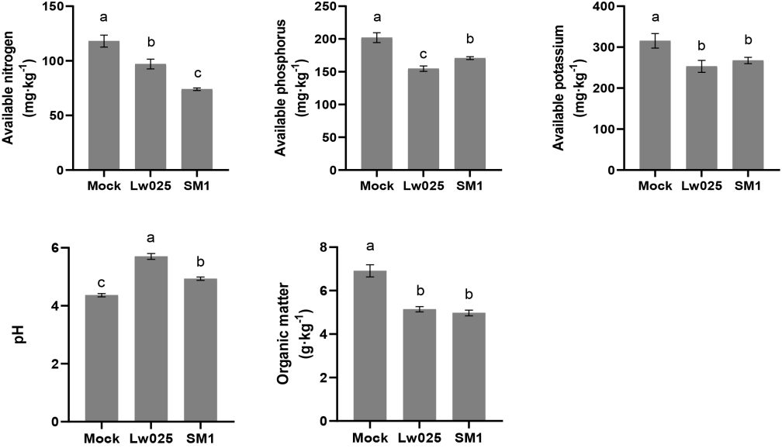
Fig. S2 Detection of Physicochemical properties of different soils.
Mock, initial soil; LW025, Rhizosphere soil planted with disease-resistant variety LW025; SM1, Rhizosphere soil planted with susceptible variety SM1. Error bars represent ±SD of 6 plant samples. The different letters within a column indicate significant differences between the means (P < 0.05).

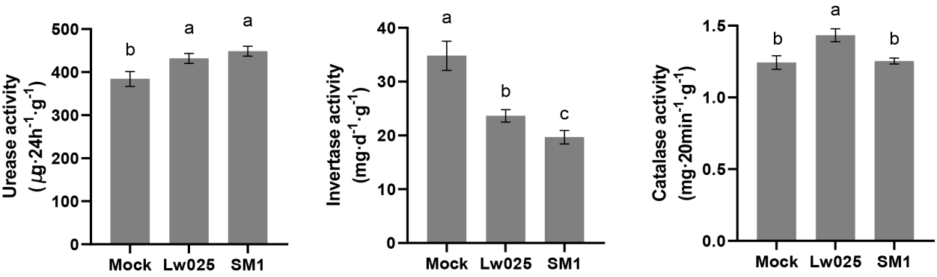
Fig. S3 Enzyme activities assays in different soils.
Mock, initial soil; LW025, Rhizosphere soil planted with disease-resistant variety LW025; SM1, Rhizosphere soil planted with susceptible variety SM1. Error bars represent ±SD of 6 plant samples. The different letters within a column indicate significant differences between the means (P < 0.05).

