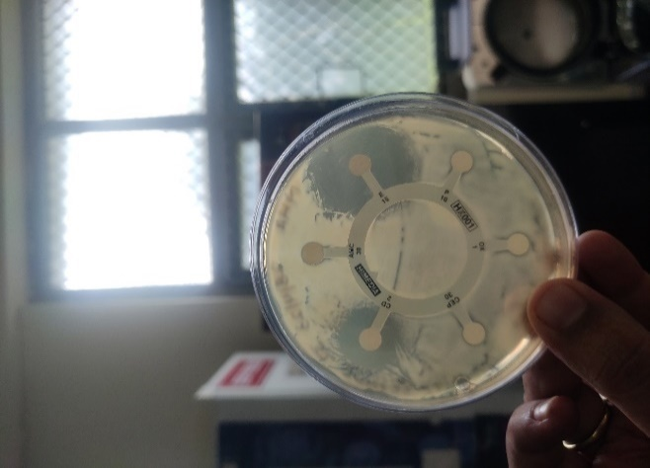
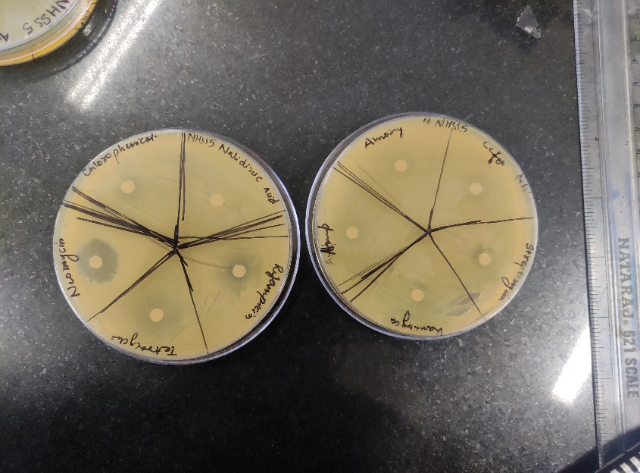
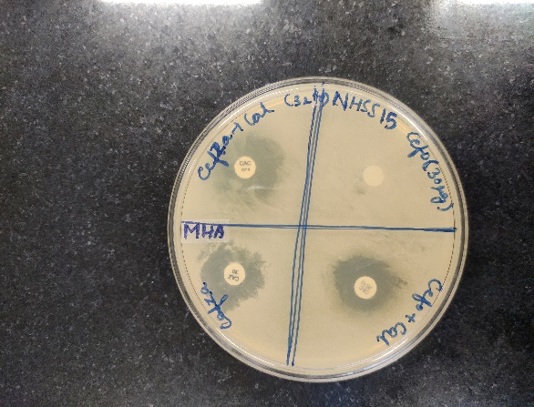
1(a) 1(b) 1(c)
Figure 1 (a) & (b) Photographs illustrating antibiotic resistance in strain NHSS15
(c) Photographs illustrating ESBL phenotype by disc diffusion method in strain NHSS15

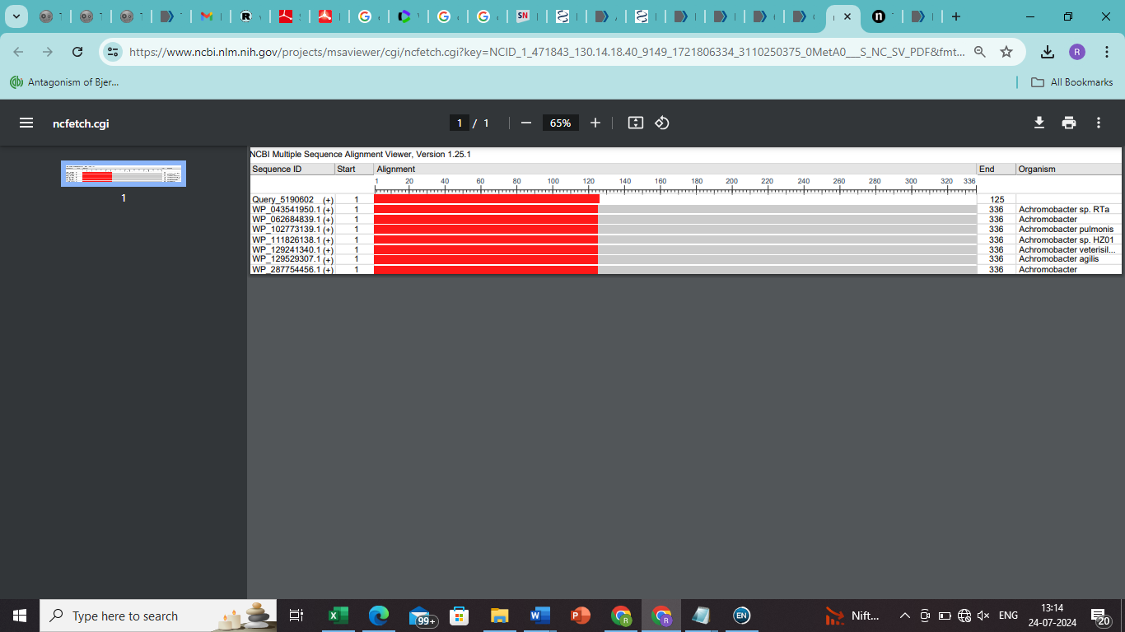
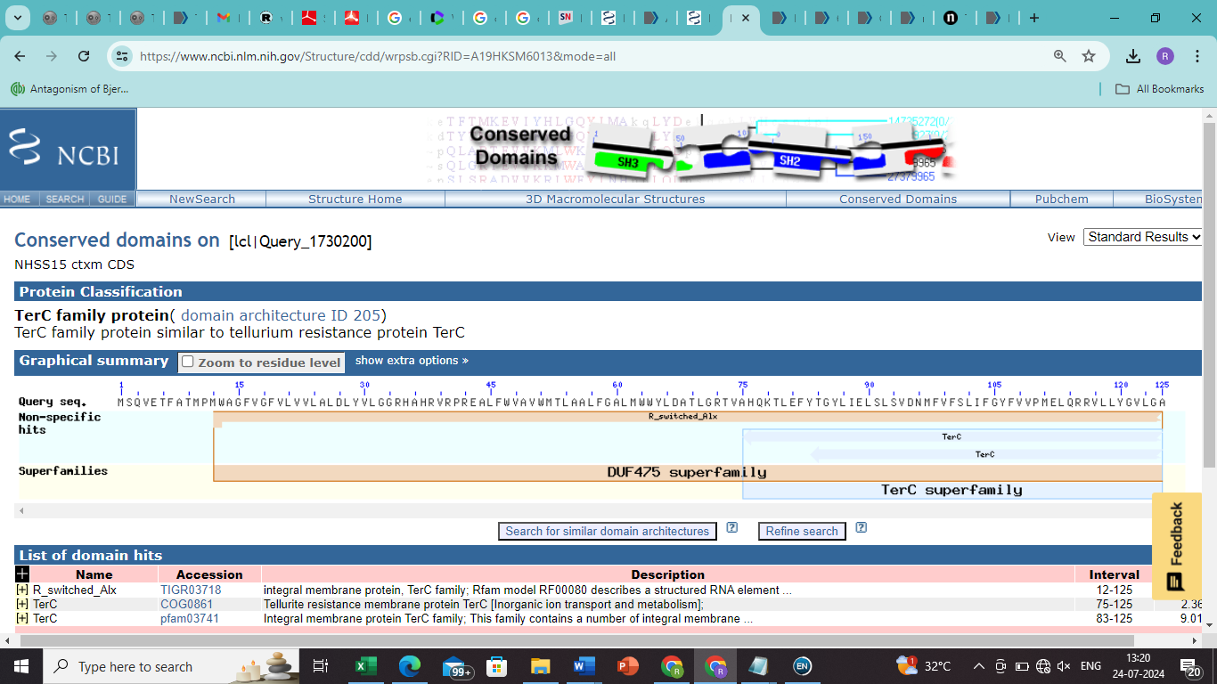
2(a)
2(b)
Figure 2 (a) Photographs illustrating the multiple sequence alignment of Seq3 by clustered nucleotide BLAST (NCBI)
(b) Photograph illustrating alignment of the conserved region of Seq3 by CD database (NCBI)

Sequence | Accession number | Name of a similar sequence | The accession number of matched aeq | E value | Identity | Species
Seq1 | PP904483 | TEM-229 | 3005260 | 0 | 99 | Bacteria, Viruses, Fungi, and other genome sequence associated with antimicrobial resistance
Seq1 | PP904483 | TEM-116 | 3000979 | 0 | 99 | Staphylococcus aureus
Seq1 | PP904483 | TEM-181 | 3001044 | 0 | 99 | Bacteria, Viruses, Fungi, and other genome sequence associated with antimicrobial resistance
Seq1 | PP904483 | TEM-157 | 3001023 | 0 | 99 | Enterobacter cloacae
Seq2 | PQ069065 | TEM-229 | 3005260 | 0 | 100 | Bacteria, Viruses, Fungi, and other genome sequence associated with antimicrobial resistance
Seq2 | PQ069065 | TEM-116 | 3000979 | 0 | 100 | Staphylococcus aureus
Seq2 | PQ069065 | TEM-181 | 3001044 | 0 | 99 | Bacteria, Viruses, Fungi, and other genome sequence associated with antimicrobial resistance
Seq2 | PQ069065 | TEM-157 | 3001023 | 0 | 99 | Enterobacter cloacae
Seq3 | PQ069066 |  |  | NO HITS
Table 1 BLAST results of Seq1, Seq2 and Seq3 in CARD database

