Table S1. The primer sequences and sequencing conditions of the six housekeeping genes for MLST
Gene | Primer (5 –3) |  | Annealing temperature (°C)
FKS |  | F：GTCAAATGCCACAACAACAACCT | 55
 |  | R: AGCACTTCAGCAGCGTCTTCAG
LEU2 |  | F：TTTCTTGTATCCTCCCATTGTTCA | 54
 |  | R：ATAGGTAAAGGTGGGTTGTGTTGC
NMT1 |  | F：GCCGGTGTGGTGTTGCCTGCTC | 59
 |  | R：CGTTACTGCGGTGCTCGGTGTCG
TRP1 |  | F：AATTGTTCCAGCGTTTTTGT | 50
 |  | R：GACCAGTCCAGCTCTTTCAC
UGP1 |  | F：TTTCAACGACAAGGACACAGA | 57
 |  | R：TCGGACTTCACTAGCAGCAAATCA
URA3 |  | F：AGCGAATTGTTGAAGTTGGTTGA | 53
 |  | R：AATTCGGTTGTAAGATGATGTTGC

Table S2. Antifungal drugs and concentrations distribution in susceptibility test plates
POS | AND  0.015 | AND  0.03 | AND  0.06 | AND  0.12 | AND  0.25 | AND  0.5 | AND  1 | AND  2 | AND  4 | AND  8 | AB  0.12
MF  0.008 | MF  0.015 | MF  0.03 | MF  0.06 | MF  0.12 | MF  0.25 | MF  0.5 | MF  1 | MF  2 | MF  4 | MF  8 | AB  0.25
CAS  0.008 | CAS  0.015 | CAS  0.03 | CAS  0.06 | CAS  0.12 | CAS  0.25 | CAS  0.5 | CAS  1 | CAS  2 | CAS  4 | CAS  8 | AB  0.5
FC  0.06 | FC  0.12 | FC  0.25 | FC  0.5 | FC  1 | FC  2 | FC  4 | FC  8 | FC  16 | FC  32 | FC  64 | AB  1
PZ  0.008 | PZ  0.016 | PZ  0.03 | PZ  0.06 | PZ  0.12 | PZ  0.25 | PZ  0.5 | PZ  1 | PZ  2 | PZ  4 | PZ  8 | AB  2
VOR  0.008 | VOR  0.016 | VOR  0.03 | VOR  0.06 | VOR  0.12 | VOR  0.25 | VOR  0.5 | VOR  1 | VOR  2 | VOR  4 | VOR  8 | AB  4
IZ  0.015 | IZ  0.03 | IZ  0.06 | IZ  0.12 | IZ  0.25 | IZ  0.5 | IZ  1 | IZ  2 | IZ  4 | IZ  8 | IZ  16 | AB  8
FZ  0.12 | FZ  0.24 | FZ  0.5 | FZ  1 | FZ  2 | FZ  4 | FZ  8 | FZ  16 | FZ  32 | FZ  64 | FZ  128 | FZ  256
Note: 1. POS - Positive control, AND - Anidulafungin, MF - Micafungin, CAS - Caspofungin, FC- 5-Flucytosine, PZ - Posaconazole, VOR - Voriconazole, IZ - Itraconazole, FZ - Fluconazole, AB - Amphotericin B, 2. number 0.008-256 indicate the concentrations of different drugs (μg/mL)

Table S3. List of analysis software for transcriptome sequencing
Analysis | Software | Software Version | Parameters | Notes
sequence alignment analysis | HISAT2 | 2.0.5 | Predefined parameters | Align with the reference genome
Quantitative study | Feature Counts | 1.5.0-p3 | Predefined parameters | Gene quantification
Differential analysis | DESeq2 | 1.20.0 | |log2(FoldChange)| > 1 & padj < 0.05 | Samples with biological replicates
Differential analysis | edgeR | 3.22.5 | |log2(FoldChange)| > 1 & padj < 0.05 | Samples without biological replicates

Table S4. List of analysis software for whole-genome sequence analysis
Analysis | Software | Software Version | Notes
Control | fastp | 0.20.0 | performing quality control on the raw data
Mapping | bwa | 0.7.17-r1188 | aligning the sequencing results with the reference genome to obtain the bam results
SNP/InDel(Joint Calling) Detection | GATK | 4.0.5.1 | detecting and filtering SNP and InDeL variations
SV Detection | Breakdancer | 1.4.4 | detecting SVs in the samples
CNV Detection | cnvnator | V0.3 | detecting CNV in the samples
Variant Function Annotation | ANNOVAR | 2015Dec14 | annotating the structure and function of the detected variations

Table S5. RT-PCR Reaction system
Components | Volume/Reaction | Final Concentration
TaqProbe 2X qPCR-Multiplex Mastermix | 10μg | 1X
TaqMan Probe | Variable | 100-300 nM
Forward Primer | Variable | 100-500 nM
Reverse Primer | Variable | 100-500 nM
RNase-Free ddH2O | Variable
Template DNA | Variable | <=500 ng/reaction
Total Volume | 20μg

Table S6. RT-PCR thermal cycling program
Procedure | Temperature | Time | cycles
Pre-denaturation | 95°C | 30s | Hold
denaturation | 95°C | 15s | 40
Annealing/Extension | 60°C | 30s

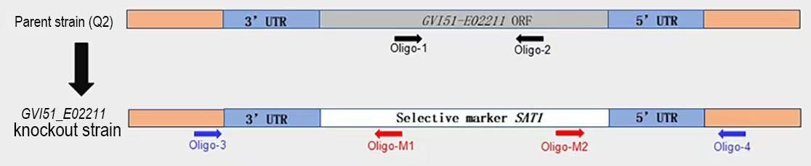
Figure S1. The schematic diagram of Gene Knockout Strategy
Note: GVI51-E02211: Gene ID of CHS3. The fragment lengths in the schematic diagram of primer locations are for positional reference only and do not represent their actual proportional lengths

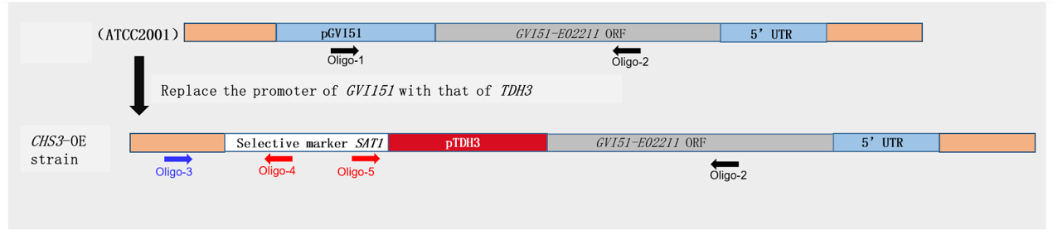
Figure S2. The schematic diagram of Gene Overexpression Strategy
Note: GVI51-E02211: Gene ID of CHS3. The fragment lengths in the schematic diagram of primer locations are for positional reference only and do not represent their actual proportional lengths

