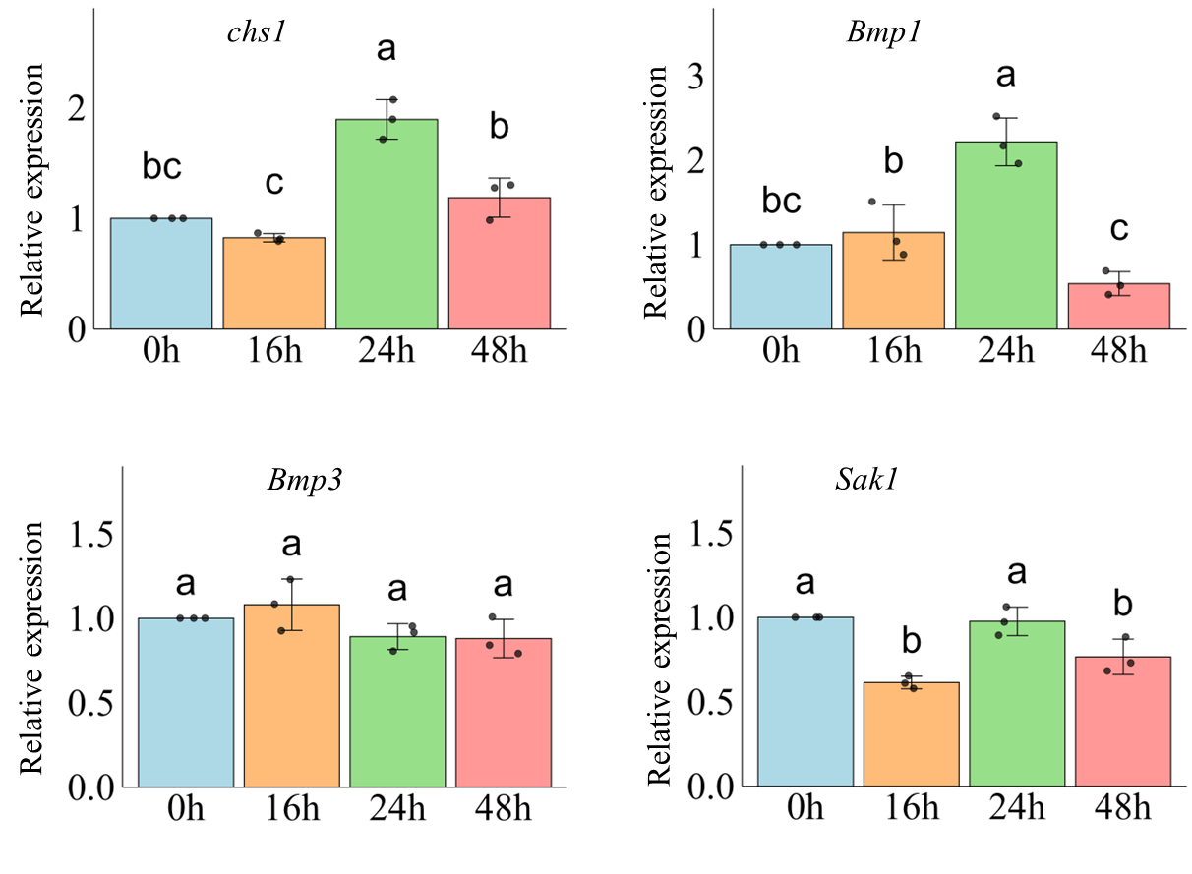

Supplementary Figure 1. Effect of sublethal dose of 3MP (21 μL/L) on transcription of CWI and MAPK coding genes of B. cinerea. Data are means ± standard errors from three biological replicates. Columns with different letters represent significant difference according to Duncan’s multiple range test at P < 0.05

