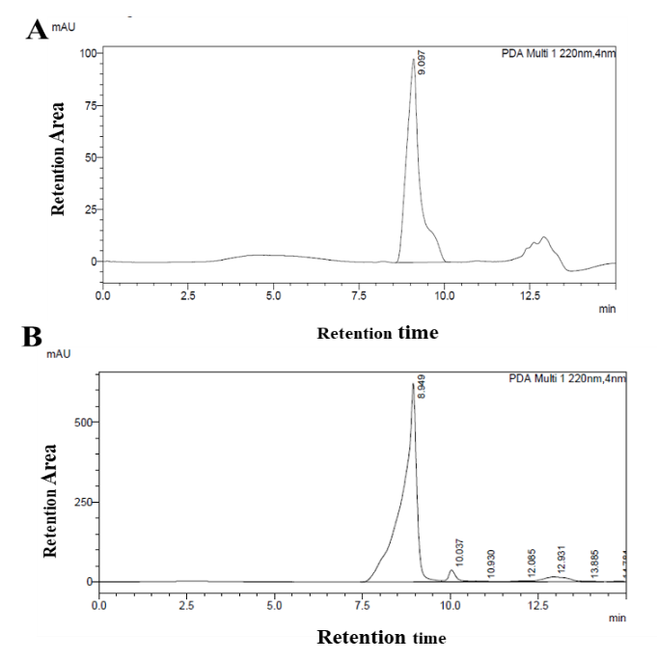
S1: Semi preparative HPLC chromatogram of a) IAA standard and b) IAA production by A. niger VN2 culture

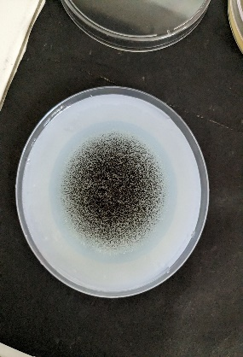
Halo Zone

S2: Phosphate solubilization by A. niger VN2.

S3: FTIR spectra of α-ketobutyrate

