Additional file 1: Identification and biofilm-forming ability of Proteus mirabilis clinical strains
Study setting and study population
The study was based on achieves P. mirabilis clinical strains obtained from the culture collection of the Department of Microbiology, Faculty of Medical Sciences, University of Sri Jayewardenepura, Sri Lanka. Forty P. mirabilis strains which were isolated from patients with UTIs (urine specimens) and 33 strains isolated from patients without UTIs (i.e: pus, wound, and blood specimens) were included in the study.

Presumptive identification of P. mirabilis
The collected clinical strains of P. mirabilis (n=73) were cultured on nutrient agar and presumptive identification was done based on conventional biochemical tests including urease, citrate, kligler iron agar (KIA), indole, motility, oxidase and Voges-Proskauer (VP) and Methyl Red (MR) tests.

Molecular confirmation of presumptively identified clinical strains of P. mirabilis
All presumptively identified P. mirabilis clinical strains (n=73) were sub-cultured on nutrient agar (Oxoid, UK) and incubated at 37°C for 18–24 hours. A few fresh colonies from each strain were separately dissolved in sterile normal saline and used for genomic extraction which was done based on the previously published procedure [18,19]. Extracted DNA was dissolved in TE buffer and stored at -20 ºC until used.
DNA was quantified using a NanoDrop 2000/200C spectrophotometer (Thermo Fisher Scientific, USA) by measuring absorbance at 260 and 280 nm. Purity was assessed using the A260/A280 ratio, with values between 1.8–2.0 indicating pure DNA.
DNA of P. mirabilis strains (n=73) were subjected to PCR using a specific UreR gene of P. mirabilis using forward (5′-GGTGAGATTTGTATTAATGG-3’) and reverse (5′- ATAATCTGGAAGATGACGAG-3′) primers [1].
The PCR master mix was prepared in a Class II biosafety cabinet placed in a work area distinct from the area of DNA extraction. Sterile, nuclease-free water (Promega, USA) was used for the preparation of the master mix. Primers (IDT, USA), were aliquoted into sterile Eppendorf tubes and stored at -20°C in a designated box to prevent cross-contamination and minimize freeze-thaw cycles. All PCR amplifications incorporated a negative control comprising master mix, primers, and nuclease-free water, devoid of a DNA template to detect contamination. All PCR amplifications were carried out in 0.2 ml sterile thin-wall PCR tubes (Biologix, USA) utilizing a thermal cycler (Techne Flexigene, UK). The PCR amplicons were processed in a designated room to prevent cross-contamination and were stored at 4°C until analysis.
Each PCR amplification was conducted in a total volume of 15μL, comprising 1 μL DNA template, 0.4 μL of 10 μmol−1 forward primer, 0.4 μL of 10 μmol−1 reverse primer, 4 μL of 5× master mix [0.4 M Tris–HCl, 7.5 mM MgCl2, 1 mM dNTP mix (200 μl each)], and 9.2 μL of nuclease-free water (Promega, USA). The amplification protocol consisted of an initial denaturation at 95 °C for 4 min, followed by 30 cycles of denaturation at 95 °C for 30 seconds, annealing at 58 °C for 1 minute, and extension at 72 °C for 40 seconds, concluding with a final extension at 72 °C for 10 min with a final hold at 40 °C in a thermal cycler (Flexigene Techne, UK). Positive and negative controls were used throughout the technique [1].
The products from the PCR reactions were visualized using agarose gel electrophoresis. A 2% (w/v) agarose gel was used for the visualization of PCR results. An agarose gel was prepared using agarose (Sigma Aldrich, USA) (1.0 g for 2% agarose gel) dissolved in 50 ml of 1x TAE buffer [40 mM Tris-HCl (pH 8), 20 mM acetic acid, 1 mM EDTA] of molecular grade (Promega, USA). 1x TAE was prepared by diluting 25 ml of 40x TAE (Promega, USA) up to 1000 ml with sterile distilled water. The mixture of agarose and 1x TAE buffer was heated in the microwave oven (SANYO, Japan) until dissolved. Ethidium bromide (2.5 µL) of molecular grade (Sigma Aldrich, USA) was incorporated into the solution and transferred into a gel casting apparatus (Bio-Rad, USA). Upon solidification, the agarose gel was placed in a gel tank and submerged in 1x TAE buffer to adequately cover the gel. The PCR products (5 µL) were loaded into wells using a micropipette and sterile tips. A coloured 100-base pair DNA ladder (5 µL), (Promega, US) was loaded into each gel to enable the positions of the PCR bands to be compared. The gel was electrophoresed for 40 min in TAE buffer at a voltage of 80V at 2A with the machine (BIO-RAD POWER PAC 200). Following electrophoresis, the gel was visualized using a UV transilluminator (VILBER LOURMAT Quantum ST4) connected to a gel documentation system (Biometra GmbH, Germany).
Assessment of biofilm-forming clinical isolates of P. mirabilis
P. mirabilis confirmed strains derived from urine and non-urine samples were tested to determine the ability to form biofilms. Biofilm-forming strains were identified using CV and MTT assays based on biofilm biomass and cell viability, respectively.
P. mirabilis colonies of 24-hour-old cultures on nutrient agar were inoculated in Trypticase Soy Broth (TSB) (Oxoid, UK) and incubated at 37°C for 1 hour. After incubation cell pellets were separated by centrifugation at 3000 rpm for 10 min. Cell pellets were washed twice with sterile Phosphate-Buffered Saline (PBS)(pH 7.2). The inoculums were adjusted to the optical density (OD) 0.1 at 595 nm wavelength (OD of 0.1 corresponds to 1 X10⁸ cells/mL) using a Multiskan EX spectrophotometer (Thermo Scientific, USA).
Standardized cell suspensions were transferred in triplicate into sterile polystyrene 96-well microtiter plates and incubated at 37°C for 24 hours. Following incubation, the content of each well was removed carefully by gentle tapping and the wells were washed three times with 200 µl of sterile PBS to remove non-adherent bacteria. Subsequently, CV and MTT assays were performed to quantify biofilm biomass and cell viability, respectively. A known biofilm forming quality control strain of P. mirabilis was used as the positive control, while media without bacterial inoculum was used as the negative control.
MTT assay
Fifty microliters of MTT working solution (1 mg/mL) were added to the pre-washed wells of the microtiter plate and incubated at 37°C for 4 h in the dark. Following incubation, the remaining MTT reagent was aspirated carefully with a micropipette. Purple-colored insoluble formazan was solubilized in 100 μL of DMSO and absorbance was measured at 595 and 620 nm using a microtiter plate reader. Biofilm formation ability was interpreted based on the standard criteria described by Pleva et al. [2]. The optical density of the cut-off was calculated based on the OD of the negative control.
Optical density cut-off value (ODc) = average OD of negative control + 3× standard deviation (SD) of negative control.
Average OD value Biofilm production
OD ≤ ODc Non-biofilm formation
OD _{C} < OD ≤ 2x ODc Weak biofilm formation
2x OD _{C} < OD Strong biofilm formation
CV assay
The wells were fixed with 200 µL of 2% sodium acetate to adhere the biofilms to the wells. Subsequently, 100 µL of 0.1% CV solution was added to pre-washed wells and incubated at 37°C for 20 min. Following incubation, the plates were washed thrice with 200 µL of sterile PBS to remove unbound CV solution. The retained CV, representing the biofilm biomass, was extracted by adding 100 µL of 30% acetic acid to each well. Fifty microliters of the extracted solution were then transferred to a new microtiter plate, and absorbance was measured at 595 nm using a microtiter plate reader.
Biofilm formation ability was interpreted based on the standard criteria described by Stepanović et al [3]. The optical density of the cut-off was calculated based on the OD of the negative control.
Optical density cut-off value (ODc) = average OD of negative control + 3× standard deviation (SD) of negative control.
Average OD value Biofilm production
≤ ODc Non biofilm formation
ODc < ~ ≤ 2 x ODc Weak biofilm formation
2 x ODc < ~ ≤ 4 x ODc Moderate biofilm formation
> 4 x ODc Strong biofilm formation
Identified biofilm-forming P. mirabilis clinical isolates were subsequently utilized in the next stages of this study.
Results
Out of a total of 73 P. mirabilis clinical strains (40 isolated from urine specimens and 33 isolated from non-urine specimens), 70 showed swarming mortality on nutrient agar, urease positivity, and motility. Citrate and indole tests were positive for 62 and 10 strains, respectively. All 73 were non-lactose fermenters (fermented only Glucose) while 68 produced gas and 69 produced H₂S. Therefore, according to the colony morphologies, Gram staining, and battery of biochemical testing, all 73 strains were presumptively identified as P. mirabilis.
Out of the 73 presumptively identified strains, 32 strains from urine and 30 strains from non-urine specimens were confirmed as P. mirabilis, using the UreR specific gene of P. mirabilis.

References
1. Zhang W, Niu Z, Yin K, Liu P, Chen L. Quick identification and quantification of Proteus mirabilis by polymerase chain reaction (PCR) assays. Annals of microbiology. 2013 Jun;63:683-9.
2. Pleva P, Bartošová L, Máčalová D, Zálešáková L, Sedlaříková J, Janalíková M. Biofilm formation reduction by eugenol and thymol on biodegradable food packaging material. Foods. 2021 Dec 21;11(1):2.
3. Stepanović S, Vuković D, Hola V, Bonaventura G Di, Djukić S, Ćirković I, et al. Quantification of biofilm in microtiter plates: overview of testing conditions and practical recommendations for assessment of biofilm production by staphylococci. Apmis. 2007;115(8):891–9.
(A) | 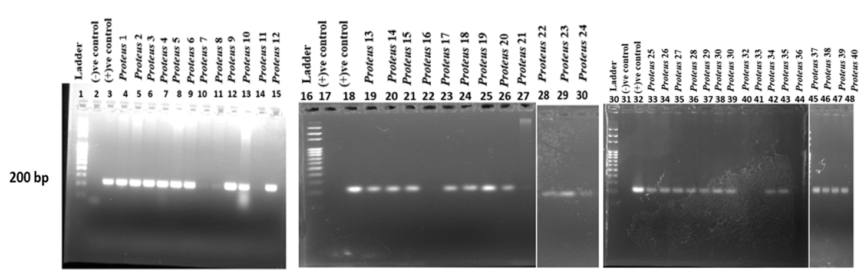
(B) | 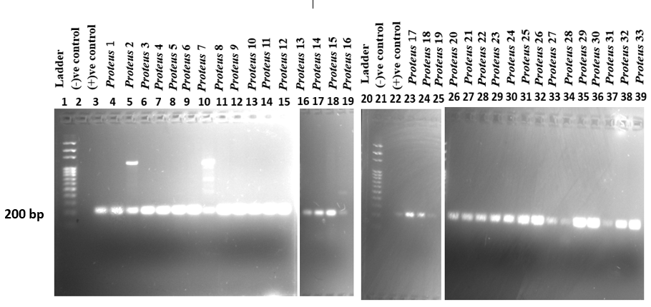
S.Figure 1: Molecular confirmation of P. mirabilis clinical strains isolated from (A) urine specimens and (B) non-urine specimens. Lane 1 - 100 bp ladder, Lane 2 -Negative control (Nuclease free water), 3 - Positive control (P. mirabilis QC strain), Lane 4 onwards - test samples (P. mirabilis clinical strains isolated from (A) urine (Proteus 1-40), and (B) non-urine specimens (Proteus 1-33))

Among molecularly confirmed urine-derived P. mirabilis strains (n=32), 27 and 31 strains exhibited strong biofilm formation in MTT and CV assays, respectively, while 5 isolates showed weak biofilm formation by MTT assay. None were classified as weak by the CV assay. Similarly, among molecularly confirmed non-urine-derived P. mirabilis strains (n=30), 29 and 30 were identified as strong biofilm formers by the MTT and CV assays, respectively. Only 1 non-urine isolate showed moderate biofilm formation by MTT assay, and no isolates were categorized as weak (S.Table 1).
S. Table 1: Quantification of biofilm biomass and metabolic activity of P. mirabilis derived from urine and non-urine samples using CV and MTT assays.
 | P. mirabilis derived from urine samples |  |  |  | P. mirabilis derived from non-urine samples
 | CV assay | MTT assay |  |  | CV assay | MTT assay
1 | 0.2075± 0.0092* | 0.1173± 0.0021* |  | 1 | 1.2487± 0.0432 | 0.8505± 0.0469
2 | 0.4634± 0.0290 | 0.2118± 0.0034 |  | 2 | 1.6464± 0.4723 | 2.0201± 0.0045
3 | 0.3961± 0.0135 | 0.2295± 0.0075 |  | 3 | 1.4473± 0.0348 | 1.0243± 0.0112
4 | 0.3104± 0.0046 | 0.1248± 0.0036* |  | 4 | 1.3004± 0.0152 | 1.0440± 0.0279
5 | 0.3034± 0.0413 | 0.1255± 0.0030* |  | 5 | 1.3204± 0.0217 | 1.0113± 0.0101
6 | 0.3665± 0.0216 | 0.2146± 0.0020* |  | 6 | 2.3469± 0.0016 | 1.1724± 0.0206
7 | 0.4249± 0.0044 | 0.1155± 0.0046* |  | 7 | 1.9216± 0.4996 | 1.2297± 0.0225
8 | 0.4783± 0.0261 | 0.3244± 0.0030 |  | 8 | 1.5081± 0.0103 | 1.0461± 0.0123
9 | 0.5184± 0.1587 | 0.4531± 0.0034 |  | 9 | 1.6537± 0.0012 | 1.3065± 0.2569
10 | 0.5627± 0.0211 | 0.5150± 0.0029 |  | 10 | 2.0793± 0.4939 | 1.2182± 0.0152
11 | 0.6014± 0.0709 | 0.4145± 0.0017 |  | 11 | 1.6400± 0.0054 | 1.1523± 0.0427
12 | 0.9566± 0.5406 | 0.4086± 0.0095 |  | 12 | 1.8566± 0.0406 | 1.0355± 0.0105
13 | 1.5144± 0.0259 | 0.9829± 0.0018 |  | 13 | 2.1603± 0.5199 | 2.0151± 0.0006
14 | 0.6565± 0.0097 | 0.4940± 0.0041 |  | 14 | 1.2007± 0.0018 | 0.8444± 0.0196
15 | 0.5528± 0.0107 | 0.3322± 0.0119 |  | 15 | 2.4837± 0.0050 | 1.2165± 0.0174
16 | 0.5754± 0.0041 | 0.3526± 0.0032 |  | 16 | 2.3291± 0.0168 | 1.2348± 0.0242
17 | 0.3780± 0.0195 | 0.1239± 0.0041* |  | 17 | 1.1763± 0.0018 | 0.7239± 0.0216
18 | 1.2446± 0.0078 | 0.8505± 0.0079 |  | 18 | 1.8479± 0.4967 | 0.9478± 0.0303
19 | 1.1261± 0.0289 | 0.8940± 0.0016 |  | 19 | 1.5532± 0.0009 | 0.9294± 0.0269
20 | 0.6505± 0.0089 | 0.6087± 0.0055 |  | 20 | 1.3554± 0.0024 | 0.7291± 0.0166
21 | 0.7237± 0.0100 | 0.6494± 0.0089 |  | 21 | 1.6687± 0.0098 | 0.8266± 0.0243
22 | 0.5688± 0.0209 | 0.3833± 0.0102 |  | 22 | 0.6219± 0.0269 | 0.1321± 0.0028*
23 | 0.7666± 0.0196 | 0.5926± 0.0068 |  | 23 | 0.4520± 0.0225 | 0.1013± 0.0009*
24 | 0.4775± 0.0138 | 0.4186± 0.0075 |  | 24 | 0.3780± 0.0252 | 0.1587± 0.0635*
25 | 0.4656± 0.0120 | 0.4233± 0.0084 |  | 25 | 0.5278± 0.0085 | 0.3126± 0.0122
26 | 0.5951± 0.0094 | 0.7834± 0.0016 |  | 26 | 0.6519± 0.0090 | 0.5967± 0.0086
27 | 1.0330± 0.0078 | 0.4222±0.0041 |  | 27 | 0.4776± 0.0093 | 0.2169± 0.0175*
28 | 0.6420± 0.0100 | 0.5284± 0.0119 |  | 28 | 0.3915± 0.0061 | 0.2257± 0.0020
29 | 0.4671± 0.0103 | 0.8508± 0.0093 |  | 29 | 1.0202± 0.0053 | 0.8282± 0.0167
30 | 0.6601± 0.0089 | 0.6212± 0.0010 |  | 30 | 0.3542± 0.0030 | 0.2229± 0.0023
31 | 0.8490± 0.0036 | 0.4535± 0.0048
32 | 0.4917± 0.0041 | 0.4841± 0.0046
*These samples were excluded from the evaluation of virulence genes.
Of them, 26 strong biofilm-forming P. mirabilis strains isolated from urine samples and 26 from non-urine samples were then utilized to detect the presence or absence of selected virulence genes responsible for P. mirabilis biofilm formation, using conventional PCR assay.

