Supplementary Materials

Functional potential and applications of Ureibacillus massiliensis based on whole-genome sequencing analysis
Shiyao He¹⁺, Qi Ding¹⁺, Wenting Wu¹, Yun Zhang¹, Yan Kang¹, Yang Meng¹, Sirui Zhu¹ and Jinyuan Wu^{2*}

¹Nanchang Key Laboratory for Quality Evaluation of Medical Devices, Jiangxi Medical Device Testing Center, Nanchang, 330029, PR China.
²College of Bioscience and Bioengineering, Jiangxi Agricultural University, Nanchang, 330045, PR China.
⁺These authors contributed equally to this article
*Corresponding author
Jinyuan Wu: 2312125704@qq.com

Supplementary Figures
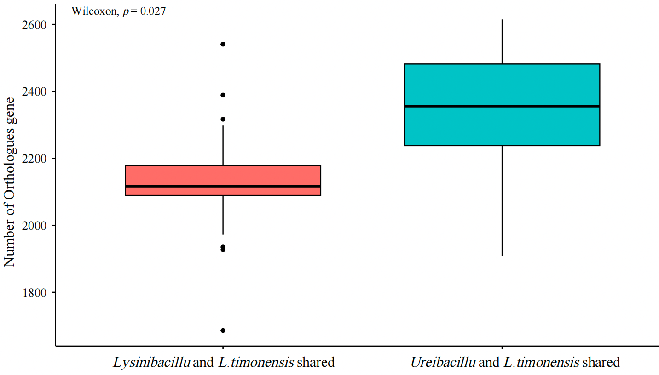
Supplementary Figure 1. Number of orthologous genes shared by L. timonensis with Lysinibacillus and Ureibacillus.

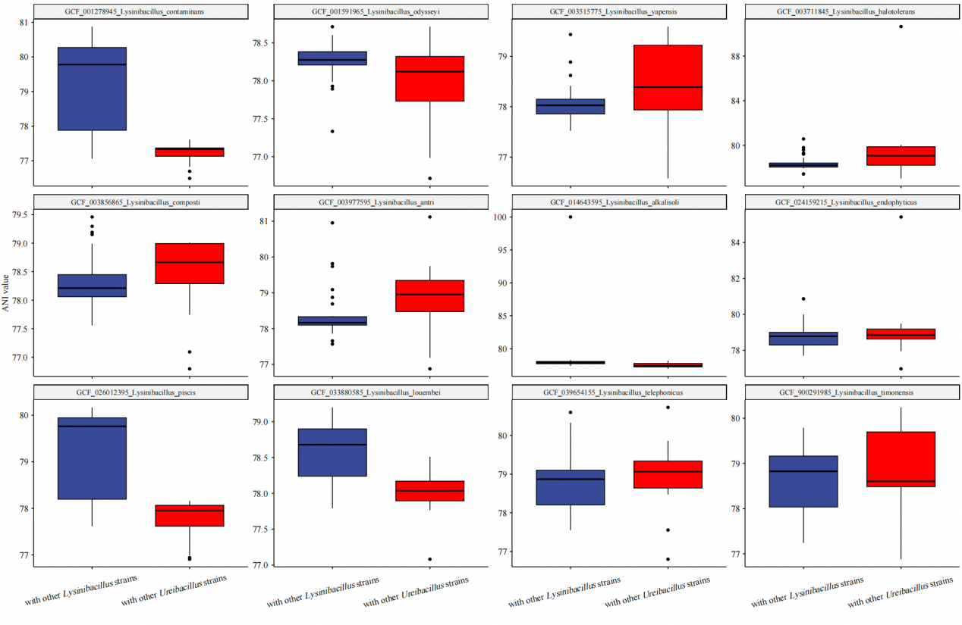
Supplementary Figure 2. ANI values of 12 Lysinibacillus strains compared to Lysinibacillus and Ureibacillus.

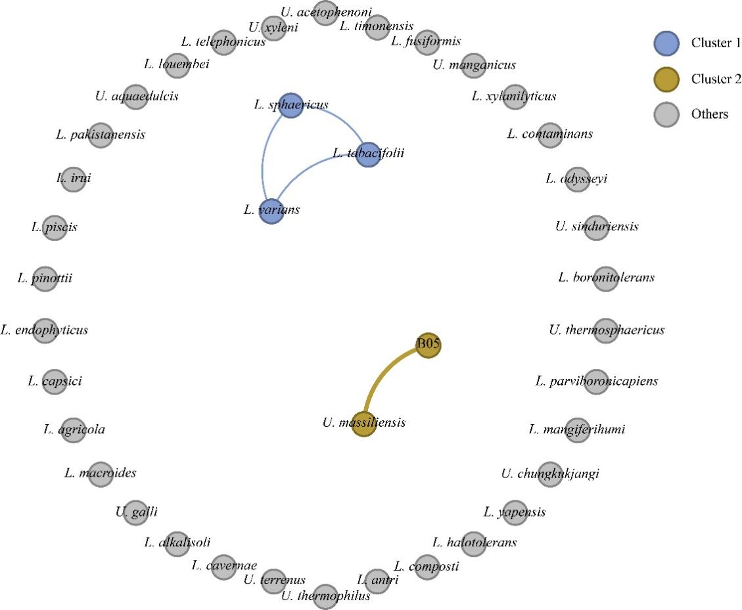
Supplementary Figure 3. Gene flow network constructed based on PopCOGenT. In the gene flow network generated using PopCOGenT, each node represents a distinct bacterial strain. The colors of the nodes correspond to the clusters inferred by PopCOGenT, while individual gray nodes denote independent clusters not grouped with others.

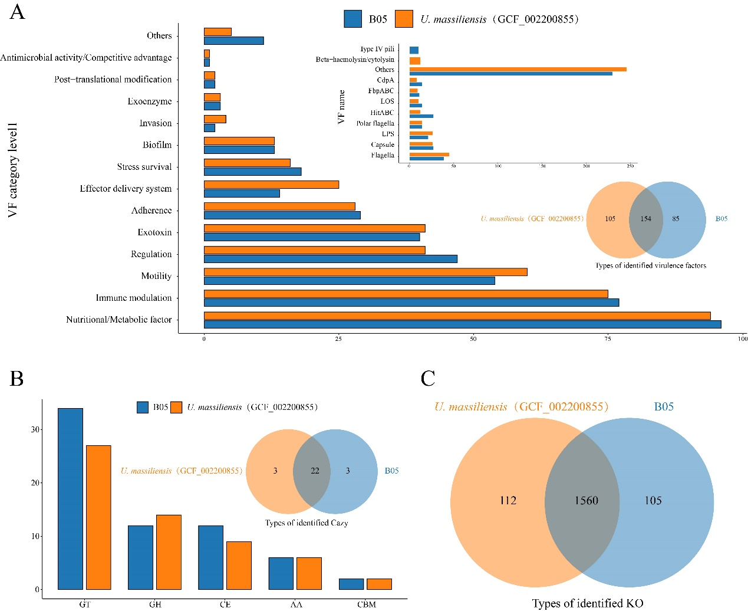
Supplementary Figure 4. A comparative analysis was conducted on the annotation results of strain B05 and GCF_002200855 in the VFDB, CAZy, and KEGG. (A) The bar chart illustrates the comparison of B05 and GCF_002200855 at the VF category level 1 and VF_name levels. The Venn diagram highlights the unique and shared VF types between B05 and GCF_002200855. (B) The bar chart illustrates the distribution of CAZyme families in strains B05 and GCF_002200855, highlighting both their differences and shared features. (C) The Venn diagram depicts the number of unique and shared KO categories between strains B05 and GCF_002200855.

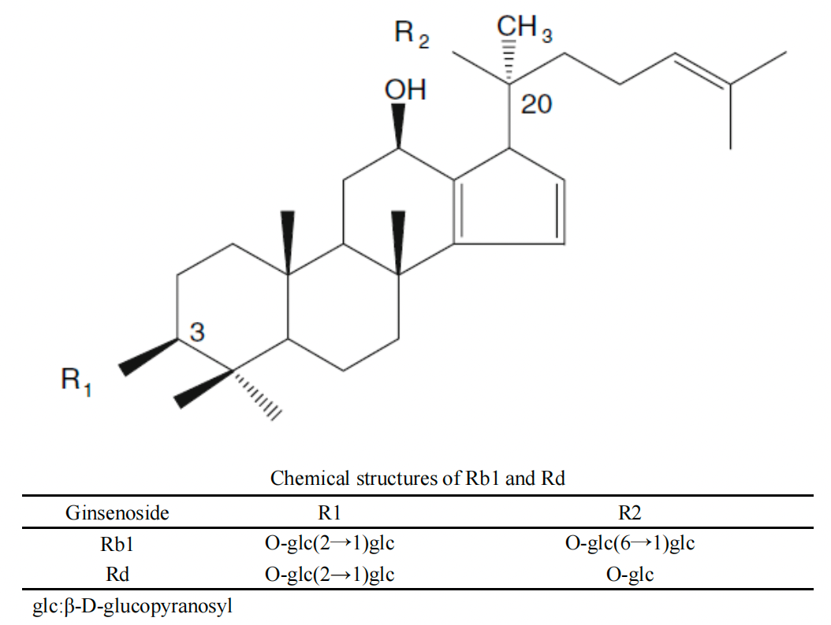
Supplementary Figure 5. Chemical structures of Rb1 and Rd [1].

References
1. Zhao X, Wang J, Li J, Fu L, Gao J, Du X, et al. Highly selective biotransformation of ginsenoside Rb1 to Rd by the phytopathogenic fungus Cladosporium fulvum (syn. Fulvia fulva). Journal of Industrial Microbiology & Biotechnology. 2009;36(5):721-6.

