Supplementary data
Table 1. Prevalence of the isolated bacterial strains among different isolation sources.
 | HW  (107 isolates ( |  | CW  (64 isolates) |  | WWTP influent  (76 isolates) |  | WWTP effluent  (55 isolates)
 | No. | % * | No. | % * | No. | (% * | No. | % *
Escherichia coli | 32 | 29.9% | 18 | 28.1% | 24 | 31.6% | 18 | 32.7%
Klebsiella pneumoniae | 31 | 29% | 16 | 25% | 20 | 26.3% | 14 | 25.5%
Staphylococcus aureus | 18 | 16.8% | 15 | 23.4% | 15 | 19.7% | 5 | 9.1%
Coagulase-negative staphylococci | 7 | 6.5% | 3 | 4.7% | 1 | 1.3% | 1 | 1.8%
Pseudomonas aeruginosa | 1 | 0.9% | 2 | 3.1% | 6 | 7.9% | 13 | 23.6%
Proteus vulgaris | 2 | 1.9% | 2 | 3.1% | 6 | 7.9% | 0 | 0.0%
Proteus mirabilis | 3 | 2.8% | 2 | 3.1% | 0 | 0.0% | 0 | 0.0%
Enterobacter spp. | 1 | 0.9% | 2 | 3.1% | 1 | 1.3% | 1 | 1.8%
Citrobacter spp. | 4 | 3.7% | 0 | 0.0% | 1 | 1.3% | 0 | 0.0%
Shigella spp. | 5 | 4.7% | 2 | 3.1% | 2 | 2.6% | 2 | 3.6%
Salmonella spp. | 2 | 1.9% | 1 | 1.6% | 0 | 0.0% | 0 | 0.0%
Acinetobacter spp. | 1 | 0.9% | 1 | 1.6% | 0 | 0.0% | 1 | 1.8%
*Percentages were correlated to the number of isolates in each source

Table 2. Antibiotic Resistance Profiles of E. coli Isolates
Isolate | Source | AZT | IMP | FEP | CN | CLM | SXT | LVX | TE | TPZ | AMS | CRO
E1 | Hospital | R | I | R | S | S | R | R | S | S | S | S
E2 | Hospital | R | S | R | I | S | R | R | S | S | S | S
E3 | Hospital | R | S | I | S | S | S | S | S | S | S | S
E4 | Community | S | S | S | R | S | S | S | S | S | S | S
E5 | WWTP effluent | R | S | R | S | S | S | S | S | S | S | S
E6 | WWTP effluent | R | R | R | I | S | S | S | S | S | R | R
E7 | Community | R | S | I | S | S | S | S | S | S | R | R
E8 | Community | I | S | I | S | S | S | S | S | S | S | S
E9 | Hospital | R | S | S | S | S | S | S | R | R | R | S
E10 | Hospital | R | R | R | S | R | R | I | R | R | R | S
E11 | WWTP influent | S | S | S | S | S | S | S | R | S | R | S
E12 | Hospital | R | S | S | S | S | R | S | R | S | R | S
E13 | Hospital | S | I | S | S | S | S | I | R | R | R | S
E14 | WWTP effluent | R | S | S | S | S | S | S | R | S | R | S
E15 | Hospital | R | I | R | S | S | R | I | R | R | R | S
E16 | Hospital | S | S | S | S | S | R | R | R | R | R | R
E17 | WWTP influent | S | S | S | R | R | R | R | R | S | R | R
E18 | WWTP effluent | S | S | S | S | S | R | R | S | I | R | R
E19 | Hospital | S | S | S | S | S | S | S | S | S | S | I
E20 | Hospital | S | S | S | S | S | S | S | R | S | S | I
E21 | Hospital | S | S | S | S | S | S | S | S | S | S | S
E22 | Hospital | S | I | S | S | S | S | S | S | S | S | R
E23 | Hospital | S | S | S | S | S | S | S | S | S | S | S
E24 | Hospital | S | S | S | S | S | S | S | S | S | S | S
E25 | Community | S | S | S | S | S | S | S | S | S | S | I
E26 | Community | S | S | S | S | R | S | S | I | R | I | S
E27 | Community | S | S | S | S | S | S | S | S | S | S | S
E28 | Community | S | S | S | S | S | S | S | S | S | S | S
E29 | Community | S | S | S | S | S | S | S | I | S | S | S
E30 | Community | S | R | S | S | S | S | S | S | S | S | S
E31 | Community | S | S | S | S | S | S | S | S | R | S | S
E32 | Community | S | S | S | S | S | S | S | S | S | S | S
E33 | Hospital | S | S | S | S | S | S | S | S | S | S | S
E34 | Hospital | S | S | S | S | S | S | S | S | S | S | S
E35 | Hospital | S | S | S | S | S | S | S | R | S | I | S
E36 | Hospital | S | S | S | S | S | S | S | S | S | I | S
E37 | Community | S | I | S | S | S | S | S | S | S | S | R
E38 | WWTP influent | R | S | R | S | S | R | R | R | I | R | S
E39 | WWTP influent | S | S | S | S | S | S | S | S | S | S | S
E40 | WWTP influent | R | S | S | S | S | R | S | S | S | S | S
E41 | WWTP effluent | S | S | S | S | S | S | S | S | S | S | S
E42 | WWTP effluent | S | S | S | S | S | S | S | S | S | S | S
E43 | WWTP effluent | S | S | S | S | S | S | S | S | S | S | S
E44 | WWTP effluent | S | S | S | S | S | S | S | S | S | S | S
E45 | WWTP effluent | S | S | S | S | S | S | S | S | S | S | S
E46 | WWTP effluent | S | S | S | S | S | S | S | S | S | S | S
E47 | Community | R | S | S | S | S | S | S | S | S | S | S
E48 | Community | S | S | S | S | S | S | S | I | S | S | S
E49 | Community | R | S | S | S | S | S | S | R | S | I | S
E50 | Community | R | S | S | S | S | S | S | R | S | S | S
E51 | Hospital | R | R | S | R | S | R | R | S | R | R | S
E52 | Hospital | R | R | S | S | R | R | R | R | R | R | S
E53 | Hospital | R | S | S | S | R | R | R | R | R | R | S
E54 | WWTP influent | S | S | S | S | S | S | S | R | S | R | R
E55 | WWTP influent | S | S | S | S | S | S | S | S | S | I | R
E56 | WWTP influent | S | S | S | S | S | S | S | R | S | R | R
E57 | WWTP influent | R | R | I | S | S | S | R | R | R | R | R
E58 | WWTP influent | S | S | S | S | R | S | R | R | S | R | R
E59 | WWTP influent | I | S | S | S | R | S | S | R | S | R | R
E60 | WWTP influent | R | I | R | I | S | S | R | R | S | R | R
E61 | WWTP influent | I | S | S | S | R | S | R | I | S | I | R
E62 | WWTP influent | R | S | S | S | R | S | R | I | S | S | R
E63 | WWTP influent | S | S | S | S | S | S | S | S | S | S | S
E64 | WWTP influent | S | S | S | S | S | S | S | S | S | S | S
E65 | WWTP influent | S | S | S | S | S | S | S | I | S | S | R
E66 | WWTP influent | S | S | S | S | S | S | S | S | S | R | S
E67 | WWTP influent | I | S | S | S | S | S | S | S | S | S | R
E68 | WWTP influent | S | S | S | S | S | S | S | S | S | S | S
E69 | WWTP influent | S | S | S | S | S | S | S | S | S | R | S
E70 | Hospital | S | S | S | S | S | S | S | R | S | I | R
E71 | Hospital | I | S | S | S | S | S | S | R | S | R | S
E72 | Hospital | S | S | S | S | S | S | S | S | S | R | S
E73 | Hospital | S | S | S | S | S | S | S | S | S | S | R
E74 | Hospital | S | S | S | S | S | S | S | R | S | S | R
E75 | Hospital | R | S | S | S | R | S | S | R | S | R | R
E76 | Hospital | S | S | S | S | R | S | S | I | S | S | R
E77 | Hospital | R | S | S | S | S | S | S | R | S | R | R
E78 | Hospital | S | S | S | S | S | S | S | S | S | S | R
E79 | WWTP effluent | S | S | S | S | S | S | S | S | R | R | S
E80 | WWTP effluent | S | S | S | S | S | S | S | S | R | S | S
E81 | WWTP effluent | S | S | S | S | S | S | S | S | S | R | S
E82 | WWTP effluent | S | S | S | S | S | S | S | S | S | S | S
E83 | WWTP effluent | S | S | S | S | S | S | S | S | S | R | S
E84 | Community | S | S | S | S | S | S | S | S | S | S | S
E85 | WWTP effluent | I | S | S | S | S | S | S | S | S | S | S
E86 | Hospital | I | S | S | S | S | S | S | S | S | I | S
E87 | WWTP effluent | I | S | S | S | S | S | S | S | S | S | S
E88 | Community | S | R | S | S | R | S | S | I | S | R | R
E89 | WWTP effluent | S | S | S | S | S | S | S | S | S | I | S
E90 | WWTP influent | S | S | S | S | S | S | S | S | S | R | S
E91 | WWTP influent | I | S | S | S | S | S | S | S | S | R | R
E92 | WWTP influent | I | S | S | S | S | S | S | S | S | S | R
R = Resistant, S = Sensitive, I = Intermediate
AZT = Aztreonam, IMP = Imipenem, FEP = Cefepime, CN = Gentamycin, CLM = Chloramphenicol, SXT = Trimethoprim/Sulphamethoxazole, LVX = Levofloxacin, TE = Tetracycline, TZP = Piperacillin/Tazobactam, AMS = Ampicillin/Sulbactam, CRO = Ceftriaxone.

Table 3. MDR patterns of E. coli isolates
MDR pattern | Source
AZT, FEP, SXT, LVX* | Hospital
AZT, IMP, FEP, AMS, CRO | WWTP effluent
AZT, AMS, CRO | Community
AZT, TE, TPZ, AMS | Hospital
AZT, IMP, FEP, CLM, SXT, TE, TPZ, AMS | Hospital
AZT, SXT, TE, AMS | Hospital
AZT, TE, AMS | WWTP effluent
AZT, FEP, SXT, TE, TPZ, AMS | Hospital
SXT, LVX, TE, TPZ, AMS, CRO | Hospital
CN, CLM, SXT, LVX, TE, AMS, CRO | WWTP influent
SXT, LVX, AMS, CRO | WWTP effluent
AZT, FEP, SXT, LVX, TE, AMS | WWTP influent
AZT, IMP, CN, SXT, LVX, TE, TPZ, AMS | Hospital
AZT, IMP, CLM, SXT, LVX, TE, TPZ, AMS | Hospital
TE, AMS, CRO* | Hospital, WWTP influent
AZT, IMP, LVX, TE, AMS, CRO | WWTP influent
CLM, LVX, TE, AMS, CRO | WWTP influent
CLM, TE, AMS, CRO | WWTP influent
AZT, FEP, LVX, TE, AMS, CRO | WWTP influent
CLM, LVX, CRO | WWTP influent
AZT, CLM, LVX, CRO | WWTP influent
AZT, CLM, TE, AMS, CRO | Hospital
AZT, TE, AMS, CRO | Hospital
IMP, CLM, AMS, CRO | Community
*Two isolates had this resistance pattern
AZT = Aztreonam, IMP = Imipenem, FEP = Cefepime, CN = Gentamycin, CLM = Chloramphenicol, SXT = Trimethoprim/Sulphamethoxazole, LVX = Levofloxacin, TE = Tetracycline, TZP = Piperacillin/Tazobactam, AMS = Ampicillin/Sulbactam, CRO = Ceftriaxone.

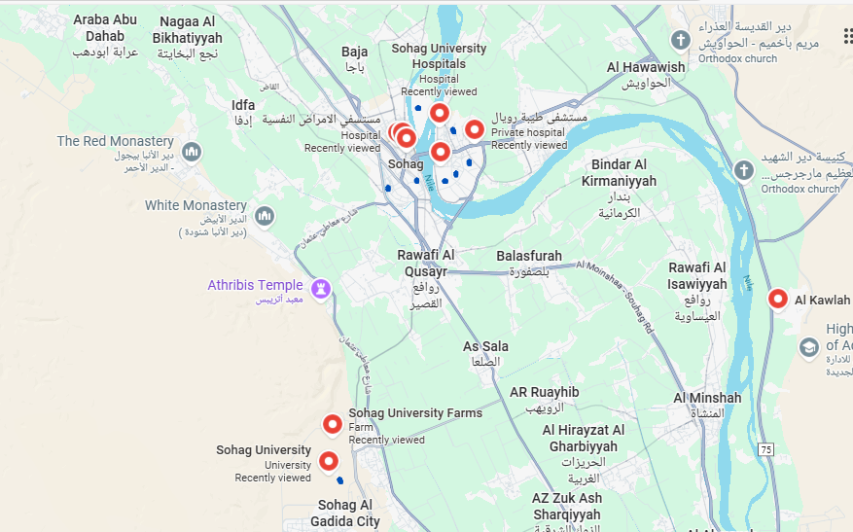
Fig 1. Map showing the sampling locations in Sohag City, Egypt. Red markers indicate Sohag University Hospital, Masr Hospital, Tiba Royal Hospital, Sohag University, and Al Kawlah Wastewater Treatment Plant (WWTP). Blue markers represent approximate residential sites and student dormitory, where community wastewater samples were collected.

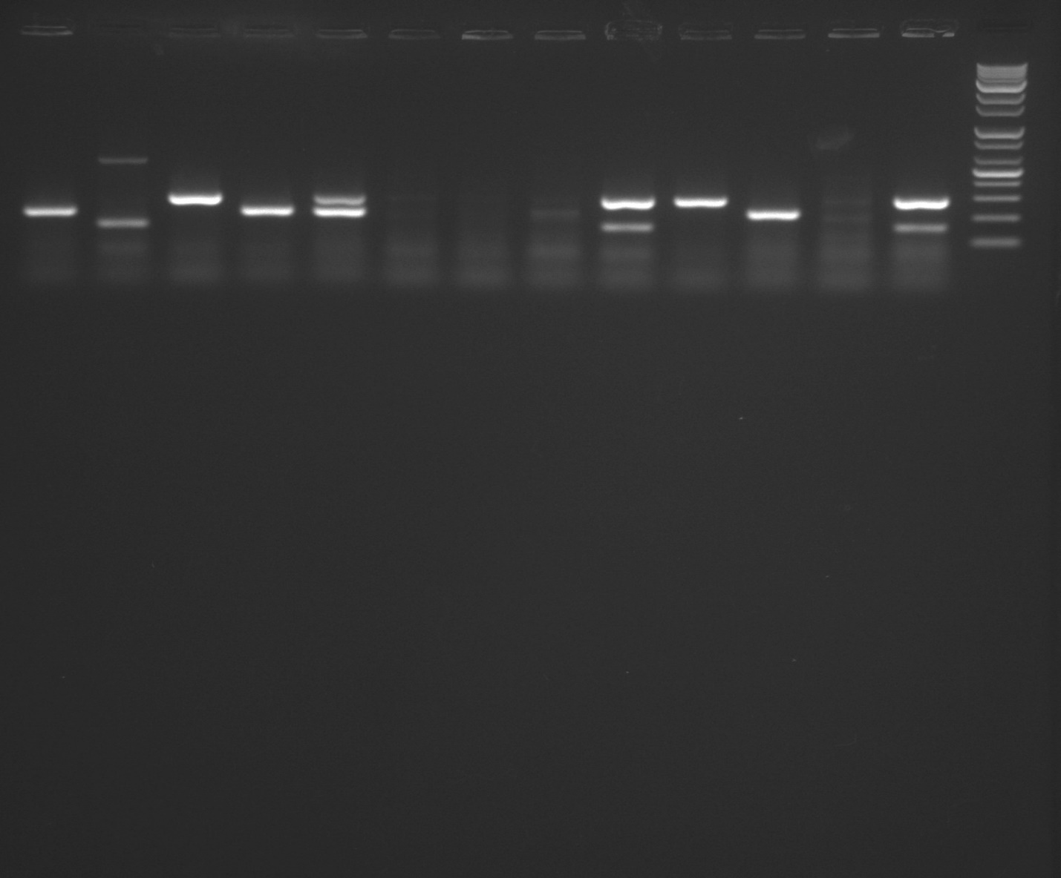
13 12 11 10 9 8 7 6 5 4 3 2 1 M
ChuA
211 bp
279 bp
YjaA
TspE4.C2
152 bp
Fig 2. Triplex PCR profiles specific for chuA and yjaA genes and DNA fragment TSPE4.C2. Lane M: 10 kb molecular weight marker; lane 1, 5: ChuA (279 bp) and TspE4.C2 (152 bp); lane 3,10,13: YjaA (200 bp); lane 4,11: ChuA (279 bp); lane 9: ChuA (279 bp) and YjaA (211 BP).

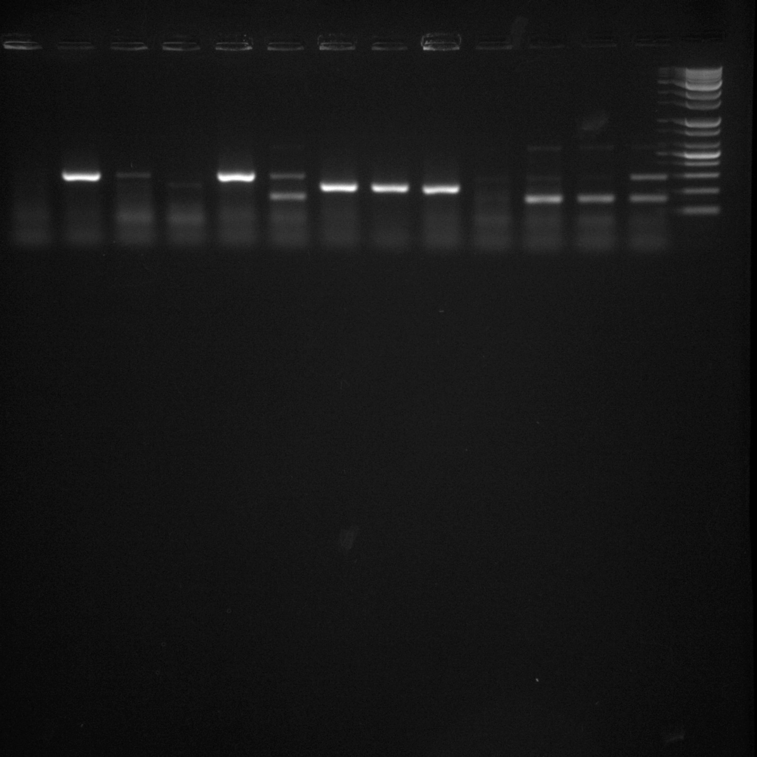
ChuA
YjaA
TspE4C2
TspE4C2
279 bp
200 bp
211 bp
152 bp
13 12 11 10 9 8 7 6 5 4 3 2 1 M
Fig 3. Triplex PCR profiles specific for chuA and yjaA genes and DNA fragment TSPE4.C2. Lane M: 10 kb molecular weight marker; lane 1, 8: ChuA (279 bp) and TspE4.C2 (152 bp); lane 2, 3: TspE4.C2 (152 bp); lane 5,6,7: YjaA (211 bp); lane 9, 11, 12: ChuA (279 bp).

19 18 17 16 15 14 13 12 11 10 9 8 7 6 5 4 3 2 1 M
bla_{TEM}
bla_{SHV}
bla_{CTX-M}
404 bp
294 bp
294 bp
754 bp
Fig 4. Triplex PCR profiles specific for bla_{TEM}, bla_{SHV,} and bla_{CTX-M}. Lane M: 10 kb molecular weight marker; lane 1,2,14,16: bla_{CTX-M} (754 bp) and bla_{TEM} (404 bp); lane 3,5,7,12: bla_{CTX-M} (754 bp); lane 10: bla_{SHV} (294 bp); lane 13: bla_{TEM} (404 bp) and bla_{SHV} (294 bp); lane 15: bla_{TEM} (404 bp).
754 bp
404 bp
M 1 2 3 4 5 6 7 8 9 10 11 12 13 14 15 16 17 18 19
bla_{TEM}
bla_{CTX-M}
Fig 5. Triplex PCR profiles specific for bla_{TEM}, bla_{SHV,} and bla_{CTX-M}. Lane M: 10 kb molecular weight marker; lane 1,2,12,18: bla_{TEM} (404 bp) and bla_{CTX-M} (754 bp); lane 5,7,11,17,19: bla_{CTX-M} (754 bp); lane 13,14,16: bla_{TEM} (404 bp).

19 18 17 16 15 14 13 12 11 10 9 8 7 6 5 4 3 2 1 M
bla_{OXA-48}
bla_{NDM}
438 bp
621 bp
Fig. 6. Triplex PCR profiles specific for bla_{KPC}, bla_{NDM,} and bla_{OXA-48}. Lane M: 10 kb molecular weight marker; lane 5,7,8,9,13,14: bla_{OXA-48} (438 bp); lane 16: bla_{OXA-48} (438 bp) and bla_{NDM} (621 bp); lane 18: bla_{NDM} (621 bp).

18 17 16 15 14 13 12 11 10 9 8 7 6 5 4 3 2 1 M
190 bp
450 bp
LT
ST
Fig 7. PCR profiles specific for enterotoxigenic E.coli. Lane M: 10 kb molecular weight marker; lane 11: LT (450 bp) and ST (190 bp); lane 16, 17, 18: ST (190 bp).

