- The original gel image of Figure S1a, the results of LAMP amplification using specific primers. M: D2000; 1-15: numbers as the strain numbers in Table 1, N: negative control.
1
M
2
3
4
6
8
10
12
14
5
7
9
11
13
15
N
- The original gel image of Figure 1a, agarose gel electrophoresis showing characteristic ladder-like banding pattern of LAMP products. M: DL2000 DNA marker; lanes 1-15: test strains corresponding to Table 1 (lane 8: F. tricinctum positive control); N: no-template negative control.
1
M
2
3
4
6
8
10
12
14
5
7
9
11
13
15
N
- The original gel image of Figure S2, the schematic diagram of the result of nested PCR amplification using specific primers. (a) primer CYP-4F/R.
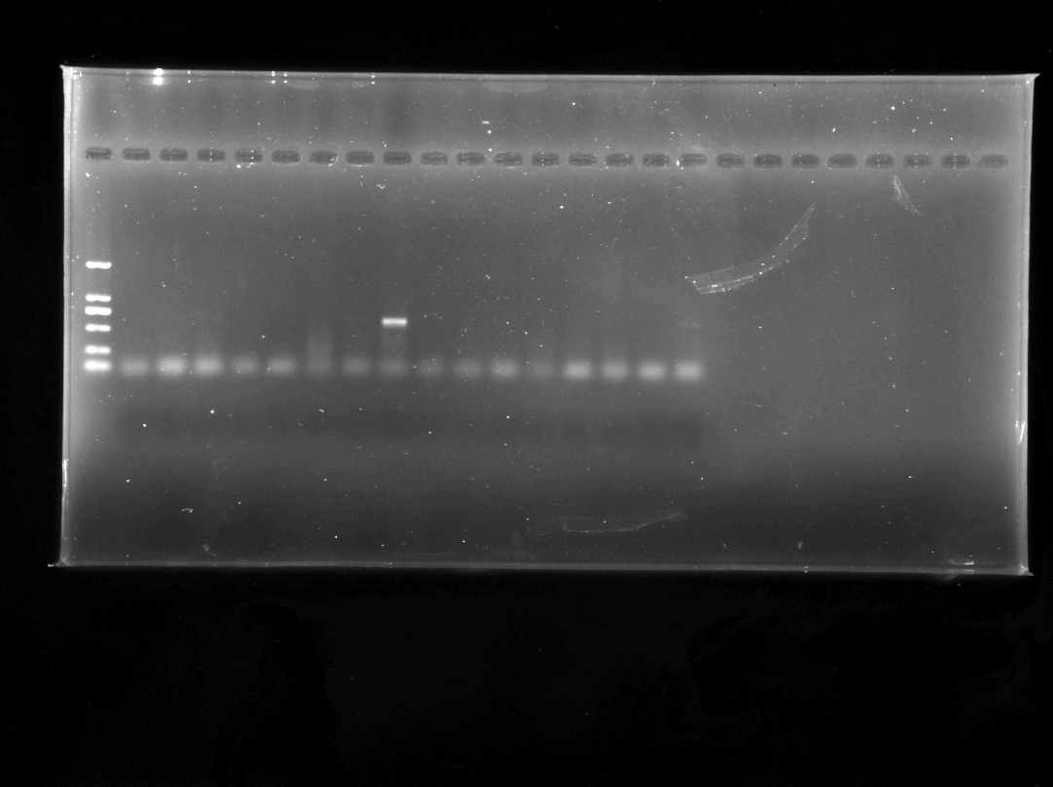
1
M
2
3
4
6
8
10
12
14
5
7
9
11
13
15
CK
(b) primer C4-10F/R. M: D2000; 1-15: numbers as the strain numbers in Table 1, CK: negative control.
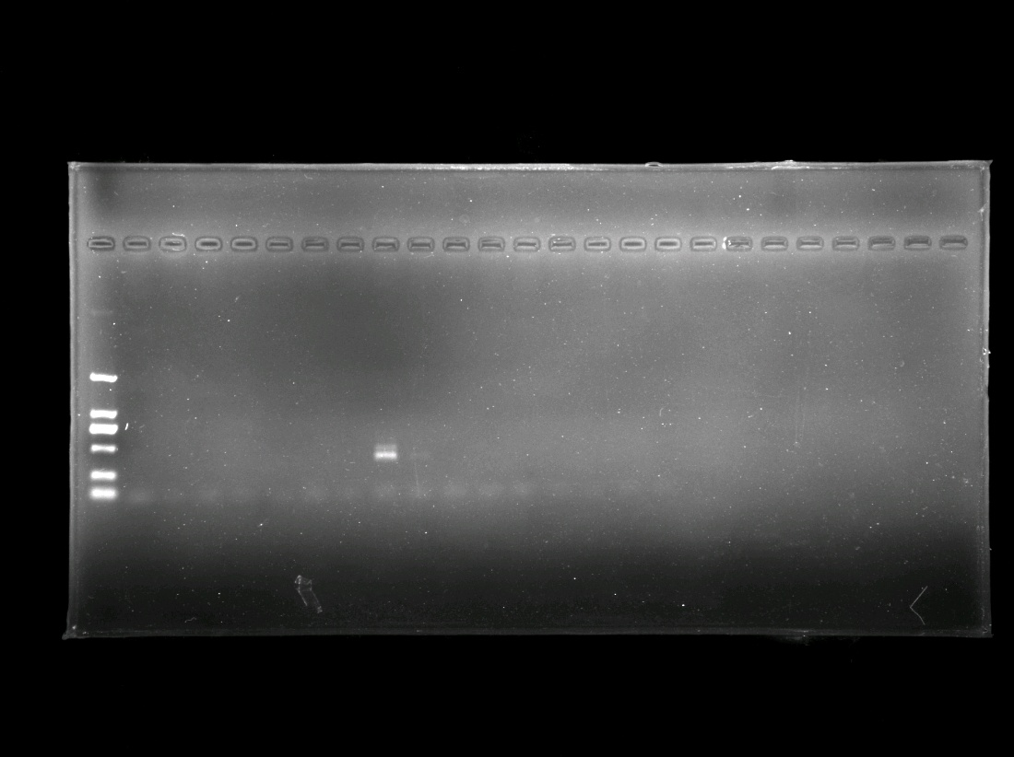
1
M
2
3
4
6
8
10
12
14
5
7
9
11
13
15
CK
- The original gel image of Figure 2, Specificity evaluation of nested PCR for Fusarium tricinctum detection. M: DL2000 DNA marker; lanes 1-15: test strains (lane 8: F. tricinctum); CK: negative control (ddH₂O).
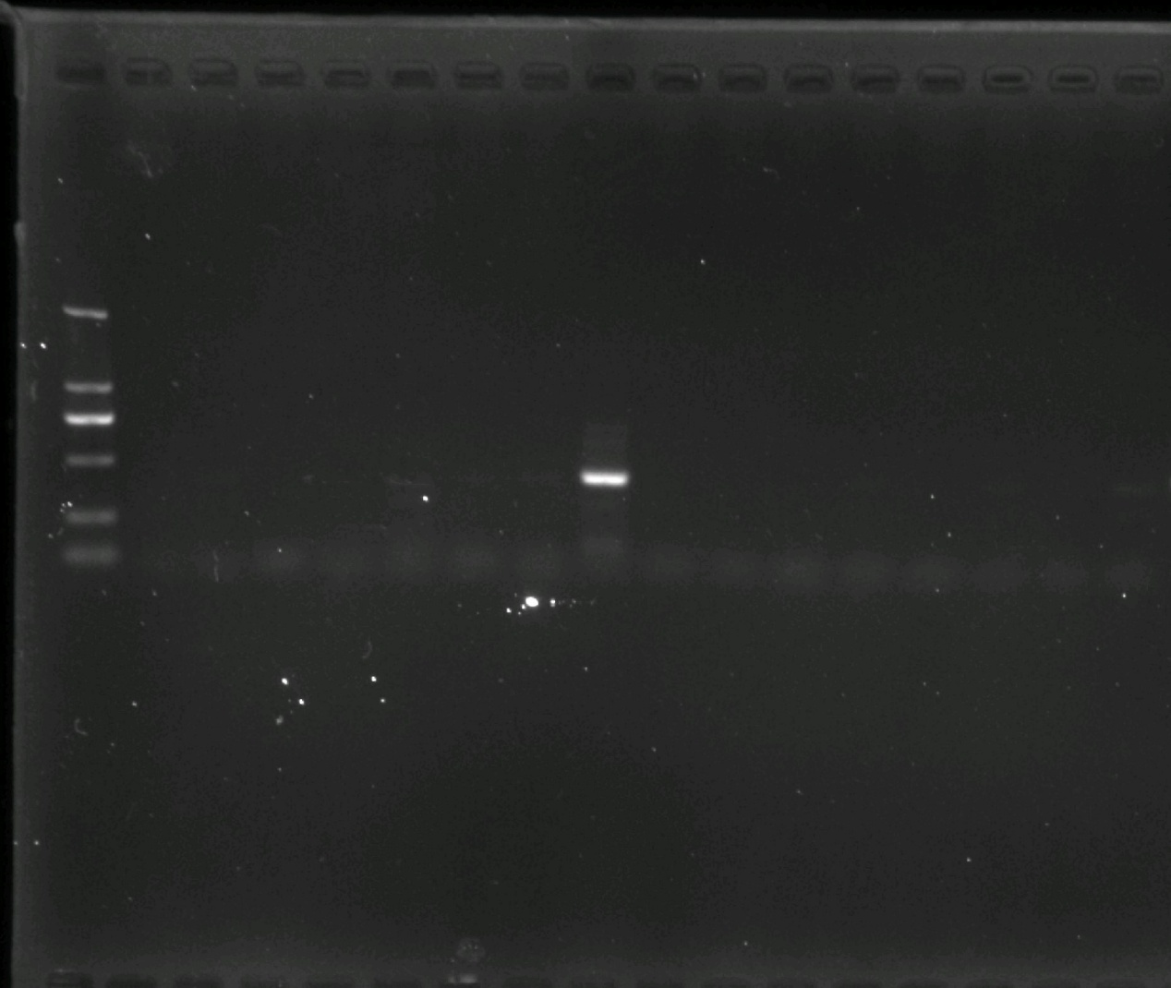
1
M
2
3
4
6
8
10
12
14
5
7
9
11
13
15
CK
- The original gel image of Figure S3, a schematic diagram of the result of general PCR amplification using specific primers CP-1F/ R. M: D2000; 1-15: numbers as the strain numbers in Table 1, CK: negative control.
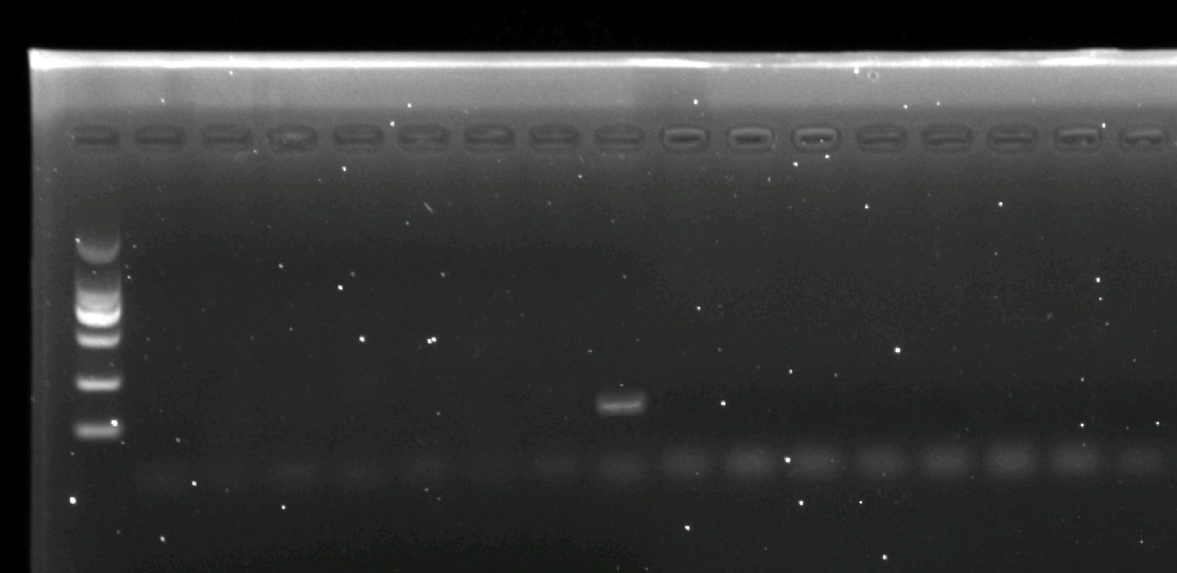
1
M
2
3
4
6
8
10
12
14
5
7
9
11
13
15
CK
- The original gel image of Figure S4a, sensitivity of LAMP for detection of F. tricinctum. M: D2000; 1-8: 31 ng/μL, 3.1 ng/μL, 310 pg/μL, 31 pg/μL, 3.1 pg/μL, 310 fg/μL, 31 fg/μL, 3.1 fg/μL; 9: Negative control.

1
M
2
3
4
6
8
5
7
9
- The original gel image of Figure S5, Sensitivity of nested PCR and general PCR for detection of F. tricinctum. (a) nested PCR.
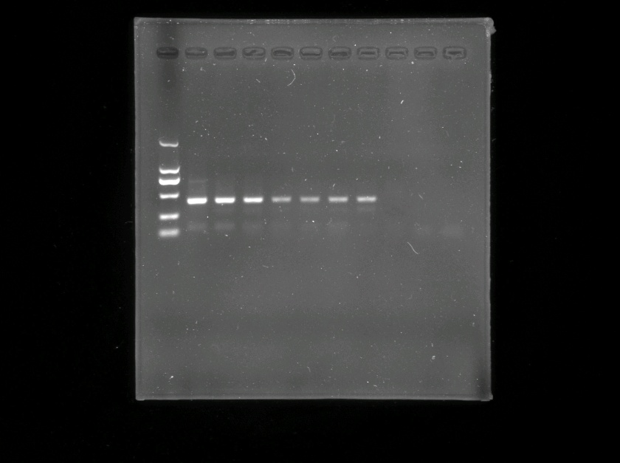
1
M
2
3
4
6
8
5
7
9
(b) general PCR. M: D2000; 1-8: 31 ng/μL, 3.1 ng/μL, 310 pg/μL, 31 pg/μL, 3.1 pg/μL, 310 fg/μL, 31 fg/μL, 3.1 fg/μL; 9: Negative control.
1
M
2
3
4
6
8
5
7
9
- The original gel image of Figure S6c, sensitivity of general PCR. M: D2000; 1-8: 31 ng/μL, 3.1 ng/μL, 310 pg/μL, 31 pg/μL, 3.1 pg/μL, 310 fg/μL, 31 fg/μL, 3.1 fg/μL; 9: Negative control.
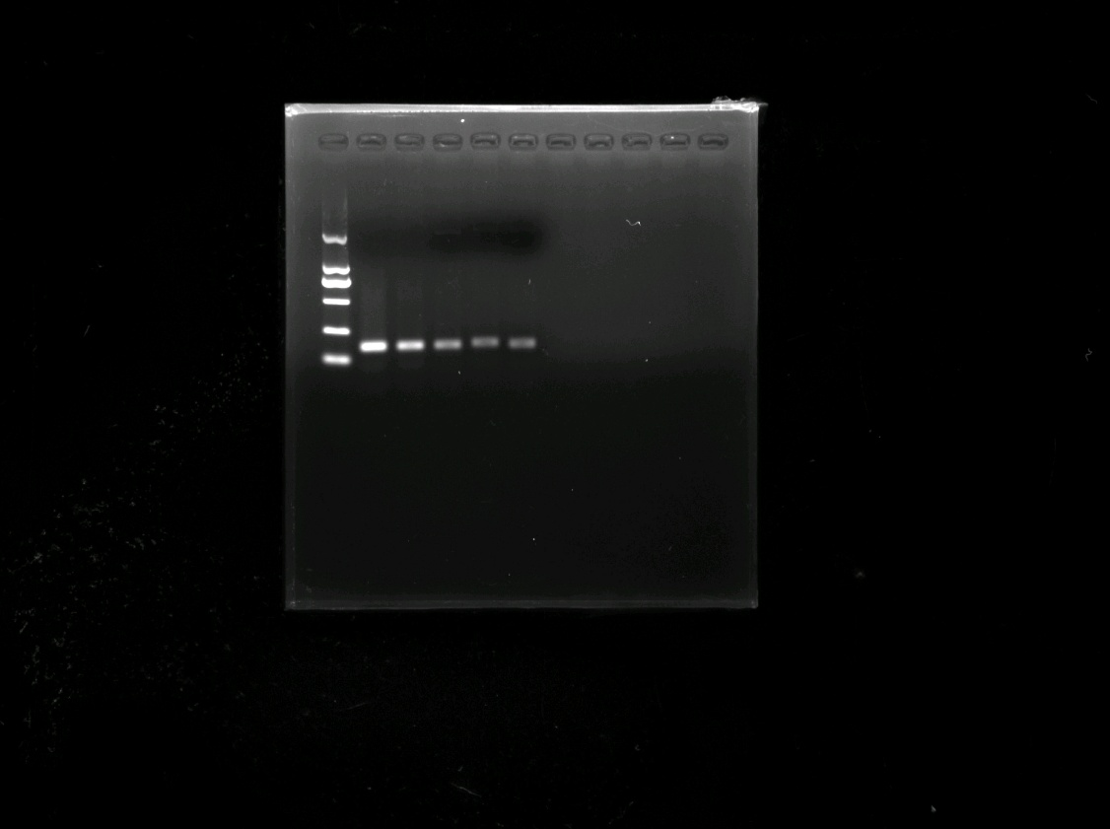
1
M
2
3
4
6
8
5
7
9

