Aztreonam Intervention Recalibrates Microbial Interactions Between Pseudomonas aeruginosa and Streptococcus salivarius
Shiyi Gouª, Mengna Fengª, Yi Wuª, Yang Yuan^{b}, Xin Huª, XiTing Yangª, Yiwen Chuª, Ting Huangª, Kelei Zhaoª*
ªAntibiotics Research and Re-evaluation Key Laboratory of Sichuan Province, School of Pharmacy, Chengdu University, Chengdu 610106, China
^{b} Sichuan Key Laboratory of Conservation Biology on Endangered Wildlife, College of Life Sciences, Sichuan University, Chengdu 610064, China
* Correspondence:
Kelei Zhao, Antibiotics Research and Re-evaluation Key Laboratory of Sichuan Province, School of Pharmacy, Chengdu University, Chengdu 610106, Sichuan, China. Email: zhaokelei@cdu.edu.cn

This file contains Supplementary Figs S1-S9, Tables S1-S2, and Additional files 1-6.
Supplementary Figures
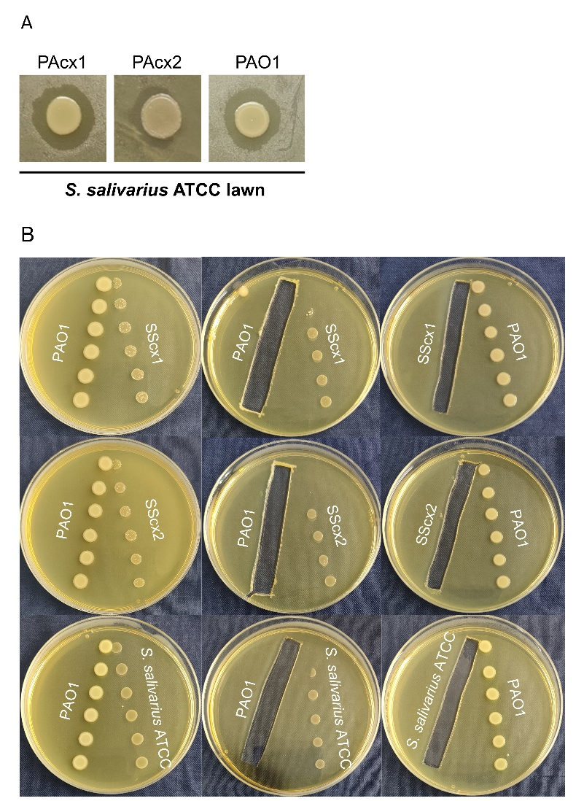
Supplementary figure 1. Interaction of clinical P.aeruginosa , PAO1, clinical S. salivarius, and S. salivarius ATCC 27945 on drug-free agar plates. A. Clinical P.aeruginosa and PAO1 form inhibition zones of varying sizes on the S. salivarius ATCC 27945 lawn. B. The extracellular products of PAO1 significantly inhibit the growth of both clinical S. salivarius and S. salivarius ATCC 27945, while clinical S. salivarius and S. salivarius ATCC 27945 have no significant effect on PAO1.
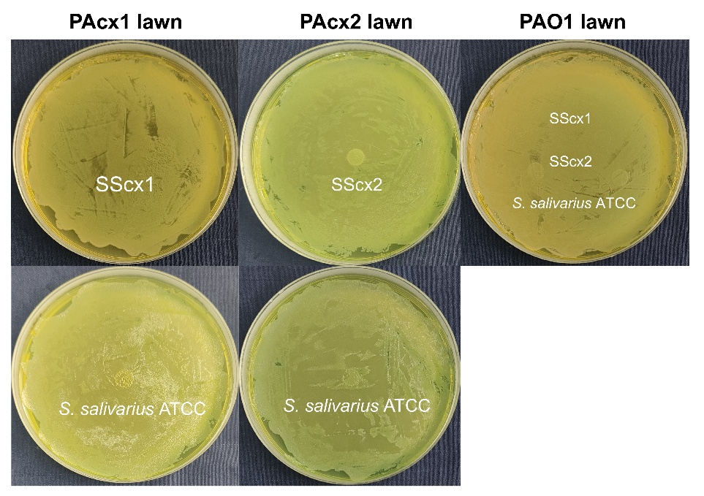
Supplementary figure 2. Growth of clinical S. salivarius and S. salivarius ATCC 27945 on clinical P.aeruginosa and PAO1 lawns. Neither clinical S. salivarius nor the standard S. salivarius strain grows on P. aeruginosa lawns.

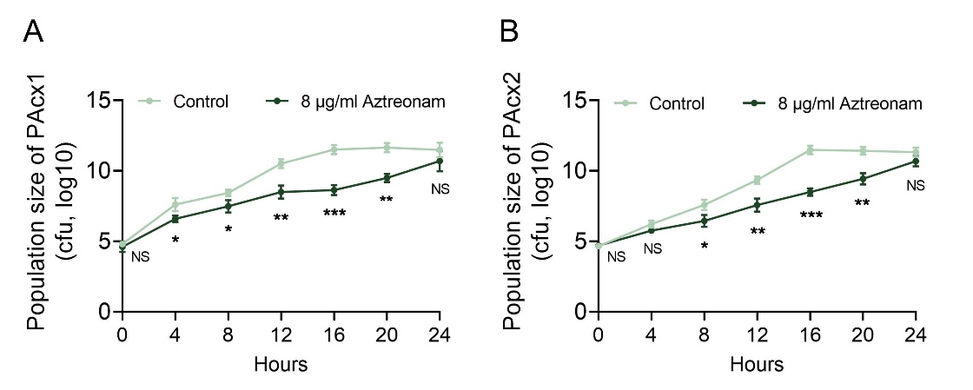
Supplementary figure 3. Effect of sub-inhibitory aztreonam on the 24-hour monoculture of P. aeruginosa. A. Sub-inhibitory aztreonam has minimal effect on the growth of PAcx1. B. Sub-inhibitory aztreonam has minimal effect on the growth of PAcx2. Data shown are the means (lines) for three independent replicates (circles). The presented data represent the mean ± standard deviation (SD) of three independent experiments, with statistical comparisons performed using a two-tailed paired t-test. *, p < 0.1; **, p < 0.01; ***, p < 0.001; NS, not significant.

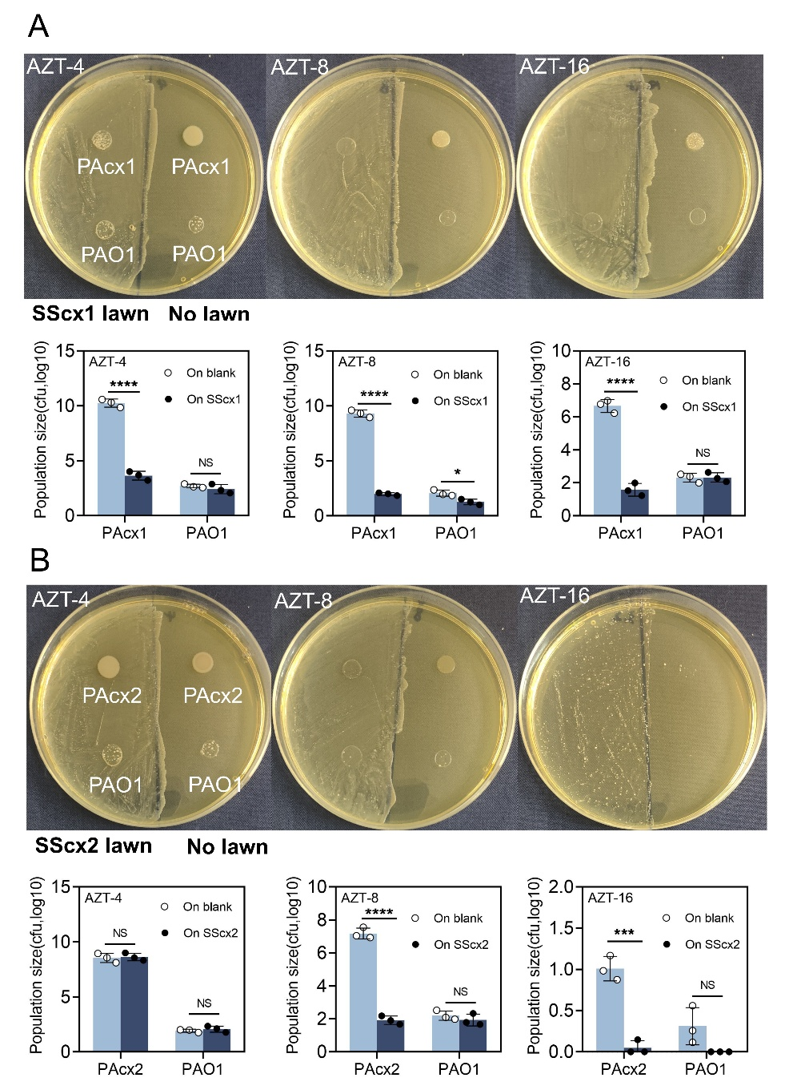
Supplementary figure 4. Growth of P. aeruginosa on aztreonam plates containing gradient concentrations (μg/mL), with or without S. salivarius lawns. A. Growth status and CFU enumeration of strain PAcx1. B. Growth status and CFU enumeration of strain PAcx2, (using PAO1 as the control strain). The most prominent phenotypic changes were observed at an aztreonam concentration of 8 µg/mL. The presented data represent the mean ± standard deviation (SD) of three independent experiments, with statistical comparisons performed using a two-tailed paired t-test. *, p < 0.1; **, p < 0.01; ***, p < 0.001; ****, p < 0.0001; NS, not significant.
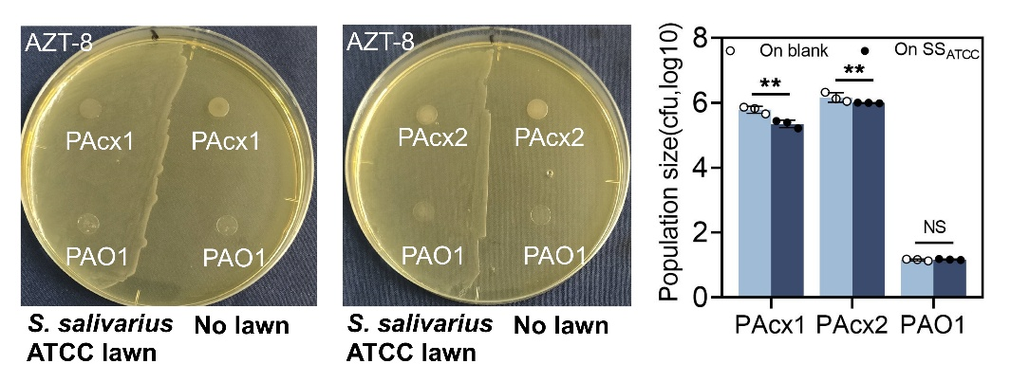
Supplementary figure 5. Comparison of the growth of clinical P. aeruginosa strains and PAO1 on S. salivarius ATCC 27945 lawns and plates with no lawn containing aztreonam. Both PAcx1 and PAcx2 growth are inhibited by S. salivarius ATCC 27945, while PAO1 showed no significant change. The presented data represent the mean ± standard deviation (SD) of three independent experiments, with statistical comparisons performed using a two-tailed paired t-test. **, p < 0.01; NS, not significant.
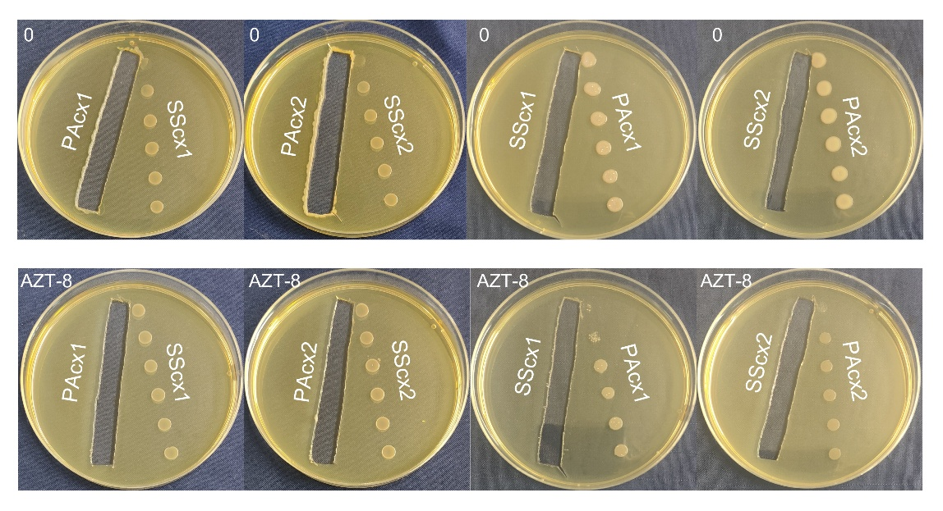
Supplementary figure 6. Aztreonam reverses the mutual inhibitory effects of extracellular products between clinical P.aeruginosa and clinical S. salivarius. The wells were made by removing the bacterial lawns of clinical P.aeruginosa and S. salivarius after 24 hours of growth, followed by culturing the remaining P.aeruginosa and S. salivarius on their respective extracellular products for 24 hours. The experiment was performed on both blank BHI plates (top) and BHI plates containing a sub-inhibitory concentration of aztreonam (bottom).

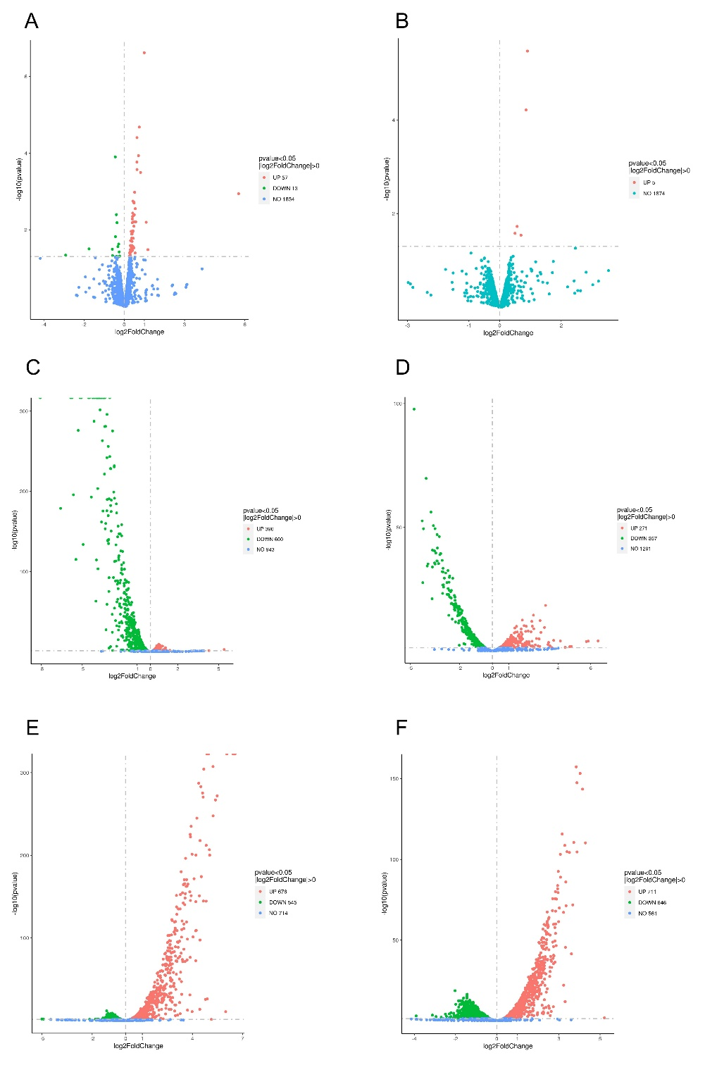
Supplementary figure 7. Volcano plot changes of S. salivarius in co-culture and monoculture conditions. A. Impact of aztreonam on SScx1 monoculture genes. B. Impact of aztreonam on SScx2 monoculture genes. C. Effect of PAcx1 on SScx1 genes under drug-free conditions. D. Effect of PAcx2 on SScx2 genes under drug-free conditions. E. Effect of PAcx1 on SScx1 genes under aztreonam conditions. F. Effect of PAcx2 on SScx2 genes under aztreonam conditions. Red represents upregulated genes, green represents downregulated genes, and blue represents genes with no significant changes.

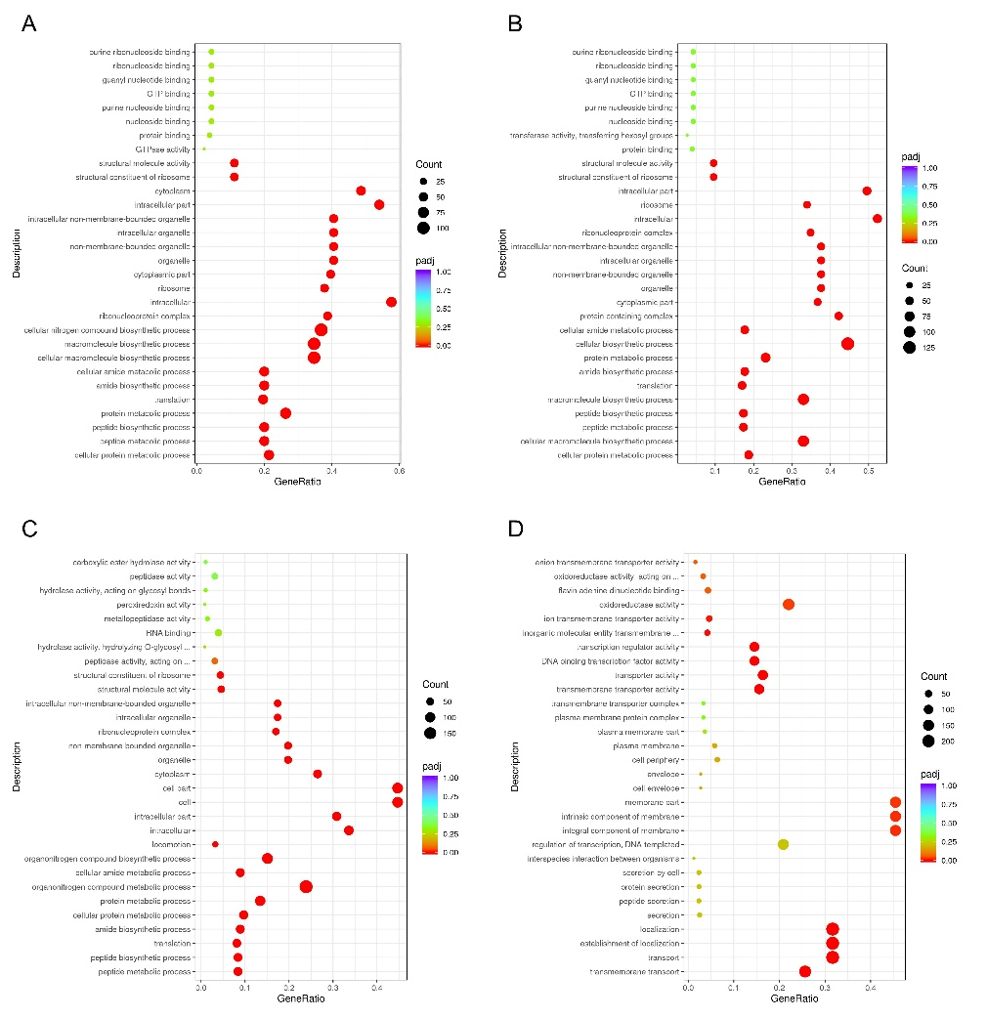
Supplementary figure 8. GO pathways differentially regulated by aztreonam intervention in P. aeruginosa and S. salivarius during co-culture. A. GO pathways upregulated in SScx1 due to aztreonam during co-culture. B. GO pathways upregulated in SScx2 due to aztreonam during co-culture. C. GO pathways downregulated in PAcx1 due to aztreonam during co-culture. D. GO pathways downregulated in PAcx2 due to aztreonam during co-culture.
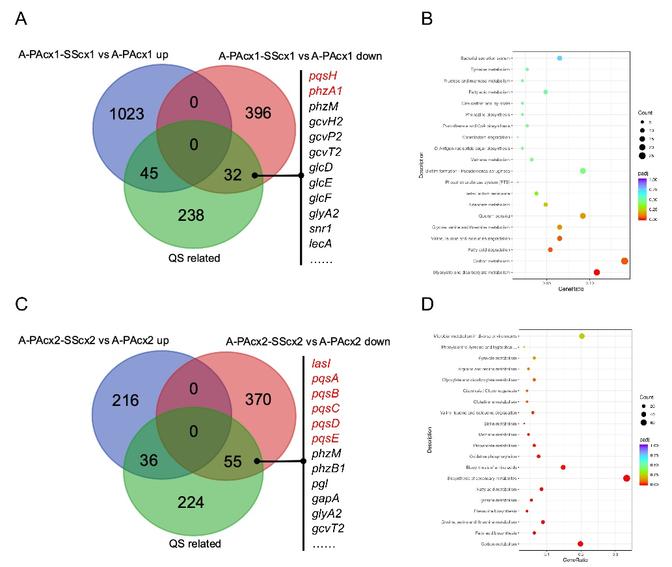
Supplementary figure 9. The effects of S. salivarius intervention on the QS genes and metabolism of P. aeruginosa under aztreonam treatment. A. Differential effects of SScx1 intervention on the QS genes of PAcx1 under aztreonam treatment. B. Downregulation of KEGG pathways in PAcx1 by SScx1 intervention under aztreonam treatment. C. Differential effects of SScx2 intervention on the QS genes of PAcx2 under aztreonam treatment. D. Downregulation of KEGG pathways in PAcx2 by SScx2 intervention under aztreonam treatment.

Supplementary Table S1. Primers used in this study
Gene | Sequence (5’-3’)
lasRrtF | CTTCATCGTCGGCAACTAC
lasRrtR | GTCTGGTAGATGGACGGTTC
lasBrtF | ATCGGCTACGACATCAAGAAGG
lasBrtR | CCGCTGTTGTAGTTGCTGGTG
rhlRrtF | GCTCCTCGGAAATGGTGGT
rhlRrtR | GGAAAGCACGCTGAGCAAAT
rhlArtF | ACTGAACCAGGCGATGCTC
rhlArtR | GCTCCAGGCAAGCCAAGTA
mvfRrtF | CACTGGTTGAAGCGGGAGA
mvfRrtR | TCGTTCTGCGATACGGTGAG
pqsArtF | GCTGAGCGGTCCTTTGGC
pqsArtR | TGGAACCCGAGGTGTATTGC
phzA1rtF | GCAACTGGACCACGGAAAG
phzA1rtR | GCACGCAGTTTCTGTATCGG
16SrtF | TCGCATCCTGTTGTCCTCCA
16SrtR | TTAGCCAGGGTCAGCGTCA

Supplementary Table S2. Minimal inhibitory concentrations (μg/mL) of antibiotics on the strains used in this study.
 | Aztreonam | Piperacillin | Imipenem | Gentamycin
PAcx1 | 16 | 8 | 4 | 1.6
PAcx2 | 16 | 16 | 4 | 1.6
PAO1 | 8 | 0.4 | <0.2 | 0.4
SScx1 | 128 | 16 | 8 | 2
SScx2 | 128 | 16 | 8 | 4
S.salivarius ATCC 27945 | 64 | 0.8 | 0.8 | <0.2

Additional file 1. Significantly differentially expressed genes of PAcx1 after SScx1 intervention under no drug treatment.
Additional file 2. Significantly differentially expressed genes of PAcx2 after SScx2 intervention under no drug treatment.
Additional file 3. Significantly differentially expressed genes of PAcx1 in monoculture after aztreonam (8 μg/mL) treatment.
Additional file 4. Significantly differentially expressed genes of PAcx2 in monoculture after aztreonam (8 μg/mL) treatment.
Additional file 5. Significantly differentially expressed genes of PAcx1 after SScx1 intervention under aztreonam (8 μg/mL) treatment.
Additional file 6. Significantly differentially expressed genes of PAcx2 after SScx2 intervention under aztreonam (8 μg/mL) treatment.

