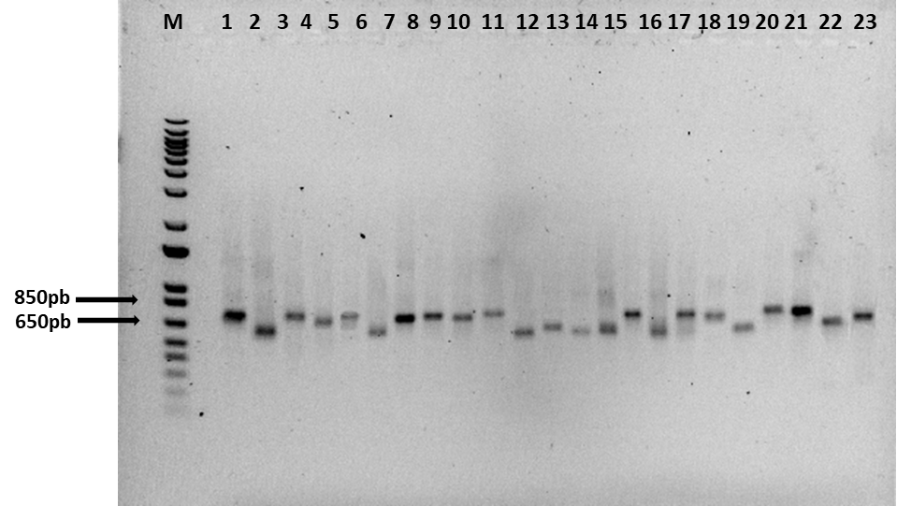
Additional File 5 Profiles of amplification of rDNA-internal transcribed spacer (ITS) region of collected plants obtained with ITS-u1 and ITS-u4 primers. Lane M = 1kb ladder; lanes 1-23 =collected plant samples.

