Supplementary Materials

The evolution of the multidrug-resistant and globally distributed ST2 Acinetobacter baumannii in China
Guili Zhang^{1,2,3,4#}, Yuan Zhou^{1,2,3,4#}, Bin Yan^{1,5}, Changbu Wu^{1,2,3,4}, Yanxian Yang^{1,6}, Tian Qiu⁷, Ji Wu^{1,2,3,4}, Shu’an Wen^{1,2,3,4}, Yuan Chen⁸, Xue Deng^{1,2,3,4}, Guo-Bao Tian^{1,2,3,4}, Lan-Lan Zhong^{1,2,3,4*}

Supplementary tables
Table S1 Detailed information on publicly available genomes.
Accession number | Collection date | Isolation source | Location
GCA_001863135.1 | 2012 | Sputum | China: Zhejiang
GCA_033129445.1 | 2016 | Sputum | China: Guangdong
GCA_000804635.1 | 2011 | Sputum | China: Beijing
GCA_004377785.1 | 2017 | NF | China: Chongqing
GCA_016496385.1 | 2010 | Sputum | China: Sichuan
GCA_001902375.1 | 2007 | NF | China: Beijing
GCA_004378395.1 | 2017 | NF | China: Chongqing
GCA_001680105.1 | 2013 | kidney preservation fluid | China: Zhejiang
GCA_033132035.1 | 2016 | Sputum | China: Guangdong
GCA_007999555.1 | 2017 | Sputum | China: Guangdong
GCA_016491295.1 | 2010 | Sputum | China: Beijing
GCA_000804735.1 | 2003 | Sputum | China: Beijing
GCA_016496625.1 | 2010 | Sputum | China: Xijiang
GCA_015694555.1 | 2008 | Sputum | China: Guangdong
GCA_013618855.1 | 2015 | Throat swab | China: Beijing
GCA_021389555.1 | 2018 | NF | China: Zhejiang
GCA_003007215.1 | 2013 | Blood | China: Guangdong
GCA_016609205.1 | 2019 | Ascites | China: Beijing
GCA_016478325.1 | 2018 | Sputum | China: Beijing
GCA_015694655.1 | 2010 | Blood | China: Guangdong
GCA_023361075.1 | 2018 | Blood | China: Zhejiang
GCA_020100175.1 | 2019 | Sputum | China: Zhejiang
GCA_033132515.1 | 2016 | Blood | China: Zhejiang
GCA_001861745.1 | 2013 | Sputum | China: Zhejiang
GCA_021387735.1 | 2018 | NF | China: Zhejiang
GCA_021386075.1 | 2018 | NF | China: Hebei
GCA_021387935.1 | 2018 | NF | China: Anhui
GCA_021388755.1 | 2018 | NF | China: Shandong
GCA_021389575.1 | 2018 | NF | China: Zhejiang
GCA_021385715.1 | 2018 | NF | China: Hunan
GCA_022759565.1 | 2018 | Ascites | China: Hebei
GCA_000804905.1 | 2005 | Sputum | China: Liaoning
GCA_023361175.1 | 2012 | Blood | China: Guangdong
GCA_023605085.1 | 2017 | Cerebrospinal fluid | China: Zhejiang
GCA_024258965.1 | 2018 | Cerebrospinal fluid | China: Zhejiang
GCA_024296145.1 | 2017 | Sputum | China: Zhejiang
GCA_025849595.1 | 2018 | NF | China: Beijing
GCA_030188715.1 | 2019 | Sputum | China: Sichuan
GCA_027084765.1 | 2021 | Blood | China: Zhejiang
GCA_028175765.1 | 2011 | Sputum | China: Beijing
GCA_025402915.1 | 2012 | Sputum | China: Guangdong
GCA_028550215.1 | 2021 | Sputum | China: Anhui
GCA_028549735.1 | 2021 | Sputum | China: Anhui
GCA_028548735.1 | 2022 | Sputum | China: Anhui
GCA_000226275.2 | 2006 | NF | China: Zhejiang
GCA_024259555.1 | 2018 | Sputum | China: Zhejiang
GCA_030193455.1 | 2021 | Sputum | China: Shandong
GCA_023362255.1 | 2005 | Sputum | China: Jiangsu
GCA_030449125.1 | 2016 | Sputum | China: Gansu
GCA_028550085.1 | 2021 | Sputum | China: Anhui
GCA_001862645.1 | 2011 | Sputum | China: Zhejiang
GCA_031197445.1 | 2019 | Blood | China: Jiangsu
GCA_031196715.1 | 2020 | Blood | China: Jiangsu
GCA_031196065.1 | 2021 | Blood | China: Jiangsu
GCA_031195995.1 | 2022 | Blood | China: Jiangsu
GCA_023606345.1 | 2018 | Blood | China: Zhejiang
GCA_033130515.1 | 2021 | Sputum | China: Shaanxi
GCA_005785125.1 | 2013 | Sputum | China: Guangdong
GCA_016496405.1 | 2010 | Sputum | China: Yunnan
GCA_033135325.1 | 2016 | Sputum | China: Shandong
GCA_033131515.1 | 2016 | Sputum | China: Shandong
GCA_033132455.1 | 2016 | Blood | China: Zhejiang
GCA_028177865.1 | 2011 | Sputum | China: Beijing
GCA_033137365.1 | 2016 | Sputum | China: Tianjin
GCA_033129035.1 | 2016 | Sputum | China: Beijing
GCA_033130415.1 | 2021 | Sputum | China: Liaoning
GCA_033133415.1 | 2016 | Sputum | China: Beijing
GCA_033133015.1 | 2016 | Sputum | China: Beijing
GCA_015731965.1 | 2017 | Sputum | China: Beijing
GCA_000342065.1 | 2005 | Sputum | China: Hong Kong
GCA_000787215.1 | 2012 | Sputum | China: Beijing
GCA_000805035.1 | 1999 | Sputum | China: Beijing
GCA_000805125.1 | 2011 | Sputum | China: Henan
GCA_000805295.1 | 2011 | Ascites | China: Beijing
GCA_001863115.1 | 2012 | Sputum | China: Zhejiang
GCA_001863315.1 | 2012 | Sputum | China: Zhejiang
GCA_006367805.1 | 2014 | Sputum | China: Zhejiang
GCA_015694505.1 | 2012 | Sputum | China: Guangdong
GCA_017096425.2 | 2014 | Blood | China: Liaoning
GCA_018454385.1 | 2021 | NF | China: Henan
GCA_019305885.1 | 2018 | Low respiratory tract | China: Guangdong
GCA_019314725.1 | 2018 | Low respiratory tract | China: Guangdong
GCA_021385095.1 | 2018 | NF | China: Anhui
GCA_021386055.1 | 2018 | NF | China: Liaoning
GCA_021386785.1 | 2018 | NF | China: Jiangxi
GCA_021388425.1 | 2018 | NF | China: Sichuan
GCA_021388875.1 | 2018 | NF | China: Jiangxi
GCA_021389035.1 | 2018 | NF | China: Zhejiang
GCA_022937495.1 | 2018 | Sputum | China: Jiangxi
GCA_023360995.1 | 2018 | Tracheal aspirate | China: Beijing
GCA_023361055.1 | 2018 | Blood | China: Liaoning
GCA_023361135.1 | 2012 | Broncho-alveolar lavage | China: Tianjin
GCA_023361255.1 | 2012 | Sputum | China: Xijiang
GCA_023361895.1 | 2010 | Blood | China: Beijing
GCA_023361915.1 | 2010 | Sputum | China: Guangdong
GCA_023362015.1 | 2014 | Blood | China: Tianjin
GCA_024258945.1 | 2018 | Sputum | China: Zhejiang
GCA_025859755.1 | 2018 | NF | China: Beijing
GCA_026704785.1 | 2017 | Sputum | China: Beijing
GCA_030188595.1 | 2019 | Sputum | China: Sichuan
GCA_030193175.1 | 2022 | Sputum | China: Shandong
GCA_030193195.1 | 2022 | Sputum | China: Shandong
GCA_030193435.1 | 2021 | Sputum | China: Shandong
GCA_030448505.1 | 2021 | Sputum | China: Gansu
GCA_030448765.1 | 2016 | Wound | China: Gansu
GCA_031197085.1 | 2020 | Blood | China: Jiangsu
GCA_033137385.1 | 2016 | Sputum | China: Shaanxi
GCA_033137405.1 | 2016 | Blood | China: Shaanxi
GCA_033136965.1 | 2016 | Sputum | China: Guangdong
GCA_033136845.1 | 2016 | Broncho-alveolar lavage | China: Guangdong
GCA_033135285.1 | 2016 | Sputum | China: Beijing
GCA_033135245.1 | 2016 | Sputum | China: Beijing
GCA_033135225.1 | 2016 | Blood | China: Beijing
GCA_033135145.1 | 2016 | Sputum | China: Hunan
GCA_033133535.1 | 2016 | Sputum | China: Beijing
GCA_033133475.1 | 2016 | Sputum | China: Beijing
GCA_033131255.1 | 2016 | Blood | China: Shandong
GCA_033131175.1 | 2016 | Blood | China: Shandong
GCA_033164955.1 | 2021 | Sputum | China: Shaanxi
GCA_033129025.1 | 2016 | Broncho-alveolar lavage | China: Beijing

Table S2 Results of BEAST analyses. Results were shown for strict clocks.
Summary Statistic | likelihood | treeModel.rootHeight | Age (root) | clock.rate
mean | -40044.6123 | 45.765 | 1976.235 | 6.15E-04
stderr of mean | 0.155 | 0.0568 | 0.0568 | 1.22E-06
stdev | 10.8908 | 1.9749 | 1.9749 | 3.97E-05
variance | 118.6087 | 3.9002 | 3.9002 | 1.57E-09
median | -40044.2259 | 45.5064 | 1976.4936 | 6.19E-04
geometric mean | n/a | 45.7233 | 1976.234 | 6.14E-04
95% HPD Interval | [-40066.0788, -40023.6303] | [42.4547, 49.979] | [1972.021, 1979.5453] | [5.3396E-4, 6.885E-4]
auto-correlation time (ACT) | 18230.8774 | 74500.1678 | 74500.1678 | 85255.715
effective sample size (ESS) | 4937.2 | 1208.2 | 1208.2 | 1055.8

Supplementary figures
Fig. S1 The screening flowchart for downloading the ST2 A. baumannii genome from Genebank and sequenceing for in this study.

Fig. S2 Geographical distribution of 2861 A. baumannii strains across China.

Fig. S3 Average nucleotide identity between all pairs of 71 genomes. 70 sequenced for in this study and the remaining one is the A. baumannii reference genome A320 (GenBank accession no. CP032055.1).
Fig. S4 A. baumannii isolates from 27 provinces and municipalities were included in this study. (a) Sankey diagram of 2861 A. baumannii isolates from different regions, ST types, and years in China. 'Others' refers to ST types with fewer than 10 A. baumannii isolates. 'NF' indicates that the ST type is unknown. (b) Bar chart showing the prevalence of OXA-23 and OXA-66 in ST2 and non-ST2 strains.

Fig. S5 Core genome phylogeny and recombination landscape of ST2 A. baumannii genomes.
Fig. S6 Scatter plot of sampling time and ML branch length.

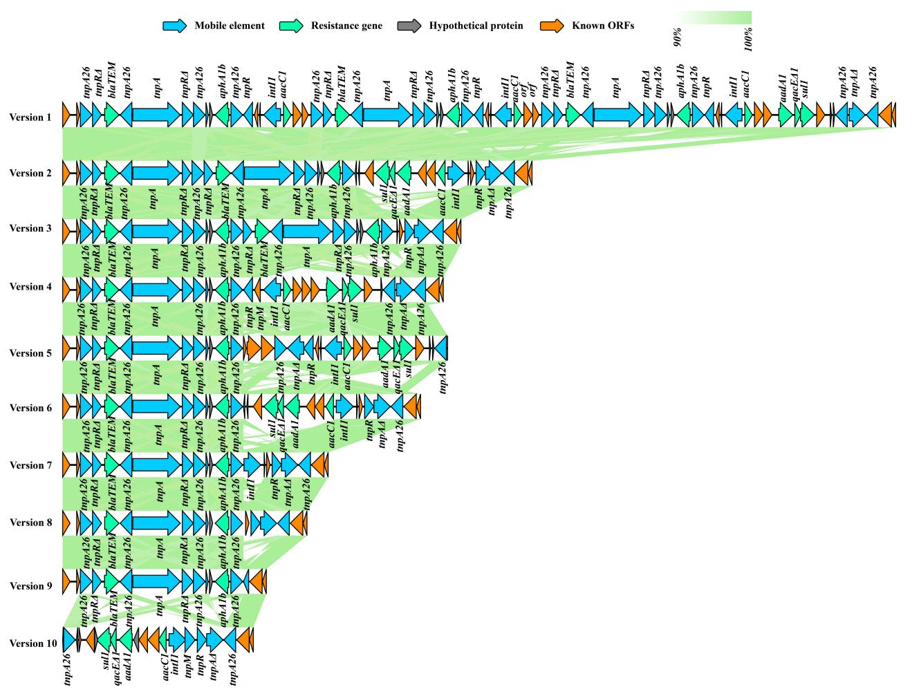
Fig. S7 Different types of genetic environments of AbGRI2 in ST2 complete genomes. Arrows indicate the direction, relative length, and function of ORFs. Sequence comparisons were performed using BLASTn and visualized using Easyfig.
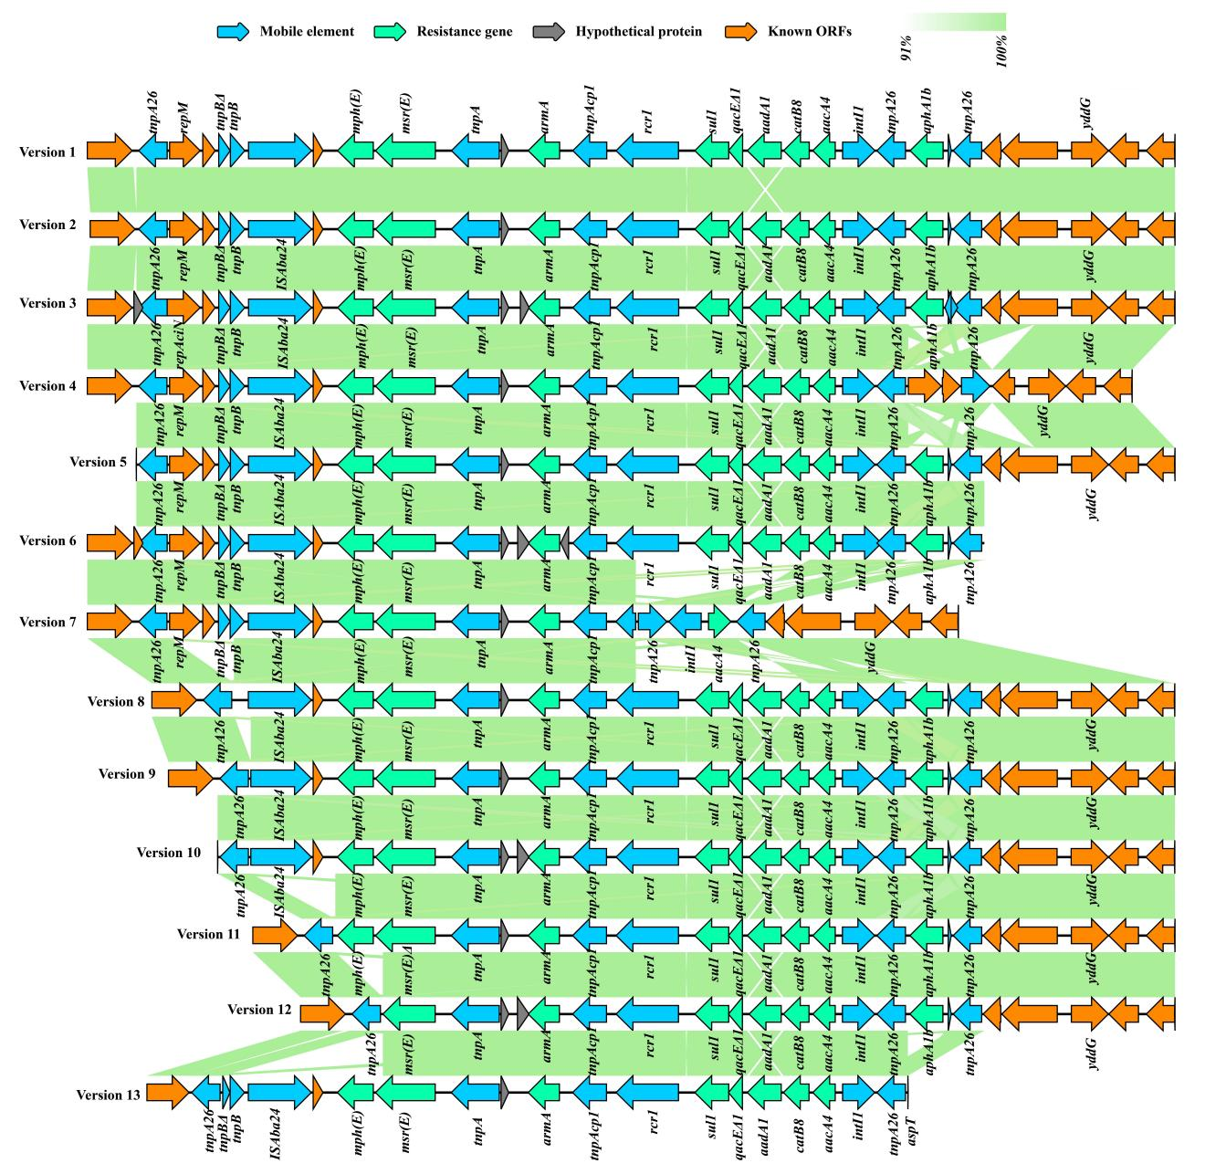
Fig. S8 Different types of genetic environments of AbGRI3 in ST2 complete genomes. Arrows indicate the direction, relative length, and function of ORFs. Sequence comparisons were performed using BLASTn and visualized using Easyfig.

