Fluconazole-Resistant Vulvovaginal Candidiasis in Reproductive Age Women: A Study from Himalayan country
Deepshikha Yadav¹, Purnima Baidya¹, Prabhakar R. Panday², Pritee Yadav³, Kul R. Rai⁴, Prasha Shrestha⁴ and Manita Aryal^{1*}
¹Central Department of Microbiology (IoST), Kathmandu 44600, Tribhuvan University, Nepal
²Microbiology Department, Narayani Hospital, Birgunj, Parsa, Nepal
³Department of Obstetrics and Gynecology, Narayani Hospital, Birgunj, Parsa, Nepal
⁴Key Laboratory of Animal Pathogen Infection and Immunology of Fujian Province, College of Animal Sciences, Fujian Agriculture and Forestry University, Fuzhou, China

*Correspondence: Manita Aryal
Email: manita.aryal@cdmi.tu.edu.np
Central Department of Microbiology
Tribhuvan University
Kitripur, Nepal

Supplementary Methodology
Method 1 Patient’s history includes, discharge, lower abdominal pain, itching or irritation in vagina, dyspareunia, dysuria, frequent urination, burning sensation during urination with urgency or leaking of urine, fever with chills and rigor [1].

Method 2 Underlying comorbidities includes thyroid, diabetes, menstrual irregularities, cervical erosion, and inflammation. Others include history of vaginal infection, douching and washes usage, and sanitary products (pads and clothing), urine infection, pregnancy were also taken into account in the analysis [2-4].

Method 3 The pH was determined by placing the collected swabs on the pH paper and compared with the color change with a standardized colorimetric reference chart. For Whiff test, HVS was rolled on a clean, grease-free slide and a drop of 10% KOH was added, and then the slide was held close to the nose to detect the amine order, positive for a fishy smell [2, 5].

Method 4 Mid-stream urine sample cultured in cystine lactose electrolyte deficient (CLED) agar, was incubated overnight at 35 ℃ for 24 h to detect uropathogens. The approximate number of colonies were counted, and the number of bacteria, i.e., the colony forming unit (CFU)/mL urine, was estimated [6].
Reporting of culture positivity
- Less than 10⁴/ mL organisms: Not significant
- Counting of 10⁴-10⁵/ mL organism: Doubtful (suggest repeat specimen)
- More than 10⁵/ mL organisms: Significant bacteriuria
However, if the culture indicated the appearance of 3 or more organism types with no predominant organism, this was interpreted as possible contamination of the specimen, and a request was made for another specimen.
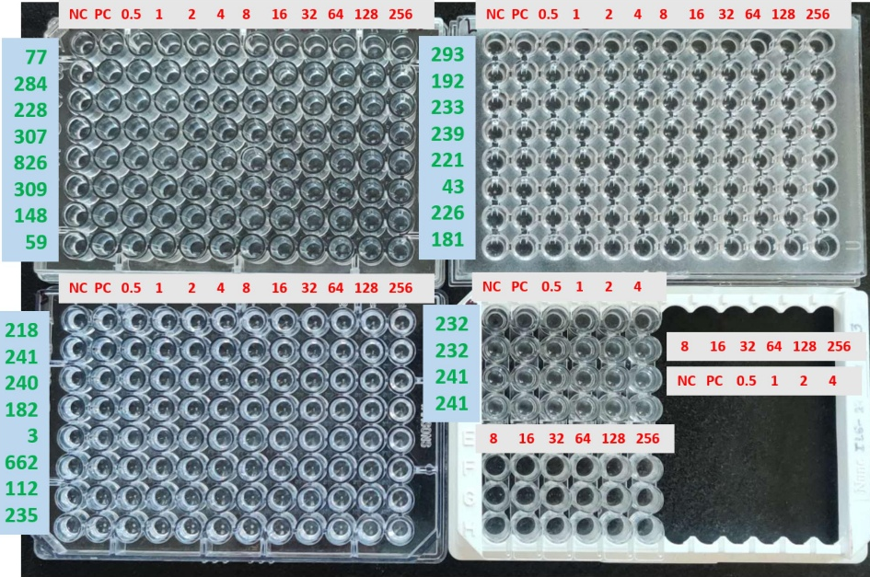
Supplementary Fig. 1 Determination of MIC by microdilution method.
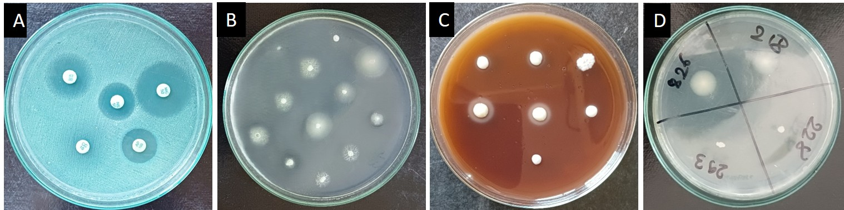
Supplementary Fig. 2 Antifungal susceptibility test and enzymatic activity. 1A: Antifungal susceptibility test in SDA. 1B: Esterase activity. 1C: Hemolysin activity. 1D: Phospholipase activity.
References
1. Brown H, Drexler M. Improving the diagnosis of vulvovaginitis: Perspectives to align practice, guidelines, and awareness. Popul Health Manag. 2020;23(S1):S3-12; doi: 10.1089/pop.2020.0265.
2. Thulkar J, Kriplani A, Agarwal N. Utility of pH test & Whiff test in syndromic approach of abnormal vaginal discharge. Indian J Med Res. 2010;131:445-8.
3. Enwuru CA, Aiyedobgon AS, Ajayi MB, Osuolale KA. Bacterial vaginosis (BV) and Trichomonas vaginalis (TV) co-infection, and bacterial antibiogram profile of pregnant women studied in Lagos, Nigeria. BMC women's health. 2024;24(1):415-28; doi: 10.1186/s12905-024-03257-y.
4. Falcon RM, Alcazar RM, Guda J, Tantengco OA. A systematic review and meta-analysis on the prevalence of vulvovaginal candidiasis in Southeast Asian countries. SciEnggJ. 2024;17(Supplement):341-55; doi: 10.54645/202417SupPYD-19.
5. Hemalatha R, Ramalaxmi BA, Swetha E, Balakrishna N, Mastromarino P. Evaluation of vaginal pH for detection of bacterial vaginosis. Indian J Med Res. 2013;138(3):354-9.
6. Shakya S, Edwards J, Gupte HA, Shrestha S, Shakya BM, Parajuli K, et al. High multidrug resistance in urinary tract infections in a tertiary hospital, Kathmandu, Nepal. Public health action. 2021;11(1):24-31; doi: 10.5588/pha.21.0035.

