Mechanisms of altitude-driven mycotoxin variation in stored wheat: a metabolomic and transcriptomic approach
Na Wei *, Jifeng Pu
Institutions of Agricultural Product Quality Standard and Testing Research, Tibet Academy of Agricultural and Animal Husbandry Sciences, Lhasa 850032, China
*Correspondence: weina@taaas.org

Supporting information:
Figure legend:
Figure S1 Isolation and identification of Alternaria alternata in grain storage in Tibet. A: Phylogeny of 65 isolates of Alternaria alternata. B. Growth assessment of candidate Alternaria strains in different regions in Tibet. C. TeA content analysis of five candidate Alternaria strains. D. Lesion diameter analysis in Figure 1D. Different letters indicate significant difference with P<0.05
Figure S2 Gene ontology (GO) enrichment analysis in the comparison of HT vs. MT.
Figure S3 Volcano plot showed differentially expressed metabolites in the comparison of HT vs. LT.
Figure S4 PCR examination of mutant and complemented strains of AaPacC.
Figure S5 Original gel examination of mutant and complemented strains of AaPacC.
Primer information
Table S1 All primers used in the paper are listed below.

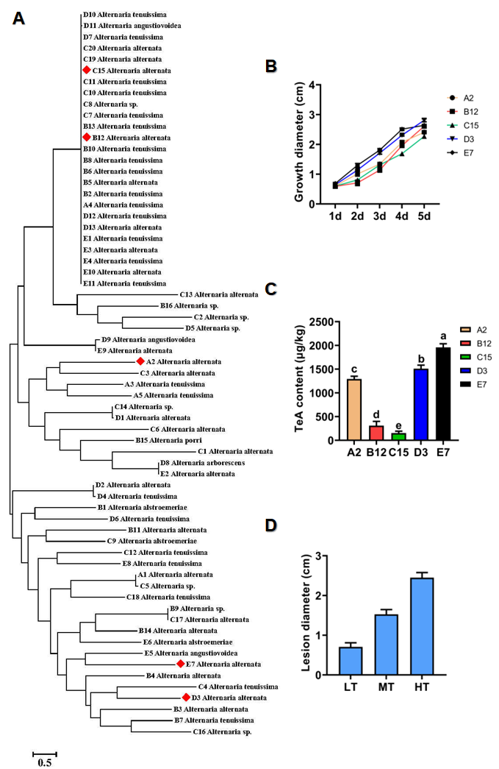
Figure S1 Isolation and identification of Alternaria alternata in grain storage in Tibet.
Figure S2 Gene ontology (GO) enrichment analysis in the comparison of HT vs. MT.
Figure S3 Volcano plot showed differentially expressed metabolites in the comparison of HT vs. LT.
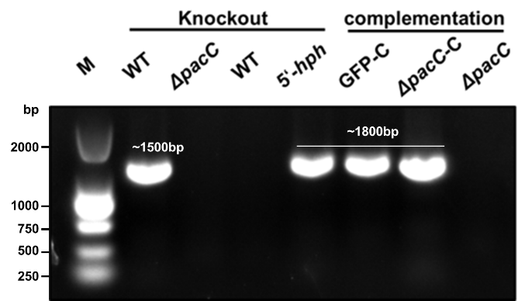
Figure S4 PCR examination of mutant and complemented strains of AaPacC.
Figure S5 Original gel examination of mutant and complemented strains of AaPacC.

Primer information
Name | Primer
ITS1 | TCCGTAGGTGAACCTGCGG
ITS4 | TCCTCCGCTTATTGATATGC
β-tublin-F | TGGTCCCTTCGGCCAGCTGT
β-tublin-R | TTCTCAACCAGCTGGTGGATGGAG
qAaPacC-F | TTTGACCTGCCAGTGGGGCA
qAaPacC-R | GACCGCCTCGGTTGGGCTCTG
qAaTFb2-F | TGAGCAGCCCTCGACTGTGT
qAaTFb2-R | AGGGCGTTTCGTAGGCTCTTC
qAaTFb4-F | TGAACAGCGAGCCGTCTTCT
qAaTFb4-R | CGAGGTGGGCGTTGATGAA
qRegA-F | CGTAAAGACGCACGCCGACGATT
qRegA-R | ACCAGCTGGAGCACCACCTG
AaPaCc-LF | TCTGCCGTACTCTTGGTGTT
AaPaCc-LR | CAAAATAGGCATTGATGTGTTGACCTCCCGTCTTGGCGAAGTCGAATG
AaPaCc-RF | CTCGTCCGAGGGCAAAGGAATAGAGTAGTGCCCGTGCTGTTTGTGGGT
AaPaCc-RR | ATCGCATGGAGGTGTCGGGC
C-AaPaCc-HAF | TATCCATATGATGTTCCAGATTATGCTATGAGCGAAGTCCAGAGTAC
C-AaPaCc-HAR | CTACTCTCGACCCTCTTGTACAGCACGCAA

