Notoginsenoside Ft1 enhances the effectiveness of gentamicin against Escherichia coli by interfering with intrinsic antibacterial mechanisms.

Yasong Yan^{a, c}, Yan Zhang^{b, c}, Xinjun Zhou^{a, c}, Xuefang Xu^{b, c}, Daomi Zhu^{b, c}, Huifeng Dong^{d}，Yu Jia^{a, c}, Lingcong Kong^{b, c} and Hongxia Ma^{a, b, c}
ª College of Life Sciences, Jilin Agricultural University, Xincheng Street No. 2888, Changchun 130118, P.R. China.
^{b} College of Animal Science and Technology, Jilin Agricultural University, Xincheng Street No. 2888, Changchun 130118, P.R. China.
^{c} The Key Laboratory of New Veterinary Drug Research and Development of Jilin Province, Jilin Agricultural University, Xincheng Street No. 2888, Changchun 130118, China.
^{d} Tianjin Key Laboratory of Biological Feed Additive Enterprise, S&E Burgeoning Biotechnology (Tianjin) Co., Ltd, No.27, Shengda Second Branch Road, Wangwenzhuang Industrial Park, Xiqing District, Tianjin, 300383, P.R. China;

Corresponding author:
Lingcong Kong
E-mail address:lingcong@jlau.edu.cn
Hongxia Ma
E-mail address: hongxia0731001@163.com
Figure S1. Notoginsenoside Ft1 does not affect the growth kinetics of bacteria. Growth kinetics of E. coli A25 in LB broth in the absence of Notoginsenoside Ft1 and in the presence of Notoginsenoside Ft1 at concentrations of 200 μM or 400 μM. OD_{600 nm} values represent the means ± SD from three independent readings.

Figure S2. Omics analysis in the presence of Notoginsenoside Ft1. A-C) Differentially expressed genes, Gene Ontology (GO) analysis, and Kyoto Encyclopedia of Genes and Genomes (KEGG) analysis for the Notoginsenoside Ft1 treatment group compared to the control group. D-F) Differentially expressed genes, GO analysis, and KEGG analysis for the combination treatment group of Notoginsenoside Ft1 and Gentamicin compared to the Gentamicin-only treatment group. G-I) Differentially expressed genes, GO analysis, and KEGG analysis for the combination treatment group of Notoginsenoside Ft1 and Gentamicin compared to the Notoginsenoside Ft1-only treatment group.

Figure S3. Notoginsenoside Ft1 inhibits the swarm motility of E.coli. A) Observation of the swarm motility of E. coli A25 on a bacterial culture plate with a diameter of 90 mm. B) Observation of the swarm motility of E. coli A25 on a bacterial culture plate with a diameter of 35 mm.

Figure S4. Determination of inoculum dosage in the Galleria mellonella model and the mouse model. A) Exploration of the inoculum size in the Galleria mellonella infection model. B) Exploration of the inoculum size in the mouse infection model.

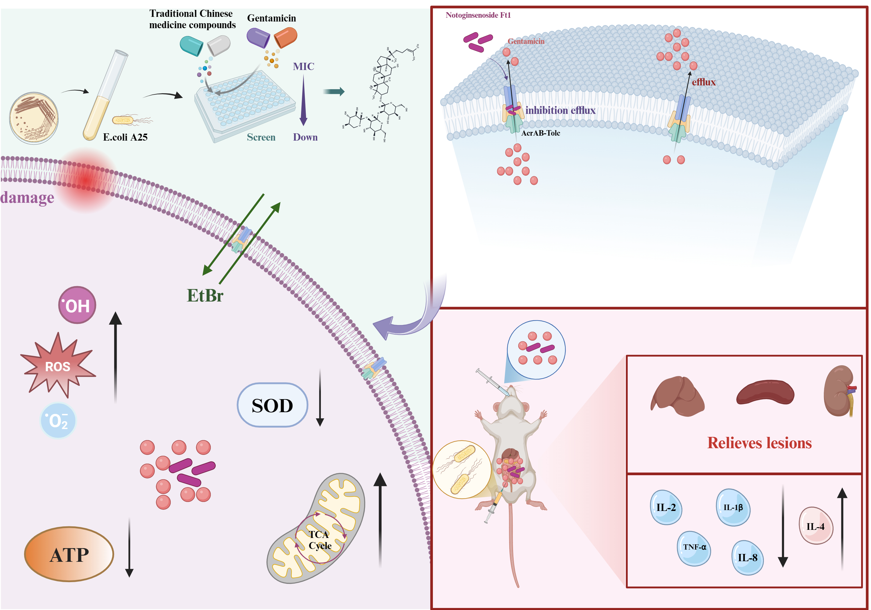
Figure S5. The in-vitro efficacy of the Notoginsenoside Ft1–Gentamicin combination is effectively translatable to the in-vivo setting.
Table S1.Design of primers for RT-PCR analysis.
Genes |  | Sequence(5'-3') |  | Fragment Size/bp
acrA-YGDL-F |  | CTCAAGTTAGCGGGATTA |  | 122bp
acrA-YGDL-R |  | ACCTTTCGCACTGTCGTA |  | 122bp
acrB-YGDL-F |  | GAAGCGATCATCCTCGTGTTC |  | 106bp
acrB-YGDL-R |  | CAAAGGTCCCGAGCAATACC |  | 106bp
tolC-YGDL-F |  | AAGCCGAAAAACGCAACCT |  | 101bp
tolC-YGDL-R |  | CAGAGTCGGTAAGTGACCATC |  | 101bp
16S-YGDL-F |  | CCTACGGGAGGCAGCAG |  | 194bp
16S-YGDL-R |  | ATTACCGCGGCTGCTGG |  | 194bp

