Supplementary Material
Table S1 Description of milk samples collected from animals with clinical mastitis (MC), subclinical mastitis (MS), and healthy condition (HG), including animal information (Parity, Lactation Stage, and Yield).
Milk ID | Animal number | Parity | Lactation stage | 305 days Lactation Yield (KG)
MC1 | 4904 | 6 | early | 2590
MC2 | 4978 | 4 | early | 3874
MC3 | 5062 | 4 | early | 2554
MS1 | 5259 | 3 | late | 3005
MS2 | 5774 | 1 | late | In lactation
MS3 | 4945 | 4 | late | 3028
MS4 | 4561 | 7 | late | 2390
MS5 | 5241 | 4 | late | 2472
MS6 | 5628 | 1 | late | In lactation
HG1 | 4251 | 7 | early | 2407
HG2 | 5075 | 5 | early | 2146
HG3 | 5049 | 5 | early | 2817
HG4 | 5685 | 5 | early | 2079
HG5 | 5380 | 2 | mid | 2330
HG6 | 5672 | 1 | mid | In lactation
HG7 | 5151 | 3 | mid | 3430

Table S2 Differential abundance of bacterial phylum in milk microbiota across Clinical, Sub-Clinical, and Healthy groups
 | Relative Abundance Frequency |  |  | p-value |  |  | FDR
Phylum | Group I: Clinical | Group II: Sub-Clinical | Group III: Healthy | SC vs C | H vs C | H vs SC | SC vs C | H vs C | H vs SC
Candidatus_  Gracilibacteria | 0.0000176 | 0.00041658 | 0.000175444 | *
Chlamydiae | 0.005003705 | 0.005988338 | 0.004237643 | * | **
Chlorobi | 0.003616713 | 0.00437409 | 0.003630338 | * | **
Chloroflexi | 0.016521003 | 0.024422005 | 0.022254375 | ** | *
Deferribacteres | 0.000649604 | 0.001614248 | 0.000985185
Deinococcus-Thermus | 0.008585304 | 0.017951996 | 5.056183187 |  | *** | *** |  | *** | ***
Proteobacteria | 79.61441629 | 62.45461718 | 44.24856666
Firmicutes | 18.39205517 | 33.677346 | 47.02489777
Actinobacteria | 1.521986453 | 2.839982363 | 2.888183305
Bacteriodetes | 0.169125212 | 0.462351774 | 0.344976551
Planctomycetes | 0.066575605 | 0.138031193 | 0.106764318
Cyanobacteria | 0.035728206 | 0.070532208 | 0.061324366
Candidatus_  Saccharibacteria | 0.053074381 | 0.053413372 | 0.044144367
Euryarchaeota | 0.021419367 | 0.05169498 | 0.042767807
Note: * indicates significance at p<0.05 and FDR<0.05, ** indicates significance at p<0.01 and FDR<0.01, *** indicates significance at p<0.001 and FDR<0.001.

Table S3 Differential abundance of the bacterial genus in milk microbiota across Clinical, Subclinical, and Healthy groups with statistical significance of group comparisons.
 | Relative Abundance |  |  | p-value |  |  | FDR
Genus | Group I: Clinical | Group II: Sub-Clinical | Group III: Healthy | SC vs C | H vs C | H vs SC | SC vs C | H vs C | H vs SC
Acaryochloris | 0.004564455 | 0.001061526 | 0.000918438 | *** | *** |  | *** | ***
Acidipropionibacterium | 0.001217188 | 0.021297695 | 0.009834353 | * | *
Acinetobacter | 76.34158736 | 52.23042628 | 33.10143005
Actinobaculum | 0.000286397 | 0.000873407 | 0.000381505 |  |  | *
Aeribacillus | 0.000250598 | 0.000335926 | 0.000635842 |  |  | *
Aeromonas | 0.016718436 | 0.014968853 | 0.044339369 |  |  | *
Aliivibrio | 0.003347267 | 0.0007256 | 0.00077714 | *** | *** |  | *** | ***
Arcanobacterium | 0.000250598 | 0.001101837 | 0.000565193 | * |  | *
Arcobacter | 0.002488076 | 0.00158557 | 0.001511891 | *** | *** |  |  | **
Atlantibacter | 0.000161098 | 0.000268741 | 0.000706491 |  |  | *
Avibacterium | 0.000966591 | 0.000214993 | 0.000409765 | *** | *** |  | *** | **
Bacillus | 0.026813937 | 0.047943328 | 3.873802639 |  | *** | *** |  | *** | ***
Bacteriovorax | 0.000501195 | 0.000618103 | 0.001172775 |  |  | *
Bifidobacterium | 0.00610384 | 0.055562125 | 0.10018041 |  | *** | * |  | **
Buttiauxella | 0.004474956 | 0.002458977 | 0.031947519 |  |  | *** |  |  | *
Candidatus_Fukatsuia | 0.002255378 | 0.000147807 | 0.000226077 | *** | *** |  | *** | ***
Candidatus_Nitrosocosmicus | 0.000447496 | 0.000537481 | 0.002204252 |  |  | *
Candidatus_Sulcia | 7.16E-05 | 8.06E-05 | 0.000240207 |  |  | *
Cedecea | 0.000501195 | 0.000550918 | 0.002091213 |  |  | **
Cetia | 0.000125299 | 0.001840873 | 0.000565193 |  |  | *
Chlamydia | 0.003562065 | 0.001209333 | 0.001441241 | *** | *** |  | ** | *
Citricoccus | 0.008019121 | 0.003896739 | 0.007517063 | *
Clostridium | 17.28756086 | 30.36519164 | 36.0445581
Colwellia | 0.008645615 | 0.002163362 | 0.001836876 | *** | *** |  | *** | ***
Coriobacterium | 0.000232698 | 0.001263081 | 0.000565193 | * |  | *
Cronobacter | 0.00204058 | 0.001209333 | 0.002416199 | * |  | *
Cutibacterium | 0.000787592 | 0.008263774 | 0.004578061 | * | *
Deinococcus | 0.005441547 | 0.011972395 | 5.286247505 |  | *** | *** | *** | *** | ***
Desulfurobacterium | 0.001252988 | 0.000188118 | 0.000113039 | *** | *** |  | *** | ***
Enterobacter | 0.064994262 | 0.006422901 | 0.014850439 | *** | *** | * | *** | ***
Enterococcus | 0.048204227 | 0.099984951 | 3.218433421 |  | *** | *** |  | *** | ***
Escherichia | 0.008484517 | 0.014055135 | 0.923369476 |  | *** | *** |  | *** | ***
Exiguobacterium | 0.127643647 | 0.001478074 | 0.007898568 | *** | *** | *** | *** | ***
Ferrimonas | 0.005459446 | 0.000846533 | 0.001299943 | *** | *** |  | *** | ***
Ferroplasma | 0.000429596 | 2.69E-05 | 0.000127168 | *** | ** |  | ***
Flavivirga | 0.000143199 | 0.000483733 | 0.000226077 |  |  | *
Flavobacterium | 0.021712487 | 0.00796816 | 0.029192204 | *** |  | *** | * |  | *
Glutamicibacter | 0.021622988 | 0.009835907 | 0.007220337 | ** | *** |  |  | *
Granulosicoccus | 0.007249429 | 0.002458977 | 0.001935785 | * | *** |  |  | *
Haemophilus | 0.005029851 | 0.002418666 | 0.001087996 |  | *** |  |  | ***
Halocynthiibacter | 0.000286397 | 0.000443422 | 0.000692361 |  |  | *
Intestinimonas | 0.001181388 | 0.000685289 | 0.000522803 | *
Izhakiella | 0.000178998 | 0.000268741 | 0.000565193 |  |  | *
Jeotgalibaca | 0.004188559 | 0.005495746 | 0.008689838 |  |  | *
Kosakonia | 0.004492856 | 0.001209333 | 0.002218381 | *** |  |  | *
Lactobacillus | 0.014695756 | 0.064578373 | 0.744867485 |  | *** | *** |  | *** | ***
Lactococcus | 0.374249528 | 3.049467087 | 1.362128584
Lelliottia | 0.009791204 | 0.001867747 | 0.004408503 | *
Marinilactibacillus | 0.000322197 | 0.00049717 | 0.0008054 |  |  | *
Marinobacter | 0.02547145 | 0.00796816 | 0.006867092 | *** | *** |  | *** | ***
Mariprofundus | 0.000286397 | 0.001746814 | 0.0008054 |  |  | *
Megamonas | 0.000250598 | 0.002042429 | 0.000974957 |  |  | *
Methanosphaera | 0.000375896 | 0.003332384 | 0.001328203 | * |  | *
Microcella | 0.000465395 | 0.001209333 | 0.000522803 |  |  | *
Minicystis | 0.004224359 | 0.013799831 | 0.006386678 |  |  | *
Novosphingobium | 0.010471397 | 0.006651331 | 0.006852962 | *** | *** |  | *** | ***
Otariodibacter | 0.000161098 | 0.00135714 | 0.000409765 |  |  | *
Oxynema | 0.000214798 | 0.000819659 | 0.000466284 |  |  | *
Paenarthrobacter | 0.000178998 | 0.000376237 | 0.000720621 |  |  | *
Pelolinea | 0.004367557 | 0.001142148 | 0.001271684 | *** | *** |  | *** | ***
Propionibacterium | 0.00105609 | 0.091640554 | 0.037571186 | *** | *
Propioniciclava | 0.000751793 | 0.026470952 | 0.011289725 | ***
Pseudomonas | 1.257408961 | 6.58092049 | 5.447058963
Rahnella | 0.005889042 | 0.001639318 | 0.004154167 | * |  | *
Rheinheimera | 0.000554895 | 0.000550918 | 0.00234555 |  | * | *** |  |  | *
Rhodobacter | 0.001879482 | 0.004272976 | 1.319046769 |  | *** | *** |  | *** | ***
Rhodococcus | 0.801643634 | 0.455434742 | 1.05580826
Rhodocytophaga | 0.00103819 | 0.001921496 | 0.003391156 |  |  | *
Rhodomicrobium | 0.00204058 | 0.001101837 | 0.001172775 | *** | *** |  | *** | ***
Salaquimonas | 0.000125299 | 0.001289955 | 0.00077714 | *
Shigella | 0.000322197 | 0.000483733 | 0.0302802 |  | *** | *** |  | *** | ***
Shimwellia | 0.000196898 | 0.00022843 | 0.000819529 |  | * | *
Simonsiella | 0.00107399 | 0.000201556 | 0.000226077 | * | ***
Staphylococcus | 0.03162899 | 0.079520352 | 0.248091344 |  |  | **
Streptococcus | 0.011026292 | 0.052431297 | 1.720616196 |  | *** | *** |  | *** | ***
Tetragenococcus | 0.001449886 | 0.007027567 | 0.013776573 |  | * | *
Thalassobius | 0.000125299 | 0.000268741 | 0.001384722 |  | *** | *** |  | * | **
Thalassotalea | 0.009236309 | 0.001034651 | 0.000890179 | *** | *** |  | *** | ***
Thiomicrorhabdus | 0.000304297 | 0.002028992 | 0.000664101 | * |  | *
Virgibacillus | 0.003812663 | 0.002539599 | 0.002430329 | *** | *** |  | * | *
Weissella | 0.012046582 | 0.004985139 | 0.003475935 | * | ** |  |  | *
Note: * indicates significance at p<0.05 and FDR<0.05, ** indicates significance at p<0.01 and FDR<0.01, *** indicates significance at p<0.001 and FDR<0.001

Figure S1 The species-level taxonomic profile of bacteria in buffalo clinical mastitis, subclinical mastitis, and healthy milk. Stacked bar plots showing the relative abundance and distribution of the 50 most abundant species
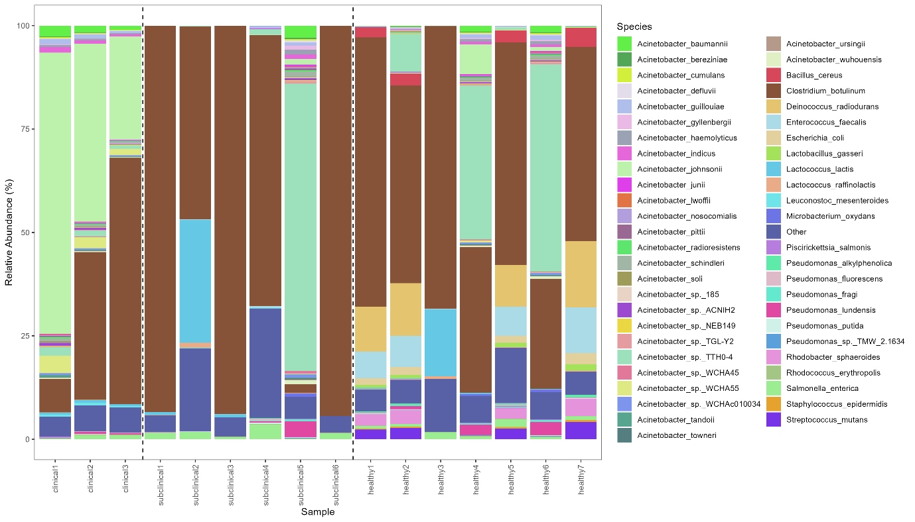
Figure S2 Heat map representing significant (p < 0.05) (a) phylum, (b) genus
Figure S3 Krona Chart illustrating taxonomic composition of Acinetobacter across (a) Clinical, (b) Subclinical, (c) Healthy groups

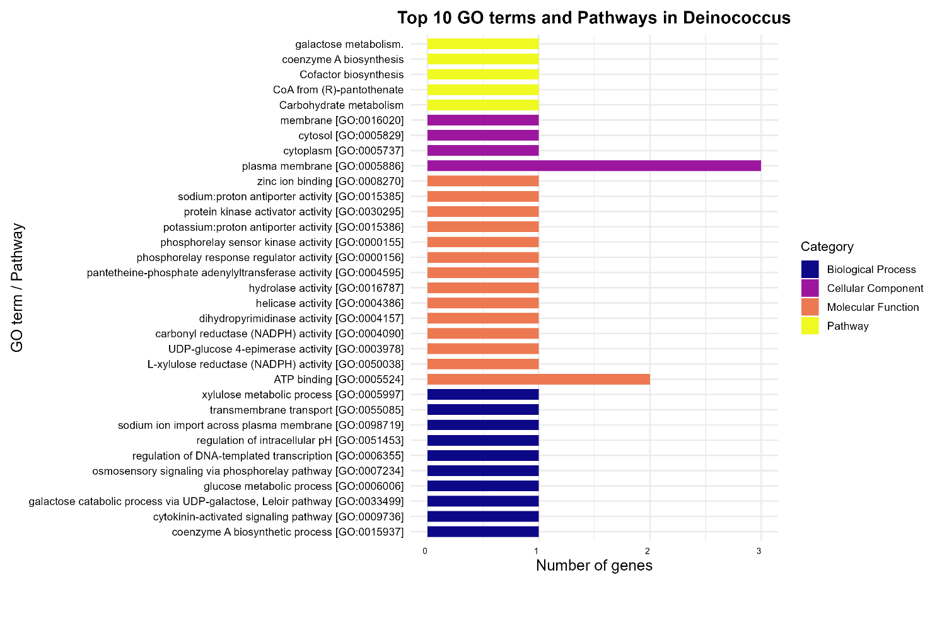
Figure S4 Top 10 GO terms for biological process, molecular function, cellular components, and pathways associated specifically with Deinococcus

R SCRIPT for Statistical Analysis
Bray-Curtis
library(vegan)
library(ggplot2)
library(dplyr)
library(ellipse)
library(readxl)

# Load data
bray_mat <- as.matrix(read.csv("E:/Metagenomics/analysis/Taxa_files/BrayCurtis_matrix.csv",
row.names = 1, header = TRUE))
metadata <- read_excel("E:/Metagenomics/metagenomic_metadata.xlsx")
metadata <- metadata[match(rownames(bray_mat), metadata$SampleID), ]

# PERMANOVA
bray_dist <- as.dist(bray_mat)
permanova_res <- adonis2(bray_dist ~ Group, data = metadata, permutations = 9999, method = "bray")
print(permanova_res)

# PCoA
pcoa <- cmdscale(bray_dist, eig = TRUE, k = 2)
pcoa_df <- data.frame(
SampleID = rownames(pcoa$points),
PC1 = pcoa$points[, 1],
PC2 = pcoa$points[, 2],
Group = metadata$Group
)

# Ellipse function
compute_ellipse <- function(df, level = 0.95) {
if (nrow(df) < 3) {
center <- colMeans(df[, c("PC1", "PC2")])
cov_matrix <- diag(c(0.001, 0.001))
} else {
center <- colMeans(df[, c("PC1", "PC2")])
cov_matrix <- cov(df[, c("PC1", "PC2")])
}
e <- as.data.frame(ellipse(cov_matrix, centre = center, level = level))
colnames(e) <- c("PC1", "PC2")
e$Group <- unique(df$Group)
return(e)
}

ellipses <- pcoa_df %>%
group_by(Group) %>%
do(compute_ellipse(.)) %>%
ungroup()

centroids <- pcoa_df %>%
group_by(Group) %>%
summarise(PC1 = mean(PC1), PC2 = mean(PC2))

# Plot
ggplot(pcoa_df, aes(x = PC1, y = PC2, color = Group, shape = Group)) +
geom_point(size = 3) +
geom_polygon(data = ellipses, aes(x = PC1, y = PC2, fill = Group, group = Group),
alpha = 0.25, inherit.aes = FALSE) +
geom_point(data = centroids, aes(x = PC1, y = PC2),
shape = 4, size = 5, color = "black", inherit.aes = FALSE) +
scale_shape_manual(values = c("Clinical" = 16, "Healthy" = 17, "Subclinical" = 15)) +
scale_color_manual(values = c("Clinical" = "red3", "Healthy" = "forestgreen", "Subclinical" = "blue3")) +
scale_fill_manual(values = c("Clinical" = "red3", "Healthy" = "forestgreen", "Subclinical" = "blue3")) +
theme_bw() +
labs(
x = paste0("PCoA1 (", round(pcoa$eig[1] / sum(pcoa$eig) * 100, 2), "% variance)"),
y = paste0("PCoA2 (", round(pcoa$eig[2] / sum(pcoa$eig) * 100, 2), "% variance)")
) +
theme(
legend.title = element_blank(),
panel.grid = element_blank()
)

Pairwise t-test for Acinetobacter
library(readr)
library(readxl)
library(dplyr)
library(tidyr)
library(rstatix)
# 1. Load abundance data
abundance <- read_csv("D:/Metagenomics/species abundance.csv")
# Check first few rows
head(abundance)
# 2. Make sure the first column is SampleID and numeric
# If the first column is already sample IDs, rename it
colnames(abundance)[1] <- "SampleID"
abundance$SampleID <- as.numeric(abundance$SampleID)
# 3. Load metadata
metadata <- read_excel("D:/Metagenomics/metagenomic_metadata.xlsx")
# 4. Merge abundance and metadata
data <- inner_join(metadata, abundance, by = "SampleID")
# 5. Convert to long format
long_data <- data %>%
pivot_longer(
cols = -c(SampleID, Group),
names_to = "Species",
values_to = "Abundance"
)
colnames(data)
# Keep Group from metadata and remove the other
data <- data %>%
rename(Group = Group.x) %>% # rename Group.x to Group
select(-Group.y) # remove Group.y
# Convert to long format for rstatix
long_data <- data %>%
pivot_longer(
cols = -c(SampleID, Group),
names_to = "Species",
values_to = "Abundance"
)
# Ensure Group is a factor
long_data$Group <- factor(long_data$Group, levels = c("Healthy", "Subclinical", "Clinical"))
# Perform pairwise t-tests with FDR correction
ttest_results <- long_data %>%
group_by(Species) %>%
pairwise_t_test(
Abundance ~ Group,
p.adjust.method = "fdr"
)
# View significant results
ttest_results %>% filter(p.adj < 0.05)
# Save full results
write.csv(ttest_results, "D:/Metagenomics/species_pairwise_ttest_final.csv", row.names = FALSE)

Species Relative Abundance
# Load libraries
library(tidyverse)
library(randomcoloR)

# Step 1. Load your data, force unique sample names
df <- read.csv("C:/Users/91972/OneDrive/Desktop/species.csv", check.names = TRUE)

# Rename first column to "Species"
colnames(df)[1] <- "Species"

# Step 2. Pivot wider → longer
df_long <- df %>%
pivot_longer(-Species, names_to = "Sample", values_to = "Abundance")

# Step 3. Get top 50 species across all samples
species_rank <- df_long %>%
group_by(Species) %>%
summarise(TotalAbundance = sum(Abundance, na.rm = TRUE)) %>%
arrange(desc(TotalAbundance))

top50_species <- species_rank %>% slice(1:50) %>% pull(Species)

# Collapse other species into "Other"
df_long <- df_long %>%
mutate(Species = ifelse(Species %in% top50_species, Species, "Other"))

# Step 4. Normalize within each sample → relative abundance
df_long <- df_long %>%
group_by(Sample) %>%
mutate(RelativeAbundance = 100 * Abundance / sum(Abundance, na.rm = TRUE))

# Step 5. Create distinct color palette
n_colors <- length(unique(df_long$Species))
my_colors <- distinctColorPalette(n_colors)
my_colors_named <- setNames(my_colors, unique(df_long$Species))

# Step 6. Reorder samples: Clinical → Subclinical → Healthy
clinical_samples <- sort(unique(df_long$Sample[grepl("clinical", df_long$Sample, ignore.case = TRUE) &
!grepl("subclinical", df_long$Sample, ignore.case = TRUE)]))
subclinical_samples <- sort(unique(df_long$Sample[grepl("subclinical", df_long$Sample, ignore.case = TRUE)]))
healthy_samples <- sort(unique(df_long$Sample[grepl("healthy", df_long$Sample, ignore.case = TRUE)]))

df_long <- df_long %>%
mutate(Sample = factor(Sample,
levels = c(clinical_samples,
subclinical_samples,
healthy_samples)))

# Step 7. Find positions to draw dashed separators
n_clinical <- length(clinical_samples)
n_subclinical <- length(subclinical_samples)

sep_positions <- c(n_clinical + 0.5, n_clinical + n_subclinical + 0.5)

# Step 8. Plot stacked barplot with dashed lines
p <- ggplot(df_long, aes(x = Sample, y = RelativeAbundance, fill = Species)) +
geom_bar(stat = "identity") +
geom_vline(xintercept = sep_positions, linetype = "dashed", color = "black") +
theme_bw() +
ylab("Relative Abundance (%)") +
xlab("Sample") +
theme(
axis.text.x = element_text(angle = 90, vjust = 0.5, hjust = 1),
panel.grid.major = element_blank(),
panel.grid.minor = element_blank()
) +
scale_fill_manual(values = my_colors_named) +
guides(fill = guide_legend(ncol = 2))

# Print plot to RStudio
print(p)

# Step 9. Save plot as PNG
ggsave("C:/Users/91972/OneDrive/Desktop/species_barplot.png",
plot = p,
width = 12, height = 6, dpi = 300)

Gene Ontology for Acinetobacter
# Load required libraries
library(dplyr)
library(tidyr)
library(stringr)
library(ggplot2)
library(readr)
library(viridis)

# Load data
data <- read_csv("C:/Users/91972/OneDrive/Desktop/Functional/Functional_annotation.csv")

# Filter Acinetobacter only
acinetobacter_data <- data %>%
filter(str_detect(Organism, "Acinetobacter"))

# Function to tidy GO columns
tidy_go <- function(df, go_column, category_name){
df %>%
select(genes, all_of(go_column)) %>%
filter(get(go_column) != "-") %>%
separate_rows(all_of(go_column), sep=";") %>%
mutate(
`GO term` = str_trim(get(go_column)),
Category = category_name
) %>%
select(genes, Category, `GO term`)
}

# Process each GO category
bp <- tidy_go(acinetobacter_data, "Gene Ontology (biological process)", "Biological Process")
mf <- tidy_go(acinetobacter_data, "Gene Ontology (molecular function)", "Molecular Function")
cc <- tidy_go(acinetobacter_data, "Gene Ontology (cellular component)", "Cellular Component")

# Combine all
all_go <- bind_rows(bp, mf, cc)

# Count genes per GO term
go_counts <- all_go %>%
group_by(Category, `GO term`) %>%
summarise(NumGenes = n(), .groups = 'drop')

# Take top 10 per category
top_go <- go_counts %>%
group_by(Category) %>%
slice_max(NumGenes, n = 10) %>%
ungroup()

# Order GO terms: first BP, then MF, then CC
top_go <- top_go %>%
arrange(factor(Category, levels = c("Biological Process", "Molecular Function", "Cellular Component")),
desc(NumGenes)) %>%
mutate(`GO term` = factor(`GO term`, levels = `GO term`))

# Horizontal bar plot with beautiful colors
ggplot(top_go, aes(x = `GO term`, y = NumGenes, fill = Category)) +
geom_bar(stat = "identity", width = 0.7) +
labs(title = "Top 10 GO terms per category in Acinetobacter",
x = "GO term",
y = "Number of genes") +
scale_fill_viridis(discrete = TRUE, option = "plasma") +
theme_minimal(base_size = 14) +
theme(
axis.text.x = element_text(angle = 0, hjust = 1, color = "black", size = 10),
axis.text.y = element_text(color = "black", size = 12),
axis.title = element_text(color = "black", size = 14),
plot.title = element_text(color = "black", hjust = 0.5, size = 16, face = "bold"),
legend.title = element_text(color = "black", size = 12),
legend.text = element_text(color = "black", size = 10),
plot.margin = margin(10, 10, 50, 10)
) +
coord_flip() # horizontal bars for better readability

# Optionally, save the plot as a PNG
ggsave("C:/Users/91972/OneDrive/Desktop/Functional/Acinetobacter_GO_top10.png",
width = 12, height = 8)

